Table of Contents

UNITED STATES
SECURITIES AND EXCHANGE COMMISSION
WASHINGTON, D.C. 20549
_______________________________________
FORM 10-K
_______________________________________
(Mark One)
☒ |  |  | ANNUAL REPORT PURSUANT TO SECTION 13 OR 15(d) OF THE SECURITIES EXCHANGE ACT OF 1934
For the fiscal year ended December 31, 2025
OR
☐ |  |  | TRANSITION REPORT PURSUANT TO SECTION 13 OR 15(d) OF THE SECURITIES EXCHANGE ACT OF 1934
For the transition period from to
Commission File Number: 0-21044
_______________________________________
UNIVERSAL ELECTRONICS INC.
(Exact Name of Registrant as Specified in its Charter)

Delaware |  |  |  |  |  | 33-0204817
(State or Other Jurisdiction of  Incorporation or Organization) |  |  |  |  |  | (I.R.S. Employer  Identification No.)
15147 N. Scottsdale Road, Suite H300, Scottsdale, Arizona 85254-2494
(Address of principal executive offices and zip code)
(480) 530-3000
(Registrant's telephone number, including area code)
_____________________
Securities registered pursuant to Section 12(b) of the Act:
Title of each class |  |  | Trading Symbol(s) |  |  | Name of each exchange on which registered
Common Stock, par value $0.01 per share |  |  | UEIC |  |  | The Nasdaq Stock Market LLC

Securities registered pursuant to Section 12(g) of the Act:
None
_______________________________________
Indicate by check mark if the registrant is a well-known seasoned issuer, as defined in Rule 405 of the Securities Act. Yes ☐ No ☒
Indicate by check mark if the registrant is not required to file reports pursuant to Section 13 or Section 15(d) of the Act. Yes ☐ No ☒
Indicate by check mark whether the registrant (1) has filed all reports required to be filed by Section 13 or 15(d) of the Securities Exchange Act of 1934 during the preceding 12 months (or for such shorter period that the registrant was required to file such reports), and (2) has been subject to such filing requirements for the past 90 days. Yes ☒ No ☐
Indicate by check mark whether the registrant has submitted electronically every Interactive Data File required to be submitted pursuant to Rule 405 of Regulation S-T (§232.405 of this chapter) during the preceding 12 months (or for such shorter period that the registrant was required to submit such files). Yes ☒ No ☐
Indicate by check mark whether the registrant is a large accelerated filer, an accelerated filer, a non-accelerated filer, a smaller reporting company, or an emerging growth company. See the definitions of "large accelerated filer", "accelerated filer," "smaller reporting company," and "emerging growth company" in Rule 12b-2 of the Exchange Act.

Large accelerated filer |  |  | ☐ |  |  | Accelerated filer |  |  | ☒
Non-accelerated filer |  |  | ☐ |  |  | Smaller reporting company |  |  | ☒
 |  |  |  |  |  | Emerging growth company |  |  | ☐

If an emerging growth company, indicate by check mark if the registrant has elected not to use the extended transition period for complying with any new or revised financial accounting standards provided pursuant to Section 13(a) of the Exchange Act. ☐

Indicate by check mark whether the registrant has filed a report on and attestation to its management's assessment of the effectiveness of its internal control over financial reporting under Section 404(b) of the Sarbanes-Oxley Act (15 U.S.C. 7262(b)) by the registered public accounting firm that prepared or issued its audit report ☒

If securities are registered pursuant to Section 12(b) of the Act, indicate by check mark whether the financial statements of the registrant included in the filing reflect the correction of an error to previously issued financial statements. ☐

Indicate by check mark whether any of those error corrections are restatements that required a recovery analysis of incentive-based compensation received by any of the registrant’s executive officers during the relevant recovery period pursuant to §240.10D-1(b). ☐
Indicate by check mark whether the registrant is a shell company (as defined in Rule 12b-2 of the Exchange Act). Yes ☐ No ☒
The aggregate market value of the voting and non-voting common equity held by non-affiliates of the registrant on June 30, 2025, the last business day of the registrant's most recently completed second fiscal quarter, was $74,352,689 based upon the closing sale price of the Company's common stock as reported on the Nasdaq Stock Market for that date.
On March 4, 2026, 12,864,412 shares of Common Stock, par value $.01 per share, of the registrant were outstanding.

DOCUMENTS INCORPORATED BY REFERENCE:
Portions of the registrant's notice of annual meeting of stockholders and proxy statement (the "Proxy Statement") to be filed pursuant to Regulation 14A within 120 days after registrant's fiscal year end of December 31, 2025 are incorporated by reference into Part III of this Form 10-K. The Proxy Statement will be filed with the Securities and Exchange Commission no later than April 30, 2026.
Except as otherwise stated, the information contained in this Form 10-K is as of December 31, 2025.

Table of Contents

UNIVERSAL ELECTRONICS INC.
Annual Report on Form 10-K
For the Fiscal Year Ended December 31, 2025
Table of Contents

Item  Number |  |  | Page  Number
Risk Factor Summary |  |  | 3
PART I
1 Business |  |  | 4
1A Risk Factors |  |  | 14
1B Unresolved Staff Comments |  |  | 29
1C Cybersecurity |  |  | 29
2 Properties |  |  | 31
3 Legal Proceedings |  |  | 31
4 Mine Safety Disclosures |  |  | 31
PART II
5 Market for Registrant's Common Equity, Related Stockholder Matters and Issuer Purchases of Equity Securities |  |  | 32
6 [Reserved] |  |  | 32
7 Management's Discussion and Analysis of Financial Condition and Results of Operations |  |  | 33
7A Quantitative and Qualitative Disclosures About Market Risk |  |  | 40
8 Financial Statements and Supplementary Data |  |  | 41
9 Changes in and Disagreements with Accountants on Accounting and Financial Disclosure |  |  | 83
9A Controls and Procedures |  |  | 83
9B Other Information |  |  | 85
9C Disclosure Regarding Foreign Jurisdictions that Prevent Inspections |  |  | 85
PART III
10 Directors, Executive Officers and Corporate Governance |  |  | 85
11 Executive Compensation |  |  | 85
12 Security Ownership of Certain Beneficial Owners and Management and Related Stockholder Matters |  |  | 86
13 Certain Relationships and Related Transactions, and Director Independence |  |  | 86
14 Principal Accountant Fees and Services |  |  | 86
PART IV
15 Exhibits and Financial Statement Schedules |  |  | 86
16 Form 10-K Summary |  |  | 90
Signatures |  |  | 91

Table of Contents

RISK FACTOR SUMMARY

Our business is subject to varying degrees of risk and uncertainty. Investors should consider the risks and uncertainties summarized below, as well as the risks and uncertainties discussed in Part I, Item 1A.“Risk Factors” of this Annual Report on Form 10-K. Additional risks not presently known to us or that we currently deem immaterial may also affect us. If any of these risks occur, our business, financial condition, or results of operations could be materially and adversely affected.

Our business is subject to the following principal risks and uncertainties:

•We have incurred losses from operations and our future profitability is not certain;
•We may not be able to obtain capital when desired on favorable terms, if at all, or without dilution to stockholders;
•Our secured credit facility contains financial and restrictive covenants that we may not satisfy, and that, if not satisfied, could result in the acceleration of any outstanding indebtedness and limit our ability to borrow additional funds;
•We may be unable to realize the level of the anticipated benefits that we expect from exiting facilities and restructuring our operations, which may adversely impact our business and results of operations;
•Our growth projections may differ from our actual results;
•Market projections and data are forward-looking in nature;
•Our quarterly results are subject to fluctuation;
•Fluctuations in foreign currency exchange rates or interest rates may adversely affect our results of operations, cash flow, liquidity or financial condition;
•Our ability to generate cash depends on many factors beyond our control;
•Cybersecurity incidents, failure to maintain the integrity of and protect internal or customer data may result in faulty business decisions, operational inefficiencies, damage to our reputation and/or subject us to costs, fines, or lawsuits;
•Our technology development activities may experience delays;
•Difficulty in ordering integrated circuits and increases in commodities and freight costs have adversely affected and will continue to adversely affect our business;
•Disruptions caused by labor disputes or organized labor activities could materially harm our business and reputation;
•The fluctuation of the Chinese Yuan Renminbi may adversely impact our manufacturing costs;
•Changes in the policies of the PRC government may have a significant impact upon the business we conduct in the PRC and the profitability of such business;
•Significant developments from potential changes in U.S. trade policies could have a material adverse effect on us;
•Policy changes affecting international trade could adversely impact the demand for our products and our competitive position;
•Risks and uncertainties associated with our expansion into and our operations outside of the United States may adversely affect our results of operations, cash flow, liquidity or financial condition; and
•Failure by our international operations to comply with anti-corruption laws or trade sanctions could increase our costs, reduce our profits, limit our growth, harm our reputation, or subject us to broader liability.

Table of Contents

PART I

ITEM 1. BUSINESS

Universal Electronics Inc. ("UEI", "we", "our", "us", or the "Company") was incorporated under the laws of Delaware in 1986 and began operations in 1987. The principal executive offices are located at 15147 N. Scottsdale Road, Suite H300, Scottsdale, Arizona 85254. As used herein, the terms "we", "us" and "our" refer to UEI and its subsidiaries unless the context indicates the contrary.

Additional information regarding UEI may be obtained at www.uei.com. Our website address is not intended to function as a hyperlink and the information available at our website address is not incorporated by reference into this Annual Report on Form 10-K. We make our periodic and current reports, together with amendments to these reports, available on our website, free of charge, as soon as reasonably practicable after such material is electronically filed with, or furnished to, the U.S. Securities and Exchange Commission (the "SEC"). The SEC maintains a website at www.sec.gov that contains the reports, proxy and other information that we file electronically with the SEC.

Our business is comprised of one reportable segment. We have two domestic subsidiaries and 22 international subsidiaries located in Brazil, France, Germany, Hong Kong (3), India, Italy, Japan, Korea, Mexico (2), the Netherlands, the People's Republic of China (the "PRC") (5), Singapore, Spain, United Kingdom and Vietnam.

Our mission is to create products and technologies that help everyday people easily discover and interact with the devices and services in their home. We aim to provide universal and interoperable control solutions that automatically set up and deliver consistent and intuitive control of connected devices, content and services.

Sales

We design, develop, manufacture, ship and support home entertainment control products, technology and software solutions, climate control solutions, wireless sensor and smart home control products and audio-video ("AV") accessories, that are used by the world's leading brands in the home entertainment, climate control, consumer electronics, security, home automation and home appliance markets. Our product and technology offerings include:

•Connected Home:
▪Climate Control Solutions. We offer a portfolio of wireless and wired thermostat controllers, smart thermostats and connected accessories sold primarily to HVAC original equipment manufacturers (“OEMs”), utilities, hospitality and multi-dwelling unit (“MDU”) system integrators. Our UEI TIDE™ family integrates Wi-Fi, Bluetooth® Low Energy, Zigbee® and Matter, as well as advanced sensing for temperature, humidity, proximity, occupancy and carbon dioxide. The platform supports intelligent energy management and comfort features enabled by QuickSet® homeSense, our privacy-first software-defined occupancy and presence detection technology.
▪Smart Home and Security. We provide radio-frequency sensors and control modules for residential security, safety and home automation applications. These products support major standards, including Zigbee, Z-Wave and sub-GHz proprietary protocols, and are sold to OEMs, service providers and professional security channel partners.

•Home Entertainment:
▪Home Entertainment Products. Our home entertainment portfolio includes RF-capable, voice-enabled remote controls; low-power microcontrollers; and embedded and cloud-based software for audio-video and smart device discovery and control. These solutions are sold to video service providers and consumer electronics OEMs. In retail, our One For All® brand offers replacement remotes, antennas, mounting solutions, as well as home office and gaming furniture and accessories in key global markets.
▪Software and Cloud Services. We license our technology and software solutions—including QuickSet®, QuickSet Cloud and lifecycle device-management services—to OEMs, video service providers and consumer electronics brands. These services support interoperability, app and content discovery, diagnostics, secure firmware updates and data-driven personalization.
▪Intellectual Property and Licensing. We license our device knowledge libraries, embedded firmware and cloud-based services to customers worldwide. Our intellectual property includes patented discovery, setup and control technologies deployed across entertainment, climate control and smart home ecosystems.

4
Table of Contents

Our overall business strategy is focused on expanding our presence in the climate control market. This focus is driven by the growing demand for energy-efficient and smart climate control solutions in both residential and commercial applications. We have a strong presence in the global market, with a top-tier customer base that includes major global smart TV brands and HVAC OEM brands. Our products are used by major video service providers, consumer electronics companies and home automation and security brands.

Our channel strategy is to partner with customers who are leaders in their respective industries. In climate control, Daikin Industries Ltd., Fujitsu General, Mitsubishi Electric, LG HVAC and Carrier Global Corporation are customers that represent top market share leaders in the global HVAC industry. In security, safety and home automation, Vivint Smart Home, Somfy SA, SimpliSafe, and Hunter Douglas NV are channel leaders in their respective connected home markets. In consumer electronics, we consider Samsung Electronics Co., Sony Group Corporation, Vizio and LG Electronics as long-term accounts
that represent a significant share of their industry. In cable video services, Comcast Corporation, Charter, Cox Communications, Liberty Global and Vodafone Group rank amongst the largest video service providers in their respective markets; and in satellite services, Dish Network Corporation, Sky plc, Bharti Airtel Limited and DIRECTV represent the majority of global service providers.

As part of our channel diversification strategy, we are also expanding our connected home growth strategy beyond core HVAC OEM offerings, entering adjacent markets such as utilities and multi-dwelling unit property management, while also increasing our presence in the security channel. Energy management is a growing priority in Western Europe -- to meet this demand, we are enhancing Tide Touch with new features that support energy efficiency and provide utilities with actionable insights. We are applying a similar approach to serve multi-dwelling unit property managers. By integrating interoperability with smart devices such as door locks and water leak detectors, Tide Touch offers a turnkey solution, delivering energy efficiency, convenience and remote management capabilities while reducing the risk of costly failures.

Distribution methods for our control solutions vary depending on the sales channel. We distribute remote control devices, connected thermostats, integrated circuits ("ICs"), home security sensors and AV accessories directly to video and security service providers and OEMs, both domestically and internationally. We distribute connected thermostats and home security sensors to pro-security installers and hospitality system integrators in the United States and Europe through a network of national and regional distributors and dealers. Additionally, we sell our wireless control devices and AV accessories under the One For All®, Ecolink® and private label brand names to retailers in key markets, such as in the United States, United Kingdom, Germany, France and Spain. We utilize third-party distributors for the retail channel in countries where we do not have subsidiaries.

For the years ended December 31, 2025, 2024 and 2023, our sales to Daikin Industries Ltd. accounted for 18.3%, 13.3% and 14.0% of our net sales, respectively.

Products and Technology

QuickSet® and QuickSet Cloud. QuickSet is deployed globally in hundreds of millions of devices and enables cross-protocol interoperability across IR, HDMI-CEC, Bluetooth LE, Zigbee, Thread, Matter and IP networks. QuickSet Cloud extends device identification, app/content discovery, AI-assisted feature enablement and lifecycle device support.

QuickSet homeSense™. QuickSet homeSense enhances the platform with contextual intelligence that enables adaptive climate control, presence-based entertainment features and privacy-first occupancy detection. QuickSet is a certified Matter controller with multi-admin capabilities.

Edge Connectivity Modules. QuickSet Widget and QuickSet Widget Pro provide Wi-Fi 6, Bluetooth 5.3, Zigbee and Thread connectivity with native Matter support. These modules integrate seamlessly with cloud services to accelerate OEM development and simplify deployment. UEI Virtual Agent and NetReady support provide automated device onboarding, diagnostics and troubleshooting.

TIDE™ Climate Control Platforms. The UEI TIDE family—including Dial, Touch and the forthcoming Tide Pro—supports advanced HVAC control across central, hybrid and space systems, including IR-controlled mini-splits. The platform offers energy insights, occupancy-based automation and intelligent comfort management powered by homeSense. Tide Pro will incorporate an enhanced display, on-device artificial intelligence ("AI") and an expanded connectivity framework including Thread and Open Thread Border Router.

5
Table of Contents

Low-Power Silicon and Sustainable Technologies. Our Graphene and Eterna voice remote platforms and proprietary low-power SoCs support batteryless, ultra-efficient control products, including Hybrid Supercap for energy storage and energy-harvesting solutions such as photovoltaic-powered remote controls. These technologies reduce or eliminate battery usage and support customer sustainability goals.

Smart Home Hubs and Sensors. Our Butler hubs, powered by QuickSet Cloud, integrate Zigbee, Wi-Fi, IP and IR technologies and provide Matter bridging to unify legacy and modern devices. Pre-integrated sensor kits support energy management, climate, lighting and automation use cases.

Markets and Competition

Demand in our climate control solution is driven by energy-efficiency and energy demand management requirements, the adoption of advanced HVAC systems and the need for predictive analytics for improved HVAC maintenance. We face competition from HVAC OEM suppliers, module and chipset vendors, smart home platform providers, traditional remote-control manufacturers and various regional or specialized providers. We compete on feature innovation, software capability, intellectual property, interoperability with our portfolio of device libraries, low-power silicon, global design support and vertically integrated manufacturing.

The consumer demand to upgrade to smart thermostats is driven by the integration of intelligent climate control solutions for enhanced user comfort and energy efficiency, increased cloud connectivity, support for smart home ecosystems and the adoption of energy management platforms utilizing occupancy and presence detection technology, such as QuickSet homeSense. Furthermore, our OEM customers are equally motivated to bring these cloud-connected capabilities to their thermostat products as the benefits gained in accessing system data for preventive and predictive maintenance of the HVAC systems, far outweigh the added investments in these more advanced (smart) thermostats.

Leveraging our scale and expertise in low-power RF microcontrollers, we continue to pursue further penetration of our traditional OEM consumer electronics markets as well as newer product categories in the smart home and IoT markets including smart lighting, smart and motorized shades, as well as smart toilets and faucets, which rely on smart connectivity and control technologies to reduce water use and improve user experience.

Home entertainment markets continue to transition from traditional Pay TV toward smart TV operating systems, streaming platforms and personalized advertising models. QuickSet and homeSense support these trends through cross-platform interoperability and presence-aware engagement. Additionally, some of our current customers have successfully introduced media streaming services and expanded their footprint to new end-users. Comcast-Charter's Xumo TV, Tivo Stream, and Sky Glass are examples of current customer offerings of these types of services. Additionally, these brands, along with our OEM customers in consumer electronics, such as LG with their WebOS, are expanding their customer footprints through distribution of their OS platforms that include our QuickSet technologies, allowing us to grow our global technology footprint and grow our licensing revenue in those channels.

Our principal competitors in the home entertainment market are Remote Solutions, Home Control International, Tech4Home and Ruwido. In the climate control market, we compete with regional specialists and global companies such as Resideo, Copeland-Emerson and Venstar, as well as Far East based OEM manufacturers such as Computime, who compete with us on customer RFQs. In the connected smart home market, we compete with the OEMs themselves as well as wireless manufacturers in North America, such as Nice, and several original design manufacturers in Asia, as well as technology system providers such as Tuya. In the home security, safety and automation market, we compete with offshore-based, original design and built-to-print hardware manufacturers, such as Leedarson and Xavi Technologies. In the international retail and private label markets for wireless controls, we compete primarily with a variety of accessory trading and branding companies like Jasco and Hama, as well as various manufacturers of AV accessories in Asia.

Global Locations and Subsidiaries

We operate on a global scale with research and development ("R&D") teams in the U.S., Europe, the PRC and India. The company has diversified manufacturing facilities in Vietnam, the PRC and Brazil. This global presence allows us to leverage our scale and reach to deliver innovative products and solutions to customers worldwide.

Our 24 domestic and international subsidiaries are the following:

•C.G. Development Ltd., established in Hong Kong;
6
Table of Contents

•CG Mexico Distribution Co., S. de R.L. de C.V., established in Mexico;
•CG Mexico Remote Controls, S. de R.L. de C.V., established in Mexico;
•Gemstar Polyfirst Ltd., established in Hong Kong;
•Gemstar Technology (Yangzhou) Co. Ltd., established in the PRC;
•Guangzhou Universal Electronics Service Co., Ltd., established in the PRC;
•One For All France S.A.S., established in France;
•One For All GmbH, established in Germany;
•One For All Iberia S.L., established in Spain;
•One For All UK Ltd., established in the United Kingdom;
•Qinzhou Universal Trading Co. Ltd., established in the PRC;
•UE Japan Ltd., established in Japan;
•UE Korea Ltd., established in South Korea;
•UE Singapore Pte. Ltd., established in Singapore;
•UE Vietnam Company Limited, established in Vietnam;
•UEI Electronics Pte. Ltd., established in India;
•UE Holdings, LLC; established under the laws of Delaware;
•UEI Hong Kong Pte. Ltd., established in Hong Kong;
•Universal Electronics B.V., established in the Netherlands;
•Universal Electronics Holdings, LLC; established under the laws of Delaware;
•Universal Electronics Italia S.R.L., established in Italy;
•Universal Electronics Yangzhou Co. Ltd., established in the PRC;
•Universal Electronics do Brasil Ltda., established in Brazil; and
•Yangzhou Universal Trading Co. Ltd., established in the PRC.

Research and Development

Engineering

Our development resources include approximately 390 engineering and R&D team members worldwide, who are dedicated to designing and developing cutting-edge consumer control products, technologies and software services. We invest heavily in technology and product innovation, focusing on creating smarter living solutions for our customers.

Our engineering resources continued to advance the UEI TIDE family of smart thermostat platforms, completing development and testing activities to support design wins across HVAC OEM, MDU and utilities customers, and integrating new capabilities showcased at CES 2026, including Matter support, QuickSet homeSense, energy insights and a device-based rules engine. The expanded TIDE portfolio—including Dial, Touch and Bridge models—now supports a range of wired and wireless connectivity options such as Zigbee Coordinator functionality and Matter interoperability, enabling seamless integration with HVAC systems and major smart home ecosystems. Designed to manage both central and space HVAC systems, the platform also offers hybrid system control through IR, and incorporates nevo®.ai for device onboarding, remote control and embedded support, delivering enhanced intelligence, energy management and ease of use across customer-specific deployments.

During 2025, our development teams successfully completed and released new products in the connected home space for customers such as Daikin, Carrier, Mitsubishi, Somfy, SimpliSafe, and Vivint.

During 2025, our advanced engineering efforts focused on further developing our existing products, services and technologies. We released a host of unique QuickSet Cloud features such as QuickSet homeSense for occupancy and presence detection, video and audio content and app history, and support for Thread, as well as continued development initiatives around existing and emerging technologies, such as Zigbee 3.0, Bluetooth Smart, WiFi and Matter, a unifying, IP-based connectivity protocol built on proven technologies designed to connect smart home devices reliably and securely across disparate IoT ecosystems.

Because of the nature of R&D activities, there can be no assurance that any of our R&D projects will be successfully completed or ultimately achieve commercial success.
Intellectual Property and Technology

A key factor in our ability to deliver advanced home entertainment, climate control and smart home solutions is our proprietary device knowledge libraries and discovery technologies. These libraries—which support IR, HDMI CEC, Bluetooth, Zigbee (Rf4CE), Z Wave, Thread, Matter and IP based protocols—continue to expand each year and form the foundation for our setup, identification and control capabilities across a broad range of devices.
7
Table of Contents

Our HVAC engine provides the logic and sequence control required for efficient operation of heating and cooling systems, including heat pumps and single, dual, and multi fuel HVAC equipment. We also maintain proprietary bi-directional communication protocols used by leading HVAC OEMs to enable optimized control and access to diagnostic system data.

We integrate our software and control libraries into the integrated circuits we ship to manufacturers, and we also license these technologies directly to OEMs and service providers. Our solutions extend to home entertainment and home automation products through wired CEC and wireless IP protocols that automatically detect, identify and configure supported devices. These libraries are continuously updated using data sourced directly from original devices and manufacturer specifications.

We maintain a broad portfolio of patents covering our discovery, setup and control technologies across climate control, safety and security, and smart home automation applications. Our patents have remaining lives ranging from less than one year to 18 years. We also hold copyrights on proprietary software and device control libraries and maintain registered trademarks for many of our product names in the United States and internationally. In certain cases, we rely on common law trade secret protection when appropriate.

Manufacturing and Supply

We are vertically integrated across design, development, and manufacturing. Our manufacturing capabilities include high-quality surface mount technology, zero-gap, plastic injection, acoustic design, painting, keypad, robot soldering, and laser etching. We currently operate manufacturing and assembly factories in the PRC, Vietnam and Brazil, which allows us to produce in the regional markets. We also use selected third-party manufacturers and suppliers in Asia and Mexico.

Our long-term factory planning strategy is to reduce our reliance on any single region and, in some cases, transition away from vertical integration and associated fixed costs, by (1) reducing our manufacturing concentration in the PRC, (2) pursuing lower cost jurisdictions for manufacturing to help ensure market competitive products and (3) offering customers a flexible and globally diverse manufacturing footprint to provide a reliable and cost-efficient supply chain. As part of the execution of this strategy, we (1) opened a new factory in Vietnam, which commenced operations in June 2023, (2) stopped production activities in our southwestern PRC factory in the third quarter 2023 and completed its shutdown in the first quarter 2024, (3) stopped production activities and shutdown operations of our smaller eastern PRC factory during the fourth quarter 2024 and (4) discontinued our Mexico operations in 2025. We continue to evaluate our global factory footprint to identify ways to operate more efficiently.

With regard to the potential for recent tariff activities related to our products sourced globally, our global supply chain team is actively monitoring, reviewing and assessing any potential impact to our products and supply chain across the world. We have strategically developed a global manufacturing footprint to enhance efficiency and mitigate risks associated with international trade policies to better serve our global customer base.

Even though we operate one factory in the PRC, one factory in Vietnam and a manufacturing and assembly plant in Brazil, respectively, we continue to evaluate additional third-party manufacturers and sources of supply. During 2025, we utilized multiple third-party manufacturers and maintained duplicate tooling for certain products. Where possible, we utilize standard parts and components, which are available from multiple sources.

We are a large consumer of integrated circuits, including low-power, RF chips and modules that are used throughout our products. We continually seek additional sources to reduce our dependence on our integrated circuit suppliers. To further manage our integrated system on a chip supplier dependence, we include microcontroller technology which incorporates non-volatile, reprogrammable flash memory in most of our products. Flash memory-based microcontrollers have shorter lead times than microcontrollers using other memory technologies and may be reprogrammed. This allows us flexibility to use a given component on many different products, has the added benefit of potentially reducing excess and obsolete inventory exposure and allows us to update our product functionality in the field. This diversification lessens our dependence on any one supplier and allows us to negotiate more favorable terms. We had one supplier, Qorvo, that represented 10.2% of our inventory purchases in 2025. We did not have any suppliers that represented over 10% of our inventory purchases in 2024 or 2023.

Our manufacturing process consists of plastic injection molding, keypad molding, coating or painting, surface mount technology, assembly, software programming, functional testing, packaging, and quality control. We conduct operations utilizing a formal, documented quality management system to ensure that our products and services satisfy customer needs and expectations. Our manufacturing facilities are certified to the ISO 9001:2015 International Standard for quality management. Testing and quality control are applied to components, parts, sub-assemblies and systems obtained from third-party suppliers. Our manufacturing facility in Yangzhou, PRC is certified to the TL 9000 Standard, which is the telecom industry's unique
8
Table of Contents

extension to ISO 9001:2015. All of our manufacturing facilities are certified to the ISO 14001:2015 International Standard for environmental management systems. In addition, our manufacturing facilities in Vietnam and Yangzhou, PRC have also achieved ISO 45001 International Standard for safety and health management systems.

We are focused on reducing the environmental impact of our operations. Our manufacturing facility in Yangzhou, PRC hosts an on-site solar renewable energy system, and we are evaluating the use of renewable energy in other locations. Our teams continue to examine practices and processes throughout our facilities to identify opportunities for greater energy efficiency. Each of our manufacturing facilities has standing policies and targets for the monitoring and management of waste generation and energy consumption and is focused on reducing electricity consumption, water usage and greenhouse gas emissions. In April 2024, we signed our Commitment Letter to the Science Based Targets Initiative ("SBTi"), showcasing our dedication to establishing an approved science based target for reducing greenhouse gas emissions.

We are committed to complying with applicable labor laws and regulations of the countries in which we operate and supporting ethical labor practices that do not infringe on human rights. We are a regular member of the Responsible Business Alliance ("RBA"), an industry coalition dedicated to driving sustainable value for workers in global supply chains, among other things. As a regular member of the RBA, we have adopted the RBA Code of Conduct, which establishes standards to ensure that working conditions are safe, that employees are treated with respect and dignity and that business operations are environmentally responsible and conducted ethically. The RBA Code of Conduct has been reflected in our employee policies and procedures. We conduct regular internal audits in line with RBA, have engaged in third-party Sedex Members Ethical Trade Audits ("SMETA") and RBA audits in our factories and regularly monitor ethics-related key performance indicators. In July 2024, our manufacturing facility in Vietnam successfully completed the RBA Validated Assessment Program ("VAP") audit, achieving a Silver VAP Recognition Level.

Our third party due diligence program and ethics and sustainability management systems are aligned with internationally recognized labor and human rights standards, including the RBA Code of Conduct. This includes evaluating and addressing human rights concerns in our supply chain. We follow RBA guidelines for the supplier risk assessment process. We utilize a combination of third party due diligence platforms and RBA management systems to screen all suppliers for sustainability and ethics concerns. Suppliers are evaluated based on key risk indicators to determine the level of due diligence required. Based on assessed risk, certain suppliers are subject to on-site audits conducted by UEI auditors or approved third party auditors. High risk suppliers are required to complete an onsite RBA VAP audit. We require suppliers to adhere to our Global Supplier Code of Conduct ("Supplier Code of Conduct"), which is available on our website. Our Supplier Code of Conduct sets forth our global expectations in the areas of fair dealing, legal compliance, business integrity, labor practices, health and safety and environmental management. Among other things, we require our suppliers to respect human rights and to not engage in any form of involuntary or forced labor and to fully comply with all laws and regulations pertaining to the appropriate and dignified treatment of all workers.

Our Global Human Rights Policy is aligned with internationally recognized human rights principles defined by the Universal Declaration of Human Rights and the United Nations Guiding Principles on Business and Human Rights. We provide training to all employees to help identify and report any signs of forced labor or other unlawful labor practices. We have a third-party confidential ethics hotline ("the UEI Ethics Line") to enable our employees or other stakeholders to anonymously report any suspected violations of applicable laws, policies or human rights violations. We are committed to investigating all communications received on the UEI Ethics Line.

Government Regulation and Environmental Matters

Many of our products are subject to various federal, state, local and international laws governing chemical substances in products, including laws regulating the manufacturing and distribution of chemical substances and laws restricting the presence of certain substances in electronics products. We may incur substantial costs, including cleanup costs, fines and civil or criminal sanctions, third-party damages, or personal injury claims, if we were to violate or become liable under environmental laws or if our products become non-compliant with environmental laws. We also face increasing complexity in our product design and procurement operations as we adjust to new and future requirements relating to the material composition of our products.

We may also face significant costs and liabilities in connection with product take-back and "right to repair" legislation both in the U.S. and abroad. For example, the European Union's Waste Electrical and Electronic Equipment ("WEEE") Directive makes producers of electrical goods financially responsible for specified collection, recycling, treatment, and disposal of past and future covered products. Our European subsidiaries are WEEE compliant.

We believe that we have materially complied with all currently existing international and domestic federal, state and local statutes and regulations regarding environmental standards and occupational safety and health matters to which we are subject.
9
Table of Contents

During the years ended December 31, 2025, 2024 and 2023, the costs incurred in complying with federal, state, local and foreign statutes and regulations pertaining to environmental standards and occupational safety and health laws and regulations did not materially affect our earnings, financial condition or competitive position. In addition, during the same period, the costs incurred in complying with other applicable government regulations likewise did not materially affect our earnings, financial condition or competitive position. However, due to the heightened awareness of corporate sustainability, human capital and governance matters and evolving laws and regulations or enforcement policies, increases in compliance costs may have a material adverse effect upon our capital expenditures, earnings or financial condition.

We are committed to reducing and eliminating substances of concern from our products and manufacturing process. Our products distributed in the European Union are compliant with the RoHS (Restriction of Hazardous Substances Directive 2011/65/EU and 2015/863/EU) and REACH (Registration, Evaluation, Authorization and Restriction of Chemicals) directives. In other regions, we also need to comply with our customers' specific requirements relating to the non-use of certain hazardous substances in the products, which are typically equally or more stringent than the RoHS directive. We have a dedicated "Green Team" comprised of engineers and environmental regulation experts, that analyze our products, processes, and raw materials to help ensure that we comply with environmental and government regulations worldwide, as well as the applicable "Green" requirements imposed by our customers. Our factories are certified to the Environmental Management System ISO 14001:2015 standard. Additionally, we have in-house testing capability to help ensure product compliance. We place great importance on compliance to local health and safety laws and regulations. At our manufacturing facilities, we are also committed to protecting our workers from exposure to hazardous substances following the principles established for the health and safety management system, ISO 45001. For example, we have replaced volatile organic compounds ("VOC") emitting inks and paints with reduced-VOC paints at some of our manufacturing facilities.

We strive to extend the useful life of our products and reduce our products' impact on the environment. We have invested in R&D to improve the energy efficiency of our battery-operated products. For example, we deploy a low energy IR-engine in some of our products, which can extend battery life regardless of the protocols utilized by the product. We have introduced our control platform and related technologies that address the growing demand for sustainable products that reduce energy use and eliminate waste. With this platform, we partnered with technology leaders and invested in bringing ultra-low power connectivity chips with built-in energy harvesting and photovoltaic cells to the market. These chips offer more computing power while consuming substantially less battery power. In addition, to reduce energy consumption even further, we have introduced solutions powered by low-light solar cells for the entertainment remote control and IoT markets.

We also offer a product refurbishment program to our customers where we reclaim, refurbish and recycle pre-owned remote controls. Under this program, major components in pre-owned remote control units are reused or recycled. For example, the printed circuit board assemblies ("PCBA") are cleaned, tested and reused, or plastics are reground to be reused. We have also employed new master carton packing methods to increase shipping efficiency and reduce cardboard usage. Some of our manufacturing facilities are switching to the use of recycled solder. To further reduce collateral waste, we have introduced an initiative to reduce and/or remove single use plastics ("SUP") from our supply chain and manufacturing process for certain customer programs.

In the nations where we have operations or otherwise conduct business, we are also subject to tariffs, import/export controls, and other trade-related laws and limitations. These limits, regulations, and tariffs, especially those pertaining to or affecting relations between the United States and the PRC, might significantly disrupt our business, affecting our capacity to manufacture, source components and sell goods. The current U.S. administration has introduced new policies imposing additional tariffs on goods manufactured abroad, including goods manufactured in the PRC, Brazil, Vietnam and Mexico. Tariffs imposed under the International Economic Emergency Powers Act on the PRC and Mexico were declared unlawful by the U.S. Supreme Court on February 20, 2026, and have since been lifted, but the Administration has moved to replace them with new duties under alternative authorities, including Section 122 of the Trade Act. Significant uncertainty continues to exist about the future of U.S. trade policy and the implementation of new tariffs, including but not limited to, new tariffs on goods manufactured in the PRC and Mexico. This includes the 2026 Joint Review of the U.S.-Canada-Mexico Agreement (“USMCA”), which could impact rules of origin and import restrictions on trade with Mexico. These measures, if fully implemented, will increase costs for certain goods imported into the United States.

Climate Change

Our operations, supply chain and products are expected to become increasingly subject to federal, state, local and foreign laws, regulations, and international treaties relating to climate change, such as climate disclosure, carbon pricing or product energy efficiency requirements. We have established an executive-level Environmental Working Group to further integrate environmental considerations throughout the product lifecycle, ensure compliance with environmental regulations and customer requirements, implement sustainable practices in our operations, reduce our product's environmental footprint, and deliver more
10
Table of Contents

cost-effective and lower carbon technology solutions to our customers. We believe that technology will be fundamental to finding solutions to achieve compliance with and manage those requirements. Our Board of Directors (the "Board"), specifically the Corporate Governance, Sustainability and Nominating Committee, is responsible for risk oversight, which includes relevant environmental-related risks such as climate change.

Government regulations are subject to change; therefore, we are unable to predict the impact of complying with potential future requirements or whether doing so will materially affect our operations, financial situation or business.

Human Capital

As of December 31, 2025, we employed 3,099 members of staff across our worldwide facilities. Of this staff, 2,392 are associated with our manufacturing and supply chain organizations in the PRC, Vietnam, Mexico and Brazil. Beyond the manufacturing and supply chain organizations, 390 of our staff work in engineering and R&D, 96 in sales, marketing, consumer service and support and 221 in executive and administrative functions.

Additionally, in the PRC, we work with third-party agencies who have recruited and provided us with a small percentage of our workers to support our production activities. These third-party agencies have been required to adhere to both the relevant RBA Code of Conduct requirements and our own Supplier Code of Conduct, which among other things, prohibits the use of forced labor and sets forth requirements on fair dealing, legal compliance, business integrity, labor practices, health and safety and environmental management. We have also standardized the qualification, contract and monitoring standards for all third-party agencies.

Employee Recruitment, Retention, and Development

We provide and maintain a work environment that is designed to attract, develop and retain top talent through offering our employees an engaging work experience that contributes to their career development. We recognize that our success is based on the collective talents and dedication of those we employ. Talent management is critical to our ability to execute our long-term growth strategy, and we utilize both internal human resource personnel and external recruiting firms to identify and attract such talent. Through our history of technological innovation, we appreciate the importance of retention, growth and development of our employees. We regularly collect feedback from employees to better understand and improve their experiences and identify opportunities to continually strengthen our culture. Due to the nature of our activities, we tend to heavily invest in engineering capital, employing highly skilled and specialized engineers and technicians in the areas of electronics, RF design, software, cloud, mechanical, industrial design, manufacturing and quality disciplines.

Our staff is located around the globe at different office and development locations. Our R&D locations are as follows:

•advanced engineering, architecture and cloud teams are located in Santa Ana, California, and Scottsdale, Arizona;
•cloud architecture, software and service teams are located in Santa Ana and San Mateo, California;
•sensor engineering and R&D teams are located in Poway, California;
•connected thermostat engineering and R&D teams are located in Santa Ana and Poway, California;
•hardware engineering teams are located in Panyu and Suzhou in the PRC;
•software, firmware and device database teams are located in Bangalore, India; and
•a software services team focused on support software solutions is located in Plymouth, Minnesota.

Next to these specialized centers of excellence, we employ engineering, sales and marketing and support staff in many of our regional offices in the United States, The Netherlands, Hong Kong, the PRC, Brazil, India, Japan, Korea, Singapore and Mexico.

11
Table of Contents

Inclusion, Ethics Line and Code of Conduct

We are an Equal Opportunity Employer and are committed to providing a workplace free of discrimination, harassment and retaliation for all employees and we value equality, opportunity and respect. We encourage any employee who believes they are the subject of discrimination, harassment or retaliation to express concerns without fear of retribution or retaliation to their immediate supervisors, any senior-level managers, or through the UEI Ethics Line. In addition, we have maintained and enforced a Code of Conduct that applies to all of our employees, including our Chief Executive Officer, Chief Financial Officer, and Principal Accounting Officer, and to each member of the Board. The Code of Conduct is available in the Investor Relations section of our website (UEI.com/investor) by clicking on "Investor", then "Governance" and then "Committee composition, documents and confidential ethics line". We intend to post on that website any future changes or amendments to our Code of Conduct, and any waiver of our Code of Conduct that applies to any of our executive officers or a member of our Board within four business days following the date of the amendment or waiver.

Labor unions represent approximately 6.0% of our 3,099 employees as of December 31, 2025. Some of these unionized workers are employed in Monterrey, Mexico, and are represented under contract with the Sindicato Industrial de Trabajadores de Nuevo León adherido a la Federación Nacional de Sindicatos Independientes. Unionized workers, employed in Manaus, Brazil, are represented under contract with the Sindicato dos Trabalhadores nas Industrias Metalugicas, Mecanicas e de Materiais Eletricos de Manaus. Additionally, workers at our Vietnam facility are covered by a collective bargaining agreement. These workers represent approximately 20.0% of our 3,099 employees as of December 31, 2025. Our business units are subject to various laws and regulations relating to their relationships with their employees. These laws and regulations are specific to the location of each business unit. We believe that our relationships with employees and their representative organizations are good.

Safety, Health and Wellness

The health and safety of our employees, contractors, visitors and the communities in which we operate is paramount. We are committed to reducing or eliminating health and safety risks through our health and safety programs, including effective control measures, emergency response plans and training programs. We continually monitor and evaluate health and safety performance against established goals and industry standards and maintain clear procedures for collecting information about health and safety incidents, near misses, and concerns. Each incident is thoroughly investigated, and corrective actions are taken to prevent their recurrence. These metrics are communicated to leadership through regular management reviews. This commitment is outlined in our global health and safety policy. As a member of RBA, we also adhere to the standards of the RBA Code of Conduct to ensure working conditions are safe throughout our supply chain.

Seasonality

Historically, our business has been influenced by the retail sales cycle, with increased sales in the second half of the year. We expect this pattern to be repeated during 2026.

Information About Our Executive Officers

The following table sets forth certain information concerning our executive officers on March 12, 2026:

Name |  |  |  |  |  | Age |  |  |  |  |  | Position
Richard K. Carnifax |  |  |  |  |  | 39 |  |  |  |  |  | Interim Chief Executive Officer and Chief Operating Officer
Wade M. Jenke |  |  |  |  |  | 42 |  |  |  |  |  | Chief Financial Officer
Ramzi S. Ammari |  |  |  |  |  | 60 |  |  |  |  |  | Senior Vice President, Corporate Planning and Strategy

Richard K. Carnifax has served as our Interim Chief Executive Officer since July 2025 and Chief Operating Officer since February 2023. He joined us in May 2020 as Vice President, Global Supply Chain and in July 2022, he was promoted to Vice President, Operations. Prior to joining us, from March 2019 until May 2020, Mr. Carnifax was the Chief Operating Officer at Cast Nylons, a privately held manufacturer and distributor of cast nylon stock shapes and custom cast parts, and was Vice President, Operations at Cast Nylons from November 2017 until March 2019. From November 2015 until September 2017, he held various operational roles at Air Enterprises, a privately held manufacturer of specialty air handling equipment. Prior to joining Air Enterprises, Mr. Carnifax spent four years scheduling and planning materials for Howden, a provider of high-quality air and gas handling products and services to the power, oil and gas, mining and petrochemical industries. Mr. Carnifax holds a Bachelor of Arts in Political Science and a Master of Arts in International Relations/Business from the University of Akron.

12
Table of Contents

Wade M. Jenke has served our Chief Financial Officer since December 2025. As Chief Financial Officer, Mr. Jenke is responsible for UEI’s financial, accounting, treasury, and investor relations functions, and implements financial strategies that support UEI’s growth and profitability initiatives. Prior to joining us, Mr. Jenke served as the Chief Financial Officer of Amtech Systems, Inc., a Nasdaq-listed public company (ASYS) that manufactures and provides advanced thermal processing equipment, services, and supplies for the semiconductor industry, from August 2024 to December 2025. Prior to joining Amtech, he served as Chief Financial Officer of EMS Group, a business unit of ASSA ABLOY Opening Solutions, an access solutions company, from January 2018 to July 2024. From September 2016 to December 2018, Mr. Jenke served as Vice President of Finance and Director of Accounting at HES Inc., a provider of electromechanical locking solutions. From June 2012 to August 2016, he served as HES Inc.’s Senior Manager of Finance and Cost Analysis. Mr. Jenke received his Bachelor of Science and Master of Business Administration from Arizona State University, is a Certified Public Accountant in the State of Arizona, has a Project Management Professional certification, and is a Six Sigma Black Belt.

Ramzi S. Ammari has served as our Senior Vice President, Corporate Planning and Strategy since 2015. He joined us in June 1997 as a Project Manager and served as our Director of Corporate Planning and Development from 1998 until 2000, as our Sr. Director, Product Management and Marketing from 2000 until 2003, as our VP, Product Development from 2003 until 2010, as our SVP, Global Product Planning from 2010 until 2013 and as our SVP, Product Planning and Strategy from 2013 until 2015. He has global responsibility for the Company's technology innovation roadmap; driving new product initiatives; directing and implementing strategic partnerships, joint ventures and acquisitions; and recommending new avenues for business creation. Prior to joining us, Mr. Ammari worked at Mitsubishi Consumer Electronics of America for four years as Business Planning Manager where he was responsible for introducing the first flat-screen plasma display panel television for the North America market. He received his Bachelor of Science, Engineering degree and a Master of Business Administration from University of California, Irvine.

13
Table of Contents

ITEM 1A. RISK FACTORS

Forward-Looking Statements

We make forward-looking statements in Management's Discussion and Analysis of Financial Condition and Results of Operations and elsewhere in this Annual Report on Form 10-K based on the beliefs and assumptions of our management and on information currently available to us. Forward-looking statements include information about our possible or assumed future results of operations, which follow under the headings "Business", "Liquidity and Capital Resources", and other statements throughout this report preceded by, followed by or that include the words "believes", "expects", "anticipates", "intends", "plans", "estimates" or similar expressions. Any number of risks and uncertainties could cause actual results to differ materially from those we express in our forward-looking statements, including the risks and uncertainties we describe below and other factors we describe from time to time in our periodic filings with the SEC. We therefore caution you not to rely unduly on any forward-looking statement. The forward-looking statements in this report speak only as of the date of this Annual Report on Form 10-K, and we undertake no obligation to update or revise any forward-looking statement, whether as a result of new information, future developments, or otherwise.

Risks and Uncertainties

We are subject to various risks that could materially and adversely affect our business, results of operations, cash flows, liquidity, or financial condition which make an investment in our securities risky. You should understand that these risks could, in circumstances we may or may not be able to accurately predict, recognize, or control, have a material adverse effect on our business, growth, reputation, prospects, financial condition, operating results (including components of our financial results), cash flows, liquidity and stock price. In addition, these risks could cause results to differ materially from those we express in forward-looking statements contained in this report or in other Company communications, including those we file from time to time with the SEC. These risk factors do not identify all risks that we face; our operations could also be affected by factors, events, or uncertainties that are not presently known to us or that we currently do not consider to present significant risks to our operations. Although the risks are organized by headings, and each risk is discussed separately, many are interrelated. Because there is no way to determine in advance whether, or to what extent, any present uncertainty will ultimately impact our business, you should give equal weight to each of the following:

Risks Relating to Finance

We have incurred losses from operations and our future profitability is not certain.
For the fiscal years ended December 31, 2025 and 2024,, we incurred a loss from operations of $6.4 million and $15.3 million, respectively, and our net loss for the fiscal years ended December 31, 2025 and 2024, was $18.6 million and $24.0 million, respectively, Our operating results and net income for future periods are subject to numerous uncertainties and we cannot be certain that we will be profitable or that we will not experience substantial losses in the future. If we are not able to increase revenue and reduce our costs, we may not be able to achieve profitability in future periods and our business, financial condition, results of operations and cash flows may be adversely affected.

We may not be able to obtain capital when desired on favorable terms, if at all, or without dilution to shareholders.
It is possible that we may not generate sufficient cash flow from operations or otherwise have the capital resources to meet our future capital needs. If this occurs, we may need additional financing to continue operations or to execute on our current or future business strategies, including to:

•invest in research and development efforts, including by hiring additional technical and other personnel;
•maintain and expand operating or manufacturing infrastructure;
•acquire complementary businesses, products, services or technologies; or
•otherwise pursue strategic plans and respond to competitive pressures.

If we raise additional funds through the issuance of equity or convertible debt securities, the percentage ownership of our shareholders could be significantly diluted, and these newly-issued securities may have rights, preferences, or privileges senior to those of existing shareholders. We cannot be certain that additional financing will be available on terms favorable to us, or at all. If adequate funds are not available or are not available on acceptable terms, if and when needed, our ability to fund our operations, take advantage of unanticipated opportunities, develop or enhance our products, or otherwise respond to competitive pressures could be significantly limited. Furthermore, in the event adequate capital is not available to us as required, or is not available on favorable terms, we may be required to adopt one or more alternatives including, but not limited to, selling assets, exiting additional business lines, further reductions of our capital expenditures, delaying, reducing the scope of or eliminating one or more research and development programs, selling and marketing initiatives, and restructuring our existing debt
14
Table of Contents

obligations on new terms that may be less favorable than the existing terms, if available at all. If we are unable to manage discretionary spending, raise additional capital, or implement any of the above activities, as needed, we may need to further curtail planned activities to reduce costs, which could include additional reductions in workforce, additional eliminations of business activities and services, and further reductions in other operating expenses. Doing so could potentially have a material and adverse effect on our business, financial condition, results of operations, cash flows, and future prospects.

Our secured credit facility contains financial and restrictive covenants that we may not satisfy, and that, if not satisfied, could result in the acceleration of any outstanding indebtedness and limit our ability to borrow additional funds. The credit facility also imposes restrictions that may limit our ability to pursue business opportunities.

Our Second Amended and Restated Credit Agreement with U.S. Bank National Association (“U.S. Bank”), dated as of October 27, 2017, as amended through the date hereof ("Second Amended Credit Agreement"), subjects us to various financial and other affirmative and negative covenants with which we must comply on an ongoing or periodic basis. These include a financial covenant pertaining to our consolidated fixed charge coverage ratio. The Credit Agreement also subjects us to various restrictions on our ability to engage in certain activities, such as selling assets outside the ordinary course of business, raising capital or acquiring businesses. These restrictions may limit or restrict our cash flow and our ability to pursue business opportunities or strategies that we would otherwise consider to be in our best interests. In addition, if an event of default occurs under the Credit Agreement, U.S. Bank can accelerate the maturity of our indebtedness under that agreement to make it due and payable immediately. If an event of default occurs under the Credit Agreement and if U.S. Bank elects to exercise its rights, we may not be able to pay our debts and other monetary obligations as they come due, which could in turn cause a significant decline in our stock price and could result in a significant loss of value for our shareholders.

We may be unable to realize the level of the anticipated benefits that we expect from exiting facilities and restructuring our operations, which may adversely impact our business and results of operations.

From time to time, we may decide to exit certain facilities or otherwise undertake restructuring, reorganization, or other strategic initiatives to realign our resources with our growth strategies, operate more efficiently, and reduce costs. For example, in August 2025, we announced the anticipated closure of our manufacturing facility in Mexico. The successful implementation of our restructuring activities may from time to time require us to effect business and asset dispositions, workforce reductions, facility consolidations and closures, restructurings, management changes, reductions in investments, shut-downs or discontinuance of businesses, and other actions, each of which may depend on a number of factors that may not be within our control. Any such effort to restructure or streamline our organization may result in restructuring or other costs, such as severance and termination costs, contract and lease termination costs, asset impairment charges, and other costs.

Further, as a result of restructuring initiatives, we may experience a loss of continuity, loss of accumulated knowledge and proficiency, adverse effects on employee morale, loss of key employees and other retention issues. Reorganization and restructuring can impact a significant amount of management and other employees’ time and resources, which may divert attention from operating and growing our business. Further, upon completion of any restructuring initiatives, our business may not be more efficient or effective than prior to the implementation of the plan and we may be unable to achieve anticipated benefits, including cost savings, which would adversely affect our business, competitive position, operating results, and financial condition.

Growth Projections
Management has made projections required for the preparation of financial statements in conformity with accounting principles generally accepted in the United States ("U.S. GAAP") regarding future events and the financial performance of the Company, including those involving:

•the benefits the Company expects as a result of the development and success of products and technologies, including new products and technologies;
•the benefits expected by conducting business in Asian and Latin American markets, without which, we may not be able to recover the costs we incur to enter into such markets;
•new contracts with new and existing customers and new market penetrations;
•the expected continued adoption of the Company's technologies in home entertainment, specifically universal AV control of connected entertainment devices;
•the expected continued growth in connected home, digital TVs, DVRs, PVRs and overall growth in the Company's industry;
•the impact competitors and OTT providers may have on our business; and
•the effects we may experience due to current global and regional economic conditions.

15
Table of Contents

Actual events or results may be unfavorable to management's projections, which may have a material adverse effect on our projected operating results, financial condition and cash flows.

Additionally, we have long-lived and intangible assets recorded on our consolidated balance sheet. We assess these assets for impairment whenever events or changes in circumstances indicate that the fair value may be below its carrying value. Factors considered important that may trigger said assessment include, among others, a significant adverse change in legal factors or in business climate, a decline in macroeconomic conditions, a significant decline in our financial performance or a significant decline in the price of our common stock for a sustained period of time. Impairment assessment involves judgment as to assumptions regarding future sales and cash flows and the impact of market conditions on those assumptions. Future events and changing market conditions may impact our assumptions and may result in changes in our estimates of future sales and cash flows that may result in us incurring substantial impairment charges, which would adversely affect our results of operations or financial condition.

Market Projections and Data are Forward-looking in Nature
Our strategy is based on our own projections and on analyst, industry observer and expert projections, which are forward-looking in nature and are inherently subject to risks and uncertainties. The validity of their and our assumptions, the timing and scope of the markets within which we compete, economic conditions, customer buying patterns, the timeliness of equipment development, pricing of products, and availability of capital for infrastructure improvements may affect these predictions. In addition, market data upon which we rely is based on third-party reports that may be inaccurate. The inaccuracy of any of these projections and/or market data may adversely affect our operating results and financial condition.

Potential Fluctuations in Quarterly Results
We may from time to time increase our operating expenses to fund greater levels of R&D, sales and marketing activities, development of new distribution channels, improvements in our operational and financial systems, moving manufacturing capabilities to other locations or countries, and/or development of our customer support capabilities. In addition, legal expenses could increase from time to time as we enhance or increase our litigation efforts and/or to support our efforts to comply with or respond to various government regulations and investigations. To the extent such expenses precede or are not subsequently followed by increased revenues, our business, operating results, financial condition and cash flows will be adversely affected. In addition, we may experience significant fluctuations in future quarterly operating results that may be caused by many other factors, including demand for our products, introduction or enhancement of products by us and our competitors, the loss or acquisition of any significant customers, market acceptance of new products, price reductions by us or our competitors, mix of distribution channels through which our products are sold, product or supply constraints, level of product returns, mix of customers and products sold, component pricing, mix of international and domestic revenues, foreign currency exchange rate fluctuations and general economic conditions. In addition, as a strategic response to changes in the competitive environment, we may from time to time make certain pricing or marketing decisions or acquisitions that may have a material adverse effect on our business, results of operations or financial condition. As a result, we believe period-to-period comparisons of our results of operations are not necessarily meaningful and should not be relied upon as an indication of future performance. Due to all of the foregoing factors, it is possible that in some future quarters our operating results will be below the expectations of public market analysts and investors. If this happens the price of our common stock may be materially adversely affected.

Fluctuations in Foreign Currency Exchange Rates or Interest Rates May Adversely Affect Our Results of Operations, Cash Flow, Liquidity or Financial Condition
Because of our international operations, we are exposed to risk associated with interest rates and value changes in foreign currencies, which may adversely affect our business. We earn revenues and incur expenses in foreign currencies as part of our operations outside of the U.S. Accordingly, fluctuations in currency exchange rates may significantly increase the amount of U.S. dollars required for foreign currency expenses or significantly decrease the U.S. dollars we receive from foreign currency revenues. We are also exposed to currency translation risk because the results of our non-U.S. business are generally reported in local currency, which we then translate to U.S. dollars for inclusion in our financial statements. As a result, changes between the foreign exchange rates and the U.S. dollar affect the amounts we record for our foreign assets, liabilities, revenues and expenses, and could have a negative effect on our financial results. We expect that our exposure to foreign currency exchange rate fluctuations will grow as the relative contribution of our non-U.S. operations increases. We actively manage the exposure of our foreign currency risk as part of our overall financial risk management policy, by entering into foreign exchange hedging agreements with financial institutions to reduce exposures to some of the principal currencies, but these efforts may not be successful. These hedging agreements also do not cover all currencies in which we do business, do not eliminate foreign currency risk entirely for the currencies that they do cover, and involve costs and risks of their own in the form of transaction costs, credit requirements and counterparty risk.

16
Table of Contents

In addition, under the Second Amended Credit Agreement with U.S. Bank, we may elect to pay interest on the revolving line of credit ("U.S. Credit Line") based on the Secured Overnight Financing Rate ("SOFR") plus an applicable margin or a base rate (based on the prime rate of U.S. Bank or as otherwise specified in the Second Amended Credit Agreement), plus an applicable margin. Further, under our Line of Credit Agreement (the "Line of Credit Agreement") with the Bank of China, we pay interest on the provided line of credit ("China Credit Line") based on the one-year rate from the National Interbank Funding Center less a margin. To the extent these interest rates increase, our interest expense will increase, which could adversely affect our financial condition, operating results and cash flows.

Our Ability to Generate Cash Depends on Many Factors Beyond Our Control
Our historical financial results have been, and we anticipate that our future financial results will be, subject to fluctuations. Our ability to generate cash is subject to general economic, financial, competitive, legislative, regulatory and other factors that are beyond our control. We cannot assure you that our business will generate sufficient cash flow from our operations or that future borrowings will be available to us in an amount sufficient to enable us to make payments of our debt, fund our other liquidity needs and make planned capital expenditures.

The degree to which we are currently leveraged could have important consequences for stockholders. For example, it could:

•require us to dedicate a substantial portion of our cash flow from operations to the payment of debt service, reducing the availability of our cash flow to fund working capital, capital expenditures, acquisitions and other general corporate purposes;
•increase our vulnerability to adverse economic or industry conditions;
•limit our ability to obtain additional financing in the future to enable us to react to changes in our business; or
•place us at a competitive disadvantage compared to businesses in our industry that have less debt.

A significant portion of our operations is conducted through our subsidiaries. As a result, our ability to generate sufficient cash flow for our needs is dependent on the earnings of our subsidiaries and the payment of those earnings to us in the form of dividends, loans or advances and through repayment of loans or advances from us. Except for Universal Electronics BV, which has guaranteed the performance under our U.S. Credit Line, our subsidiaries are separate and distinct legal entities and have no obligation to pay any amounts due on our debt or to provide us with funds to meet our cash flow needs. In addition, any payment of dividends, loans or advances by our subsidiaries may be subject to statutory or contractual restrictions. Payments to us by our subsidiaries will also be contingent upon our subsidiaries' earnings and business considerations. Our right to receive any assets of any of our subsidiaries upon their liquidation or reorganization will be effectively subordinated to the claims of that subsidiary's creditors, including trade creditors. In addition, even if we are a creditor of any of our subsidiaries, our rights as a creditor would be subordinate to any security interest in the assets of our subsidiaries and any indebtedness of our subsidiaries senior to that held by us. Further, changes in the laws of foreign jurisdictions in which we operate may adversely affect the ability of some of our foreign subsidiaries to repatriate funds to us.

We may also fund a portion of our seasonal working capital needs and obtain funding for other general corporate purposes through short-term borrowings backed by our revolving credit facilities. If any of the banks in these credit and financing facilities are unable to perform on their commitments, our cash flow, liquidity or financial condition may be adversely impacted. Although we currently have available credit facilities to fund our current operating needs, we cannot be certain that we will be able to replace our existing credit facilities or refinance our existing or future debt when necessary. Our cost of borrowing and ability to access the capital markets are affected not only by market conditions, but also by our debt and credit ratings assigned by the major credit rating agencies. Downgrades in these ratings will increase our cost of borrowing and may have an adverse effect on our access to the capital markets, including our access to the commercial paper market. An inability to access the capital markets may have a material adverse effect on our results of operations, cash flow, liquidity or financial condition. Additionally, any failure to comply with covenants in the instruments governing our debt could result in an event of default which, if not cured or waived, would have a material adverse effect on us.

Risks Relating to Operations

Cybersecurity Issues: Cybersecurity Incidents, Failure to Maintain the Integrity of and Protect Internal or Customer Data May Result in Faulty Business Decisions, Operational Inefficiencies, Damage to our Reputation and/or Subject Us to Costs, Fines, or Lawsuits
Our business requires collection, processing, and retention of large volumes of data, including personally identifiable information of our customers in various information systems that we maintain and in those maintained by third parties with whom we contract, including in areas such as customer product servicing, human resources outsourcing, website hosting, and various forms of electronic communications. We and third parties who provide services to us also maintain personally identifiable information about our employees. The integrity and protection of that customer, employee, and company data,
17
Table of Contents

including proprietary information, is critical to us. If that data is inaccurate or incomplete or inaccessible, we may make faulty decisions or experience business interruptions. Despite the security measures we have in place, our facilities and systems, and those of the retailers, dealers, licensees and other third-party suppliers and vendors with which we do business, may be vulnerable to cybersecurity threats, attacks or incidents, failures or disruptions, acts of vandalism or misconduct, computer viruses, misplaced or lost data, programming and/or human errors or other similar events. Any cybersecurity incidents involving the misappropriation, loss or other unauthorized disclosure of customer, employee, supplier or Company information, whether caused by us, an unknown third party, or the retailers, dealers, licensees or other third-party suppliers and vendors with which we do business, could result in losses, severely damage our reputation, expose us to the risks of litigation and liability, disrupt our operations and have a material adverse effect on our business, results of operations and financial condition. As cybersecurity threats may evolve in sophistication and become more prevalent worldwide, we continue to aim to increase our sensitivity and attention to these threats, seek additional investments and resources to address these threats and enhance the security of our facilities and systems and strengthen our controls and procedures to monitor, protect against and mitigate these threats. The domestic and international legal and regulatory environment related to information security, data collection and privacy is increasingly rigorous and complex, with new and constantly changing requirements applicable to our business. Compliance with these requirements, including the European Union's General Data Protection Regulation ("GDPR"), China's newly enacted Personal Information Protection Law ("PIPL") and other domestic (including state law) and international regulations, could result in additional costs and changes to our business practices.

Moreover, we rely heavily on computer systems and software to manage and operate our business, record and process transactions, and manage, support and communicate with our employees, customers, suppliers, vendors, and other third parties. Computer systems and software are important to production planning, finance, company operations and customer service, among other business-critical processes. Despite our efforts to prevent disruptions to our computer systems and software, these systems and software may be affected by damage, disruption, attack, or interruption from, among other causes, power outages, system failures, computer viruses, the development of harmful malware or ransomware, denial-of-service attacks and other intrusions, including cybersecurity incidents and other disruptions or failures. Cybersecurity threat actors also may attempt to exploit vulnerabilities through software that is commonly used by companies in cloud-based services and bundled software. Computer hardware and storage equipment that is integral to efficient operations, such as email, telephone and other functionality, is concentrated in certain physical locations in the various continents in which we operate. We rely on software applications, enterprise cloud storage systems and cloud computing services provided by third-party vendors, and our business may be adversely affected by service disruptions in or cybersecurity incidents and disruptions and failures related to such systems. Remote work and remote access also increases the risk of cybersecurity incidents and disruptions and failures on our systems surface. In addition, there has been a global increase in cybersecurity threat volume, frequency, and sophistication driven by the global enablement of remote workforces. Geopolitical tensions or conflicts, such as ongoing conflicts and uncertainties in Ukraine, Iran and Venezuela, may further heighten the risk of cybersecurity incidents and disruptions of our services and software on which we rely. We continue to try to mitigate these risks in a number of ways, including through additional investment, engagement of third-party experts and consultants, improving the security of our facilities and systems (including through upgrades to our security and information technology systems), providing training for all employees (with more enhanced or frequent training based on role or responsibility), assessing the continued appropriateness of relevant insurance coverage and strengthening our controls and procedures to monitor, mitigate and respond appropriately to these threats. We carry cyber insurance, and while we have not incurred any material losses due to any failure of or disruptions to our systems, or from any cybersecurity incidents, we cannot be certain that our coverage will be adequate for liabilities actually incurred, that insurance will continue to be available to us on economically reasonable terms, or that any insurer will not deny coverage as to any future claim.

As part of our QuickSet Cloud feature delivery, our cloud data captures device information and data elements that are used to enhance product performance and create a more personalized consumer experience. These features, and any device specific data are delivered for use by our customers and not sold to third parties. While QuickSet Cloud services a subset of the data used by QuickSet, the majority of the data is captured, analyzed and stored on the device, and in the home, and is not stored outside of the home. This includes the more personal and private data classes such as content usage and user occupancy and presence.

Proprietary Technologies
We produce highly complex products that incorporate leading-edge technology, including hardware, firmware, and software. Firmware and software may contain bugs that may unexpectedly interfere with product operation. There can be no assurance that our testing programs will detect all defects in individual products or defects that may affect numerous shipments. The presence of defects may harm customer satisfaction, reduce sales opportunities, or increase warranty claims and/or returns. An inability to cure or repair such a defect may result in the failure of a product line, temporary or permanent withdrawal of a product or market, damage to our reputation, increased inventory costs, or product re-engineering expenses, any of which may have a material impact on our operating results, financial condition and cash flows.
18
Table of Contents

Technology Changes in Control and Sensing
We currently derive substantial revenue from the sale of remote controls, thermostats, sensors and home automation products based on IR and RF and other technologies. Other control technologies exist or may be developed that may compete with our technology. In addition, we develop and maintain our own database of IR and RF codes, as well as elements critical to the delivery of our HVAC engine. There are other IR and RF libraries offered by companies that we compete with in the marketplace. In addition, if competing control and sensing technology and products gain acceptance and start to be integrated into home electronics devices and home security and automation products, demand for our products may decrease, resulting in decreased operating results, financial condition and cash flows.

Our Technology Development Activities May Experience Delays
We may experience technical, financial, resource or other difficulties or delays related to the further development of our technologies. Delays may have adverse financial effects and may allow competitors to gain an advantage over us in the marketplace or in the standards setting arena. There can be no assurance that we will continue to have adequate staffing or that our development efforts will ultimately be successful. Moreover, certain of our technologies have not been fully tested in commercial use, and it is possible that they may not perform as expected. In such cases, our business, financial condition and operating results may be adversely affected, and our ability to secure new licensees and other business opportunities may be diminished.

Dependence upon New Product Introduction
Our ability to remain competitive in the video services, consumer electronics, climate control, security, home automation and home appliance markets will depend considerably upon our ability to successfully identify new product opportunities, as well as develop and introduce these products and enhancements on a timely and cost effective basis. There can be no assurance that we will be successful at developing and marketing new products or enhancing our existing products, or that these new or enhanced products will achieve consumer acceptance and, if achieved, will sustain that acceptance. In addition, there can be no assurance that products developed by others will not render our products non-competitive or obsolete or that we will be able to obtain or maintain the rights to use proprietary technologies developed by others which are incorporated in our products. Any failure to anticipate or respond adequately to technological developments and customer requirements, or any significant delays in product development or introduction, may have a material adverse effect on our operating results, financial condition and cash flows. Moreover, the introduction of new products may require significant expenditures for R&D, tooling, manufacturing processes, inventory and marketing. In order to achieve high-volume production of any new product, we may have to make substantial investments in inventory and expand our production capabilities. We cannot be certain that we will recover the costs we incurred in developing new products, investing in inventory, expanding our production capabilities, or that those new products will be successful.

Artificial Intelligence
We may incorporate AI solutions into some of our platforms, offerings, services and features, and these applications may become more important in our operations over time. Our competitors, or other third parties, may incorporate AI into their products more quickly or more successfully than us, which could impair our ability to compete effectively and affect our results or operations. Additionally, if our AI applications are based on data, algorithms, or other inputs that are flawed, or if they assist in producing content, analyses, or recommendations that are or are alleged to be deficient, inaccurate, or biased, our business, financial condition, and results of operations may be adversely affected. The use of AI applications may result in cybersecurity incidents that implicate the personal data of end users of such applications. Any such cybersecurity incidents related to our use of AI applications could adversely affect our reputation and results of operations. AI also presents emerging ethical issues, and if our use of AI becomes controversial, we may experience brand, reputational, or competitive harm, or legal liability. The rapid evolution of AI, including the potential regulation of AI by government or other regulatory agencies, will require significant resources to develop, test, and maintain our platforms, offerings, services, and features in order to implement AI ethically and minimize any unintended, harmful impacts.

Dependence on Consumer Preference
We are susceptible to fluctuations in our business based upon consumer demand for our products. We cannot guarantee that increases in demand for our products associated with increases in the deployment of new technology will continue. We believe that our success depends on our ability to anticipate, gauge and respond to fluctuations in consumer preferences. However, it is impossible to predict with complete accuracy the occurrence and effect of fluctuations in consumer demand over a product's life cycle. Moreover, any growth in revenues that we achieve may be transitory and should not be relied upon as an indication of future performance.

19
Table of Contents

Dependence on Major Customers
The economic strength and weakness of our worldwide customers affect our performance. We sell our products, accessory products, and proprietary technologies to video service providers, OEMs, retailers and private label customers. We also supply our products, accessory products, and technologies to our wholly owned, non-U.S. subsidiaries and to independent foreign distributors, who in turn distribute our products worldwide. While we generally have a broad and varied customer base, during the years ended December 31, 2025, 2024 and 2023, Daikin Industries Ltd. accounted for sales totaling more than 10% of our net sales. In addition, we have some customers that, individually or through their subsidiaries or affiliated partners, purchase a large amount of products from us. Although our broad distribution channels help to minimize the impact of the loss of any one customer, the loss of any of these large individual customers, or our inability to maintain order volume with these customers, may have an adverse effect on our sales, operating results, financial condition and cash flows.

Demand for Consumer Service and Support
We provide consumer service and support to our retail customers to add overall value and to help differentiate us from our competitors. Certain of our products have more features than others and therefore require more end-user technical support, which may increase our support costs and have an adverse effect on our business, operating results, financial condition and cash flows. We continually review our service and support group and are marketing our expertise in this area to other potential retail customers.

Manufacturing Risks
We operate factories in the PRC, Vietnam and Brazil. In addition, we utilize third-party manufacturers located in Asia and Mexico to manufacture a portion of our products. We believe that the loss of any one or more of these third-party manufacturers would not have a long-term material adverse effect on our business, results of operations and cash flows, because numerous other manufacturers are available to fulfill our requirements; however, the loss of any of our major third-party manufacturers may adversely affect our business, operating results, financial condition and cash flows until alternative manufacturing arrangements are secured.

U.S.-China Trade and Supply Chain Compliance Risks
In recent years, U.S.-China trade and investment has become subject to additional regulatory conditions and restrictions, including restrictions on certain imports and exports, increased tariffs, inbound and outbound investment restrictions, and enhanced prohibitions targeting the use of forced labor in supply chains. Political leaders, regulatory agencies and legislators have also increased their focus on enforcing these rules and monitoring companies’ compliance. We maintain policies and procedures designed to ensure compliance with these rules, and we do not believe that these rules or our efforts to comply with them materially impact our business, but it is possible that these restrictions, tariffs and related government initiatives will expand and that their effect our business will become more onerous, and we cannot be certain that our compliance efforts will in all cases be successful.

In the United States, among other relevant restrictions, the Uyghur Forced Labor Prevention Act (the "UFLPA") creates a rebuttable presumption that all goods produced or manufactured, even partially, in the PRC’s Xinjiang Uyghur Autonomous Region ("XUAR") were made with forced labor and, therefore, would not be allowed entry at U.S. ports. Importers that source from the XUAR are required to present clear and convincing evidence that goods from the XUAR are not made with forced labor. While we do not authorize the sourcing of any product from the XUAR and have increased compliance to ensure our entire supply chain is free of any products made with forced labor, there is nonetheless a risk, particularly in light of prior media allegations and government inquiries focusing on one of our former facilities, that our business, results of operations and financial condition could be adversely affected by the UFLPA, related regulatory requirements and enforcement activity, or related customer concerns. Overall, our reliance on international supply chains involves a risk of adverse effects to our business, including from government restrictions and enforcement efforts.

Among other things, we utilize third-party suppliers as well as third-party employment or labor agencies to provide us with staff to support our production activities. While we require these suppliers and agencies to adhere to our Supplier Code of Conduct and the RBA Code of Conduct, which among other things prohibits forced labor in any manner and requires them to treat all employees with respect and dignity, use of third-party agencies has come under worldwide scrutiny. If a supplier or third-party labor agency were to engage in actual or apparent non-compliance with our Supplier Code of Conduct or otherwise violate applicable laws or regulations, this could create compliance challenges for us and adversely affect our business or our customer relationships.

Dependence upon Key Suppliers
We continue to operate in a supply-constrained environment, and we are heavily dependent on third-party suppliers and their ability to deliver sufficient quantities of key components and products at reasonable prices and in time for us to meet schedules for the delivery of our products and services. Most of the components used in our products are available from multiple sources.
20
Table of Contents

However, we purchase ICs used in products, from a small number of key suppliers. To reduce our dependence on our IC suppliers we continually seek additional sources. We maintain inventories of our ICs, which may be used in part to mitigate, but not eliminate, delays resulting from supply interruptions. Further, we have identified alternative sources of supply for our ICs, component parts, and finished goods; however, there can be no assurance that we will be able to continue to obtain these inventory purchases on a timely basis or in the quantities we need. Any extended interruption, shortage or termination in the supply of any of the components used in our products, or a reduction in their quality or reliability, or a significant increase in prices of components, would have an adverse effect on our operating results, financial position and cash flows.

From time to time, we may obtain components from a single source due to technology, availability, price, quality or other considerations. New products that we introduce may utilize custom components obtained initially from only one source until we have determined whether there is a need for additional suppliers. Replacing a single-source supplier could delay production of some products as replacement suppliers may be subject to capacity constraints or other output limitations. For some components, alternative sources may not exist or may be unable to produce the quantities necessary to satisfy our requirements. The loss of, deterioration of our relationship with, or limits in allocation by, a single-source supplier, could adversely affect our business and financial performance.

Difficulty in Ordering Integrated Circuits and Increases in Commodities and Freight Costs Have Adversely Affected and Will Continue to Adversely Affect Our Business
We have experienced difficulty in ordering ICs in the recent past and this difficulty could continue in the future. While we have identified other sources of ICs and are taking other production and inventory control steps in order to mitigate the effects caused by these types of shortages, we cannot guarantee that the alternative sources will meet our short- and longer-term IC needs and/or without experiencing increases in the prices we pay for these components. If we are not able to purchase sufficient quantities of ICs from our current and alternative suppliers, we may not be able to produce sufficient quantities of products to meet our customers' demands. This, in turn, may affect our ability to meet our quarterly revenue targets and otherwise adversely affect our business. In addition, many of our products are paired with certain of our customers' products, like set-top boxes and televisions. If those customers are not able to obtain sufficient quantities of ICs for their products, their demand for our products may decrease. Also, we are continuing to experience increases in freight costs which have adversely affected and may continue to adversely affect our margins. At the same time, in order to secure components for our products or services, we have made and may continue to make advance payments to suppliers and/or enter into non-cancelable commitments with suppliers. We have strategically purchased and may continue to strategically purchase ICs and other key components in advance of demand to take advantage of favorable pricing or to address concerns about future availability. If we fail to anticipate customer demand properly or if customer changes its demand significantly, a temporary "oversupply" could result in excess or obsolete components.

Transportation Costs and Impact of Oil Prices
We ship products from our factories and foreign manufacturers via ocean and air transport. It is sometimes difficult to forecast swings in demand or delays in production and, as a result, products may be shipped via air, which is more costly than ocean shipments. We typically cannot recover the increased cost of air freight from our customers. Additionally, tariffs and other export fees may be incurred to ship products from foreign manufacturers to the customer. These increases in costs and tariffs may have a material adverse effect on our product margins. We also have an exposure to oil prices in two forms. The first is in the prices of oil-based materials in our products, which are primarily the plastics and other components that we include in our finished products. The second is in the cost of delivery and freight, which would be passed on by the carriers that we use in the form of higher rates. Rising oil prices may have an adverse effect on cost of sales and operating expenses, and international conflicts may continue to create uncertainty in oil prices and may produce continued or increased disruptions to international shipping and fluctuating freight costs.

Disruptions Caused by Labor Disputes or Organized Labor Activities Could Materially Harm our Business and Reputation
Currently, approximately 200 of our Brazil and Mexico employees are represented by labor unions. Additionally, approximately 600 of our Vietnam employees are covered by a collective bargaining agreement. Disputes with the current labor unions or new union organizing activities could lead to production slowdowns or stoppages and make it difficult for us to meet scheduled delivery times for product shipments to some of our customers, which could result in a loss of business and material damage to our reputation. In addition, union activity and compliance with international labor standards could result in higher labor costs, which could have a material adverse effect on our financial position and results of operations.

Leased Property
We lease all of the properties used in our business. We can give no assurance that we will enter into new or renewal leases, or that, if entered into, the new lease terms will be similar to the existing terms or that the terms of any such new or renewal leases will not have a significant and material adverse effect on our operating results, financial condition and cash flows.

21
Table of Contents

Competition
Competition within the industries we serve is based primarily on product availability, price, speed of delivery, ability to tailor specific solutions to customer needs, quality, and depth of product lines. Our competition is fragmented across our products, and, accordingly, we do not compete with any one company across all product lines. We compete with a variety of entities, some of which have greater financial resources. Other competitors are smaller and may be able to offer more specialized products. Our ability to remain competitive in this industry depends in part on our ability to successfully identify new product opportunities, develop and introduce new products and enhancements on a timely and cost-effective basis, as well as our ability to successfully identify and enter into strategic alliances with entities doing business within the industries we serve. Competition in any of these areas may reduce our sales and adversely affect our earnings or cash flow resulting from decreased sales volumes, reduced prices and increased costs of manufacturing, distributing and selling our products. There can be no assurance that our product offerings will be, and/or will remain, competitive or that strategic alliances, if any, will achieve the type, extent, and amount of success or business that we expect them to achieve. The sales of our products and technology may not occur or grow in the manner we expect, and thus we may not recoup costs incurred in R&D as quickly as we expect, if at all. Some customers may elect to engage a second source to manufacture the same product, and there is no guarantee that these customers will maintain the volume that was initially allocated to us throughout the product life cycle.

Smart control solutions in the HVAC market tend to have long development lead-times, ranging from 12-24 months depending on product complexity. These development cycles include initial longer customer engagement upfront to define new product requirements as well as extensive testing and validation of thermostat control and performance against legacy and new HVAC equipment at the end of development. These long development lead-times translate into longer product life cycles, ranging from 5-8 years, as the product replacement cycle takes longer to define, develop and launch. Major HVAC OEMs typically select more than one supplier across their climate controller product categories: remote controls, wall-mount controllers and smart or connected thermostats. Suppliers are typically selected based on the breadth of their technology, development experience in the product category and their supply chain capabilities.

The home security and automation industry is highly fragmented and subject to significant competition and pricing pressures. In particular, the monitored security industry providers have highly recognized brands which may drive increased awareness of their security/automation offerings rather than ours, have access to greater capital and resources than us, and may spend significantly more on advertising, marketing and promotional activities, which could have a material adverse effect on our ability to drive awareness and demand for our products and services. In addition, video service providers have expanded into the monitored security industry and are bundling their existing offerings with monitored security services. We also face competition from DIY companies that are increasingly providing products which enable customers to self-monitor and control their environments without third-party involvement. Further, DIY providers may also offer professional monitoring with the purchase of their systems and equipment or new IoT devices and services with automated features and capabilities that may be appealing to customers. Continued pricing pressure, improvements in technology and shifts in customer preferences towards self-monitoring or DIY could adversely impact our customer base and/or pricing structure and have a material adverse effect on our business, financial condition, results of operations and cash flows.

Change in Competition and Pricing
Even with having our own factories, we will continue to rely on third-party manufacturers to build a portion of our products. As customers become increasingly price sensitive, we have experienced new competition arising from manufacturers who decided to go into direct competition with us by performing their own manufacturing. If this development continues, we may experience downward pressure on our pricing or lose sales, which may have a material adverse effect on our operating results, financial condition and cash flows.

Strategic Business Transactions
We have historically made strategic acquisitions of businesses in industries adjacent to our core business and will likely acquire additional businesses or engage in strategic partnerships in the future as part of our long-term growth strategy. The success of future acquisitions depends in large part on our ability to integrate the operations and personnel of the acquired companies and manage challenges that may arise as a result of the acquisitions, particularly when the acquired businesses operate in new or foreign markets. In the event we do not successfully integrate such future acquisitions into our existing operations so as to realize the expected return on our investment, our results of operations, cash flow or financial condition could be adversely affected. Furthermore, we may sell or divest certain non-core businesses or assets as a part of our business strategy. However, there can be no assurance that we will be successful in selling or divesting from any such businesses or assets. We may incur substantial expenses associated with identifying and evaluating potential sales. The process of exploring any sale or divestment may be time consuming and disruptive to our business operations, and if we are unable to effectively manage the process, our business, financial condition and operating results could be adversely affected. We also cannot assure that any potential sale or divestment, if consummated, will prove to be beneficial to our shareholders. Any potential sale or divestment would be
22
Table of Contents

dependent upon a number of factors that may be beyond our control, including, among other factors, market conditions, industry trends, the interest of third parties in the assets and the availability of financing to potential buyers on reasonable terms.

Recruitment and Retention of Talent and Key Employees
In order to be successful, we must attract, hire, retain, train, motivate, and develop qualified executives, engineers, technical staff and other key employees. Identifying, developing internally or hiring externally, training and retaining qualified executives, engineers and qualified sales representatives are critical to our future, and competition for experienced employees in the technology industry can be intense as employees' expectations of compensation, benefits and work flexibility continue to increase. Equity-based compensation can be important to attracting and retaining qualified employees and lack of positive performance in our stock price may adversely affect our ability to attract or retain key employees. In addition, workforce dynamics are constantly evolving in all regions, and we may not be able to manage changing workforce dynamics successfully.

Risks Related to Doing Business in the PRC

Presently, we manufacture many of our products in our factory in the PRC. Additionally, many of our contract manufacturers are located in the PRC. In addition to the other risks identified herein, doing business in the PRC carries a number of risks including the following:

The Fluctuation of the Chinese Yuan Renminbi May Adversely Impact Our Manufacturing Costs
Under Chinese monetary policy, the Chinese Yuan Renminbi is permitted to fluctuate within a managed band against a basket of certain foreign currencies and has resulted in increased volatility in the exchange rate of the Chinese Yuan Renminbi against the U.S. Dollar. Any significant appreciation of the Chinese Yuan Renminbi against the U.S. Dollar could lead to higher manufacturing costs for our products.

Availability of Adequate Workforce Levels
Presently, a portion of workers at our PRC factory are obtained from third-party employment agencies. As the labor laws, social insurance and wage levels continue to grow, our costs to employ these and other workers in the PRC may grow beyond that anticipated by management. Some of our key customers have demanded that we reduce the percentage of workers sourced from third-party employment agencies, which may also lead to increased costs in recruitment, retention and compliance. While we have already experienced increases in labor rates in the PRC, as the PRC market continues to open up and grow, we may experience an increase in competition for the same workers, resulting in either an inability to attract and retain an adequate number of qualified workers or an increase in our employment costs to obtain and retain these workers.

Changes in the Policies of the PRC Government May Have a Significant Impact Upon the Business We Conduct in the PRC and the Profitability of Such Business
Our business operations may be adversely affected by the current and future political environment in the PRC. The government of the PRC has exercised and continues to exercise substantial control over virtually every sector of the Chinese economy through regulation and state ownership. Our ability to operate in the PRC may be adversely affected by changes in Chinese laws and regulations, including those relating to taxation, labor and social insurance, import and export tariffs, raw materials, environmental regulations, land use rights, property and other matters. Additionally, in light of recent geo-political tensions and competing territorial claims, the PRC's relationships with other countries or governments could grow more complex or openly adversarial, potentially leading to far-reaching market disruptions. Potential conflict across the Taiwan Strait or between the PRC and other countries or governments could cause a significant adverse effect to our business and could lead to a disruption in our ability to operate in or source from the PRC.

The PRC Laws and Regulations Governing Our Current Business Operations are Sometimes Vague and Uncertain
There are substantial uncertainties regarding the interpretation and application of PRC laws and regulations, including but not limited to the laws and regulations governing our business, or the enforcement and performance of our arrangements with customers. We cannot predict what effect the interpretation of existing or new PRC laws or regulations may have on our business. If the relevant authorities find that we are in violation of PRC laws or regulations, they would have broad discretion in dealing with such a violation, including, without limitation: levying fines; revoking our business and other licenses; requiring that we restructure our ownership or operations; and requiring that we discontinue any portion or all of our business.

The PRC's Legal and Judicial System May Not Adequately Protect Our Business and Operations and the Rights of Foreign Investors
The PRC legal and judicial system may negatively impact foreign investors, with inconsistent enforcement of existing laws. In addition, the promulgation of new laws, changes to existing laws and the preemption of local regulations by national laws may adversely affect foreign investors.

23
Table of Contents

Risks Relating to Regulation and Legal Matters

Certain Regulatory and Financial Risks Related to Climate Change
Concerns about climate change may result in the imposition of additional regulations or restrictions to which we may become subject. A number of governments or governmental bodies have introduced or are contemplating regulatory changes in response to climate change, including regulating greenhouse gas emissions. The outcome of new legislation or regulation in the U.S. and other jurisdictions in which we operate may result in new or additional requirements, additional charges to fund energy efficiency activities, and fees or restrictions on certain activities. Compliance with these climate change initiatives may also result in additional costs to us. Any adopted future climate change regulations could also negatively impact our ability to compete with companies situated in areas not subject to such limitations. Even without such regulation, increased public awareness and adverse publicity about potential impacts on climate change emanating from us or our industry could harm us. We may not be able to recover the cost of compliance with new or more stringent laws and regulations, which could adversely affect our results of operations, financial position or cash flows. Ultimately, the impacts of climate change, whether involving physical risks or transition risks, are expected to be widespread and unpredictable and may materially adversely affect our business and financial results.

Significant Developments From Potential Changes in U.S. Trade Policies Could Have a Material Adverse Effect On Us
In the nations where we have operations or otherwise conduct business, we are also subject to tariffs, import/export controls, and other trade-related laws and limitations. These limits, regulations, and tariffs may significantly disrupt our business, affecting our capacity to manufacture, source components and sell goods. The current U.S. administration has introduced policies imposing tariffs on goods manufactured abroad, including goods manufactured in the PRC, Vietnam, Taiwan and Mexico. Significant uncertainty continues to exist about the future of U.S. trade policy and the implementation of new tariffs, as well as any possible exemptions from the tariffs (such as through the USMCA). We are monitoring these actions, which could have an adverse impact on our business strategy, operating results and financial condition. The measures by the administration may increase costs for certain goods imported into the United States, and there can be no assurance that these tariffs will not be implemented or increased in the future, with the previously mentioned countries or additional countries with which we do business. The degree to which these changes in U.S. trade policy affect our operating results will be influenced by the specific details of the changes in trade policies, their timing and duration, and our effectiveness in deploying tools and strategies to address these issues. We manufacture a substantial amount of our products in the PRC and Mexico and are presently subject to these additional tariffs and will remain so until the tariff lists are altered. These tariffs, and other governmental action relating to international trade agreements or policies, may adversely impact demand for our products, our costs, customers, suppliers and/or the U.S. economy or certain sectors thereof and, as a result, adversely impact our business. These additional tariffs may cause us to increase prices to our customers, which may reduce demand, or, if we are unable to increase prices, result in lowering our margin on products sold. It remains unclear what the U.S. or foreign governments will or will not do with respect to tariffs, international trade agreements and policies on a short-term or long-term basis. We cannot predict future trade policy or the terms of any renegotiated trade agreements and their impacts on our business. The adoption and expansion of trade restrictions, the occurrence of a trade war, or other governmental action related to tariffs or trade agreements or policies has the potential to adversely impact demand for our products, our costs, our customers, our suppliers, and the U.S. economy, which in turn could adversely impact our business, financial condition and results of operations.

Policy Changes Affecting International Trade Could Adversely Impact the Demand for Our Products and Our Competitive Position
Due to the international scope of our operations, changes in government policies on foreign trade and investment may affect the demand for our products and services, impact the competitive position of our products or prevent us from being able to sell products in certain countries. Our business may benefit from free trade agreements. Efforts to withdraw from or substantially modify such agreements or the implementation of more restrictive trade policies such as more detailed inspections, higher tariffs, import or export licensing requirements, exchange controls or new barriers to entry, could have a material adverse effect on our results of operations, financial condition or cash flow and that of our customers, vendors and suppliers.

Risks and Uncertainties Associated with Our Expansion Into and Our Operations Outside of the United States May Adversely Affect Our Results of Operations, Cash Flow, Liquidity or Financial Condition
Our international operations continue to grow, making up a significant part of our current business and future strategic plans. We presently operate factories in the PRC, Vietnam and Brazil, engineering centers in India, Japan and Korea and rely on third-party manufacturers located in Asia and Mexico. We are increasingly exposed to the challenges and risks of doing business outside the United States, which could reduce our revenues or profits, increase our costs, result in significant liabilities or sanctions, or otherwise disrupt our business. These challenges include: (1) compliance with complex and changing laws, regulations and policies of governments that may impact our operations, such as foreign ownership restrictions, import and export controls, tariffs, and trade restrictions; (2) compliance with U.S. and foreign laws that affect the activities of companies abroad, such as anti-corruption laws, competition laws, currency regulations, and laws affecting dealings with certain nations; (3) limitations on our ability to repatriate non-U.S. earnings in a tax effective manner; (4) the difficulties involved in managing
24
Table of Contents

an organization doing business in many different countries; (5) uncertainties as to the enforceability of contract and intellectual property rights under local laws; (6) rapid changes in government policy, political or civil unrest, acts of terrorism, or the threat of international boycotts or U.S. anti-boycott legislation; and (7) currency exchange rate fluctuations.

We are also exposed to risks relating to U.S. policy with respect to companies doing business in foreign jurisdictions, and as such we are subject to a variety of taxes in the U.S. (federal, state, and local) and numerous foreign jurisdictions. We may recognize additional tax expense and be subject to additional tax liabilities due to changes in laws, regulations, administrative practices, principles, and interpretations related to tax, including changes to the global tax framework, competition, and other laws and accounting rules in various jurisdictions. Such changes could come about as a result of economic, political, and other conditions. Our tax expense and liabilities are also affected by other factors, such as changes in our business operations, acquisitions, investments, entry into new businesses and geographies, intercompany transactions, the relative amount of our foreign earnings, losses incurred in jurisdictions for which we are not able to realize related tax benefits, the applicability of special tax regimes, changes in foreign currency exchange rates, changes in our stock price, and changes in our deferred tax assets and liabilities and their valuation. Significant judgment is required in evaluating and estimating our tax expense and liabilities. In the ordinary course of our business, there are many transactions and calculations which make the ultimate tax determination uncertain.

We become subject to tax controversies in various jurisdictions at various times, and these jurisdictions may assess additional tax liabilities against us. Developments in an audit, investigation, or other tax controversy could have a material effect on our operating results or cash flows in the period or periods for which that development occurs, as well as for prior and subsequent periods. We regularly assess the likelihood of an adverse outcome resulting from these proceedings to determine the adequacy of our tax accruals. Although we believe our tax estimates are reasonable, the final outcome of audits, investigations, and any other tax controversies could be materially different from our historical tax accruals.

Failure by Our International Operations to Comply With Anti-Corruption Laws or Trade Sanctions Could Increase Our Costs, Reduce Our Profits, Limit Our Growth, Harm Our Reputation, or Subject Us to Broader Liability
We are subject to restrictions imposed by the U.S. Foreign Corrupt Practices Act and anti-corruption laws and regulations of other countries applicable to our operations, such as the U.K. Bribery Act. These laws require us to maintain adequate internal controls and accurate books and records. We have properties and do business in many parts of the world where corruption is common, and our compliance with anti-corruption laws may potentially conflict with local customs and practices. The compliance programs, internal controls and policies we maintain and enforce to promote compliance with these laws may not prevent our employees, contractors or agents from acting in ways prohibited by these laws and regulations. We are also subject to trade sanctions administered by the U.S. Office of Foreign Assets Control and the U.S. Department of Commerce, and other U.S. government agencies, and authorities in other countries where we do business. Our Global Compliance Department, compliance programs, and internal control policies and procedures may not prevent conduct that is prohibited under these rules. The United States or other countries may impose additional sanctions at any time against any country in which or with whom we do business. Depending on the nature of the sanctions imposed, our operations in the relevant country could be restricted or otherwise adversely affected. Any violations of anti-corruption laws and regulations or trade sanctions could result in significant civil and criminal penalties, reduce our profits, disrupt or have a material adverse effect on our business or damage our reputation or result in lawsuits or regulatory actions being brought against us or our officers or directors. In addition, the operation of these laws and regulations or an imposition of further restrictions in these areas could increase our cost of operations, reduce our profits or cause us to forgo development opportunities or limit certain business operations that would otherwise support growth.

We are Subject to a Wide Variety of Complex Domestic and Foreign Laws and Regulations
We are subject to a wide variety of complex domestic and foreign laws and regulations, and legal compliance risks, including securities laws, tax laws, employment and pension-related laws, competition laws, U.S. and foreign export and trading laws, laws governing improper business practices, and health, safety and environmental laws and regulations. These laws and regulations not only govern our current operations and products but could also impose liability on us for our past operations. From time to time, our Company, our operations and the industries in which we operate are being reviewed or investigated by regulators, which may lead to enforcement actions or the assertion of private litigation claims and damages. Our costs to respond to any investigation or to comply with these laws and regulations may increase as these requirements become more stringent in the future, and these increased costs may adversely affect our results of operations, cash flow or financial condition. Although we believe that we have adopted appropriate risk management and compliance programs to mitigate these risks, the global and diverse nature of our operations means that compliance risks will continue to exist. Investigations, examinations and other proceedings, the nature and outcome of which cannot be predicted, will likely arise from time to time. These investigations, examinations and other proceedings may subject us to significant liability and require us to pay significant settlements, fines and penalties, which may have a material adverse effect on our results of operations, cash flows or financial condition.
25
Table of Contents

Patents, Trademarks, and Copyrights
We have numerous patents, trade secrets, trademarks, trade names, and know-how that are valuable to our business. However, the procedures by which we identify, document, and file for patent, trademark, and copyright protection are based solely on engineering and management judgment, with no assurance that a specific filing will be issued, or if issued, will deliver any lasting value to us. Because of the rapid innovation of products and technologies that is characteristic of our industry, there can be no assurance that rights granted under any patent will provide competitive advantages to us or will be adequate to safeguard and maintain our proprietary rights. We further believe that while our business is not materially dependent upon any single patent, trade secret, trademark, trade name, copyright, or know-how, we do have "families" of patents that are interrelated, which if determined to be invalid or unenforceable, could have a detrimental effect on our business. Despite our efforts to protect such intellectual property and other proprietary information from unauthorized use or disclosure, third parties may attempt to disclose, obtain or use our intellectual property and information without our authorization. Although we rely on the patent, trademark, trade secret and copyright laws of the United States and other countries to protect our intellectual property rights, the laws of some countries may not protect such rights to the same extent as the laws of the United States. Unauthorized use of our intellectual property by third parties, the failure of foreign countries to have laws to protect our intellectual property rights, or an inability to effectively enforce such rights in foreign countries could have an adverse effect on our business.

In addition, as is typical in our business, third parties (including non-practicing entities ("NPEs")) may challenge the validity of our patents. In the event that such challenges prove successful, the value of our patents may decline which, in turn, could have an adverse effect on our business. Further, some of our products include or use technology and/or components of third parties. While it may be necessary in the future to seek or renew licenses relating to various aspects of such products, we believe that, based upon past experience and industry practice, such licenses may be obtained on commercially reasonable terms; however, there can be no guarantee that such licenses may be obtained on such terms or at all. Because of technological changes in the wireless and home control industry, current extensive patent coverage, and the rapid rate of issuance of new patents, it is possible certain components of our products and business methods may unknowingly infringe upon the patents of others.

Potential for Litigation
As is typical in our industry and for the nature and kind of business in which we are engaged, from time to time various claims, charges and litigation are asserted or commenced by third parties against us or by us against third parties, arising from or related to product liability, infringement of patent or other intellectual property rights, breach of warranty, contractual relations or employee relations. The amounts claimed may be substantial, but they may not bear any reasonable relationship to the merits of the claims or the extent of any real risk of court awards assessed against us or in our favor. If a customer or third party believes that he or she has suffered harm to person or property due to an actual or alleged security system failure, he or she (or their insurers) may pursue legal action against us, and the cost of defending the legal action and of any judgment against us could be substantial. In particular, because some of our products and services are intended to help protect lives and real and personal property, we may have greater exposure to litigation risks than businesses that provide other consumer and small business products and services. While our customer contracts contain a series of risk-mitigation provisions that are aimed at limiting our liability and/or limiting a claimant's ability to pursue legal action against us, in the event of litigation with respect to such matters it is possible that these risk-mitigation provisions may be deemed not applicable or unenforceable and, regardless of the ultimate outcome, we may incur significant costs of defense that could materially and adversely affect our business, financial condition, results of operations and cash flows.

Environmental Matters
Many of our products are subject to various federal, state, local and international laws governing chemical substances in products, including laws regulating the manufacture and distribution of chemical substances and restricting the presence of certain substances in electronics products. In addition, many of these laws and regulations make producers of electrical goods responsible for collection, recycling, treatment and disposal of recovered products. As a result, we may face significant costs and liabilities in complying with these laws and any future laws and regulations or enforcement policies that may have a material adverse effect upon our operating results, financial condition, and cash flows. In addition, our operations, supply chain and our products are expected to become increasingly subject to federal, state, local and foreign laws, regulations, and international treaties relating to climate change, such as climate disclosure, carbon pricing or product energy efficiency requirements, requiring us to comply or potentially face market-access limitations or other sanctions including fines. We strive to continually improve the energy and carbon efficiency of our operations, supply chain and product portfolio and deliver more cost-effective and lower carbon technology solutions to our customers.

Regulations Related to the Use of Conflict-Free Minerals May Increase Our Costs and Expenses, and an Inability to Certify that Our Products are Conflict-Free May Adversely Affect Customer Relationships
The Dodd-Frank Wall Street Reform and Consumer Protection Act contains provisions to improve the transparency and accountability of the use by public companies in their products of minerals mined in certain countries and to prevent the
26
Table of Contents

sourcing of such "conflict" minerals. As a result, the SEC enacted annual disclosure and reporting requirements for public companies to conduct due diligence to determine the source of any conflict minerals used in our products and to make annual disclosures in filings with the SEC. Because our supply chain is broad-based and complex, we may not be able to easily verify the origins for all minerals used in our products. In addition, the rules may reduce the number of suppliers who provide components and products containing conflict-free minerals and thus may increase the cost of the components used in manufacturing our products and the costs of our products to us. Any increased costs and expenses may have a material adverse impact on our financial condition and results of operations. Further, if we are unable to certify that our products are conflict free, we may face challenges with our customers, which may place us at a competitive disadvantage, and our reputation may be harmed.

The Prominence and Evolution on Disclosures related to Sustainability, Human Capital, and Governance and Other Corporate Responsibility Matters May Expose Us to Certain Performance and Reputational Risks
We have established certain goals related to sustainability, human capital, and governance matters and the reporting of such data. Our failure to adequately update, accomplish or accurately track and report on these goals on a timely basis, or at all, could adversely affect our reputation, financial performance and growth and expose us to increased scrutiny from the investment community, special interest groups and enforcement authorities. Standards for tracking and reporting such matters continue to evolve. Methodologies for reporting such data may be updated and previously reported data may be adjusted to reflect improvement in availability and quality of third-party data, changing assumptions, changes in the nature and scope of our operations and other changes in circumstances. Our processes and controls for reporting these matters relating to our operations and supply chain are evolving along with various standards for identifying, measuring, and reporting such metrics, including related disclosures that may be required by the SEC, European and other regulators, and such standards may change over time. One such method is our use of the EcoVadis sustainability rating system. Further, we may amend, abandon or replace our goals related to sustainability, human capital, and governance matters due to a change in strategy, reduced relevance of such goals or changing market conditions and we may take certain actions that stakeholders or regulators view as contrary to such goals. Certain stakeholders may have different views on where our focus on such matters should be placed, including different views of regulators in the various jurisdictions in which we operate. If our practices do not meet evolving investor or other stakeholder expectations and standards, then our reputation or our attractiveness as an investment, business partner, service provider or employer could be negatively impacted.

Risks Relating to Our Stock

The Price of Our Common Stock is Volatile and May Decline Regardless of Our Operating Performance
Historically, we have had large fluctuations in the price of our common stock, including a significant decline in our stock price, and such fluctuations may continue. The trading market for our common stock has historically been at low volumes and our market price is volatile and may fluctuate significantly in response to a number of factors, most of which we cannot control, including the public's response to press releases or other public announcements by us or third parties, including our filings with the SEC and announcements relating to product and technology development, relationships with new and existing customers, litigation and other legal proceedings in which we are involved and intellectual property impacting us or our business; announcements concerning strategic transactions, such as spin-offs, joint ventures and acquisitions or divestitures; the financial projections we may provide to the public, any changes in these projections or our failure to meet these projections; changes in financial estimates or ratings by any securities analysts who follow our common stock, our failure to meet these estimates or failure of those analysts to initiate or maintain coverage of our common stock; the inclusion or removal of our common stock from any indices; investor perceptions as to the likelihood of achievement of near-term goals; changes in market share of significant customers; changes in operating performance and stock market valuations of other technology or content providing companies generally; and market conditions or trends in our industry or the economy as a whole. Stockholders of other companies have instituted securities class action litigation against such companies after periods of price volatility in such companies’ stock. If we were to become involved in such securities litigation, we may incur substantial costs and the attention of management may be diverted from our business.

In addition, our officers and directors periodically sell shares of our common stock which they own, many times pursuant to trading plans established under Rule 10b5-1 of the Securities Exchange Act of 1934, as amended (the “Exchange Act”). Sales of shares by our officers and directors may not be indicative of their respective opinions of our performance at the time of sale or of our potential future performance. Nonetheless, the market price of our stock may be affected by such sales of shares by our officers and directors.

Approved Stock Repurchase Programs May Not Result in a Positive Return of Capital to Stockholders
Periodically, our Board approves programs to repurchase our common stock based upon an assessment of the then current value as compared to the then trading ranges and investor analyst reports. Also considered in this decision is the effect any such repurchases may have on our cash balances and needs, cash flow, and short- and long-term borrowing. Additionally, we, the
27
Table of Contents

technology industry and the stock market as a whole have experienced extreme stock price and volume fluctuations that have affected stock prices in ways that may have been unrelated to our and these companies’ operating performance. Price volatility over a given period may cause the average price at which we repurchase our own stock to exceed the stock’s price at a given point in time. While we believe our stock price should reflect expectations of future growth and profitability, we also believe our stock price should reflect expectations that our share repurchase program will be fully consummated even though our share repurchase program does not obligate us to acquire any specific number of shares. If we fail to meet expectations related to future growth, profitability, share repurchases or other market expectations, our stock price may decline significantly, which could have a material adverse impact on investor confidence.

Our Governing Corporate Documents Contain, and Our Board May Implement, Antitakeover Provisions that May Deter Takeover Attempts
Our governing corporate documents, among other things, require super-majority votes in connection with certain mergers and similar transactions. In addition, our Board may, without stockholder approval, implement other anti-takeover defenses, such as a stockholder's rights plan.

Risks Relating to Economic Conditions and Global Events

General political and economic factors beyond our control could adversely affect our business and results of operations. These factors include, but are not limited to, supply chain disruptions, labor shortages, wage pressures, geo-political matters and conflicts, rising inflation and potential economic slowdown or recession, as well as increases in costs including fuel and energy costs, foreign currency exchange rate fluctuations, tariffs, and other matters that influence consumer spending and preferences. Among other events, international conflicts have led to disruption of international shipping lanes, causing shipping delays and fluctuating freight costs. These conflicts and the resulting sanctions and related countermeasures could lead to market disruptions, including significant volatility in commodity prices, credit and capital markets, and supply chain interruptions. Additionally, they have the potential to spread to or exacerbate tensions in other countries or regions, leading to new and unanticipated disruptions.

Global markets continued to face threats and uncertain economic and financial market conditions that may also adversely affect the financial condition of our customers, suppliers and other business partners. Any significant decrease in customers' purchases of our products or our inability to collect accounts receivable resulting from an adverse impact of the global markets on customers' financial condition could have a material adverse effect on our business, financial condition and results of operations. Additionally, disruptions in financial markets could reduce our access to debt capital markets, negatively affecting our ability to implement our business strategy.

In the nations where we have operations or otherwise conduct business, we are also subject to tariffs, import/export controls, and other trade-related laws and limitations. These limits, regulations, and tariffs may significantly disrupt our business, affecting our capacity to manufacture, source components and sell goods. The current U.S. administration has introduced policies imposing tariffs on goods manufactured abroad, including goods manufactured in the PRC, Vietnam, Taiwan and Mexico. Significant uncertainty continues to exist about the future of U.S. trade policy and the implementation of new tariffs, as well as any possible exemptions from the tariffs (such as through the USMCA). We are monitoring these actions, which could have an adverse impact on our business strategy, operating results and financial condition. The measures by the administration may increase costs for certain goods imported into the United States, and there can be no assurances that additional tariffs will not be implemented or increased in the future, with the previously mentioned countries or additional countries with which we do business. The degree to which these changes in U.S. trade policy affect our operating results will be influenced by the specific details of the changes in trade policies, their timing and duration, and our effectiveness in deploying tools and strategies to address these issues. In addition, retaliatory tariffs imposed by other countries or other potential government actions, could result in further adverse impacts on our business strategy, operating results and financial condition.

General Risks

Economic Downturns and Other Global, National, and Regional Conditions May Adversely Affect Our Results of Operations, Cash Flow, Liquidity or Financial Condition
Because we conduct our business on a global platform, our business is sensitive to global and regional business and economic conditions. Adverse changes in global, national, regional economies, governmental policies (including in areas such as trade, travel, immigration, healthcare, and related issues), and geopolitical conditions (such as the Russian invasion of Ukraine, conflict in the Middle East, tension across the Taiwan Strait and tension between the United States and foreign countries, and the ramifications of those and other events) impact our activities. Additionally, we conduct business in countries, including Argentina, that have policies which restrict outbound U.S. Dollar transactions. Such conditions in the United States and worldwide may impact our business due to weak economic conditions, changes in energy prices and currency values, political instability, heightened travel security measures, advisories, or disruptions, and concerns over disease, violence, war, or
28
Table of Contents

terrorism may reduce the demand for some of our products and impair the ability of those with whom we do business to satisfy their obligations to us, each of which could adversely affect our results of operations, cash flow, liquidity or financial condition. Higher inflation rates, interest rates, tax rates and unemployment rates, higher labor and healthcare costs, recessions, changing governmental policies, laws and regulations, and other economic factors could also adversely affect demand for some of our products and our results of operations, cash flow, liquidity or financial condition and that of our customers, vendors and suppliers.

Global economic uncertainty continues to exist. The continuation or worsening of the global economic downturn may adversely impact our net sales, the collection of accounts receivable, funding for working capital needs, expected cash flow generation from current and acquired businesses, and our investments, which may adversely impact our results of operations, cash flow, liquidity or financial condition. We finance a portion of our sales through trade credit. Credit markets remain tight, and some customers who require financing for their businesses have not been able to obtain necessary financing. A continuation or worsening of these conditions could limit our ability to collect our accounts receivable, which could adversely affect our results of operations, cash flow, liquidity or financial condition.

Our ability to meet customers’ demands depends, in part, on our ability to obtain timely and adequate delivery of quality materials, parts and components from our suppliers. Certain of our components are available only from a single source or limited sources. If certain key suppliers were to become capacity constrained or insolvent as a result of an economic downturn, it may result in a reduction or interruption in supplies or a significant increase in the price of supplies and adversely impact our financial results. In addition, credit constraints at key suppliers may result in accelerated payment of accounts payable by us, impacting our cash flow.

Risks Relating to Natural or Man-Made Disasters, Contagious Disease, Climate Change, Violence, or War May Cause Increases in the Cost of Raw Materials, Production, and Energy which May Adversely Affect Our Earnings or Cash Flow
Our ability, including manufacturing or distribution capabilities, and that of our suppliers, business partners and contract manufacturers, to make, move and sell products is critical to our success. We purchase raw materials and energy for use in the manufacturing, distribution and sale of our products. So called “Acts of God,” such as hurricanes, earthquakes, tsunamis, floods, volcanic activity, wildfires, and other natural disasters, as well as man-made disasters and the spread of contagious diseases in locations where we lease and/or own properties and equipment or manage our business, and these circumstances could continue or worsen in the future to an extent and for durations that we are not able to predict. Actual or threatened war, terrorist activity, political unrest, civil or geopolitical strife, and other acts of violence could have a similar effect. As with the effects we previously experienced from the COVID-19 pandemic, any one or more of these events, including the actions taken in ongoing international conflicts, could disrupt sales volumes, raw material and fuel supplies and increase our costs, reduce our ability to manufacture and supply our products, and/or increase our operating costs, all of which could adversely affect our earnings or cash flows and profits. There are also inherent climate-related risks wherever our business is conducted. Changes in market dynamics, stakeholder expectations, local, national and international climate change policies, and the frequency and intensity of extreme weather events on critical infrastructure globally, all have the potential to disrupt our business and operations. Such events could result in increases in our costs and expenses and harm our future revenue, cash flows and financial positions.

Although raw materials and energy supplies (including oil and natural gas) are generally available from various sources in sufficient quantities, unexpected shortages and increases in the cost of raw materials and energy, or any deterioration in our relationships with or the financial viability of our suppliers, may have an adverse effect on our earnings or cash flow in the event we are unable to offset higher costs in a timely manner by sufficiently decreasing our operating costs or raising the prices of our products. In recent years, some raw material and energy prices have increased, particularly silicon and plastic packaging. The cost of raw materials and energy has in the past experienced, and likely will in the future continue to experience, periods of volatility.

ITEM 1B. UNRESOLVED STAFF COMMENTS
None.

ITEM 1C. CYBERSECURITY

We have developed cybersecurity risk management processes to identify, manage, and prevent risks related to cybersecurity. Our Information Technology ("IT") team manages our cybersecurity program and the security measures and processes we have in place.

Risk Management and Strategy

29
Table of Contents

Cybersecurity is managed as part of our enterprise risk management program. We have integrated cybersecurity risk management into our enterprise-wide risk assessment through evaluations of IT infrastructure, compliance audits and aligning cybersecurity goals with overall business objectives. We work with cybersecurity experts to better understand potential cybersecurity threats.

Measures we have employed to identify potential cybersecurity threats include advanced threat detection systems, such as intrusion detection systems and security information and event management tools. We manage and work to prevent these cybersecurity threats using a variety of strategies, including deploying firewalls and anti-malware tools, implementing access controls and leading security audits. Our incident response plans and monitoring systems also support detection and prevention of cybersecurity threats.

We aim to monitor these risks in connection with third parties in addition to our own operations. We collaborate with external cybersecurity consultants and auditors for independent audits and vulnerability assessments of our existing processes and systems. Our third-party cybersecurity risk assessment program is designed to oversee certain third parties and have those third parties adhere to cybersecurity standards. This program has measures to help further manage and attempt to mitigate potential cybersecurity risks arising from third-party engagements, including security audits, compliance checks for cybersecurity standards, risk evaluation procedures for certain third parties, contractual security requirements in certain third party agreements and monitoring tools. We conduct cybersecurity training with our employees as appropriate based on their roles within the Company.

Governance

Our Board plays a role in guiding and overseeing our cybersecurity strategies and has tasked our Audit Committee with the responsibility for cybersecurity oversight by setting policies, reviewing risk management strategies and reviewing compliance with legal and regulatory requirements. The Audit Committee, as appropriate, briefs the Board on cybersecurity matters.

Management is also responsible for upholding our cybersecurity processes. To this end, we have established a global cybersecurity management team, led by our Vice President, Cybersecurity. Our Vice President, Cybersecurity reports directly to our Senior Vice President and CFO and is primarily responsible for cybersecurity oversight and for developing strategies to mitigate risks from cybersecurity threats, monitoring policy compliance and educating staff on security practices. In carrying out his duties, our Vice President, Cybersecurity provides periodic reports to the Director of our Internal Audit Department, who, in turn, briefs the Audit Committee of the Board on the contents of such reports, including incident reports, compliance status and updates on cybersecurity initiatives.

Our Vice President, Cybersecurity has extensive experience assessing and managing risks from cybersecurity threats, including more than 20 years of experience in information technology and information security positions; serving in information technology leadership positions at the Company for more than 7 years; and has other significant experience in the areas of risk management, information technology and information security, including the following industry certifications: MCSE, MCDBA and CISSP.

To date, management has not identified risks from cybersecurity threats, including as a result of any previous cybersecurity incidents, that have materially affected or are reasonably likely to materially affect the Company, including its business strategy, results of operations, or financial condition. While we work to maintain our cybersecurity processes, there can be no assurance that such actions will be sufficient to prevent cybersecurity incidents or mitigate all potential risks or threats to such systems, networks, and data or those of our third-party providers.

30
Table of Contents

ITEM 2. PROPERTIES

Our global headquarters is located in Scottsdale, Arizona. We utilize the following facilities:
Location |  |  |  |  |  | Purpose or Use |  |  |  |  |  | Square  Feet |  |  |  |  |  | Status
Scottsdale, Arizona |  |  |  |  |  | Corporate headquarters, engineering, research and development |  |  |  |  |  | 25,106 |  |  |  |  |  | Leased, expires February 27, 2027
Hong Kong, PRC |  |  |  |  |  | Asian headquarters |  |  |  |  |  | 6,550 |  |  |  |  |  | Leased, expires July 31, 2028
Enschede, Netherlands |  |  |  |  |  | European headquarters and call center |  |  |  |  |  | 19,440 |  |  |  |  |  | Leased, expires February 28, 2029
Bangalore, India |  |  |  |  |  | Engineering, research and development |  |  |  |  |  | 21,326 |  |  |  |  |  | Leased, expires May 31, 2026
Carlsbad, California |  |  |  |  |  | Engineering, research and development |  |  |  |  |  | 30,758 |  |  |  |  |  | Leased, expires December 31, 2027
Plymouth, Minnesota |  |  |  |  |  | Engineering, research and development |  |  |  |  |  | 2,000 |  |  |  |  |  | Leased, expires June 30, 2027
Poway, California |  |  |  |  |  | Engineering, research and development |  |  |  |  |  | 7,891 |  |  |  |  |  | Leased, expires December 31, 2026
Santa Ana, California |  |  |  |  |  | Engineering, research and development |  |  |  |  |  | 18,420 |  |  |  |  |  | Leased, expires November 30, 2027
Suzhou, PRC |  |  |  |  |  | Engineering, research and development |  |  |  |  |  | 5,705 |  |  |  |  |  | Leased, expires December 31, 2027
Hai Duong, Vietnam |  |  |  |  |  | Manufacturing facility |  |  |  |  |  | 124,776 |  |  |  |  |  | Leased, expires June 30, 2035
Manaus, Brazil |  |  |  |  |  | Manufacturing facility |  |  |  |  |  | 56,120 |  |  |  |  |  | Leased, expires August 19, 2028
Monterrey, Mexico |  |  |  |  |  | Manufacturing facility |  |  |  |  |  | 61,296 |  |  |  |  |  | Leased, closed July 31, 2025.
Yangzhou, PRC (1) |  |  |  |  |  | Manufacturing facility |  |  |  |  |  | 1,247,688 |  |  |  |  |  | Land leased, expires November 19, 2060
Guangzhou, PRC |  |  |  |  |  | Service center |  |  |  |  |  | 26,850 |  |  |  |  |  | Leased, expires April 14, 2028

(1)Private ownership of land in mainland PRC is not allowed. All land in the PRC is owned by the government and cannot be sold to any individual or entity. These facilities were developed on land which we lease from the PRC government.

In addition to the facilities listed above, we lease space in various international locations, primarily for use as sales offices.

Upon expiration of our facilities leases, we believe we will obtain lease agreements under similar terms; however, there can be no assurance that we will receive similar terms or that any offer to renew will be accepted.

We currently believe that our manufacturing, engineering, and research and development facilities are suitable and adequate for our continued needs. We will continue to assess the suitability and adequacy of these facilities to meet both our current needs, as well as our expected future requirements.

See "ITEM 8. FINANCIAL STATEMENTS AND SUPPLEMENTARY DATA — Notes to Consolidated Financial Statements — Note 8" for additional information regarding our obligations under leases.

ITEM 3. LEGAL PROCEEDINGS

We are subject to lawsuits arising out of the conduct of our business. The discussion of our litigation matters in "ITEM 8. FINANCIAL STATEMENTS AND SUPPLEMENTARY DATA — Notes to Consolidated Financial Statements — Note 13 — Commitments and Contingencies — Litigation" is incorporated by reference.

ITEM 4. MINE SAFETY DISCLOSURES
Not applicable.

31
Table of Contents

PART II

ITEM 5. MARKET FOR REGISTRANT'S COMMON EQUITY, RELATED STOCKHOLDER MATTERS AND ISSUER PURCHASES OF EQUITY SECURITIES

Our common stock trades on the Nasdaq Global Select Market under the symbol UEIC. Our stockholders of record on March 4, 2026 numbered 134. We have never paid cash dividends on our common stock. We intend to retain our earnings, if any, to reinvest in the business for future operations and expansion and, as such, we do not anticipate paying any cash dividends in the foreseeable future.

Purchases of Equity Securities

The following table sets forth, for the fourth quarter, our total stock repurchases, average price paid per share and the maximum number of shares that may yet be purchased on the open market under our plans or programs:

Period |  |  |  |  |  | Total Number of Shares Purchased (1) |  |  |  |  |  | Weighted  Average  Price Paid  per Share |  |  |  |  |  | Total Number of Shares Purchased as Part of Publicly Announced Plans or Programs |  |  |  |  |  | Maximum Number of Shares that May Yet Be Purchased Under the Plans or Programs (2)
October 1, 2025 - October 31, 2025 |  |  |  |  |  | — |  |  |  |  |  | $ | — |  |  |  |  | — |  |  |  |  |  | 778,362
November 1, 2025- November 30, 2025 |  |  |  |  |  | 607,557 |  |  |  |  |  | 2.96 |  |  |  |  |  | (607,557) |  |  |  |  |  | 170,805
December 1, 2025- December 31, 2025 |  |  |  |  |  | 157,644 |  |  |  |  |  | 3.20 |  |  |  |  |  | (157,249) |  |  |  |  |  | 13,556
Total |  |  |  |  |  | 765,201 |  |  |  |  |  | $ | — |  |  |  |  | (764,806)

(1)Of the repurchases in December, 395 shares represent common stock of the Company that was owned and tendered by employees to satisfy tax withholding obligations in connection with the vesting of restricted shares.

(2)On October 26, 2023, our Board approved a share repurchase program with an effective date of November 7, 2023 (the "Share Repurchase Program"). Pursuant to the Share Repurchase Program, we are authorized to repurchase up to 1,000,000 shares of our common stock and to date, we have repurchased 986,444 shares of our common stock. On November 4, 2025, our Board authorized management to continue to execute under the Share Repurchase Program. As a result, pursuant to this authorization, we may, from time to time, repurchase up to the lesser of $1.2 million worth of our common stock or 13,556 shares (the total remaining number of shares available for repurchase under the Share Repurchase Program). This authorization will remain in effect until such time as the Board terminates the authorization or the Share Repurchase Program is executed in full. We may utilize various methods to effect the repurchases, including in privately negotiated and/or open-market transactions, and pursuant to plans complying with Rule 10b5-1 promulgated under the Securities Exchange Act of 1934. Neither this authorization nor the Share Repurchase Program obligates us to repurchase any shares of our common stock, and any repurchase of shares will be subject to market and other conditions and may be discontinued at any time.

On March 11, 2026, the Board authorized an amendment to the Share Repurchase Program to repurchase up to an additional 1,000,000 shares, or a total of 1,013,556 shares (including the 13,556 shares remaining available under the prior Board authorization for repurchase under the Share Repurchase Program).

ITEM 6. [RESERVED]

32
Table of Contents

ITEM 7. MANAGEMENT'S DISCUSSION AND ANALYSIS OF FINANCIAL CONDITION AND RESULTS OF OPERATIONS

We generally discuss fiscal years 2025 and 2024 items and year-to-year comparisons between 2025 and 2024 in the section that follows. Discussions of fiscal year 2023 items and year-to-year comparisons between 2024 and 2023 that are not included in this Annual Report on Form 10-K may be found in "Management's Discussion and Analysis of Financial Condition and Results of Operations" in Part II, Item 7 of our Annual Report on Form 10-K for the year ended December 31, 2024.

The following discussion should be read in conjunction with the Consolidated Financial Statements and the related notes that appear elsewhere in this document. In addition to historical information, the following discussion contains forward-looking statements that involve risks and uncertainties. These forward-looking statements include, but are not limited to, those matters discussed under the heading “Forward-looking Statements.” Our actual results could differ materially from those anticipated by these forward-looking statements due to various factors, including, but not limited to, those set forth under Item 1A. Risk Factors of this Annual Report on Form 10-K and elsewhere in this document.

Overview

We design, develop, manufacture, ship and support climate control solutions, wireless sensors and smart home control products, home entertainment control products, technology and software solutions and audio-video ("AV") accessories, that are used by the world's leading brands in the climate control, security, home automation and home appliance, home entertainment and consumer electronics markets. Our product and technology offerings include:

Connected home:

•Climate Control Solutions: Our innovative climate control solutions include wireless and wired controllers, smart thermostats and connected peripherals for sensing and smart energy management. These products are primarily sold to original equipment manufacturer ("OEM") customers, as well as hotels, utilities and system integrators. Our UEI TIDE Family of Climate Control solutions feature advanced technologies such as WiFi, BLE, Zigbee and Matter, and connect to sensors for temperature, humidity, proximity, occupancy and carbon dioxide sensing.
•Smart Home and Security Products: We offer proprietary and standards-based radio frequency ("RF") wireless remote controls and sensors designed for residential security, safety and a broad variety of home automation applications, such as smart lighting and motorized shades.

Home entertainment:

•Home Entertainment Products: Our industry-leading portfolio includes RF-capable, voice-enabled universal remote control products; low-power RF and energy-harvesting microcontrollers, as well as embedded and Cloud software for AV and Smart Home device and content discovery and control. These solutions are sold primarily to video service providers and consumer electronics OEMs. We also distribute a broad portfolio of replacement remote controls, powerful free-to-air antennae and television and soundbar wall mounts direct to retailers worldwide under the One For All brand.
•Software and Cloud Services: Our software, firmware and technology solutions enable devices such as smart TVs, hybrid set-top boxes, game consoles and other consumer electronic and smart home devices to wirelessly connect and interoperate on the home network. These solutions support control and delivery of home entertainment application services and content, smart home services and device or system information. New features include private, on-premise user presence and occupancy detection to enhance user experiences and extend user engagement on connected devices.
•Intellectual Property and Licensing: We license our intellectual property primarily to OEMs and video service providers. Our cloud-enabled software provides reliable firmware update provisioning and digital rights management validation services to major consumer electronics brands. We offer regular control library database and software updates to our licensing customers to ensure their systems are compatible with the latest devices entering the home. Our integrated circuits, on which our software and universal control database is embedded, are sold primarily to OEMs, video service providers, smart home dealers and private label customers.

We operate as one business segment. We have one domestic subsidiary and 22 international subsidiaries located in Brazil, France, Germany, Hong Kong (3), India, Italy, Japan, Korea, Mexico (2), the Netherlands, People's Republic of China (the "PRC") (6), Singapore, Spain, United Kingdom and Vietnam.
33
Table of Contents

To recap our results for 2025:

•Net sales decreased 6.7% to $368.3 million in 2025 from $394.9 million in 2024.
•Our gross profit percentage remained consistent at 28.9% in 2025 and in 2024.
•Operating expenses, as a percent of sales, decreased to 30.6% in 2025 from 32.7% in 2024.
•Operating loss was $6.4 million in 2025 compared to $15.3 million in 2024, and our operating loss percentage was 1.7% in 2025, compared to 3.9% in 2024.
•Income tax expense was $6.6 million in 2025 compared to $5.4 million in 2024.

We intend for the following discussion of our financial condition and results of operations to provide information that will assist in understanding our consolidated financial statements, the changes in certain key items in those financial statements from period to period, and the primary factors that accounted for those changes, as well as how certain accounting principles, policies and estimates affect our consolidated financial statements.

Macroeconomic Conditions

We have been negatively impacted and we expect to continue to be negatively impacted by adverse macroeconomic conditions, including new tariffs imposed or to be imposed on goods manufactured in Vietnam, Taiwan, the PRC, and Mexico, and reduced consumer spending on durable goods. Economic tensions and changes in international trade policies, including the recent widespread tariffs announced by the U.S. on its major trading partners, higher tariffs on imported goods, actions taken in response (such as retaliatory tariffs or other trade protectionist measures or the renegotiation of free trade agreements), could also further impact the global market for our products. The full impact of these governmental actions on macroeconomic conditions and on our business is uncertain and difficult to predict and may result in lower sales and/or cost increases, which would negatively impact our gross margins and overall financial results. Management will continue to seek ways to lessen the impact these pressures may have on our margins and financial results; however, these mitigation efforts may not be successful and these pressures may have a material adverse effect on our business.

Manufacturing Footprint

We have continued to evaluate our global manufacturing footprint as part of our overall cost optimization and return to profitability strategy. In July 2025, our Board approved a plan to shut down our Mexico manufacturing facility. As of December 31, 2025 we have successfully closed the Mexico manufacturing facility and moved production from such facility to a combination of our Vietnam factory and a contract manufacturer based in Mexico.

Short-Term Employee Furlough

In October 2025, we announced a short-term furlough program affecting approximately 3% of our workforce in November 2025 and 4% of our workforce in December 2025. This action was taken as part of our cost containment efforts, and was designed to align labor costs with current business activity levels during the year-end holiday season, while preserving long-term employment relationships. The furloughs were temporary in nature, with affected employees returning to work after 80 hours. During the furlough period, the Company continued to provide certain benefits to affected employees, including healthcare coverage. The furlough program modestly reduced our labor-related expenses and supported ongoing cost management objectives.

Critical Accounting Estimates

The preparation of financial statements in conformity with accounting principles generally accepted in the United States ("U.S. GAAP") requires us to make estimates and judgments that affect the reported amounts of assets and liabilities, disclosure of contingent assets and liabilities at the date of the financial statements and the reported amounts of revenues and expenses during the reporting period. On an ongoing basis, we evaluate our estimates and judgments, including those related to revenue recognition, inventory valuation, impairment of long-lived assets, intangible assets and goodwill and income taxes. Actual results may differ from these judgments and estimates, and they may be adjusted as more information becomes available. Any adjustment may be significant and may have a material impact on our consolidated financial statements.

An accounting estimate is deemed to be critical if it requires an accounting estimate to be made based on assumptions about matters that are highly uncertain at the time the estimate is made, if different estimates reasonably may have been used, or if changes in the estimate that are reasonably likely to occur may materially impact the financial statements. Management believes the following critical accounting estimates affect our more significant judgments and estimates used in the preparation of our
34
Table of Contents

consolidated financial statements. In addition to the accounting policies mentioned below, see "ITEM 8. FINANCIAL STATEMENTS AND SUPPLEMENTARY DATA — Notes to Consolidated Financial Statements — Note 2" for other significant accounting policies.

Revenue recognition

Revenue is recognized when control of a good or service is transferred to a customer. Our performance obligations are satisfied over time or at a point in time, depending on the nature of the product. Revenue is recognized over time when performance creates an asset with no alternative use to us (custom products) and we have an enforceable right to payment for performance completed to date, including a reasonable margin, through a contractual commitment from the customer. Custom products are those products for which we are unable to redirect the asset to another customer in the foreseeable future without significant rework. There is significant judgment exercised by management in identifying and evaluating whether new contracts and/or products meet the criteria for over time or point in time revenue recognition. Significant judgments include the evaluation of legal terms and rights within each jurisdiction that we operate, specifically as it relates to our entitlement to gross margin at termination, and the evaluation of whether it is possible, contractually or economically, to repurpose or redirect products.

Inventories

Our finished good, component part, and raw material inventories are valued at the lower of cost or net realizable value. Cost is determined using the first-in, first-out method. We write down our inventory for the estimated difference between cost and estimated net realizable value based upon our best estimates of future demand and market conditions. We carry inventory in amounts necessary to satisfy our customers' inventory requirements on a timely basis. We continually monitor our inventory status to control inventory levels and write down any excess or obsolete inventories on hand. If actual market conditions become less favorable than those projected by management, additional inventory write-downs may be required, which may have a material impact on our financial statements. Such circumstances may include, but are not limited to, the development of new competing technology that impedes the marketability of our products or the occurrence of significant price decreases in our raw material or component parts, such as integrated circuits. Each percentage point change in the ratio of excess and obsolete inventory reserve to inventory would impact cost of sales by approximately $0.9 million.

Income Taxes

We calculate our current and deferred tax provisions based on estimates and assumptions that may differ from the actual results reflected in our income tax returns filed during the subsequent year. We record adjustments based on filed returns when we have identified and finalized them, which is generally in the third and fourth quarters of the subsequent year.

We recognize deferred tax assets and liabilities for the expected tax consequences of temporary differences between the tax basis of assets and liabilities and their reported amounts using enacted tax rates in effect for the year in which we expect the differences to reverse. We record a valuation allowance to reduce the deferred tax assets to the amount that we are more likely than not to realize. We have considered future market growth, forecasted earnings and tax rates, future taxable income, the mix of earnings in the jurisdictions in which we operate and prudent tax planning strategies in determining the need for a valuation allowance. In the event we were to determine that we would not be able to realize all or part of our net deferred tax assets in the future, we would increase the valuation allowance and make a corresponding charge to earnings in the period in which we make such determination. Likewise, if we later determine that we are more likely than not to realize the net deferred tax assets, we would reverse the applicable portion of the previously provided valuation allowance. In order for us to realize our deferred tax assets we must be able to generate sufficient taxable income in the tax jurisdictions in which the deferred tax assets are located. Any changes to the realizability of our deferred tax assets or liabilities may have a material impact on our financial statements.

We are subject to income taxes in the United States and foreign countries, and we are subject to routine corporate income tax audits in many of these jurisdictions. We believe that our tax return positions are fully supported, but tax authorities could challenge certain positions which may not be fully sustained. Our income tax expense includes amounts intended to satisfy income tax assessments that result from these challenges in accordance with the accounting for uncertainty in income taxes prescribed by U.S. GAAP. Determining the income tax expense for these potential assessments and recording the related assets and liabilities requires management judgments and estimates.

We maintain reserves for uncertain tax positions, including related interest and penalties. We review our reserves quarterly, and we may adjust such reserves due to proposed assessments by tax authorities, changes in facts and circumstances, issuance of new regulations or new case law, previously unavailable information obtained during the course of an examination, negotiations between tax authorities of different countries concerning our transfer prices, execution of advanced pricing agreements,
35
Table of Contents

resolution with respect to individual audit issues, the resolution of entire audits, or the expiration of statutes of limitations. The amounts ultimately paid upon resolution of audits may be materially different from the amounts previously included in our income tax expense and, therefore, may have a material impact on our financial statements.

Results of Operations
The following table sets forth our results of operations expressed as a percentage of net sales for the periods indicated.

 |  |  | Year Ended December 31,
 |  |  | 2025 |  |  |  |  |  | 2024
Net sales |  |  | 100.0 |  | % |  |  |  | 100.0 |  | %
Cost of sales |  |  | 71.1 |  |  |  |  |  | 71.1
Gross profit |  |  | 28.9 |  |  |  |  |  | 28.9
Research and development expenses |  |  | 7.1 |  |  |  |  |  | 7.5
Selling, general and administrative expenses |  |  | 23.2 |  |  |  |  |  | 23.3
Factory restructuring charges |  |  | 0.3 |  |  |  |  |  | 0.9
Legal judgment |  |  | — |  |  |  |  |  | 1.1
Operating income (loss) |  |  | (1.7) |  |  |  |  |  | (3.9)
Interest income (expense), net |  |  | (0.3) |  |  |  |  |  | (0.8)
Other income (expense), net |  |  | (1.3) |  |  |  |  |  | 0.0
Income (loss) before provision for income taxes |  |  | (3.3) |  |  |  |  |  | (4.7)
Provision for income taxes |  |  | 1.8 |  |  |  |  |  | 1.4
Net income (loss) |  |  | (5.1) |  | % |  |  |  | (6.1) |  | %

Year Ended December 31, 2025 ("2025") Compared to Year Ended December 31, 2024 ("2024")

Net sales. Net sales for 2025 were $368.3 million, a decrease of 6.7% compared to $394.9 million in 2024. Net sales by channel were as follows:

 |  |  | Year Ended December 31,
(In thousands) |  |  | 2025 |  |  |  |  |  | 2024
Connected home |  |  | $ | 125,384 |  |  |  |  | $ | 108,258
Home entertainment |  |  | 242,904 |  |  |  |  |  | 286,621
Total net sales |  |  | $ | 368,288 |  |  |  |  | $ | 394,879

Net sales in connected home were $125.4 million for the year ended December 31, 2025 compared to $108.3 million for the year ended December 31, 2024. This growth is driven primarily by shipments to large climate control and home automation customers relating to projects won over the past couple of years.

Net sales in home entertainment were $242.9 million for the year ended December 31, 2025 compared to $286.6 million for the year ended December 31, 2024. The decrease in sales within the home entertainment channel was primarily driven by lower demand for subscription broadcasting products in Europe and Latin America, particularly for basic remote controls with lower price points and limited or no advanced features. In addition, several customers in the consumer electronics industry experienced reduced demand for televisions, which led to a corresponding decline in remote control sales in this channel. The retail market also remained weak in 2025, reflecting elevated inventory levels and soft sell-through performance.

Gross profit. Gross profit in 2025 was $106.5 million compared to $114.0 million in 2024. Gross profit as a percent of sales remained consistent at 28.9% in 2025 and 2024. During 2025, gross margin benefited from the stabilization of global freight rates and the Company’s ongoing initiatives to optimize freight and logistics spending, which collectively contributed approximately 60 basis points of improvement compared to the prior year. Gross margin was further favorably impacted by foreign currency movements. A weaker U.S. dollar relative to the Euro and British Pound, together with a stronger U.S. dollar relative to the Vietnamese Dong, contributed approximately 90 basis points of gross margin improvement. These favorable impacts were partially offset by incremental tariff costs that were not recoverable through customer pricing actions, which reduced gross margin by approximately 100 basis points during 2025. In addition, we recorded an additional $0.9 million
36
Table of Contents

impairment charge related to machinery and equipment that will no longer be utilized following the closure of our Mexico manufacturing facility in the fourth quarter of 2025.

Research and development ("R&D") expenses. R&D expenses decreased 11.6% to $26.3 million in 2025 from $29.7 million in 2024. The decrease in R&D expenses is primarily attributable to reductions in payroll and related personnel expenses of $2.6 million following headcount optimization actions, a reduction of discretionary travel spending of $0.3 million and also reduced third-party product development costs.

Selling, general and administrative ("SG&A") expenses. SG&A expenses decreased 7.0% to $85.4 million in 2025 from $91.8 million in 2024. The decrease in operating expenses primarily reflects lower volume-driven expenses of approximately $2.2 million, consistent with the decline in sales volume during the year. The Company has also implemented cost-reduction initiatives, including organizational rightsizing efforts, which resulted in savings from headcount reductions. People-related expenses decreased by approximately $4.8 million. These reductions were further complemented by approximately $2.8 million of lower discretionary spending, including reductions in travel, software, and professional service expenses. These cost savings were partially offset by certain one-time charges incurred during the year, including $1.3 million related to the abandonment of office space in Carlsbad, California and $2.6 million of severance costs associated with the Company’s global reduction in force.

Factory restructuring charges. During the year ended December 31, 2025, we recorded $1.2 million in expense, including severance and moving costs associated with the closure of our factory in Mexico. During the year ended December 31, 2024, we recorded $3.6 million in expense, including severance and other closure related activities pertaining to our southern PRC factory, and moving costs associated with the transfer of equipment from our Mexico factory to our facility in Vietnam.

Legal judgment. During the year ended December 31, 2024, we recorded $4.2 million in expense, relating to an adverse judgment against one of our subsidiaries located in the PRC.

Interest income (expense), net. Net interest expense decreased to $0.9 million in 2025 from $3.4 million in 2024, primarily as a result of a lower average loan balance and lower interest rates.

Other income (expense), net. Other income, net was $4.6 million in 2025, from $0.1 million in 2024. The deterioration was primarily due to an increase in net foreign currency losses.

Provision for income taxes. Income tax expense was $6.6 million in 2025 compared to $5.4 million in 2024. Our effective tax rate in 2025 and 2024, (55.5)% and (29.2)%, respectively, differs from the U.S. statutory rate of 21% primarily as a result of our jurisdictional mix of pre-tax income/loss, as well as losses incurred in the U.S. which are not benefited due to a valuation allowance.

Liquidity and Capital Resources

Sources of Cash

While we incurred a loss from operations of $6.4 million in 2025 and $15.3 million in 2024, historically, we have utilized cash provided from operations as our primary source of liquidity, as internally generated cash flows have typically been sufficient to support our business operations, capital expenditures and discretionary share repurchases. When needed, we have utilized our revolving lines of credit to fund operations, share repurchases and acquisitions. We anticipate that we will continue to utilize both cash flows from operations and our revolving lines of credit to support ongoing business operations, capital expenditures, discretionary share repurchases and potential acquisitions. We believe our current cash balances, anticipated cash flow to be generated from operations and available borrowing resources will be sufficient to cover expected cash outlays for at least the next twelve months and for the foreseeable future thereafter; however, because our cash is located in various jurisdictions throughout the world, we may at times need to increase borrowing from our revolving lines of credit or take on additional debt until we are able to transfer cash among our various entities.

 |  |  | December 31,
 |  |  | 2025 |  |  |  |  |  | 2024
Cash and cash equivalents |  |  | $ | 32,306 |  |  |  |  | $ | 26,783
Available borrowing resources |  |  | 42,459 |  |  |  |  |  | 32,300

37
Table of Contents

Cash and cash equivalents – At December 31, 2025, we had $1.6 million, $9.0 million, $4.6 million, $10.0 million and $7.2 million of cash and cash equivalents in North America, the PRC, Asia (excluding the PRC), Europe, and South America, respectively. We attempt to mitigate our exposure to liquidity, credit and other relevant risks by placing our cash and cash equivalents with financial institutions we believe are high quality.

Our cash balances are held in numerous locations throughout the world. The majority of our cash is held outside of the United States and may be repatriated to the United States but, under current law, may be subject to federal and state income taxes and foreign withholding taxes. Additionally, repatriation of some foreign balances is restricted by local laws.
Available Borrowing Resources – Our Second Amended and Restated Credit Agreement ("Second Amended Credit Agreement") with U.S. Bank National Association ("U.S. Bank") provides for a revolving line of credit ("U.S. Credit Line") that expires on September 30, 2027. The U.S. Credit Line has a maximum availability up to $60.0 million, subject to meeting certain financial conditions. Availability is based on Borrowing Base defined as 75% of accounts receivable aged less than 90 days less reserves for doubtful accounts and returns. The Borrowing Base is calculated monthly. At December 31, 2025, the U.S. Credit Line total availability was $48.5 million. At February 24, 2026, the U.S. Credit Line total availability was $47.1 million.

The U.S. Credit Line may be used for working capital and other general corporate purposes including acquisitions, share repurchases and capital expenditures. Amounts available for borrowing under the U.S. Credit Line are reduced by the balance of any outstanding letters of credit, of which there were $0.5 million at December 31, 2025. At December 31, 2025, we had an outstanding balance of $5.5 million on our U.S. Credit Line and $42.5 million of availability.

Our subsidiary, Gemstar Technology (Yangzhou) Co. Ltd. ("GTY"), has a Line of Credit Agreement ("Line of Credit Agreement") with the Bank of China, which provides for a revolving line of credit ("China Credit Line" and, together with the U.S. Credit Line, "Credit Lines") through July 16, 2026. We expect to renew the Line of Credit Agreement with the Bank of China prior to its expiration; however, no assurance can be given that future financing will be available or, if available, that we will be offered terms satisfactory to us. The China Credit Line has a maximum availability up to RMB 130.0 million (approximately $18.6 million), subject to meeting certain financial conditions.

The China Credit Line may be used for working capital purposes. Amounts available for borrowing under the China Credit Line are reduced by the balance of any outstanding letters of credit, of which there were none at December 31, 2025. At December 31, 2025, we had an outstanding balance of RMB 130.0 million (approximately $18.6 million) on our China Credit Line and no remaining availability.

See "ITEM 8. FINANCIAL STATEMENTS AND SUPPLEMENTARY DATA - Notes to Consolidated Financial Statements - Note 9" for further information regarding our Credit Lines.

Uses of Cash

Our cash flows were as follows:
(In thousands) |  |  | Year Ended December 31, 2025 |  |  |  |  |  | Increase  (Decrease) |  |  |  |  |  | Year Ended December 31, 2024
Cash provided by (used for) operating activities |  |  | $ | 23,626 |  |  |  |  | $ | 8,804 |  |  |  |  | $ | 14,822
Cash provided by (used for) investing activities |  |  | (6,751) |  |  |  |  |  | 1,677 |  |  |  |  |  | (8,428)
Cash provided by (used for) financing activities |  |  | (16,658) |  |  |  |  |  | 3,106 |  |  |  |  |  | (19,764)
Effect of foreign currency exchange rate changes on cash and cash equivalents |  |  | 5,306 |  |  |  |  |  | 7,904 |  |  |  |  |  | (2,598)
Net increase (decrease) in cash and cash equivalents |  |  | $ | 5,523 |  |  |  |  | $ | 21,491 |  |  |  |  | $ | (15,968)

 |  |  | December 31, 2025 |  |  |  |  |  | Increase  (Decrease) |  |  |  |  |  | December 31, 2024
Cash and cash equivalents |  |  | $ | 32,306 |  |  |  |  | $ | 5,523 |  |  |  |  | $ | 26,783
Working capital |  |  | 85,809 |  |  |  |  |  | 1,606 |  |  |  |  |  | 84,203

Net cash provided by operating activities was $23.6 million during 2025 compared to $14.8 million during 2024. Net loss was $18.6 million for the year ended December 31, 2025 compared to $24.0 million for the year ended December 31, 2024.
38
Table of Contents

Depreciation and amortization was $14.2 million for the year ended December 31, 2025 compared to $18.1 million during the year ended December 31, 2024, due to decreased purchases of property, plant and equipment over recent years. Inventories decreased by $4.6 million during the year ended December 31, 2025 compared to a decrease of $6.2 million during the year ended December 31, 2024. The decreases in inventories in both years were consistent with the lower sales demand. Our inventory turns were 2.8 turns at December 31, 2025 compared to 3.0 turns at December 31, 2024. The decline in turns was primarily attributable to maintaining required safety stock levels amid lower sales demand. Changes in accounts receivables and contract assets resulted in cash inflows of $41.5 million during the year ended December 31, 2025 compared to cash outflows of $12.2 million during the year ended December 31, 2024, largely as a result of decreased sales and improved customer collections. Days sales outstanding were 75 days at December 31, 2025 compared to 81 days at December 31, 2024. Changes in accounts payable and accrued liabilities resulted in cash outflows of $33.2 million during the year ended December 31, 2025, due primarily to the timing of payments in the fourth quarter and the reduced inventory purchases associated with lower sales demand. Changes in accounts payable and accrued liabilities resulted in cash outflows of $15.7 million during the year ended December 31, 2024, due primarily to the timing of payments in the fourth quarter. Changes in accrued income taxes resulted in cash inflows of $1.9 million during the year ended December 31, 2025 compared to cash inflows of $1.3 million during the year ended December 31, 2024.

Net cash used for investing activities during 2025 was $6.8 million, of which $3.9 million and $3.0 million was used for capital expenditures and the development of patents, respectively. Net cash used for investing activities during 2024 was $8.4 million, of which $4.5 million and $3.9 million was used for capital expenditures and the development of patents, respectively.

Future cash flows used for investing activities are largely dependent on the timing and amount of capital expenditures and the development of patents. We estimate that we will incur between $6.0 million and $8.0 million during 2026.

Net cash used for financing activities was $16.7 million during 2025 compared to $19.8 million during 2024. The primary financing activities in 2025 and 2024 were borrowings and repayments on our Credit Lines and repurchases of shares of our common stock. Net repayments on our Credit Lines were $13.6 million in 2025 and $17.8 million in 2024. During 2025, we purchased 871,501 shares of our common stock at a cost of $3.1 million compared to 206,598 shares at a cost of $2.0 million during 2024.

Future cash flows used for financing activities are affected by our financing needs which are largely dependent on the level of cash provided by or used in operations and the level of cash used in investing activities. Additionally, potential future repurchases of shares of our common stock will impact our cash flows used for financing activities. See "ITEM 8. FINANCIAL STATEMENTS AND SUPPLEMENTARY DATA - Notes to Consolidated Financial Statements - Note 14" for further information regarding our share repurchase programs.

Material Cash Commitments – The following table summarizes our material cash commitments and the effect these commitments are expected to have on our cash flows in future periods:

 |  |  | Payments Due by Period
(In thousands) |  |  | Total |  |  |  |  |  | Less than  1 year |  |  |  |  |  | 1 - 3  years |  |  |  |  |  | 4 - 5  years |  |  |  |  |  | After  5 years
Credit Lines |  |  | $ | 24,079 |  |  |  |  | $ | 18,579 |  |  |  |  | $ | 5,500 |  |  |  |  | $ | — |  |  |  |  | $ | —
Inventory purchases |  |  | 4,314 |  |  |  |  |  | 4,310 |  |  |  |  |  | 4 |  |  |  |  |  | — |  |  |  |  |  | —
Operating lease obligations |  |  | 11,017 |  |  |  |  |  | 3,899 |  |  |  |  |  | 4,355 |  |  |  |  |  | 1,101 |  |  |  |  |  | 1,662
Property, plant, and equipment purchases |  |  | 736 |  |  |  |  |  | 736 |  |  |  |  |  | — |  |  |  |  |  | — |  |  |  |  |  | —
Software license |  |  | 6,101 |  |  |  |  |  | 1,074 |  |  |  |  |  | 2,461 |  |  |  |  |  | 2,566 |  |  |  |  |  | —
Total material cash commitments |  |  | $ | 46,247 |  |  |  |  | $ | 28,598 |  |  |  |  | $ | 12,320 |  |  |  |  | $ | 3,667 |  |  |  |  | $ | 1,662

We anticipate meeting our material cash commitments with our cash generated from operations and available borrowing on our Credit Lines.

Recent Accounting Pronouncements

See "ITEM 8. FINANCIAL STATEMENTS AND SUPPLEMENTARY DATA — Notes to Consolidated Financial Statements — Note 2" for a discussion of recent accounting pronouncements.

39
Table of Contents

ITEM 7A. QUANTITATIVE AND QUALITATIVE DISCLOSURES ABOUT MARKET RISK

Not applicable

40
Table of Contents

ITEM 8. FINANCIAL STATEMENTS AND SUPPLEMENTARY DATA
INDEX TO CONSOLIDATED FINANCIAL STATEMENTS

 |  |  | Page
Report of Independent Registered Public Accounting Firm (PCAOB ID Number 248) |  |  | 42
Consolidated Balance Sheets at December 31, 2025 and 2024 |  |  | 44
Consolidated Statements of Operations for the Years Ended December 31, 2025, 2024 and 2023 |  |  | 45
Consolidated Statements of Comprehensive Income (Loss) for the Years Ended December 31, 2025, 2024 and 2023 |  |  | 46
Consolidated Statements of Stockholders' Equity for the Years Ended December 31, 2025, 2024 and 2023 |  |  | 47
Consolidated Statements of Cash Flows for the Years Ended December 31, 2025, 2024 and 2023 |  |  | 48
Notes to Consolidated Financial Statements |  |  | 49
All schedules are omitted because they are not applicable or the required information is shown in the consolidated financial statements or notes thereto.

41
Table of Contents

REPORT OF INDEPENDENT REGISTERED PUBLIC ACCOUNTING FIRM

Board of Directors and Stockholders
Universal Electronics Inc.

Opinion on the financial statements
We have audited the accompanying consolidated balance sheets of Universal Electronics Inc. (a Delaware corporation) and subsidiaries (the "Company") as of December 31, 2025, and 2024, and the related consolidated statements of operations, comprehensive income (loss), stockholders' equity, and cash flows for each of the three years in the period ended December 31, 2025, and the related notes (collectively referred to as the "consolidated financial statements"). In our opinion, the consolidated financial statements present fairly, in all material respects, the financial position of the Company as of December 31, 2025, and 2024, and the results of its operations and its cash flows for each of the three years in the period ended December 31, 2025, in conformity with accounting principles generally accepted in the United States of America.

We also have audited, in accordance with the standards of the Public Company Accounting Oversight Board (United States) ("PCAOB"), the Company's internal control over financial reporting as of December 31, 2025, based on criteria established in the 2013 Internal Control-Integrated Framework issued by the Committee of Sponsoring Organizations of the Treadway Commission ("COSO"), and our report dated March 12, 2026, expressed an unqualified opinion.

Basis for opinion
These consolidated financial statements are the responsibility of the Company’s management. Our responsibility is to express an opinion on the Company’s consolidated financial statements based on our audits. We are a public accounting firm registered with the PCAOB and are required to be independent with respect to the Company in accordance with the U.S. federal securities laws and the applicable rules and regulations of the Securities and Exchange Commission and the PCAOB.

We conducted our audits in accordance with the standards of the PCAOB. Those standards require that we plan and perform the audit to obtain reasonable assurance about whether the financial statements are free of material misstatement, whether due to error or fraud. Our audits included performing procedures to assess the risks of material misstatement of the financial statements, whether due to error or fraud, and performing procedures that respond to those risks. Such procedures included examining, on a test basis, evidence regarding the amounts and disclosures in the financial statements. Our audits also included evaluating the accounting principles used and significant estimates made by management, as well as evaluating the overall presentation of the financial statements. We believe that our audits provide a reasonable basis for our opinion.

Critical audit matter
The critical audit matter communicated below is a matter arising from the current period audit of the financial statements that was communicated or required to be communicated to the audit committee and that: (1) relates to accounts or disclosures that are material to the financial statements and (2) involved our especially challenging, subjective, or complex judgments. The communication of critical audit matters does not alter in any way our opinion on the financial statements, taken as a whole, and we are not, by communicating the critical audit matter below, providing a separate opinion on the critical audit matter or on the accounts or disclosures to which it relates.

Revenue recognition - Determination of over time versus point in time revenue recognition

As described further in Note 2 and Note 4 to the consolidated financial statements, product revenue is generated through manufacturing and delivering home entertainment control products, climate control solutions, wireless sensor and smart home control products and audio-video accessories. The Company recognizes revenue over time when performance creates an asset with no alternative use (custom products) and when the Company has an enforceable right to payment for performance completed to date, including a reasonable margin, through a contractual commitment from the customer. Revenue is recognized at a point in time if the criteria for recognizing revenue over time are not met. For each new product and/or contract, management performs an analysis to determine whether the asset created is a product with no alternative use and whether the terms and conditions of the contract indicate the Company has an enforceable right to payment for performance completed to date, including a reasonable margin. We identified the determination of over time versus point in time revenue recognition as a critical audit matter.

The principal considerations for our determination that over time versus point in time revenue recognition is a critical audit matter is the significant judgment exercised by management in identifying and evaluating whether new products and/or
42
Table of Contents

contracts meet the criteria for over time or point in time revenue recognition. Significant judgments include the evaluation of whether it is possible, contractually or economically, to repurpose or redirect products for an alternative use, as well as the evaluation of contractual legal terms and rights within each jurisdiction in which the Company operates.

Our audit procedures related to the over time versus point in time revenue recognition included the following, among others:

•We tested the design and operating effectiveness of key controls associated with the Company's classification of new products, including those associated with the determination and classification of a product as having no alternative use.
•We tested the design and operating effectiveness of key controls over the Company's new and amended contract review process, specifically those related to the identification and evaluation of terms and conditions associated with an enforceable right to payment, including a reasonable margin.
•For a selection of products from the Company's active products listing, we performed testing to determine whether products identified as having no alternative use are restricted, either contractually or economically, to be repurposed or redirected. This includes evaluating management judgments regarding the economic feasibility of repurposing a finished product and evidence to support that the final product has no alternative use.
•For a selection of products, we traced the products into the Company's listing of active products and determined whether that product was appropriately classified as having no alternative use or not. For transactions selected with no alternative use, we also obtained and read the contract to determine whether the contract terms specifically identified an enforceable right to payment, including a reasonable margin, for performance completed to date. The two parts to this test serve to determine whether the revenue was appropriately recorded over time or at a point in time.

/s/ GRANT THORNTON LLP
We have served as the Company's auditor since 2005.

Phoenix, Arizona
March 12, 2026

43
Table of Contents

UNIVERSAL ELECTRONICS INC.
CONSOLIDATED BALANCE SHEETS
(In thousands, except share-related data)

 |  |  | December 31, 2025 |  |  |  |  |  | December 31, 2024
ASSETS
Current assets:
Cash and cash equivalents |  |  | $ | 32,306 |  |  |  |  | $ | 26,783
Accounts receivable, net |  |  | 79,320 |  |  |  |  |  | 114,182
Contract assets |  |  | 8,091 |  |  |  |  |  | 10,346
Inventories |  |  | 77,793 |  |  |  |  |  | 79,355
Prepaid expenses and other current assets |  |  | 6,803 |  |  |  |  |  | 9,478
Income tax receivable |  |  | 806 |  |  |  |  |  | 2,350
Total current assets |  |  | 205,119 |  |  |  |  |  | 242,494
Property, plant and equipment, net |  |  | 27,600 |  |  |  |  |  | 34,207
Intangible assets, net |  |  | 21,968 |  |  |  |  |  | 24,038
Operating lease right-of-use assets |  |  | 10,203 |  |  |  |  |  | 14,322
Deferred income taxes |  |  | 5,496 |  |  |  |  |  | 6,425
Other assets |  |  | 3,611 |  |  |  |  |  | 1,868
Total assets |  |  | $ | 273,997 |  |  |  |  | $ | 323,354
LIABILITIES AND STOCKHOLDERS' EQUITY
Current liabilities:
Accounts payable |  |  | $ | 48,945 |  |  |  |  | $ | 72,031
Lines of credit |  |  | 24,079 |  |  |  |  |  | 36,960
Accrued compensation |  |  | 17,496 |  |  |  |  |  | 20,927
Accrued sales discounts, rebates and royalties |  |  | 6,132 |  |  |  |  |  | 5,204
Accrued income taxes |  |  | 2,524 |  |  |  |  |  | 2,161
Other accrued liabilities |  |  | 20,134 |  |  |  |  |  | 21,008
Total current liabilities |  |  | 119,310 |  |  |  |  |  | 158,291
Long-term liabilities:
Operating lease obligations |  |  | 6,193 |  |  |  |  |  | 9,232
Deferred income taxes |  |  | 1,507 |  |  |  |  |  | 1,931
Income tax payable |  |  | 74 |  |  |  |  |  | 72
Other long-term liabilities |  |  | 729 |  |  |  |  |  | 723
Total liabilities |  |  | 127,813 |  |  |  |  |  | 170,249
Commitments and contingencies (Note 13)
Stockholders' equity:
Preferred stock, $0.01 par value, 5,000,000 shares authorized; none issued or outstanding |  |  | — |  |  |  |  |  | —
Common stock, $0.01 par value, 50,000,000 shares authorized; 26,146,367 and 25,712,940 shares issued on December 31, 2025 and 2024, respectively |  |  | 261 |  |  |  |  |  | 257
Paid-in capital |  |  | 350,222 |  |  |  |  |  | 344,697
Treasury stock, at cost, 13,537,944 and 12,666,443 shares on December 31, 2025 and 2024, respectively |  |  | (375,016) |  |  |  |  |  | (371,930)
Accumulated other comprehensive income (loss) |  |  | (19,115) |  |  |  |  |  | (28,350)
Retained earnings |  |  | 189,832 |  |  |  |  |  | 208,431
Total stockholders' equity |  |  | 146,184 |  |  |  |  |  | 153,105
Total liabilities and stockholders' equity |  |  | $ | 273,997 |  |  |  |  | $ | 323,354

The accompanying notes are an integral part of these consolidated financial statements.

44
Table of Contents

UNIVERSAL ELECTRONICS INC.
CONSOLIDATED STATEMENTS OF OPERATIONS
(In thousands, except per share amounts)

 |  |  | Year Ended December 31,
 |  |  | 2025 |  |  |  |  |  | 2024 |  |  |  |  |  | 2023
Net sales |  |  | $ | 368,288 |  |  |  |  | $ | 394,879 |  |  |  |  | $ | 420,457
Cost of sales |  |  | 261,827 |  |  |  |  |  | 280,885 |  |  |  |  |  | 322,897
Gross profit |  |  | 106,461 |  |  |  |  |  | 113,994 |  |  |  |  |  | 97,560
Research and development expenses |  |  | 26,269 |  |  |  |  |  | 29,723 |  |  |  |  |  | 31,281
Selling, general and administrative expenses |  |  | 85,375 |  |  |  |  |  | 91,811 |  |  |  |  |  | 98,490
Factory restructuring charges (Note 13) |  |  | 1,221 |  |  |  |  |  | 3,585 |  |  |  |  |  | 4,015
Legal judgment (Note 13) |  |  | — |  |  |  |  |  | 4,172 |  |  |  |  |  | —
Goodwill impairment (Note 7) |  |  | — |  |  |  |  |  | — |  |  |  |  |  | 49,075
Operating loss |  |  | (6,404) |  |  |  |  |  | (15,297) |  |  |  |  |  | (85,301)
Interest expense, net |  |  | (935) |  |  |  |  |  | (3,361) |  |  |  |  |  | (4,332)
Other income (expense), net |  |  | (4,621) |  |  |  |  |  | 60 |  |  |  |  |  | (2,621)
Loss before provision for income taxes |  |  | (11,960) |  |  |  |  |  | (18,598) |  |  |  |  |  | (92,254)
Provision for income taxes |  |  | 6,639 |  |  |  |  |  | 5,431 |  |  |  |  |  | 5,984
Net loss |  |  | $ | (18,599) |  |  |  |  | $ | (24,029) |  |  |  |  | $ | (98,238)
Earnings (loss) per share:
Basic |  |  | $ | (1.41) |  |  |  |  | $ | (1.85) |  |  |  |  | $ | (7.64)
Diluted |  |  | $ | (1.41) |  |  |  |  | $ | (1.85) |  |  |  |  | $ | (7.64)
Shares used in computing earnings (loss) per share:
Basic |  |  | 13,172 |  |  |  |  |  | 12,959 |  |  |  |  |  | 12,855
Diluted |  |  | 13,172 |  |  |  |  |  | 12,959 |  |  |  |  |  | 12,855

The accompanying notes are an integral part of these consolidated financial statements.

45
Table of Contents

UNIVERSAL ELECTRONICS INC.
CONSOLIDATED STATEMENTS OF COMPREHENSIVE INCOME (LOSS)
(In thousands)
 |  |  | Year Ended December 31,
 |  |  | 2025 |  |  |  |  |  | 2024 |  |  |  |  |  | 2023
Net loss |  |  | $ | (18,599) |  |  |  |  | $ | (24,029) |  |  |  |  | $ | (98,238)
Other comprehensive income (loss):
Change in foreign currency translation adjustment |  |  | 9,235 |  |  |  |  |  | (7,592) |  |  |  |  |  | 429
Comprehensive loss |  |  | $ | (9,364) |  |  |  |  | $ | (31,621) |  |  |  |  | $ | (97,809)

The accompanying notes are an integral part of these consolidated financial statements.

46
Table of Contents

UNIVERSAL ELECTRONICS INC.
CONSOLIDATED STATEMENTS OF STOCKHOLDERS' EQUITY
(In thousands)

 |  |  | Common Stock  Issued |  |  |  |  |  |  |  |  |  |  |  | Common Stock  in Treasury |  |  |  |  |  |  |  |  |  |  |  | Paid-in  Capital |  |  |  |  |  | Accumulated  Other  Comprehensive  Income (Loss) |  |  |  |  |  | Retained  Earnings |  |  |  |  |  | Totals
 |  |  | Shares |  |  |  |  |  | Amount |  |  |  |  |  | Shares |  |  |  |  |  | Amount
Balance at January 1, 2023 |  |  | 25,000 |  |  |  |  |  | $ | 250 |  |  |  |  | (12,295) |  |  |  |  |  | $ | (368,194) |  |  |  |  | $ | 326,839 |  |  |  |  | $ | (21,187) |  |  |  |  | $ | 330,698 |  |  |  |  | $ | 268,406
Net income |  |  |  |  |  |  |  |  |  |  |  |  |  |  |  |  |  |  |  |  |  |  |  |  |  |  |  |  |  |  |  |  |  |  |  |  |  |  | (98,238) |  |  |  |  |  | (98,238)
Currency translation adjustment |  |  |  |  |  |  |  |  |  |  |  |  |  |  |  |  |  |  |  |  |  |  |  |  |  |  |  |  |  |  |  |  | 429 |  |  |  |  |  |  |  |  |  |  |  | 429
Shares issued for employee benefit plan and compensation |  |  | 317 |  |  |  |  |  | 3 |  |  |  |  |  |  |  |  |  |  |  |  |  |  |  |  |  | 1,290 |  |  |  |  |  |  |  |  |  |  |  |  |  |  |  |  |  | 1,293
Purchase of treasury shares |  |  |  |  |  |  |  |  |  |  |  |  |  |  | (165) |  |  |  |  |  | (1,779) |  |  |  |  |  |  |  |  |  |  |  |  |  |  |  |  |  |  |  |  |  |  |  | (1,779)
Stock options exercised |  |  | — |  |  |  |  |  | — |  |  |  |  |  |  |  |  |  |  |  |  |  |  |  |  |  | — |  |  |  |  |  |  |  |  |  |  |  |  |  |  |  |  |  | —
Shares issued to directors |  |  | 29 |  |  |  |  |  | — |  |  |  |  |  |  |  |  |  |  |  |  |  |  |  |  |  | — |  |  |  |  |  |  |  |  |  |  |  |  |  |  |  |  |  | —
Employee and director stock-based compensation |  |  |  |  |  |  |  |  |  |  |  |  |  |  |  |  |  |  |  |  |  |  |  |  |  |  | 8,809 |  |  |  |  |  |  |  |  |  |  |  |  |  |  |  |  |  | 8,809
Balance at December 31, 2023 |  |  | 25,346 |  |  |  |  |  | 253 |  |  |  |  |  | (12,460) |  |  |  |  |  | (369,973) |  |  |  |  |  | 336,938 |  |  |  |  |  | (20,758) |  |  |  |  |  | 232,460 |  |  |  |  |  | 178,920
Net loss |  |  |  |  |  |  |  |  |  |  |  |  |  |  |  |  |  |  |  |  |  |  |  |  |  |  |  |  |  |  |  |  |  |  |  |  |  |  | (24,029) |  |  |  |  |  | (24,029)
Currency translation adjustment |  |  |  |  |  |  |  |  |  |  |  |  |  |  |  |  |  |  |  |  |  |  |  |  |  |  |  |  |  |  |  |  | (7,592) |  |  |  |  |  |  |  |  |  |  |  | (7,592)
Shares issued for employee benefit plan and compensation |  |  | 338 |  |  |  |  |  | 4 |  |  |  |  |  |  |  |  |  |  |  |  |  |  |  |  |  | 1,059 |  |  |  |  |  |  |  |  |  |  |  |  |  |  |  |  |  | 1,063
Purchase of treasury shares |  |  |  |  |  |  |  |  |  |  |  |  |  |  | (206) |  |  |  |  |  | (1,957) |  |  |  |  |  |  |  |  |  |  |  |  |  |  |  |  |  |  |  |  |  |  |  | (1,957)
Shares issued to directors |  |  | 29 |  |  |  |  |  | — |  |  |  |  |  |  |  |  |  |  |  |  |  |  |  |  |  | — |  |  |  |  |  |  |  |  |  |  |  |  |  |  |  |  |  | —
Employee and director stock-based compensation |  |  |  |  |  |  |  |  |  |  |  |  |  |  |  |  |  |  |  |  |  |  |  |  |  |  | 6,700 |  |  |  |  |  |  |  |  |  |  |  |  |  |  |  |  |  | 6,700
Balance at December 31, 2024 |  |  | 25,713 |  |  |  |  |  | 257 |  |  |  |  |  | (12,666) |  |  |  |  |  | (371,930) |  |  |  |  |  | 344,697 |  |  |  |  |  | (28,350) |  |  |  |  |  | 208,431 |  |  |  |  |  | 153,105
Net loss |  |  |  |  |  |  |  |  |  |  |  |  |  |  |  |  |  |  |  |  |  |  |  |  |  |  |  |  |  |  |  |  |  |  |  |  |  |  | (18,599) |  |  |  |  |  | (18,599)
Currency translation adjustment |  |  |  |  |  |  |  |  |  |  |  |  |  |  |  |  |  |  |  |  |  |  |  |  |  |  |  |  |  |  |  |  | 9,235 |  |  |  |  |  |  |  |  |  |  |  | 9,235
Shares issued for employee benefit plan and compensation |  |  | 365 |  |  |  |  |  | 3 |  |  |  |  |  |  |  |  |  |  |  |  |  |  |  |  |  | 428 |  |  |  |  |  |  |  |  |  |  |  |  |  |  |  |  |  | 431
Purchase of treasury shares |  |  |  |  |  |  |  |  |  |  |  |  |  |  | (872) |  |  |  |  |  | (3,086) |  |  |  |  |  |  |  |  |  |  |  |  |  |  |  |  |  |  |  |  |  |  |  | (3,086)
Shares issued to directors |  |  | 68 |  |  |  |  |  | 1 |  |  |  |  |  |  |  |  |  |  |  |  |  |  |  |  |  | (1) |  |  |  |  |  |  |  |  |  |  |  |  |  |  |  |  |  | —
Employee and director stock-based compensation |  |  |  |  |  |  |  |  |  |  |  |  |  |  |  |  |  |  |  |  |  |  |  |  |  |  | 5,098 |  |  |  |  |  |  |  |  |  |  |  |  |  |  |  |  |  | 5,098
Balance at December 31, 2025 |  |  | 26,146 |  |  |  |  |  | $ | 261 |  |  |  |  | (13,538) |  |  |  |  |  | $ | (375,016) |  |  |  |  | $ | 350,222 |  |  |  |  | $ | (19,115) |  |  |  |  | $ | 189,832 |  |  |  |  | $ | 146,184

The accompanying notes are an integral part of these consolidated financial statements.

47
Table of Contents

UNIVERSAL ELECTRONICS INC.
CONSOLIDATED STATEMENTS OF CASH FLOWS
(In thousands)
 |  |  | Year Ended December 31,
 |  |  | 2025 |  |  |  |  |  | 2024 |  |  |  |  |  | 2023
Cash flows from operating activities:
Net loss |  |  | $ | (18,599) |  |  |  |  | $ | (24,029) |  |  |  |  | $ | (98,238)
Adjustments to reconcile net income (loss) to net cash provided by (used for) operating activities:
Depreciation and amortization |  |  | 14,188 |  |  |  |  |  | 18,058 |  |  |  |  |  | 22,927
Provision for credit losses |  |  | 454 |  |  |  |  |  | 1,081 |  |  |  |  |  | 70
Gain on sale of property, plant, and equipment |  |  | (312) |  |  |  |  |  | — |  |  |  |  |  | —
Deferred income taxes |  |  | 866 |  |  |  |  |  | (256) |  |  |  |  |  | (1,149)
Shares issued for employee benefit plan |  |  | 431 |  |  |  |  |  | 1,063 |  |  |  |  |  | 1,293
Employee and director stock-based compensation |  |  | 5,098 |  |  |  |  |  | 6,700 |  |  |  |  |  | 8,809
Impairment of goodwill |  |  | — |  |  |  |  |  | — |  |  |  |  |  | 49,075
Impairment of long-lived assets |  |  | 1,309 |  |  |  |  |  | 333 |  |  |  |  |  | 7,963
Changes in operating assets and liabilities:
Accounts receivable and contract assets |  |  | 41,536 |  |  |  |  |  | (12,174) |  |  |  |  |  | 5,040
Inventories |  |  | 4,571 |  |  |  |  |  | 6,239 |  |  |  |  |  | 51,458
Prepaid expenses and other assets |  |  | 5,401 |  |  |  |  |  | 764 |  |  |  |  |  | 2,860
Accounts payable and accrued liabilities |  |  | (33,226) |  |  |  |  |  | 15,733 |  |  |  |  |  | (21,379)
Accrued income taxes |  |  | 1,909 |  |  |  |  |  | 1,310 |  |  |  |  |  | (3,539)
Net cash provided by operating activities |  |  | 23,626 |  |  |  |  |  | 14,822 |  |  |  |  |  | 25,190
Cash flows from investing activities:
Purchase of Blue Chip Swap securities (Note 16) |  |  | (2,544) |  |  |  |  |  | — |  |  |  |  |  | —
Sale of Blue Chip Swap securities (Note 16) |  |  | 2,314 |  |  |  |  |  | — |  |  |  |  |  | —
Proceeds on sale of property, plant, and equipment |  |  | 344 |  |  |  |  |  | — |  |  |  |  |  | —
Acquisitions of property, plant and equipment |  |  | (3,875) |  |  |  |  |  | (4,572) |  |  |  |  |  | (8,116)
Acquisitions of intangible assets |  |  | (2,990) |  |  |  |  |  | (3,856) |  |  |  |  |  | (5,761)
Net cash used for investing activities |  |  | (6,751) |  |  |  |  |  | (8,428) |  |  |  |  |  | (13,877)
Cash flows from financing activities:
Borrowings under lines of credit |  |  | 103,650 |  |  |  |  |  | 102,193 |  |  |  |  |  | 78,000
Repayments on lines of credit |  |  | (117,222) |  |  |  |  |  | (120,000) |  |  |  |  |  | (111,000)
Treasury stock purchased |  |  | (3,086) |  |  |  |  |  | (1,957) |  |  |  |  |  | (1,779)
Net cash used for financing activities |  |  | (16,658) |  |  |  |  |  | (19,764) |  |  |  |  |  | (34,779)
Effect of foreign currency exchange rate changes on cash and cash equivalents |  |  | 5,306 |  |  |  |  |  | (2,598) |  |  |  |  |  | (523)
Net increase (decrease) in cash and cash equivalents |  |  | 5,523 |  |  |  |  |  | (15,968) |  |  |  |  |  | (23,989)
Cash and cash equivalents at beginning of period |  |  | 26,783 |  |  |  |  |  | 42,751 |  |  |  |  |  | 66,740
Cash and cash equivalents at end of period |  |  | $ | 32,306 |  |  |  |  | $ | 26,783 |  |  |  |  | $ | 42,751
Supplemental cash flow information:
Income taxes paid |  |  | $ | 2,624 |  |  |  |  | $ | 3,481 |  |  |  |  | $ | 13,176
Interest paid |  |  | $ | 1,967 |  |  |  |  | $ | 4,738 |  |  |  |  | $ | 7,015

The accompanying notes are an integral part of these consolidated financial statements.

48
Table of Contents
UNIVERSAL ELECTRONICS INC.
NOTES TO CONSOLIDATED FINANCIAL STATEMENTS
DECEMBER 31, 2025

Note 1 — Description of Business

Universal Electronics Inc. ("UEI"), based in Scottsdale, Arizona, is a global leader in universal wireless control solutions for the home. We design, develop, manufacture, ship and support climate control solutions, wireless sensor and smart home control products, home entertainment control products, technology and software solutions and audio-video ("AV") accessories that are used by the world's leading brands in the climate control, security, home automation, home appliance, home entertainment and consumer electronics markets. In addition, over the past 39 years, we have developed a broad portfolio of patented technologies and cloud-based connectivity and control software solutions that we license to our customers, including many leading Fortune 500 companies.

Distribution methods for our control solutions vary depending on the sales channel. We distribute remote control devices, connected thermostats, integrated circuits ("ICs"), smart home automation and security sensors and AV accessories directly to video and security service providers and original equipment manufacturers ("OEMs"), both domestically and internationally. We distribute connected and smart thermostats and home security sensors to pro-security installers and hospitality system integrators in the United States and Europe through a network of national and regional distributors and dealers. Additionally, we sell our wireless control devices and AV accessories under the One For All®, Ecolink® and private label brand names to retailers in key markets, such as in the United States, United Kingdom, Germany, France and Spain. We utilize third-party distributors for the retail channel in countries where we do not have subsidiaries.

As used herein, the terms "we", "us" and "our" refer to Universal Electronics Inc. and its subsidiaries unless the context indicates the contrary.

Note 2 — Summary of Significant Accounting Policies

Principles of Consolidation

The consolidated financial statements include our accounts and those of our wholly-owned subsidiaries. All intercompany accounts and transactions have been eliminated in the consolidated financial statements.

Reportable Segment

An operating segment, in part, is a component of an enterprise whose operating results are regularly reviewed by the chief operating decision maker to make decisions about resources to be allocated to the segment and assess its performance. Operating segments may be aggregated only to a limited extent. Our chief operating decision maker, the Interim Chief Executive Officer and Chief Operating Officer, reviews financial information presented on a consolidated basis, accompanied by disaggregated information about revenues for purposes of making operating decisions and assessing financial performance. Accordingly, we only have a single operating and reportable segment.

Estimates and Assumptions

The preparation of financial statements in conformity with accounting principles generally accepted in the United States of America ("U.S. GAAP") requires us to make estimates and assumptions that affect the reported amounts of assets and liabilities, disclosure of contingent assets and liabilities at the date of the financial statements, and the reported amounts of revenues and expenses during the reporting period. On an on-going basis, we evaluate our estimates and assumptions, including those related to revenue recognition, allowance for credit losses, inventory valuation, impairment of long-lived assets, intangible assets and goodwill, business combinations, income taxes and related valuation allowances and stock-based compensation expense. Actual results may differ from these assumptions and estimates, and they may be adjusted as more information becomes available. Any adjustment may be material.

Revenue Recognition

Revenue is recognized when control of a good or service is transferred to a customer. Control is considered to be transferred when the customer has the ability to direct the use of and obtain substantially all of the remaining benefits of that good or service. Revenues are generated from manufacturing, shipping and supporting home entertainment products, climate control solutions, wireless sensor and smart home control products and AV accessories that are used in the home entertainment, climate
49
Table of Contents
UNIVERSAL ELECTRONICS INC.
NOTES TO CONSOLIDATED FINANCIAL STATEMENTS
DECEMBER 31, 2025
control, consumer electronics, security, home automation and home appliance markets, which are sold through multiple channels, and licensing intellectual property that is embedded in these products or licensed to others for use in their products. We also generate revenues from a cloud-based software solution enabling software updates, digital rights management provisioning and remote technical support to consumer electronics customers.

Revenue - Product revenue is generated through manufacturing, shipping and supporting our products, as described above. Our performance obligations are satisfied over time or at a point in time, depending on the nature of the product. Our contracts have an anticipated duration of less than a year and consideration may be variable based on indeterminate volumes.

Revenue is recognized over time when our performance creates an asset with no alternative use to us (custom products) and we have an enforceable right to payment for performance completed to date, including a reasonable margin, through a contractual commitment from the customer. Custom products are those products for which we are unable to redirect the asset to another customer in the foreseeable future without significant rework or due to contract restrictions. The method for measuring progress towards satisfying a performance obligation for a custom product is based on the costs incurred to date (input method). We believe that the costs associated with production are most closely aligned with the revenue associated with those products. Costs to obtain a contract are expensed when incurred because the amortization period would have been one year or less. These costs are recorded in selling, general, and administrative expense in the consolidated statements of operations.

We recognize revenue at a point in time if the criteria for recognizing revenue over time are not met, the title of the goods has transferred (based upon the terms of the contract, which can be upon shipment or delivery) and we have a present right to payment.

While unit prices are generally fixed, we have variable consideration for certain of our customers, typically in the form of discounts and rebates based on product volumes and indeterminate volumes themselves. We utilize the most likely amount to estimate the effect of uncertainty on the amount of variable consideration to which we would be entitled. The most likely amount method considers the single most likely amount from a range of possible consideration amounts which, for us, is typically based on historical experience and our expectations regarding future sales to our customers. Accruals for discounts and rebates are recorded as a reduction to sales in the same period as the related revenue. We have concluded that our estimates of variable consideration are not constrained according to the definition within the accounting standard. Changes in such accruals may be required if future rebates and incentives differ from our estimates. Such discounts were $12.8 million, $12.3 million and $10.5 million for the years ended December 31, 2025, 2024 and 2023, respectively.

We allow product returns of certain products sold to business-to-consumer customers based upon contract terms. A provision is recorded for estimated sales returns and allowances and is deducted from gross sales to arrive at net sales in the period the related revenue is recorded. These estimates are based on historical sales returns and allowances, analysis of credit memo data and other known factors. Actual returns and claims in any future period are inherently uncertain and thus may differ from our estimates. If actual or expected future returns and claims are significantly greater or lower than the reserves that we have established, we will record a reduction or increase to net sales in the period in which we make such a determination.

We license our [symbolic] intellectual property which includes our patented technologies and database of control codes. Royalty revenue is recognized for these licensing arrangements on an over time basis. We record license revenue for per-unit based licenses when our customers manufacture or ship a product incorporating our intellectual property and we have a present right to payment. We record per-unit-based licenses with minimum guarantees ratably over the license period to which the minimum guarantee relates and any per-unit sales in excess of the minimum guarantee in the period in which the sale occurs. We record licenses with fixed consideration ratably over the license period. Tiered royalties are recorded on a straight-line basis according to the forecasted per-unit fees taking into account the pricing tiers.

We recognize service revenues related to our cloud-based software solution on an over-time basis, as our customers simultaneously receive and consume the benefits provided by our performance. Revenues are recognized over the period during which the performance obligations are satisfied, and control of the service is transferred to the customers.

Contract assets - Contract assets represent the value of revenue recognized over time for which we have not yet invoiced the customer. Generally, we invoice the customer within 90 days of revenue recognition.

Contract liabilities - A contract liability is recorded when consideration is received from a customer prior to fully satisfying a performance obligation in a contract. Our contract liabilities primarily consist of cash received in advance of
50
Table of Contents
UNIVERSAL ELECTRONICS INC.
NOTES TO CONSOLIDATED FINANCIAL STATEMENTS
DECEMBER 31, 2025
providing our cloud-based software services. These contract liabilities will be recognized as revenues when control of the related product or service is transferred to the customer.

Other sales-related matters - Trade receivables are recorded at the invoiced amount and do not bear interest. Payment terms typically range from 30 to 120 days, are typically on open credit terms consistent with industry practice and do not have significant financing components.

We provide our customers an assurance-type warranty, generally for periods of 12 to 36 months. Assurance-type warranties are not considered a performance obligation. A provision is recorded for estimated product warranty claim costs and is included in cost of sales. Estimates are based on analysis of product warranty claims and other known factors. Actual product warranty claim costs are inherently uncertain and thus may differ from our estimates. If actual product warranty claims costs are greater or lower than the reserves that we have established, we will record an increase or reduction to cost of sales in the period in which we make such determination.

We present all non-income government-assessed taxes (sales, use and value added taxes) collected from our customers and remitted to governmental agencies on a net basis (excluded from revenue) in our financial statements. The government-assessed taxes are recorded in our consolidated balance sheets until they are remitted to the government agency.

See Notes 4 and 13 for further information concerning revenue, contract assets, contract liabilities and other sales-related matters.

Income Taxes

We provide for income taxes utilizing the asset and liability approach of accounting for income taxes. Under this approach, deferred taxes represent the future tax consequences expected to occur when the reported amounts of assets and liabilities are recovered or paid. Deferred taxes are presented net as non-current by jurisdiction. The provision for income taxes generally represents income taxes paid or payable for the current year plus the change in deferred taxes during the year. Deferred taxes result from the differences between the financial and tax bases of our assets and liabilities and are adjusted for changes in tax rates and tax laws when changes are enacted. Valuation allowances are recorded to reduce deferred tax assets when a judgment is made that is considered more likely than not that a tax benefit will not be realized. A decision to record a valuation allowance results in an increase in income tax expense or a decrease in income tax benefit. If the valuation allowance is released in a future period, income tax expense will be reduced accordingly.

The calculation of tax liabilities involves dealing with uncertainties in the application of complex global tax regulations. The impact of an uncertain income tax position is recognized at the largest amount that is more likely than not to be sustained upon audit by the relevant taxing authority. An uncertain income tax position will not be recognized if it has less than a 50% likelihood of being sustained. If the estimate of tax liabilities proves to be less than the ultimate assessment, a further charge to expense would result.

In assessing the realizability of deferred tax assets, management considers whether it is more likely than not, on a jurisdiction-by-jurisdiction basis, that some portion or all of the deferred tax assets will be realized. The ultimate realization of deferred tax assets is dependent upon the generation of future taxable income during the periods in which those temporary differences become deductible. We continue to assess the need for a valuation allowance on deferred tax assets by evaluating both positive and negative evidence that may exist. Any adjustment to the net deferred tax asset valuation allowance would be recorded in the income statement for the period that the adjustment is determined to be required. We continue to have a valuation allowance against U.S. federal and state deferred tax assets and certain foreign deferred tax assets in jurisdictions where we have cumulative losses or otherwise are not expected to utilize certain tax attributes. If projected future taxable income in the U.S., for example, were to increase from what we assumed in our estimates, in periods subsequent to recording valuation allowances, it may be more likely than not that a proportional amount of the valuation against deferred tax assets will be released, resulting in an impact to our tax provision (benefit).

The Tax Cuts and Jobs Act (the "Tax Act") subjects a U.S. shareholder to tax on Global Intangible Low-Taxed Income ("GILTI") earned by certain foreign subsidiaries. We have elected to account for GILTI in the year the tax is incurred as a period expense.

See Note 10 for further information concerning income taxes.
51
Table of Contents
UNIVERSAL ELECTRONICS INC.
NOTES TO CONSOLIDATED FINANCIAL STATEMENTS
DECEMBER 31, 2025

Research and Development

Research and development ("R&D") costs are expensed as incurred and consist primarily of salaries, employee benefits, supplies and materials.

Advertising

Advertising costs are expensed as incurred. Advertising expense totaled $0.6 million, $0.7 million and $0.6 million for the years ended December 31, 2025, 2024 and 2023, respectively.

Shipping and Handling Fees and Costs

We include shipping and handling fees billed to customers in net sales. Shipping and handling costs associated with in-bound freight or amounts reimbursable by customers are recorded in cost of sales. All other shipping and handling activities performed prior to or after the customer obtains control of a good are treated as part of fulfilling the promise of transferring the good to the customer and are including in selling, general and administrative ("SG&A") expenses. These costs recorded in SG&A expenses totaled $7.3 million, $8.6 million and $8.3 million for the years ended December 31, 2025, 2024 and 2023, respectively.

Stock-Based Compensation

We recognize the grant date fair value of stock-based compensation awards as expense in proportion to vesting during the derived service period, which ranges from one to three years. Forfeitures of stock-based awards are accounted for as they occur. Upon the vesting of restricted stock awards, the vesting of performance stock awards or exercise of stock options, newly issued shares of our common stock are issued. Our stock-based compensation awards are made at the discretion of the Compensation Committee and are not timed or coordinated with the release of material, non-public information.

We determine the fair value of restricted stock awards with a service condition utilizing the average of the high and low trading prices of our common shares on the date they were granted.

The fair value of performance stock awards with a service and market condition is determined utilizing a Monte Carlo simulation model as of the grant date. The assumptions utilized in a Monte Carlo simulation model include the risk-free interest rate, expected volatility, term of the award and dividend yield. The risk-free interest rate over the expected term is equal to the prevailing U.S. Treasury note rate over the same period. Expected volatility is determined utilizing historical volatility. The dividend yield is assumed to be zero since we have not historically declared dividends and do not have any plans to declare dividends in the future.

The fair value of stock options awards is determined utilizing the Black-Scholes option pricing model. The assumptions utilized in the Black-Scholes model include the risk-free interest rate, expected volatility, expected life in years and dividend yield. The risk-free interest rate over the expected term is equal to the prevailing U.S. Treasury note rate over the same period. Expected volatility is determined utilizing historical volatility over a period of time equal to the expected life of the stock option. Expected life is computed utilizing historical exercise patterns and post-vesting behavior. The dividend yield is assumed to be zero since we have not historically declared dividends and do not have any plans to declare dividends in the future. See Note 15 for further information regarding stock-based compensation.

Foreign Currency Translation and Foreign Currency Transactions

We use the U.S. Dollar as our functional currency for financial reporting purposes. The functional currency for most of our foreign subsidiaries is their local currency. The translation of foreign currencies into U.S. Dollars is performed for balance sheet accounts using exchange rates in effect at the balance sheet dates and for revenue and expense accounts using the average exchange rate during each period. The gains and losses resulting from the translation are included in the foreign currency translation adjustment account, a component of accumulated other comprehensive income in stockholders' equity, and are excluded from net income. The portions of intercompany accounts receivable and accounts payable that are intended for settlement are translated at exchange rates in effect at the balance sheet date. Our intercompany foreign investments and long-term debt that are not intended for settlement are translated using historical exchange rates.

52
Table of Contents
UNIVERSAL ELECTRONICS INC.
NOTES TO CONSOLIDATED FINANCIAL STATEMENTS
DECEMBER 31, 2025
Transaction gains and losses generated by the effect of changes in foreign currency exchange rates on recorded assets and liabilities denominated in a currency different than the functional currency of the applicable entity are recorded in other income (expense), net. See Note 16 for further information concerning transaction gains and losses.

Earnings (Loss) Per Share

Basic earnings (loss) per share is computed by dividing net income (loss) available to common stockholders by the weighted average number of common shares outstanding during the period. Diluted earnings per share is computed by dividing net income by the weighted average number of common shares and dilutive potential common shares, including the dilutive effect of restricted stock, performance stock, stock options and common stock warrants, outstanding during the period. Dilutive potential common shares for all periods presented are computed utilizing the treasury stock method; however, dilutive potential common shares are excluded where their inclusion would be anti-dilutive. See Note 17 for further information concerning our earnings (loss) per share.

Financial Instruments

Our financial instruments consist primarily of cash and cash equivalents, term deposit, accounts receivable, accounts payable, accrued liabilities, debt and derivatives. The carrying value of our financial instruments, excluding derivatives, approximates fair value as a result of their short maturities. Our derivatives are carried at fair value. See Notes 3, 4, 9, 11, 12 and 18 for further information concerning our financial instruments.

Cash and Cash Equivalents

Cash and cash equivalents include cash accounts and all investments purchased with initial maturities of three months or less and investments purchased with longer maturities which can be liquidated at any time prior to maturity without penalty or forfeiture of interest earned to date. Domestically, we generally maintain balances in excess of federally insured limits. We attempt to mitigate our exposure to liquidity, credit and other relevant risks by placing our cash, cash equivalents and term deposit with financial institutions we believe are high quality. These financial institutions are located in many different geographic regions. As part of our cash and risk management processes, we perform periodic evaluations of the relative credit standing of our financial institutions. We have not sustained credit losses from instruments held at financial institutions. See Note 3 for further information concerning cash, cash equivalents and term deposit.

Allowance for Credit Losses

We maintain an allowance for credit losses for estimated losses on our trade receivables, resulting from the inability of our customers to make payments for products sold or services rendered. The allowance for credit losses is based on a variety of factors, including credit reviews, historical experience, length of time receivables are past due, current economic trends and changes in customer payment behavior.

We also record specific provisions for individual accounts when we become aware of a customer's inability to meet its financial obligations to us, such as in the case of bankruptcy filings or deterioration in the customer's operating results or financial position. If circumstances related to a customer change, our estimates of the recoverability of the receivables would be further adjusted. See Note 4 for further information concerning our allowance for credit losses.

Inventories

Inventories consist of remote controls, thermostats, wireless sensors and AV accessories, as well as the related component parts and raw materials. Inventoriable costs include materials, labor, freight-in and manufacturing overhead related to the purchase and production of inventories. We value our inventories at the lower of cost or net realizable value. Cost is determined using the first-in, first-out method. We attempt to carry inventories in amounts necessary to satisfy our customer requirements on a timely basis. See Note 5 for further information concerning our inventories and suppliers.

Product innovations and technological advances may shorten a given product's life cycle. We continually monitor our inventories to identify any excess or obsolete items on hand. We write down our inventories for estimated excess and obsolescence in an amount equal to the difference between the cost of the inventories and estimated net realizable value. These estimates are based upon management's judgment about future demand and market conditions.
53
Table of Contents
UNIVERSAL ELECTRONICS INC.
NOTES TO CONSOLIDATED FINANCIAL STATEMENTS
DECEMBER 31, 2025

Property, Plant, and Equipment

Property, plant, and equipment are recorded at cost. The cost of property, plant, and equipment includes the purchase price of the asset and all expenditures necessary to prepare the asset for its intended use. We capitalize additions and improvements and expense maintenance and repairs as incurred.

We capitalize certain internal and external costs incurred to acquire or create internal use software, principally related to software coding, designing system interfaces and installation and testing of the software.

For financial reporting purposes, depreciation is calculated using the straight-line method over the estimated useful lives of the respective assets. When assets are retired or otherwise disposed of, the cost and accumulated depreciation are removed from the appropriate accounts and any gain or loss is included as a component of depreciation expense.

Estimated useful lives are as follows:
Buildings |  |  | 25 years
Tooling and equipment |  |  | 2-8 years
Computer equipment |  |  | 3-5 years
Software |  |  | 3-7 years
Furniture and fixtures |  |  | 5-8 years
Leasehold and building improvements |  |  | Lesser of lease term or useful life  (approximately 3-8 years)

See Note 6 for further information concerning our property, plant, and equipment.

Goodwill

We record the excess purchase price of net tangible and intangible assets acquired over their estimated fair value as goodwill. We evaluate the carrying value of goodwill on December 31 of each year and between annual evaluations if events occur or circumstances change that may reduce the fair value of the reporting unit below its carrying amount. Such circumstances may include, but are not limited to: (1) a significant adverse change in legal factors or in business climate, (2) a decline in macroeconomic conditions, (3) a significant decline in our financial performance or (4) a significant decline in the price of our common stock for a sustained period of time.

We perform our annual impairment test, and any required interim tests, using the optional qualitative assessment, weighing the relative impact of factors that are specific to our single reporting unit including our market capitalization compared to the carrying value of our stockholders' equity, as well as industry and macroeconomic factors. Based on the qualitative assessment performed, we consider the aggregation of the relevant factors, and conclude whether it is more likely than not that the fair value of our single reporting unit is less than the carrying value. If we conclude that it is more likely than not that the fair value of our single reporting unit is less than the carrying value, or if we decide not to elect the optional qualitative assessment, we perform a quantitative impairment test, using cash flow projections, discounted by our weighted-average cost of capital. In addition to any quantitative impairment analysis, we also consider the implied control premium compared to our market capitalization.

See Note 7 for further information concerning goodwill and goodwill impairment.

Intangible Assets

Intangible assets consist of capitalized software development costs, customer relationships, developed and core technologies, patents and trademarks and trade names. Capitalized amounts related to patents represent external legal costs for the application, maintenance and extension of the useful life of patents. Intangible assets are amortized using the straight-line method over their estimated period of benefit.

54
Table of Contents
UNIVERSAL ELECTRONICS INC.
NOTES TO CONSOLIDATED FINANCIAL STATEMENTS
DECEMBER 31, 2025
Estimated useful lives are as follows:
Capitalized software development |  |  | 2 years
Customer relationships |  |  | 6-10 years
Developed and core technology |  |  | 6-14 years
Patents |  |  | 10 years
Trademarks and trade names |  |  | 6-8 years

See Note 7 for further information concerning intangible assets.

Long-Lived and Intangible Assets Impairment

We assess the impairment of long-lived and intangible assets whenever events or changes in circumstances indicate that the carrying value may not be recoverable. Factors considered important which may trigger an impairment review may include the following, but are not limited to: (1) significant underperformance relative to historical or projected future operating results; (2) significant changes in the manner or use of the assets, their physical condition or strategy for the overall business; (3) significant negative industry or economic trends; (4) a current expectation that a long-lived asset will be sold or otherwise disposed of significantly before the end of its previously estimated useful life; or (5) a significant decline in our stock price for a sustained period.

We conduct an impairment review when we determine that the carrying value of a long-lived or intangible asset may not be recoverable based upon the existence of one or more of the above indicators of impairment. The asset is impaired if its carrying value exceeds the sum of the undiscounted cash flows expected to result from the use and eventual disposition of the asset.

An impairment loss is the amount by which the carrying value of an asset exceeds its fair value. We estimate fair value utilizing the projected discounted cash flow method and a discount rate determined by our management to be commensurate with the risk inherent in our current business model.

See Note 6 for further information concerning long-lived assets. See Note 7 for further information concerning intangible assets.

Leases

We determine if an arrangement is a lease at inception and determine the classification of the lease, as either operating or finance, at commencement. Operating leases are included in operating lease right-of-use ("ROU") assets, other accrued liabilities and long-term operating lease obligations on our consolidated balance sheets. We presently do not have any finance leases.

ROU assets represent our right to use an underlying asset for the lease term and lease liabilities represent our obligation to make lease payments arising from the lease. Operating lease ROU assets and liabilities are recognized at the commencement date of the lease based on the present value of lease payments over the lease term. As most of our leases do not provide an implicit rate, we use our incremental borrowing rate based on the information available at the commencement date, including the lease term, in determining the present value of lease payments. Operating lease ROU assets also factor in any lease payments made, initial direct costs and lease incentives received. Our lease terms may include options to extend or terminate the lease when it is reasonably certain that we will exercise that option. Some of our leases include options to extend with a range of three years to five years with one extension at the then current market rate. Lease expense for lease payments is recognized on a straight-line basis over the lease term.

When we commit to a plan to abandon an operating lease at a future date, the amortization of the operating lease ROU asset and depreciation of the associated leasehold improvements are accelerated based on the revised useful life of the operating lease.

Leases with an initial term of twelve months or less are not recorded on the balance sheet and are recognized on a straight-line basis over the lease term. If applicable, we combine lease and non-lease components, which primarily relate to ancillary expenses associated with real estate leases such as common area maintenance charges and management fees.

See Note 8 for further information concerning our leases.
55
Table of Contents
UNIVERSAL ELECTRONICS INC.
NOTES TO CONSOLIDATED FINANCIAL STATEMENTS
DECEMBER 31, 2025

Derivatives

Our foreign currency exposures are primarily concentrated in the Brazilian Real, British Pound, Chinese Yuan Renminbi, Euro, Hong Kong Dollar, Indian Rupee, Japanese Yen, Korean Won, Mexican Peso and Vietnamese Dong. We periodically enter into foreign currency exchange contracts with terms normally lasting less than nine months, to protect against the adverse effects that exchange-rate fluctuations may have on our foreign currency-denominated receivables, payables, cash flows and reported income. We do not enter into financial instruments for speculation or trading purposes.

The derivatives we enter into have not qualified for hedge accounting. The gains and losses on both the derivatives and the foreign currency-denominated balances are recorded as foreign exchange transaction gains or losses and are classified in other income (expense), net. The gains and losses on the derivatives are reflected in cash provided by (used for) operating activities in our consolidated statements of cash flows. Derivatives are recorded on the balance sheet at fair value. The estimated fair value of derivative financial instruments represents the amount required to enter into similar offsetting contracts with similar remaining maturities based on quoted market prices. See Note 18 for further information concerning derivatives.

Fair-Value Measurements

We measure fair value using the framework established by the Financial Accounting Standards Board ("FASB") in ASC Topic 820 for fair value measurements and disclosures. This framework requires fair value to be determined based on the exchange price that would be received for an asset or paid to transfer a liability (an exit price) in the principal or most advantageous market for the asset or liability in an orderly transaction between market participants.

The valuation techniques are based upon observable and unobservable inputs. Observable or market inputs reflect market data obtained from independent sources. Unobservable inputs require management to make certain assumptions and judgments based on the best information available. Observable inputs are the preferred data source. These two types of inputs result in the following fair value hierarchy:

Level 1: |  |  | Quoted prices (unadjusted) for identical instruments in active markets.
Level 2: |  |  | Quoted prices for similar instruments in active markets, quoted prices for identical or similar instruments in markets that are not active, and model-based valuation techniques for which all significant assumptions are observable in the market or can be corroborated by observable market data for substantially the full term of the assets or liabilities.
Level 3: |  |  | Prices or valuations that require management inputs that are both significant to the fair value measurement and unobservable.

Business Combinations

We allocate the purchase price of acquired businesses to the tangible and intangible assets and the liabilities assumed based on their estimated fair values on the acquisition date. The excess of the purchase price over the fair value of net assets acquired is recorded as goodwill. We engage independent third-party appraisal firms to assist us in determining the fair values of assets acquired and liabilities assumed. Such valuations require management to make significant fair value estimates and assumptions, especially with respect to intangible assets and contingent consideration. Management estimates the fair value of certain intangible assets and contingent consideration by utilizing the following (but not limited to):

•future cash flow from customer contracts, customer lists, distribution agreements, acquired developed technologies, trademarks, trade names and patents;
•expected costs to complete development of in-process technology into commercially viable products and cash flows from the products once they are completed;
•brand awareness and market position, as well as assumptions regarding the period of time the brand will continue to be used in our product portfolio; and
•discount rates utilized in discounted cash flow models.

Results of operations and cash flows of acquired businesses are included in our operating results from the date of acquisition.

56
Table of Contents
UNIVERSAL ELECTRONICS INC.
NOTES TO CONSOLIDATED FINANCIAL STATEMENTS
DECEMBER 31, 2025
In those circumstances where an acquisition involves a contingent consideration arrangement, we recognize a liability equal to the fair value of the contingent payments we expect to make as of the acquisition date. We re-measure this liability at each reporting period and record changes in the fair value within operating expenses. Increases or decreases in the fair value of the contingent consideration liability can result from changes in discount periods and rates, as well as changes in the timing and amount of earnings estimates or in the timing or likelihood of achieving earnings-based milestones. Contingent consideration is recorded in other accrued liabilities and long-term contingent consideration in our consolidated balance sheets.

Recently Adopted Accounting Pronouncements

In December 2023, the FASB issued ASU 2023-09, "Income Taxes – Improvements to Tax Disclosures." The guidance expands income tax disclosures by requiring public business entities, on an annual basis, to disclose specific categories in the rate reconciliation and provide additional information for reconciling items that meet a quantitative threshold, equal to or greater than 5% of the amount computed by multiplying the income (loss) from continuing operations before income taxes by the applicable statutory income tax rate, and disaggregation of certain items that are significant. Additionally, this guidance requires that all entities disaggregate disclosures by jurisdiction on the amount of income taxes paid (net of refunds received), income or loss from continuing operations before income tax expense (or benefit) and income tax expense (or benefit) from continuing operations. The guidance applies to all entities subject to income taxes and is effective for annual periods beginning after December 15, 2024. The Company adopted this standard on a prospective basis for the year ended December 31, 2025. See Note 10 for additional information.

Accounting Pronouncements Not Yet Effective

In September 2025, the FASB issued Accounting Standards Update ("ASU") 2025-06, "Intangibles-Goodwill and Other-Internal Use Software (Subtopic 350-40): Targeted Improvements to the Accounting for Internal-Use Software". This guidance removes all references to software development project stages so that the guidance is neutral to different software development methods. Therefore, under the ASU, software capitalization will begin when management has authorized and committed to funding the software project and when it is probable that the project will be completed and the software will be used to perform the function intended. This guidance is effective for annual periods beginning after December 15, 2027, and interim reporting periods within those annual reporting periods. The guidance is to be applied on a prospective basis, or on a modified transition approach or a retrospective transition approach, with early adoption permitted. We are currently evaluating the impact of adopting this guidance on our consolidated financial statements and disclosures.

In July 2025, the FASB issued ASU 2025-05, "Financial Instruments-Credit Losses (Topic 326): Measurement of Credit Losses for Accounts Receivable and Contract Assets". This guidance allows entities to elect a practical expedient that assumes that the current conditions as of the balance sheet date do not change for the remaining life of the asset. This guidance is effective for annual periods beginning after December 15, 2025, and interim reporting periods within those annual reporting periods. The guidance is to be applied on a prospective basis, with early adoption permitted. The adoption of this ASU is not expected to have a material impact on our consolidated financial statements and disclosures.

In November 2024, the FASB issued ASU 2024-03 "Income Statement – Reporting Comprehensive Income (Topic 220): Disaggregation of Income Statement Expenses." This guidance requires additional disclosures by disaggregating the costs and expense line items that are presented on the face of the consolidated statements of operations. This guidance is effective for annual periods beginning in 2027 and interim periods beginning in 2028, with early adoption permitted. This guidance requires a public company to apply the amendments either prospectively to financial statements issued for reporting periods after the effective date of this ASU or retrospectively to any or all prior periods presented in the financial statements. We are currently evaluating the impact of adopting this guidance on our disclosures.

We have assessed all other ASUs issued but not yet adopted and concluded that those not disclosed are not relevant to the Company or are not expected to have a material impact.

Note 3 — Cash and Cash Equivalents

Cash and cash equivalents were held in the following geographic regions:
57
Table of Contents
UNIVERSAL ELECTRONICS INC.
NOTES TO CONSOLIDATED FINANCIAL STATEMENTS
DECEMBER 31, 2025
 |  |  | December 31,
(In thousands) |  |  | 2025 |  |  |  |  |  | 2024
North America |  |  | $ | 1,556 |  |  |  |  | $ | 1,986
People's Republic of China ("PRC") |  |  | 8,980 |  |  |  |  |  | 10,117
Asia (excluding the PRC) |  |  | 4,579 |  |  |  |  |  | 2,343
Europe |  |  | 9,980 |  |  |  |  |  | 7,035
South America |  |  | 7,211 |  |  |  |  |  | 5,302
Total cash and cash equivalents |  |  | $ | 32,306 |  |  |  |  | $ | 26,783

Note 4 — Revenue and Accounts Receivable, Net

Revenue Details

The pattern of revenue recognition was as follows:
 |  |  | Year Ended December 31,
(In thousands) |  |  | 2025 |  |  |  |  |  | 2024 |  |  |  |  |  | 2023
Goods and services transferred at a point in time |  |  | $ | 294,337 |  |  |  |  | $ | 321,410 |  |  |  |  | $ | 324,433
Goods and services transferred over time |  |  | 73,951 |  |  |  |  |  | 73,469 |  |  |  |  |  | 96,024
Net sales |  |  | $ | 368,288 |  |  |  |  | $ | 394,879 |  |  |  |  | $ | 420,457

Our net sales to external customers by channel were as follows:
 |  |  | Year Ended December 31,
(In thousands) |  |  | 2025 |  |  |  |  |  | 2024 |  |  |  |  |  | 2023
Connected home (1) |  |  | $ | 125,384 |  |  |  |  | $ | 108,258 |  |  |  |  | $ | 125,546
Home entertainment (2) |  |  | 242,904 |  |  |  |  |  | 286,621 |  |  |  |  |  | 294,911
Net sales |  |  | $ | 368,288 |  |  |  |  | $ | 394,879 |  |  |  |  | $ | 420,457
(1)The connected home channel represents climate control, smart home and security product sales sold primarily to HVAC, security, home automation and home appliance customers.
(2)The home entertainment channel represents entertainment-related product sales sold primarily to video service providers, consumer electronics original equipment manufacturers ("OEMs") and retailers. It also includes sales associated with intellectual property licensing and our cloud-based software solution.

Our net sales to external customers by geographic area were as follows:
 |  |  | Year Ended December 31,
(In thousands) |  |  | 2025 |  |  |  |  |  | 2024 |  |  |  |  |  | 2023
United States |  |  | $ | 110,564 |  |  |  |  | $ | 106,718 |  |  |  |  | $ | 129,528
Asia (excluding the PRC) |  |  | 81,186 |  |  |  |  |  | 78,225 |  |  |  |  |  | 85,347
Europe |  |  | 98,108 |  |  |  |  |  | 90,622 |  |  |  |  |  | 90,221
Latin America |  |  | 24,135 |  |  |  |  |  | 34,433 |  |  |  |  |  | 28,870
PRC |  |  | 32,463 |  |  |  |  |  | 60,338 |  |  |  |  |  | 63,334
Other |  |  | 21,832 |  |  |  |  |  | 24,543 |  |  |  |  |  | 23,157
Total net sales |  |  | $ | 368,288 |  |  |  |  | $ | 394,879 |  |  |  |  | $ | 420,457

Specific identification of the customer billing location was the basis used for attributing revenues from external customers to geographic areas.

58
Table of Contents
UNIVERSAL ELECTRONICS INC.
NOTES TO CONSOLIDATED FINANCIAL STATEMENTS
DECEMBER 31, 2025
Accounts Receivable, Net

Accounts receivable, net were as follows:
 |  |  | December 31,
(In thousands) |  |  | 2025 |  |  |  |  |  | 2024
Trade receivables, gross |  |  | $ | 71,410 |  |  |  |  | $ | 93,773
Allowance for credit losses |  |  | (723) |  |  |  |  |  | (1,863)
Allowance for sales returns |  |  | (283) |  |  |  |  |  | (383)
Trade receivables, net |  |  | 70,404 |  |  |  |  |  | 91,527
Other (1) |  |  | 8,916 |  |  |  |  |  | 22,655
Accounts receivable, net (2) |  |  | $ | 79,320 |  |  |  |  | $ | 114,182
(1) Other accounts receivable is primarily comprised of supplier, supplier rebate and interest receivables.
(2) Accounts receivable, net at December 31, 2023 was $112.6 million.

Allowance for Credit Losses

Changes in the allowance for credit losses were as follows:
(In thousands) |  |  | Year Ended December 31,
 |  |  | 2025 |  |  |  |  |  | 2024 |  |  |  |  |  | 2023
Balance at beginning of period |  |  | $ | 1,863 |  |  |  |  | $ | 815 |  |  |  |  | $ | 957
Additions (reductions) to costs and expenses |  |  | 454 |  |  |  |  |  | 1,081 |  |  |  |  |  | 70
Cash receipts |  |  | (1,063) |  |  |  |  |  | — |  |  |  |  |  | —
Write-offs/Foreign exchange effects |  |  | (531) |  |  |  |  |  | (33) |  |  |  |  |  | (212)
Balance at end of period |  |  | $ | 723 |  |  |  |  | $ | 1,863 |  |  |  |  | $ | 815

Contract Assets

Contract assets were $8.1 million, $10.3 million, and $4.2 million at December 31, 2025, 2024 and 2023, respectively. The change in balances between periods is due to the fluctuation of custom product inventory balances for which we have an enforceable right to payment for performance completed to date.

Contract Liabilities

We have current and non-current contract liability balances primarily consist of cash received in advance of providing our cloud-based software services. Contract liabilities are included within other accrued liabilities and other long-term liabilities in our consolidated balance sheets.

Changes in the carrying amount of contract liabilities were as follows:
(In thousands) |  |  | Year Ended December 31,
 |  |  | 2025 |  |  |  |  |  | 2024
Balance at beginning of period |  |  | $ | 3,236 |  |  |  |  | $ | 3,501
Payments received |  |  | 4,270 |  |  |  |  |  | 5,524
Revenue recognized |  |  | (4,640) |  |  |  |  |  | (5,736)
Foreign exchange effects |  |  | 13 |  |  |  |  |  | (53)
Balance at end of period |  |  | $ | 2,879 |  |  |  |  | $ | 3,236

59
Table of Contents
UNIVERSAL ELECTRONICS INC.
NOTES TO CONSOLIDATED FINANCIAL STATEMENTS
DECEMBER 31, 2025
Significant Customers

Net sales to the following customers totaled more than 10% of our net sales:
 |  |  | Year Ended December 31,
 |  |  | 2025 |  |  |  |  |  |  |  |  |  |  |  | 2024 |  |  |  |  |  |  |  |  |  |  |  | 2023
 |  |  | $ (thousands) |  |  |  |  |  | % of Net  Sales |  |  |  |  |  | $ (thousands) |  |  |  |  |  | % of Net  Sales |  |  |  |  |  | $ (thousands) |  |  |  |  |  | % of Net  Sales
Daikin Industries Ltd. |  |  | $ | 67,511 |  |  |  |  | 18.3 |  | % |  |  |  | $ | 52,421 |  |  |  |  | 13.3 |  | % |  |  |  | $ | 58,843 |  |  |  |  | 14.0 |  | %
Comcast Corporation |  |  | $ | 45,431 |  |  |  |  | 12.3 |  | % |  |  |  | (1) |  |  |  |  |  | (1) |  |  |  |  |  | (1) |  |  |  |  |  | (1)
(1) Sales associated with this customer did not total more than 10% of our net sales for the indicated period.
At December 31, 2025, Daikin Industries Ltd. represented 12.3% of the Company's consolidated accounts receivable balance.

Note 5 — Inventories

Inventories were as follows:
 |  |  | December 31,
(In thousands) |  |  | 2025 |  |  |  |  |  | 2024
Raw materials |  |  | $ | 18,678 |  |  |  |  | $ | 21,245
Components |  |  | 9,923 |  |  |  |  |  | 10,820
Work in process |  |  | 1,241 |  |  |  |  |  | 1,896
Finished goods |  |  | 47,951 |  |  |  |  |  | 45,394
Inventories |  |  | $ | 77,793 |  |  |  |  | $ | 79,355

Significant Supplier

We purchase integrated circuits, components and finished goods from multiple sources. Purchases from the following supplier totaled 10% of our total inventory purchases:
 |  |  | Year Ended December 31,
 |  |  | 2025 |  |  |  |  |  |  |  |  |  |  |  | 2024 |  |  |  |  |  |  |  |  |  |  |  | 2023
 |  |  | $ (thousands) |  |  |  |  |  | % of Total Inventory Purchases |  |  |  |  |  | $ (thousands) |  |  |  |  |  | % of Total Inventory Purchases |  |  |  |  |  | $ (thousands) |  |  |  |  |  | % of Total Inventory Purchases
Qorvo International Pte Ltd. |  |  | $ | 17,908 |  |  |  |  | 10.2 |  | % |  |  |  | (1) |  |  |  |  |  | (1) |  |  |  |  |  | (1) |  |  |  |  |  | (1)
(1) Purchases associated with this supplier did not total more than 10% of our total inventory purchases for the indicated period.

60
Table of Contents
UNIVERSAL ELECTRONICS INC.
NOTES TO CONSOLIDATED FINANCIAL STATEMENTS
DECEMBER 31, 2025
Note 6 — Property, Plant, and Equipment, Net

Property, plant, and equipment, net ("PP&E") were as follows:
 |  |  | December 31,
(In thousands) |  |  | 2025 |  |  |  |  |  | 2024
Buildings |  |  | $ | 18,019 |  |  |  |  | $ | 17,273
Computer equipment |  |  | 9,381 |  |  |  |  |  | 9,159
Furniture and fixtures |  |  | 2,623 |  |  |  |  |  | 2,501
Leasehold and building improvements |  |  | 28,674 |  |  |  |  |  | 29,404
Machinery and equipment |  |  | 73,906 |  |  |  |  |  | 75,637
Software |  |  | 25,075 |  |  |  |  |  | 25,411
Tooling |  |  | 31,824 |  |  |  |  |  | 30,314
 |  |  | 189,502 |  |  |  |  |  | 189,699
Accumulated depreciation |  |  | (163,683) |  |  |  |  |  | (156,804)
 |  |  | 25,819 |  |  |  |  |  | 32,895
Construction in progress |  |  | 1,781 |  |  |  |  |  | 1,312
Total property, plant, and equipment, net |  |  | $ | 27,600 |  |  |  |  | $ | 34,207

Depreciation expense was $9.1 million, $12.9 million and $18.0 million for the years ended December 31, 2025, 2024 and 2023, respectively.

During the year ended December 31, 2023 , as part of our manufacturing footprint optimization efforts, we made the decision to close our southwestern PRC factory and manufacturing operations at this factory were stopped in September 2023. We also downsized and streamlined the Mexico operations by moving to a smaller, more efficient facility. As a result of these decisions, we recorded impairment charges of $7.7 million, of which $7.6 million and $0.1 million was recorded in cost of sales and SG&A expenses, respectively. In addition, during the year ended December 31, 2023, we recorded an additional $0.2 million of impairment charges, recorded in cost of sales, relating to the underutilization of property, plant and equipment in our other PRC-based factories. During the year ended December 31, 2023, we incurred $7.9 million in impairment charges, recorded in cost of sales, relating to the underutilization of certain property, plant and equipment in our Mexico factory. We have continued to evaluate our global manufacturing footprint as part of our overall cost optimization and return to profitability strategy and, in July 2025, we decided to cease all production activities and began to shut down our Mexico manufacturing facility. As a result of this decision, we recorded impairment charges of $1.2 million in cost of sales on our consolidated statements of operations during the year ended December 31, 2025.

Construction in progress was as follows:
 |  |  | December 31,
(In thousands) |  |  | 2025 |  |  |  |  |  | 2024
Leasehold and building improvements |  |  | $ | 45 |  |  |  |  | $ | 102
Machinery and equipment |  |  | 775 |  |  |  |  |  | 483
Software |  |  | 10 |  |  |  |  |  | 60
Tooling |  |  | 752 |  |  |  |  |  | 638
Other |  |  | 199 |  |  |  |  |  | 29
Total construction in progress |  |  | $ | 1,781 |  |  |  |  | $ | 1,312

We expect that most of the assets under construction will be placed into service during the first six months of 2026. We will begin to depreciate the cost of these assets under construction once they are placed into service.

61
Table of Contents
UNIVERSAL ELECTRONICS INC.
NOTES TO CONSOLIDATED FINANCIAL STATEMENTS
DECEMBER 31, 2025
Long-lived tangible assets by geographic area, which include property, plant, and equipment, net and operating lease ROU assets, were as follows:
 |  |  | December 31,
(In thousands) |  |  | 2025 |  |  |  |  |  | 2024
United States |  |  | $ | 5,637 |  |  |  |  | $ | 9,683
PRC |  |  | 19,935 |  |  |  |  |  | 22,139
Vietnam |  |  | 7,630 |  |  |  |  |  | 8,520
Mexico |  |  | 698 |  |  |  |  |  | 5,164
All other countries |  |  | 3,903 |  |  |  |  |  | 3,023
Total long-lived tangible assets |  |  | $ | 37,803 |  |  |  |  | $ | 48,529

Note 7 — Goodwill and Intangible Assets, Net

Goodwill

During the year ended December 31, 2023, a decline in our financial performance, overall negative trend in the video service provider channel and an uncertain economic environment contributed to a significant decline in our market capitalization. We considered this to be an impairment trigger. We, therefore, performed a quantitative valuation analysis under an income approach to estimate our reporting unit's fair value. The income approach used projections of estimated operating results and cash flows that were discounted using a discount rate based on the weighted-average cost of capital. The main assumptions supporting the cash flow projections include, but are not limited to, revenue growth, margins, discount rate, and terminal growth rate. The financial projections reflect our best estimate of economic and market conditions over the projected period, including forecasted revenue growth, margins, capital expenditures, depreciation and amortization. In addition to our valuation analysis under an income approach, we also considered the implied control premium compared to our market capitalization. We determined that the implied control premium over our market capitalization to be substantial; therefore, we recorded an impairment charge of $49.1 million during the year ended December 31, 2023.

Intangible Assets, Net

The components of intangible assets, net were as follows:
 |  |  | December 31,
 |  |  | 2025 |  |  |  |  |  |  |  |  |  |  |  |  |  |  |  |  |  | 2024
(In thousands) |  |  | Gross (1) |  |  |  |  |  | Accumulated  Amortization (1) |  |  |  |  |  | Net (1) |  |  |  |  |  | Gross (1) |  |  |  |  |  | Accumulated  Amortization (1) |  |  |  |  |  | Net (1)
Capitalized software development costs |  |  | $ | 1,675 |  |  |  |  | $ | (677) |  |  |  |  | $ | 998 |  |  |  |  | $ | 2,575 |  |  |  |  | $ | (1,150) |  |  |  |  | $ | 1,425
Customer relationships |  |  | 6,340 |  |  |  |  |  | (5,250) |  |  |  |  |  | 1,090 |  |  |  |  |  | 6,340 |  |  |  |  |  | (4,526) |  |  |  |  |  | 1,814
Developed and core technology |  |  | 740 |  |  |  |  |  | (493) |  |  |  |  |  | 247 |  |  |  |  |  | 740 |  |  |  |  |  | (398) |  |  |  |  |  | 342
Patents |  |  | 35,171 |  |  |  |  |  | (15,557) |  |  |  |  |  | 19,614 |  |  |  |  |  | 34,758 |  |  |  |  |  | (14,339) |  |  |  |  |  | 20,419
Trademarks and trade names |  |  | 50 |  |  |  |  |  | (31) |  |  |  |  |  | 19 |  |  |  |  |  | 450 |  |  |  |  |  | (412) |  |  |  |  |  | 38
Total intangible assets, net |  |  | $ | 43,976 |  |  |  |  | $ | (22,008) |  |  |  |  | $ | 21,968 |  |  |  |  | $ | 44,863 |  |  |  |  | $ | (20,825) |  |  |  |  | $ | 24,038
(1)This table excludes the gross value of fully amortized intangible assets totaling $52.5 million and $49.3 million on December 31, 2025 and 2024, respectively.

Amortization expense is recorded in SG&A expenses, except amortization expense related to capitalized software development costs, which is recorded in cost of sales. Amortization expense by statement of operations caption was as follows:
 |  |  | Year Ended December 31,
(In thousands) |  |  | 2025 |  |  |  |  |  | 2024 |  |  |  |  |  | 2023
Cost of sales |  |  | $ | 650 |  |  |  |  | $ | 729 |  |  |  |  | $ | 443
Selling, general and administrative expenses |  |  | 4,412 |  |  |  |  |  | 4,438 |  |  |  |  |  | 4,440
Total amortization expense |  |  | $ | 5,062 |  |  |  |  | $ | 5,167 |  |  |  |  | $ | 4,883

62
Table of Contents
UNIVERSAL ELECTRONICS INC.
NOTES TO CONSOLIDATED FINANCIAL STATEMENTS
DECEMBER 31, 2025
Estimated future annual amortization expense related to our intangible assets at December 31, 2025 is as follows:
(In thousands)
2026 |  |  | $ | 4,913
2027 |  |  | 4,176
2028 |  |  | 3,122
2029 |  |  | 2,972
2030 |  |  | 2,371
Thereafter |  |  | 4,414
Total |  |  | $ | 21,968

The remaining weighted average amortization period of our intangible assets at December 31, 2025 is 6.1 years.

Note 8 — Leases

We have entered into various operating lease agreements for automobiles, offices and manufacturing facilities throughout the world. At December 31, 2025, our operating leases had remaining lease terms of up to 35 years, including any reasonably probable extensions.

Lease balances within our consolidated balance sheets were as follows:
(In thousands) |  |  | December 31, 2025 |  |  |  |  |  | December 31, 2024
Assets:
Operating lease right-of-use assets |  |  | $ | 10,203 |  |  |  |  | $ | 14,322
Liabilities:
Other accrued liabilities |  |  | $ | 3,213 |  |  |  |  | $ | 3,553
Long-term operating lease obligations |  |  | 6,193 |  |  |  |  |  | 9,232
Total lease liabilities |  |  | $ | 9,406 |  |  |  |  | $ | 12,785

Operating lease expense, operating lease cash flows and supplemental cash flow information were as follows:
 |  |  | Year Ended December 31,
(In thousands) |  |  | 2025 |  |  |  |  |  | 2024 |  |  |  |  |  | 2023
Cost of sales |  |  | $ | 1,312 |  |  |  |  | $ | 2,390 |  |  |  |  | $ | 3,012
Selling, general and administrative expenses |  |  | 5,954 |  |  |  |  |  | 5,017 |  |  |  |  |  | 4,378
Total operating lease expense |  |  | $ | 7,266 |  |  |  |  | $ | 7,407 |  |  |  |  | $ | 7,390
Operating lease expenses from variable and short-term lease costs |  |  | $ | 1,401 |  |  |  |  | $ | 1,146 |  |  |  |  | $ | 1,033
Operating cash outflows from operating leases |  |  | $ | 6,002 |  |  |  |  | $ | 8,152 |  |  |  |  | $ | 7,736
Operating lease right-of-use assets obtained in exchange for lease obligations |  |  | $ | 4,806 |  |  |  |  | $ | 1,249 |  |  |  |  | $ | 4,360

As part of our continued evaluation of our global manufacturing footprint and our overall cost optimization and return to profitability strategy, we ceased production activities and shut down our manufacturing facility in Mexico and vacated and abandoned our office space in Carlsbad, California. As a result of these actions, we reassessed our Mexico factory lease and recorded a decrease of $0.7 million and $0.8 million to our Mexico operating lease ROU asset and lease liability, respectively, during the year ended December 31, 2025. In addition, the estimated useful lives of the Mexico and Carlsbad related ROU assets were revised to reflect shorter lease terms than those originally estimated at lease inception. A change in the estimated useful life of a long-lived asset represents a change in accounting estimate and is accounted for prospectively. The Mexico
63
Table of Contents
UNIVERSAL ELECTRONICS INC.
NOTES TO CONSOLIDATED FINANCIAL STATEMENTS
DECEMBER 31, 2025
ROU asset was fully amortized by December 31, 2025. The Carlsbad ROU asset was fully amortized by December 31, 2025 and we recognized accelerated amortization of $1.3 million during the year ended December 31, 2025.

The weighted average remaining lease liability term and the weighted average discount rate were as follows:
 |  |  | Year Ended December 31,
 |  |  | 2025 |  |  |  |  |  | 2024
Weighted average lease liability term (in years) |  |  | 4.3 |  |  |  |  |  | 4.6
Weighted average discount rate |  |  | 5.80 |  | % |  |  |  | 5.45 |  | %

The following table reconciles the undiscounted cash flows for each of the first five years and thereafter to the operating lease liabilities recognized in our consolidated balance sheet at December 31, 2025. The reconciliation excludes short-term leases that are not recorded on the balance sheet.

(In thousands)
2026 |  |  | $ | 3,519
2027 |  |  | 2,958
2028 |  |  | 1,201
2029 |  |  | 584
2030 |  |  | 487
Thereafter |  |  | 1,661
Total lease payments |  |  | 10,410
Less: imputed interest |  |  | (1,004)
Total lease liabilities |  |  | $ | 9,406

At December 31, 2025, we did not have any operating leases that had not yet commenced.

Prepaid Land Lease

We operate one factory within the PRC on which the land is leased from the government as of December 31, 2025. This land lease was prepaid to the PRC government at the time our subsidiary occupied the land. We have obtained a land-use right certificate for the land pertaining to this factory.

The factory is located in the city of Yangzhou in the Jiangsu province. The remaining net book value of this operating lease ROU asset was $2.1 million at December 31, 2025, and is being amortized on a straight-line basis over the remaining term of approximately 33 years. The buildings located on this land had a net book value of $10.6 million at December 31, 2025 and are being depreciated over a remaining weighted average period of approximately 14 years.

64
Table of Contents
UNIVERSAL ELECTRONICS INC.
NOTES TO CONSOLIDATED FINANCIAL STATEMENTS
DECEMBER 31, 2025
Note 9 — Lines of Credit

U.S. Line of Credit

On November 17, 2025, we executed an amendment to our Second Amended and Restated Credit Agreement ("Second Amended Credit Agreement") with U.S. Bank National Association ("U.S. Bank"), which provides for a revolving line of credit ("U.S. Credit Line") through September 30, 2027. The U.S. Credit Line may be used for working capital and other general corporate purposes including acquisitions, share repurchases and capital expenditures.

The U.S. Credit Line has a maximum availability up to $60.0 million, subject to meeting certain financial conditions. Availability is based on Borrowing Base defined as 75% of accounts receivable aged less than 90 days less reserves for doubtful accounts and returns. The Borrowing Base is calculated monthly. At December 31, 2025, the U.S. Credit Line availability was $48.5 million. At February 24, 2026, the U.S. Credit Line total availability was $47.1 million.

Amounts available for borrowing under the U.S. Credit Line are reduced by the balance of any outstanding letters of credit, of which there was $0.5 million at December 31, 2025 and none at December 31, 2024. At February 19, 2026 the balance of the letter of credit was $1.9 million.

All obligations under the U.S. Credit Line are secured by substantially all of our U.S. personal property and tangible and intangible assets, as well as a guaranty of the U.S. Credit Line by our wholly-owned subsidiary, Universal Electronics BV.

Under the Second Amended Credit Agreement, we pay interest on the U.S. Credit Line based on the Secured Overnight Financing Rate ("SOFR") plus a 3.00% margin. The Second Amended Credit Agreement also contains a facility fee of 0.25%. The interest rates in effect at December 31, 2025 and 2024 were 6.65% and 7.31%, respectively.

The Second Amended Credit Agreement includes financial covenants and contains other customary affirmative and negative covenants and events of default. Our covenants are based upon a minimum fixed charge coverage ratio and a maximum cash flow leverage ratio. We were in compliance with the covenants and conditions of the Second Amended Credit Agreement at and during the years ended December 31, 2025 and 2024.

On March 11, 2026, the Company entered into a Twelfth Amendment (the "Twelfth Amendment") to the Second Amended Credit Agreement with U.S. Bank. The Twelfth Amendment increases the limit on Restricted Payments (as defined in the Second Amended Credit Agreement) from $4.0 million to $8.0 million. All other provisions of the Second Amended Credit Agreement remain substantially the same.

At December 31, 2025, we had $5.5 million outstanding under the U.S. Credit Line. At December 31, 2025, our remaining availability under the U.S. Credit Line was $42.5 million. Our total interest expense on borrowings under the U.S. Credit Line was $1.6 million, $4.2 million and $6.0 million during the years ended December 31, 2025, 2024 and 2023, respectively. Our total facility fee expense under the U.S. Credit Line was $0.2 million during the year ended December 31, 2025.

China Line of Credit

In August 2024, our subsidiary, Gemstar Technology (Yangzhou) Co. Ltd. ("GTY"), executed a Line of Credit Agreement (the "Line of Credit Agreement") with the Bank of China, which provides for a revolving line of credit (the "China Credit Line"). As a continuation of the agreement, on July 30, 2025, we executed an amendment to the Line of Credit Agreement, which extended the term of the China Credit Line to July 16, 2026. We expect to renew our China Credit Line prior to its expiration; however, no assurance can be given that future financing will be available or, if available, that we will be offered terms satisfactory to us. The China Credit Line may be used for working capital purposes.

The China Credit Line has a maximum availability up to RMB 130.0 million (approximately $18.6 million), subject to meeting certain financial conditions.

Amounts available for borrowing under the China Credit Line are reduced by the balance of any outstanding letters of credit, of which there were none at December 31, 2025 or December 31, 2024.

All obligations under the China Credit Line are secured by GTY's buildings and land use rights.
65
Table of Contents
UNIVERSAL ELECTRONICS INC.
NOTES TO CONSOLIDATED FINANCIAL STATEMENTS
DECEMBER 31, 2025

Under the Line of Credit Agreement, we pay interest on the China Credit Line based on the one-year rate from the National Interbank Funding Center less a 0.1% margin. There are no associated commitment fees on the China Credit Line. The interest rate in effect at December 31, 2025 and December 31, 2024 was 2.92% and 3.07%, respectively.

The Line of Credit Agreement includes financial covenants and contains other customary affirmative and negative covenants and events of default. Our covenants are based on a debt to asset ratio and a dividends paid to net income ratio. We were in compliance with the covenants and conditions of the Line of Credit Agreement at and during the year ended December 31, 2025.

At December 31, 2025, we had RMB 130.0 million (approximately $18.6 million) outstanding under the China Credit Line. At December 31, 2025, we had no remaining availability under our China Credit Line. Our total interest expense on borrowings under the China Credit Line was RMB 3.0 million (approximately $0.4 million) and RMB 0.5 million (approximately $0.1 million) during the years ended December 31, 2025 and 2024.

Note 10 — Income Taxes

In 2025, 2024 and 2023, pre-tax income (loss) was attributed to the following jurisdictions:
 |  |  | Year Ended December 31,
(In thousands) |  |  | 2025 |  |  |  |  |  | 2024 |  |  |  |  |  | 2023
Domestic operations |  |  | $ | (47,871) |  |  |  |  | $ | (53,708) |  |  |  |  | $ | (95,876)
Foreign operations |  |  | 35,911 |  |  |  |  |  | 35,110 |  |  |  |  |  | 3,622
Total pre-tax income (loss) |  |  | $ | (11,960) |  |  |  |  | $ | (18,598) |  |  |  |  | $ | (92,254)

The provision for income taxes charged to operations was as follows:
 |  |  | Year Ended December 31,
(In thousands) |  |  | 2025 |  |  |  |  |  | 2024 |  |  |  |  |  | 2023
Current tax expense:
U.S. federal |  |  | $ | 90 |  |  |  |  | $ | 37 |  |  |  |  | $ | 23
State and local |  |  | 35 |  |  |  |  |  | 45 |  |  |  |  |  | 44
Foreign |  |  | 6,012 |  |  |  |  |  | 5,068 |  |  |  |  |  | 7,193
Total current |  |  | 6,137 |  |  |  |  |  | 5,150 |  |  |  |  |  | 7,260
Deferred tax (benefit) expense:
U.S. federal |  |  | — |  |  |  |  |  | 269 |  |  |  |  |  | (813)
State and local |  |  | — |  |  |  |  |  | — |  |  |  |  |  | (126)
Foreign |  |  | 502 |  |  |  |  |  | 12 |  |  |  |  |  | (337)
Total deferred |  |  | 502 |  |  |  |  |  | 281 |  |  |  |  |  | (1,276)
Total provision for income taxes |  |  | $ | 6,639 |  |  |  |  | $ | 5,431 |  |  |  |  | $ | 5,984

Reconciliation of Statutory Federal Income Tax Rate to the Effective Income Tax Rate

Below is a tabular rate reconciliation for the year ended December 31, 2025:
 |  |  | Year Ended December 31,
(In thousands) |  |  | Amount |  |  |  |  |  | Percent
Tax provision at U.S. federal statutory rate |  |  | $ | (2,512) |  |  |  |  | 21.0 |  | %
State and local income taxes, net of U.S. federal income tax effect * |  |  | 28 |  |  |  |  |  | (0.2) |  | %
Foreign tax effect
Brazil
Statutory tax rate difference between Brazil & the United States |  |  | 301 |  |  |  |  |  | (2.5) |  | %
66
Table of Contents
UNIVERSAL ELECTRONICS INC.
NOTES TO CONSOLIDATED FINANCIAL STATEMENTS
DECEMBER 31, 2025
Preferential income tax rate |  |  | (291) |  |  |  |  |  | 2.4 |  | %
Non-taxable and nondeductible items:
Non-taxable legal settlement income |  |  | (126) |  |  |  |  |  | 1.1 |  | %
Other adjustments |  |  | 11 |  |  |  |  |  | (0.1) |  | %
China
Statutory tax rate difference between China & the United States |  |  | 230 |  |  |  |  |  | (1.9) |  | %
Research and development super deduction |  |  | (437) |  |  |  |  |  | 3.7 |  | %
Changes in unrecognized tax benefits |  |  | (152) |  |  |  |  |  | 1.3 |  | %
Changes in valuation allowance |  |  | (2,013) |  |  |  |  |  | 16.8 |  | %
Effect of cross-border tax laws:
Withholding taxes |  |  | 312 |  |  |  |  |  | (2.6) |  | %
Other adjustments:
DTA write-off from factory shutdown |  |  | 1,743 |  |  |  |  |  | (14.6) |  | %
Miscellaneous other items |  |  | (41) |  |  |  |  |  | 0.3 |  | %
Hong Kong
Statutory tax rate difference between Hong Kong & the United States |  |  | (775) |  |  |  |  |  | 6.5 |  | %
Non-taxable and nondeductible items:
Non-territorial income |  |  | (1,812) |  |  |  |  |  | 15.2 |  | %
Non-taxable foreign exchange gain |  |  | (282) |  |  |  |  |  | 2.4 |  | %
Other adjustments |  |  | 107 |  |  |  |  |  | (0.9) |  | %
Korea
Effect of cross-border tax laws:
Withholding taxes |  |  | 1,227 |  |  |  |  |  | (10.3) |  | %
Other adjustments |  |  | 21 |  |  |  |  |  | (0.2) |  | %
Mexico
Statutory tax rate difference between Mexico & the United States |  |  | 197 |  |  |  |  |  | (1.7) |  | %
Non-taxable and nondeductible items:
Annual inflationary adjustment |  |  | (192) |  |  |  |  |  | 1.6 |  | %
Employee fringe benefits |  |  | 174 |  |  |  |  |  | (1.5) |  | %
Other adjustments:
Fixed asset provision to return adjustment |  |  | 192 |  |  |  |  |  | (1.6) |  | %
Intercompany sale of fixed assets |  |  | (229) |  |  |  |  |  | 1.9 |  | %
Miscellaneous other items |  |  | 168 |  |  |  |  |  | (1.4) |  | %
Netherlands |  |  | 318 |  |  |  |  |  | (2.7) |  | %
Other foreign jurisdictions |  |  | 323 |  |  |  |  |  | (2.7) |  | %
Effect of changes in taw laws or rates enacted in the current period
Effect of cross-border tax laws:
Global intangible low-taxed income |  |  | 6,459 |  |  |  |  |  | (54.0) |  | %
Subpart F income |  |  | 331 |  |  |  |  |  | (2.8) |  | %
Tax credits: |  |  | (571) |  |  |  |  |  | 4.8 |  | %
Changes in valuation allowance: |  |  | 2,606 |  |  |  |  |  | (21.8) |  | %
Non-taxable or nondeductible items:
Stock-based compensation |  |  | 872 |  |  |  |  |  | (7.3) |  | %
Provision to return |  |  | 412 |  |  |  |  |  | (3.4) |  | %
Miscellaneous other items |  |  | 46 |  |  |  |  |  | (0.4) |  | %
67
Table of Contents
UNIVERSAL ELECTRONICS INC.
NOTES TO CONSOLIDATED FINANCIAL STATEMENTS
DECEMBER 31, 2025
Changes in unrecognized tax benefits |  |  | 1 |  |  |  |  |  | — |  | %
Other adjustments |  |  | (7) |  |  |  |  |  | 0.1 |  | %
Total provision for income taxes |  |  | $ | 6,639 |  |  |  |  | (55.5) |  | %
* The Company is subject to state & local minimum taxes, with Texas, Mississippi, and North Carolina comprising greater than 50%.

The provision for income taxes differs from the amount of income tax determined by applying the applicable U.S. statutory federal income tax rate to pre-tax income from operations, for the years ended December 31, 2024 and December 31, 2023, as a result of the following:
 |  |  |  |  |  | Year Ended December 31,
(In thousands) |  |  |  |  |  |  |  |  | 2024 |  |  |  |  |  | Percent |  |  |  |  |  | 2023 |  |  |  |  |  | Percent
Tax provision (benefit) at statutory U.S. rate |  |  |  |  |  |  |  |  | $ | (3,906) |  |  |  |  | 21.0 |  | % |  |  |  | $ | (19,373) |  |  |  |  | 21.0 |  | %
Increase (decrease) in tax provision (benefit) resulting from:
Distribution of previously taxed foreign earnings and profits |  |  |  |  |  |  |  |  | — |  |  |  |  |  | — |  |  |  |  |  | (9,450) |  |  |  |  |  | 10.2
Federal research and development credits |  |  |  |  |  |  |  |  | (816) |  |  |  |  |  | 4.3 |  |  |  |  |  | (1,043) |  |  |  |  |  | 1.1
Foreign participation exemption |  |  |  |  |  |  |  |  | — |  |  |  |  |  | — |  |  |  |  |  | (12,571) |  |  |  |  |  | 13.6
Foreign permanent benefit |  |  |  |  |  |  |  |  | (650) |  |  |  |  |  | 3.5 |  | % |  |  |  | (1,426) |  |  |  |  |  | 1.6
Foreign tax rate differential |  |  |  |  |  |  |  |  | (295) |  |  |  |  |  | 1.6 |  |  |  |  |  | 21,794 |  |  |  |  |  | (23.6)
Foreign undistributed earnings, net of credits |  |  |  |  |  |  |  |  | 6,231 |  |  |  |  |  | (33.2) |  |  |  |  |  | 7,198 |  |  |  |  |  | (7.8)
Goodwill impairment |  |  |  |  |  |  |  |  | — |  |  |  |  |  | — |  |  |  |  |  | 5,383 |  |  |  |  |  | (5.8)
Non-deductible items |  |  |  |  |  |  |  |  | 635 |  |  |  |  |  | (3.4) |  |  |  |  |  | 594 |  |  |  |  |  | (0.6)
Non-territorial income |  |  |  |  |  |  |  |  | (2,088) |  |  |  |  |  | 11.1 |  |  |  |  |  | (945) |  |  |  |  |  | 1.0
Provision to return |  |  |  |  |  |  |  |  | (350) |  |  |  |  |  | 1.9 |  |  |  |  |  | (19) |  |  |  |  |  | —
State and local taxes, net |  |  |  |  |  |  |  |  | (992) |  |  |  |  |  | 5.3 |  |  |  |  |  | (2,629) |  |  |  |  |  | 2.9
Stock-based compensation |  |  |  |  |  |  |  |  | 2,045 |  |  |  |  |  | (10.9) |  |  |  |  |  | 980 |  |  |  |  |  | (1.1)
Tax rate change |  |  |  |  |  |  |  |  | (2,286) |  |  |  |  |  | 12.2 |  |  |  |  |  | 1,648 |  |  |  |  |  | (1.8)
Valuation allowance |  |  |  |  |  |  |  |  | 5,943 |  |  |  |  |  | (31.8) |  |  |  |  |  | 15,090 |  |  |  |  |  | (16.4)
Withholding tax |  |  |  |  |  |  |  |  | 1,521 |  |  |  |  |  | (8.1) |  |  |  |  |  | 1,229 |  |  |  |  |  | (1.3)
Other |  |  |  |  |  |  |  |  | 439 |  |  |  |  |  | (2.2) |  |  |  |  |  | (476) |  |  |  |  |  | 0.5
Tax provision |  |  |  |  |  |  |  |  | $ | 5,431 |  |  |  |  | (28.7) |  | % |  |  |  | $ | 5,984 |  |  |  |  | (6.5) |  | %

Net deferred tax assets were comprised of the following:
68
Table of Contents
UNIVERSAL ELECTRONICS INC.
NOTES TO CONSOLIDATED FINANCIAL STATEMENTS
DECEMBER 31, 2025
 |  |  | December 31,
(In thousands) |  |  | 2025 |  |  |  |  |  | 2024
Deferred tax assets:
Accounts receivable |  |  | $ | 2,245 |  |  |  |  | $ | 464
Accrued liabilities |  |  | 1,850 |  |  |  |  |  | 4,820
Amortization of intangible assets |  |  | 8,404 |  |  |  |  |  | 9,223
Capitalized inventory costs |  |  | 3,391 |  |  |  |  |  | 3,553
Capitalized research and development costs |  |  | 10,744 |  |  |  |  |  | 10,245
Depreciation |  |  | 3,510 |  |  |  |  |  | 3,797
Income tax credits |  |  | 21,560 |  |  |  |  |  | 20,375
Inventory reserves |  |  | 3,143 |  |  |  |  |  | 2,371
Net operating losses |  |  | 15,296 |  |  |  |  |  | 14,003
Operating lease obligations |  |  | 1,953 |  |  |  |  |  | 2,865
Stock-based compensation |  |  | 2,664 |  |  |  |  |  | 2,915
Total deferred tax assets |  |  | 74,760 |  |  |  |  |  | 74,631
Deferred tax liabilities:
Right-of-use assets |  |  | (2,026) |  |  |  |  |  | (3,175)
Other |  |  | (1,386) |  |  |  |  |  | (1,333)
Total deferred tax liabilities |  |  | (3,412) |  |  |  |  |  | (4,508)
Net deferred tax assets before valuation allowance |  |  | 71,348 |  |  |  |  |  | 70,123
Less: Valuation allowance |  |  | (67,359) |  |  |  |  |  | (65,629)
Net deferred tax assets |  |  | $ | 3,989 |  |  |  |  | $ | 4,494

At December 31, 2025, we had U.S. federal and state Research and Development ("R&D") income tax credit carryforwards of approximately $6.5 million and $18.4 million, respectively. The federal R&D income tax credits begin expiring in 2039. The state R&D income tax credits do not have an expiration date.

At December 31, 2025, we had U.S. federal, state and local, and foreign net operating loss carryforwards of approximately $38.7 million, $108.1 million and $1.3 million, respectively. The U.S. federal net operating loss carryforwards do not have an expiration date. The state and local and foreign net operating loss carryforwards begin to expire in 2025 and 2028, respectively.

At December 31, 2025, we assessed the realizability of the Company's deferred tax assets by considering whether it is more likely than not some portion or all of the deferred tax assets will not be realized. The ultimate realization of deferred tax assets is dependent upon the generation of future taxable income during the periods in which those temporary differences become deductible. We considered the scheduled reversal of deferred tax liabilities, tax planning strategies and projected future taxable income in making this assessment. Due to cumulative operating losses for the three years ended December 31, 2025, we have recorded a valuation allowance against our U.S. federal, state, and foreign deferred tax assets of $41.9 million, $24.8 million, and $0.7 million respectively, as we have determined that it is more likely than not that the tax benefits will not be realized in the future. The valuation allowance increased by $1.7 million and $6.0 million during the years ended December 31, 2025 and 2024, respectively.

In general, under Section 382, a corporation that undergoes an "ownership change" is subject to limitations on its ability to utilize pre-change net operating losses and tax credits to offset future taxable income. We do not believe that we have experienced such an ownership change and do not expect our net operating losses and tax credits to be subject to the limitations under Section 382.
69
Table of Contents
UNIVERSAL ELECTRONICS INC.
NOTES TO CONSOLIDATED FINANCIAL STATEMENTS
DECEMBER 31, 2025
Uncertain Tax Positions

At December 31, 2025 and 2024, we had gross unrecognized tax benefits of approximately $3.7 million including interest and penalties. In accordance with accounting guidance, we have elected to classify interest and penalties as components of tax expense. Interest and penalties were immaterial for the year ended December 31, 2025, 2024 and 2023. Interest and penalties are included in the unrecognized tax benefits.

Changes to our gross unrecognized tax benefits were as follows:
 |  |  | Year Ended December 31,
(In thousands) |  |  | 2025 |  |  |  |  |  | 2024 |  |  |  |  |  | 2023
Balance at beginning of period |  |  | $ | 3,637 |  |  |  |  | $ | 3,315 |  |  |  |  | $ | 3,150
Additions as a result of tax positions taken during the current year |  |  | 153 |  |  |  |  |  | 322 |  |  |  |  |  | 165
Other |  |  | (150) |  |  |  |  |  | — |  |  |  |  |  | —
Balance at end of period |  |  | $ | 3,640 |  |  |  |  | $ | 3,637 |  |  |  |  | $ | 3,315

Approximately $3.7 million, $3.7 million and $3.3 million of the total amount of unrecognized tax benefits at December 31, 2025, 2024 and 2023, respectively, would favorably effect the annual effective tax rate if not for the valuation allowance. We have classified uncertain tax positions as non-current income tax liabilities unless expected to be paid within one year.

We file income tax returns in the U.S. and in various state and foreign jurisdictions. As of December 31, 2025, the open statutes of limitations for our significant tax jurisdictions are as follows: U.S. federal for 2022 through 2024, state and local for 2021 through 2024, and non-U.S. for 2019 through 2024.

Income Taxes Paid

Disclosed below is a summary of income taxes paid by jurisdiction for the year ended December 31, 2025

(In thousands) |  |  | Year Ended December 31, 2025
United States - Federal |  |  | $ | (316)
United States - State and local |  |  | (10)
Brazil |  |  | 466
China |  |  | 237
Hong Kong |  |  | 1,223
India |  |  | 302
Mexico |  |  | 275
Vietnam |  |  | 260
Other |  |  | 187
Total income taxes paid, net |  |  | $ | 2,624

Indefinite Reinvestment Assertion

Beginning in 2018, the Tax Act generally provides a 100% federal deduction for dividends received from foreign subsidiaries. Nevertheless, companies must still apply the guidance of ASC Topic 740 to account for the tax consequences of outside basis differences and other tax impacts of their investments in foreign subsidiaries, including potential foreign withholding taxes on distributions. For the years ended December 31, 2025, 2024 and 2023, we recorded a deferred tax liability of $1.9 million, $0.4 million and $0.4 million, respectively, relating to state tax and foreign tax withholding liabilities on future distributions.

70
Table of Contents
UNIVERSAL ELECTRONICS INC.
NOTES TO CONSOLIDATED FINANCIAL STATEMENTS
DECEMBER 31, 2025
Enactment of H.R.1

On July 4, 2025, H.R.1, commonly referred to as the One Big Beautiful Bill Act, was enacted in the U.S., which includes a broad range of tax reform provisions, including extending and modifying certain key Tax Cuts and Jobs Act provisions (both domestic and international), and provisions allowing accelerated tax deductions for qualified property and research expenditures. The legislation has multiple effective dates, with certain provisions effective in 2025 and others to be implemented through 2027. The legislation’s enactment did not materially impact our effective income tax rate or cash tax position for the year ended December 31, 2025.

Note 11 — Accrued Compensation

The components of accrued compensation were as follows:
 |  |  | December 31,
(In thousands) |  |  | 2025 |  |  |  |  |  | 2024
Accrued bonus |  |  | $ | 1,863 |  |  |  |  | $ | 2,386
Accrued commission |  |  | 577 |  |  |  |  |  | 1,545
Accrued salary/wages (1) |  |  | 4,606 |  |  |  |  |  | 4,676
Accrued social insurance (2) |  |  | 7,065 |  |  |  |  |  | 6,718
Accrued vacation/holiday |  |  | 1,175 |  |  |  |  |  | 3,036
Other accrued compensation |  |  | 2,210 |  |  |  |  |  | 2,566
Total accrued compensation |  |  | $ | 17,496 |  |  |  |  | $ | 20,927
(1)For the year ended December 31, 2025, this includes $0.8 million of accrued severance expenses related to our 2025 restructuring plan and global reduction in force. At December 31, 2024, this includes $0.9 million of accrued severance expenses related to our 2023 - 2024 restructuring plan. See Note 13 for further information related to our restructuring activities.
(2)PRC employers are required by law to remit the applicable social insurance payments to their local government. Social insurance is comprised of various components such as pension, medical insurance, job injury insurance, unemployment insurance, and a housing assistance fund, and is administered in a manner similar to social security in the United States. This amount represents our estimate of the amounts due to the PRC government for social insurance on December 31, 2025 and 2024.

71
Table of Contents
UNIVERSAL ELECTRONICS INC.
NOTES TO CONSOLIDATED FINANCIAL STATEMENTS
DECEMBER 31, 2025
Note 12 — Other Accrued Liabilities
The components of other accrued liabilities were as follows:
 |  |  | December 31,
(In thousands) |  |  | 2025 |  |  |  |  |  | 2024
Contract liabilities |  |  | $ | 2,158 |  |  |  |  | $ | 2,521
Duties |  |  | 2,966 |  |  |  |  |  | 543
Expense associated with fulfilled performance obligations |  |  | 817 |  |  |  |  |  | 678
Freight and handling fees |  |  | 2,754 |  |  |  |  |  | 2,275
Interest |  |  | 16 |  |  |  |  |  | 10
Legal judgment (1) |  |  | 43 |  |  |  |  |  | 4,162
Operating lease obligations |  |  | 3,213 |  |  |  |  |  | 3,553
Product warranty claim costs |  |  | 11 |  |  |  |  |  | 35
Professional fees |  |  | 1,173 |  |  |  |  |  | 1,128
Sales and value added taxes |  |  | 3,946 |  |  |  |  |  | 2,684
Other (2) |  |  | 3,037 |  |  |  |  |  | 3,419
Total other accrued liabilities |  |  | $ | 20,134 |  |  |  |  | $ | 21,008
(1)This amount relates to the judgment of a lawsuit with an employment agency in the PRC. See Note 13 for further information related to this matter.
(2)Includes $0.2 million and $0.1 million at December 31, 2025 and 2024, respectively, associated with the purchase of property, plant and equipment.

Note 13 — Commitments and Contingencies

Indemnifications

We indemnify our directors and officers to the maximum extent permitted under the laws of the state of Delaware and we have entered into indemnification agreements with each of our directors and executive officers. In addition, we insure our individual directors and officers against certain claims and attorney's fees and related expenses incurred in connection with the defense of such claims. The amounts and types of coverage may vary from period to period as dictated by market conditions. Management is not aware of any matters that require material indemnification of its officers or directors.

Fair Price Provisions and Other Anti-Takeover Measures

Our Restated Certificate of Incorporation, as amended, contains certain provisions restricting business combinations with interested stockholders under certain circumstances and imposing higher voting requirements for the approval of certain transactions ("fair price" provisions). Any of these provisions may delay or prevent a change in control.

The "fair price" provisions require that holders of at least two-thirds of our outstanding shares of voting stock approve certain business combinations and significant transactions with interested stockholders.

Purchase Commitments

We have entered into various inventory and property, plant and equipment related purchase agreements with suppliers. Certain of these agreements have provisions for a binding forecast (inventory) or non-cancellable purchase orders (inventory and PP&E). As of December 31, 2025, we had non-cancellable purchase commitments with suppliers for inventory and PP&E of $4.3 million and $0.7 million, respectively. These amounts are expected to be paid within the next twelve months.

72
Table of Contents
UNIVERSAL ELECTRONICS INC.
NOTES TO CONSOLIDATED FINANCIAL STATEMENTS
DECEMBER 31, 2025
Product Warranties

Changes in the liability for product warranty claim costs were as follows:
 |  |  | Year Ended December 31,
(In thousands) |  |  | 2025 |  |  |  |  |  | 2024 |  |  |  |  |  | 2023
Balance at beginning of period |  |  | $ | 35 |  |  |  |  | $ | 522 |  |  |  |  | $ | 522
Additions (reductions) to costs and expenses |  |  | 11 |  |  |  |  |  | (305) |  |  |  |  |  | —
Settlements (in cash or in kind) |  |  | (35) |  |  |  |  |  | (182) |  |  |  |  |  | —
Foreign currency translation gain (loss) |  |  | — |  |  |  |  |  | — |  |  |  |  |  | —
Balance at end of period |  |  | $ | 11 |  |  |  |  | $ | 35 |  |  |  |  | $ | 522

Restructuring

In conjunction with our long term factory planning strategy to de-risk our reliance on a PRC-based supply chain and optimize our global manufacturing footprint, beginning in 2023 we have undertaken the restructuring activities further described below. Restructuring costs are included within factory restructuring charges on our consolidated statements of operations.

Asia

Beginning in the third quarter of 2023, we stopped all production activities and began to shut down our southwestern PRC factory. In addition, during the fourth quarter of 2024, we stopped production activities and shut down one of our two eastern PRC factories. In connection with these factory closures, we incurred $0.5 million of severance and $0.1 million of other exit costs during the year ended December 31, 2024, and $3.4 million of severance and $0.6 million of other exit costs during the year ended December 31, 2023. We have recognized a cumulative total of $4.6 million in factory restructuring charges in connection with the PRC factory closures, and we do not expect any further associated expenses.

73
Table of Contents
UNIVERSAL ELECTRONICS INC.
NOTES TO CONSOLIDATED FINANCIAL STATEMENTS
DECEMBER 31, 2025
Mexico

In 2024, we downsized our factory in Mexico due to decreased demand in the U.S. market and our Vietnam facility's ability to supply our North American customers. In July 2025, the further decision was made to cease production activities and shut down our Mexico manufacturing facility. In connection with this wind down and closure, we incurred $0.8 million of severance and $0.4 million of other exit costs during the year ended December 31, 2025, and $1.5 million of severance and $1.5 million of other exit costs during the year ended December 31, 2024. We have recognized a cumulative total of $4.2 million in factory restructuring charges in connection with the wind down of our Mexico manufacturing facility, and we do not expect to incur additional factory restructuring charges in connection with this shutdown.

Restructuring liabilities are included in accrued compensation, accounts payable and other accrued liabilities on our consolidated balance sheets. Total restructuring activities for the years ended December 31, 2025, December 31, 2024, and December 31, 2023 are as follows:

 |  |  | Restructuring Costs
(In thousands) |  |  | Total |  |  |  |  |  | Severance  Expense |  |  |  |  |  | Other Exit  Expense
Balance at December 31, 2022 |  |  | $ | — |  |  |  |  | $ | — |  |  |  |  | $ | —
Restructuring charges |  |  | $ | 4,015 |  |  |  |  | $ | 3,425 |  |  |  |  | $ | 590
Cash payments |  |  | $ | (3,553) |  |  |  |  | $ | (3,278) |  |  |  |  | $ | (275)
Balance at December 31, 2023 |  |  | $ | 462 |  |  |  |  | $ | 147 |  |  |  |  | $ | 315
Restructuring charges |  |  | 3,585 |  |  |  |  |  | 2,008 |  |  |  |  |  | 1,577
Cash payments |  |  | (3,036) |  |  |  |  |  | (1,288) |  |  |  |  |  | (1,748)
Balance at December 31, 2024 |  |  | $ | 1,011 |  |  |  |  | $ | 867 |  |  |  |  | $ | 144
Restructuring charges |  |  | 1,221 |  |  |  |  |  | 776 |  |  |  |  |  | 445
Cash payments |  |  | (1,793) |  |  |  |  |  | (1,267) |  |  |  |  |  | (526)
Balance at December 31, 2025 |  |  | $ | 439 |  |  |  |  | $ | 376 |  |  |  |  | $ | 63
Total costs incurred inception to date |  |  | $ | 8,821 |  |  |  |  | $ | 6,209 |  |  |  |  | $ | 2,612
Total estimated expense to be incurred after December 31, 2025 |  |  | $ | — |  |  |  |  | $ | — |  |  |  |  | $ | —

Litigation

Roku Matters

UEI and Roku Inc. ("Roku") and certain of its customers have been in litigation in various forums since 2018—i.e., two actions in the Central District of California ("CDCA") beginning in 2018 and 2020 including related cases against certain of Roku's customers (collectively, the "CDCA cases"), the International Trade Commission ("ITC"), the Patent and Trademark Office ("PTO") (ex parte reexams) and the Patent and Trademark Appeals Board ("PTAB"). The CDCA cases were all stayed on various grounds. The 2018 case was stayed in November 2019 pending resolution of Roku-initiated PTO and PTAB matters, all of which have since been resolved.

The 2020 case was also immediately stayed due to UEI's related ITC action against Roku, in which UEI ultimately prevailed when in July 2021, the Administrative Law Judge ("ALJ") issued an initial determination finding Roku in violation of Section 337. The Commission issued a final determination in November 2021, affirming the ALJ’s finding. The Commission then issued a limited exclusion order and cease and desist order against Roku, which went into effect following the expiration of the Presidential Review Period in January 2022. The Federal Circuit affirmed in January 2024. Following UEI's win and affirmance by the Federal Circuit, Roku sought rehearing en banc and sought cert from the Supreme Court on a domestic industry question. In January 2025, the Supreme Court denied cert.

While this ITC matter has been finally resolved and Roku has no more ability to appeal, we agreed to continue the stay of the CDCA cases pending the outcome of one final PTAB action involving one of our patents. UEI and Roku participated in a hearing in July 2025 regarding the consolidation of the 2018 and 2020 cases, the stay of the cases, and amending the claims that
74
Table of Contents
UNIVERSAL ELECTRONICS INC.
NOTES TO CONSOLIDATED FINANCIAL STATEMENTS
DECEMBER 31, 2025
UEI would be allowed to move forward with a consolidated case by the court if unstayed. On July 29, 2025 the Judge issued an order lifting the stay, consolidating the cases and allowing UEI to move forward on 25 claims in the case. On September 4, 2025, the Court set various dates and deadlines for the case, including a trial date of March 16, 2027. On December 15, 2025, UEI filed a second amended complaint in the consolidated case, and on January 20, 2026, Roku filed a motion to dismiss one of the patents in suit, to which UEI filed a response on February 24, 2026.

Roku also filed its own retaliatory ITC action against UEI and certain of our customers on two patents it purchased for this purpose. Roku’s action failed when in June 2022, the ALJ found on of Roku’s patents to be invalid as indefinite. Thereafter, in June 2022, the ALJ issued its initial determination ("ID") fully exonerating us and our customers, finding Roku’s second patent invalid and that Roku failed to establish the requisite domestic industry and thus no violation of the Tariff Act. Roku and UEI filed petitions to appeal certain portions of the ID. In October 2022, the full ITC issued its final determination affirming the ID, ruling there was no violation of the Tariff Act and terminating the investigation. In December 2022, Roku filed an appeal. Further, in October 2023, the PTAB issued its Final Written Decision invalidating all of Roku's infringement claims. Roku also filed an appeal of this decision. On June 17, 2025, the Federal Circuit affirmed the PTAB decision that invalidated the Roku patent and also remanded the case to the PTAB with respect to one remaining claim. On January 21, 2026, the PTAB issued a ruling invalidating the final remaining claim, and thus all claims of both asserted patents have been invalidated. As a companion to its ITC request, on April 8, 2021, Roku also filed a lawsuit against us in Federal CDCA alleging that we are infringing the same two patents they alleged were infringed in the ITC investigation explained above. On February 27, 2026, Roku voluntarily dismissed this District Court case.

Tongshun Matters

On January 23, 2024, Tongshun Company ("TS") filed suit against one of our subsidiaries, Gemstar Technology (Yangzhou) Co. Ltd. ("GTY"), claiming among other things, breach of an employment agency, and as is standard in Chinese litigation matters such as these, TS requested the Court to order a hold on GTY's bank account for the total claimed amount. On February 8, 2024, we deposited RMB 35.0 million (approximately $4.9 million) with the court. On July 12, 2024, we were refunded RMB 10.0 million (approximately $1.4 million) of the original deposit. This deposit was included in prepaid expenses and other current assets on our consolidated balance sheets at December 31, 2024. On December 20, 2024, the Jiangsu Province Baoying People’s Court rendered a decision in favor of TS and ordered a judgment of RMB 27.4 million (approximately $3.8 million) plus interest and costs totaling approximately RMB 30.4 million (approximately $4.2 million). We recorded an accrual of RMB 30.4 million (approximately $4.2 million) for this judgment during the fourth quarter of 2024. This accrual is included in other accrued expenses on our consolidated balance sheets at December 31, 2024. We filed an appeal of this judgment and on May 20, 2025, the Jiangsu Province Yangzhou Intermediate People's Court affirmed the lower court’s decision in its entirety. The full judgment amount of RMB 30.4 million (approximately $4.2 million) was paid to TS during the second quarter of 2025. Both the deposit and accrual have been released from our consolidated balance sheets at September 30, 2025.

IT Convergence Matters

In mid-2024, an arbitration proceeding commenced between UEI and IT Convergence, Inc. ("IT Convergence"), in which IT Convergence alleged misappropriation of confidential information and theft of trade secrets, and we denied these claims and filed a counterclaim asserting breach of contract. The arbitration hearing took place in August 2025 and the arbitrator issued his decision on October 29, 2025. After making rulings on various claims and counterclaims, the arbitrator awarded the net amount of approximately $0.2 million in favor of UEI and against IT Convergence, which amount was received by the Company during the quarter ended December 31, 2025.

Other Litigation Matters

There are no other material pending legal proceedings to which we or any of our subsidiaries is a party or of which our respective property is the subject. However, as is typical in our industry and to the nature and kind of business in which we are engaged, from time to time, various claims, charges and litigation are asserted or commenced by third parties against us or by us against third parties arising from or related to product liability, infringement of patent or other intellectual property rights, breach of warranty, contractual relations, or employee relations. The amounts claimed may be substantial, but may not bear any reasonable relationship to the merits of the claims or the extent of any real risk of court awards assessed against us or in our favor. However, no assurances can be made as to the outcome of any of these matters, nor can we estimate the range of potential losses to us. In our opinion, final judgments, if any, which might be rendered against us in potential or pending
75
Table of Contents
UNIVERSAL ELECTRONICS INC.
NOTES TO CONSOLIDATED FINANCIAL STATEMENTS
DECEMBER 31, 2025
litigation would not have a material adverse effect on our consolidated financial condition, results of operations, or cash flows. Moreover, we believe that our products do not infringe any third parties' patents or other intellectual property rights.

We maintain directors' and officers' liability insurance which insures our individual directors and officers against certain claims, as well as attorney's fees and related expenses incurred in connection with the defense of such claims.

Defined Benefit Plan

Our subsidiary in India maintains a defined benefit pension plan ("India Plan") for local employees, which is consistent with local statutes and practices. The pension plan was adequately funded on December 31, 2025 based on its latest actuarial report. The India Plan has an independent external manager that advises us of the appropriate funding contribution requirements to which we comply. At December 31, 2025, approximately 52 percent of our India subsidiary employees had qualified for eligibility. An individual must be employed by our India subsidiary for a minimum of five years before becoming eligible. Upon the termination, resignation or retirement of an eligible employee, we are liable to pay the employee an amount equal to 15 days salary for each full year of service completed. The total amount of liability outstanding at December 31, 2025 and 2024 for the India Plan was not material. During the years ended December 31, 2025, 2024 and 2023, the net periodic benefit costs were also not material.

Note 14 — Treasury Stock

From time to time, our Board of Directors (the "Board") authorizes management to repurchase shares of our issued and outstanding common stock. On October 26, 2023, our Board approved a share repurchase program with an effective date of November 7, 2023 (the "Share Repurchase Program"). Pursuant to the Share Repurchase Program, we are authorized to repurchase up to 1,000,000 shares of our common stock and to date, we have repurchased 986,444 shares of our common stock. On March 11, 2026, the Board authorized an amendment to the Share Repurchase Program to repurchase up to an additional 1,000,000 shares, or a total of 1,013,556 shares (including the 13,556 shares remaining available under the prior Board authorization for repurchase under the Share Repurchase Program). This authorization will remain in effect until such time as the Board terminates the authorization or the Share Repurchase Program is executed in full. We may utilize various methods to effect the repurchases, including in privately negotiated and/or open-market transactions, and pursuant to plans complying with Rule 10b5-1 promulgated under the Securities Exchange Act of 1934. Neither this authorization nor the Share Repurchase Program obligates us to repurchase any shares of our common stock, and any repurchase of shares will be subject to market and other conditions and may be discontinued at any time. We also repurchase shares of our issued and outstanding common stock to satisfy income tax withholding obligations relating to the stock-based compensation of our employees and directors and/or the cost of stock option exercises.

Repurchased shares of our common stock were as follows:
 |  |  | Year Ended December 31,
(In thousands) |  |  | 2025 |  |  |  |  |  | 2024 |  |  |  |  |  | 2023
Open market shares repurchased |  |  | 250 |  |  |  |  |  | 121 |  |  |  |  |  | 100
Stock-based compensation related shares repurchased |  |  | 107 |  |  |  |  |  | 85 |  |  |  |  |  | 65
Privately negotiated repurchase |  |  | 515 |  |  |  |  |  | — |  |  |  |  |  | —
Total shares repurchased |  |  | 872 |  |  |  |  |  | 206 |  |  |  |  |  | 165
Cost of open market shares repurchased |  |  | $ | 781 |  |  |  |  | $ | 1,109 |  |  |  |  | $ | 864
Cost of stock-based compensation related shares repurchased |  |  | 781 |  |  |  |  |  | 848 |  |  |  |  |  | 915
Cost of privately negotiated repurchase |  |  | 1,524 |  |  |  |  |  | $ | — |  |  |  |  | $ | —
Total cost of shares repurchased |  |  | $ | 3,086 |  |  |  |  | $ | 1,957 |  |  |  |  | $ | 1,779

Repurchased shares are recorded as shares held in treasury at cost. We hold these shares for future use as management and the Board deem appropriate.

76
Table of Contents
UNIVERSAL ELECTRONICS INC.
NOTES TO CONSOLIDATED FINANCIAL STATEMENTS
DECEMBER 31, 2025
Note 15 — Stock-Based Compensation

Stock-based compensation expense for each employee and director is presented in the same statement of operations caption as their cash compensation. Stock-based compensation expense by statement of operations caption and the related income tax benefit were as follows:
 |  |  | Year Ended December 31,
(In thousands) |  |  | 2025 |  |  |  |  |  | 2024 |  |  |  |  |  | 2023
Cost of sales |  |  | $ | 55 |  |  |  |  | $ | 106 |  |  |  |  | $ | 125
Research and development expenses |  |  | 567 |  |  |  |  |  | 769 |  |  |  |  |  | 1,098
Selling, general and administrative expenses:
Employees |  |  | 3,402 |  |  |  |  |  | 5,379 |  |  |  |  |  | 6,980
Outside directors |  |  | 1,074 |  |  |  |  |  | 446 |  |  |  |  |  | 606
Total employee and director stock-based compensation expense |  |  | $ | 5,098 |  |  |  |  | $ | 6,700 |  |  |  |  | $ | 8,809
Income tax benefit |  |  | $ | 767 |  |  |  |  | $ | 1,026 |  |  |  |  | $ | 1,369

Restricted Stock

Non-vested restricted stock award activity was as follows:
 |  |  | 2025 |  |  |  |  |  |  |  |  |  |  |  | 2024 |  |  |  |  |  |  |  |  |  |  |  | 2023
 |  |  | Shares  (in 000's) |  |  |  |  |  | Weighted-Average  Grant Date  Fair Value |  |  |  |  |  | Shares  (in 000's) |  |  |  |  |  | Weighted-Average  Grant Date  Fair Value |  |  |  |  |  | Shares  (in 000's) |  |  |  |  |  | Weighted-Average  Grant Date  Fair Value
Non-vested at beginning of the year |  |  | 595 |  |  |  |  |  | $ | 13.07 |  |  |  |  | 486 |  |  |  |  |  | $ | 21.66 |  |  |  |  | 376 |  |  |  |  |  | $ | 36.82
Granted |  |  | 367 |  |  |  |  |  | 6.73 |  |  |  |  |  | 391 |  |  |  |  |  | 10.55 |  |  |  |  |  | 340 |  |  |  |  |  | 14.15
Vested |  |  | (362) |  |  |  |  |  | 14.48 |  |  |  |  |  | (264) |  |  |  |  |  | 24.85 |  |  |  |  |  | (211) |  |  |  |  |  | 35.77
Forfeited |  |  | (106) |  |  |  |  |  | 9.04 |  |  |  |  |  | (18) |  |  |  |  |  | 17.40 |  |  |  |  |  | (19) |  |  |  |  |  | 17.72
Non-vested at end of the year |  |  | 494 |  |  |  |  |  | $ | 8.25 |  |  |  |  | 595 |  |  |  |  |  | $ | 13.07 |  |  |  |  | 486 |  |  |  |  |  | $ | 21.66

As of December 31, 2025, we expect to recognize $2.7 million of total unrecognized pre-tax stock-based compensation expense related to non-vested restricted stock awards over a weighted-average life of 1.5 years.

Performance Stock
Our performance stock awards (PSUs) vest subject to a service condition over a three-year period and stock price-based market conditions over a three to five-year performance period. PSU awards are divided into three vesting tranches. Each tranche will vest upon the later of the service retention date as set forth in the agreement (provided the employee is continuously employed by the Company through such date) and the achievement of the applicable volume weighted average share price goal. In the event the applicable service condition is not met or the applicable performance goals are not achieved during the performance period, any unvested PSUs will be forfeited.
Non-vested performance stock award activity was as follows:
 |  |  | 2025 |  |  |  |  |  |  |  |  |  |  |  | 2024
 |  |  | Shares  (in 000s) |  |  |  |  |  | Weighted-Average Grant Date Fair Value |  |  |  |  |  | Shares  (in 000s) |  |  |  |  |  | Weighted-Average Grant Date Fair Value
Non-vested at beginning of the year |  |  | 116 |  |  |  |  |  | $ | 4.72 |  |  |  |  | — |  |  |  |  |  | $ | —
Granted |  |  | 744 |  |  |  |  |  | 1.87 |  |  |  |  |  | 116 |  |  |  |  |  | 4.72
Vested |  |  | — |  |  |  |  |  | — |  |  |  |  |  | — |  |  |  |  |  | —
Forfeited |  |  | (116) |  |  |  |  |  | 2.84 |  |  |  |  |  | — |  |  |  |  |  | —
Non-vested at end of the year |  |  | 744 |  |  |  |  |  | $ | 2.16 |  |  |  |  | 116 |  |  |  |  |  | $ | 4.72

77
Table of Contents
UNIVERSAL ELECTRONICS INC.
NOTES TO CONSOLIDATED FINANCIAL STATEMENTS
DECEMBER 31, 2025
The assumptions we utilized in the Monte Carlo simulation model and the resulting weighted average fair value of performance stock grants were the following:
 |  |  | Year Ended December 31,
 |  |  | 2025 |  |  |  |  |  | 2024
Weighted average fair value of grants |  |  | 1.87 |  |  |  |  |  | $ | 4.72
Risk-free interest rate |  |  | 3.71 |  | % |  |  |  | 4.08 |  | %
Expected volatility |  |  | 55.86 |  | % |  |  |  | 57.00 |  | %
Expected life in years |  |  | 2.86 |  |  |  |  |  | 2.73

As of December 31, 2025, we expect to recognize $1.1 million of total unrecognized pre-tax stock-based compensation expense related to non-vested performance stock awards over a weighted-average life of 2.4 years.

Stock Options

Stock option activity was as follows:
 |  |  | 2025 |  |  |  |  |  |  |  |  |  |  |  |  |  |  |  |  |  |  |  |  |  |  |  | 2024 |  |  |  |  |  |  |  |  |  |  |  |  |  |  |  |  |  |  |  |  |  |  |  | 2023
 |  |  | Number of Options  (in 000's) |  |  |  |  |  | Weighted-Average Exercise Price |  |  |  |  |  | Weighted-Average Remaining Contractual Term  (in years) |  |  |  |  |  | Aggregate Intrinsic Value  (in 000's) |  |  |  |  |  | Number of Options  (in 000's) |  |  |  |  |  | Weighted-Average Exercise Price |  |  |  |  |  | Weighted-Average Remaining Contractual Term  (in years) |  |  |  |  |  | Aggregate Intrinsic Value  (in 000's) |  |  |  |  |  | Number of Options  (in 000's) |  |  |  |  |  | Weighted-Average Exercise Price |  |  |  |  |  | Weighted-Average Remaining Contractual Term  (in years) |  |  |  |  |  | Aggregate Intrinsic Value  (in 000's)
Outstanding at beginning of the year |  |  | 779 |  |  |  |  |  | $ | 35.67 |  |  |  |  |  |  |  |  |  |  |  |  |  |  |  |  | 901 |  |  |  |  |  | $ | 38.78 |  |  |  |  |  |  |  |  |  |  |  |  |  |  |  |  | 782 |  |  |  |  |  | $ | 44.16
Granted |  |  | 280 |  |  |  |  |  | 3.07 |  |  |  |  |  |  |  |  |  |  |  |  |  |  |  |  |  | — |  |  |  |  |  | — |  |  |  |  |  |  |  |  |  |  |  |  |  |  |  |  |  | 235 |  |  |  |  |  | 24.77
Exercised |  |  | — |  |  |  |  |  | — |  |  |  |  |  |  |  |  |  |  |  | $ | — |  |  |  |  | — |  |  |  |  |  | — |  |  |  |  |  |  |  |  |  |  |  | $ | — |  |  |  |  | — |  |  |  |  |  | — |  |  |  |  |  |  |  |  |  |  |  | $ | —
Forfeited/canceled/expired |  |  | (203) |  |  |  |  |  | 38.68 |  |  |  |  |  |  |  |  |  |  |  |  |  |  |  |  |  | (122) |  |  |  |  |  | 58.52 |  |  |  |  |  |  |  |  |  |  |  |  |  |  |  |  |  | (116) |  |  |  |  |  | 46.59
Outstanding at end of the year (1) |  |  | 856 |  |  |  |  |  | $ | 24.29 |  |  |  |  | 4.96 |  |  |  |  |  | $ | 150 |  |  |  |  | 779 |  |  |  |  |  | $ | 35.67 |  |  |  |  | 3.12 |  |  |  |  |  | $ | — |  |  |  |  | 901 |  |  |  |  |  | $ | 38.78 |  |  |  |  | 3.67 |  |  |  |  |  | $ | —
Vested and expected to vest at the end of the year (1) |  |  | 856 |  |  |  |  |  | $ | 24.29 |  |  |  |  | 4.96 |  |  |  |  |  | $ | 150 |  |  |  |  | 779 |  |  |  |  |  | $ | 35.67 |  |  |  |  | 3.12 |  |  |  |  |  | $ | — |  |  |  |  | 901 |  |  |  |  |  | $ | 38.78 |  |  |  |  | 3.67 |  |  |  |  |  | $ | —
Exercisable at the end of the year (1) |  |  | 576 |  |  |  |  |  | $ | 34.61 |  |  |  |  | 2.54 |  |  |  |  |  | $ | — |  |  |  |  | 673 |  |  |  |  |  | $ | 37.24 |  |  |  |  | 2.79 |  |  |  |  |  | $ | — |  |  |  |  | 620 |  |  |  |  |  | $ | 44.06 |  |  |  |  | 2.60 |  |  |  |  |  | $ | —
(1)The aggregate intrinsic value represents the total pre-tax value (the difference between our closing stock price on the last trading day of 2025, 2024 and 2023 and the exercise price, multiplied by the number of in-the-money options) that would have been received by the option holders had they all exercised their options on December 31, 2025, 2024 and 2023. This amount will change based on the fair market value of our stock.

The assumptions we utilized in the Black-Scholes option pricing model and the resulting weighted average fair value of stock option grants were the following:
 |  |  | Year Ended December 31,
 |  |  | 2025 |  |  |  |  |  | 2024 |  |  |  |  |  | 2023
Weighted average fair value of grants |  |  | $ | 1.60 |  |  |  |  | $ | — |  |  |  |  | $ | 10.83
Risk-free interest rate |  |  | 3.72 |  | % |  |  |  | — |  | % |  |  |  | 3.86 |  | %
Expected volatility |  |  | 54.46 |  | % |  |  |  | — |  | % |  |  |  | 45.89 |  | %
Expected life in years |  |  | 5.27 |  |  |  |  |  | 0.00 |  |  |  |  |  | 4.70

Significant option groups outstanding at December 31, 2025 and the related weighted average exercise price and life information were as follows:
78
Table of Contents
UNIVERSAL ELECTRONICS INC.
NOTES TO CONSOLIDATED FINANCIAL STATEMENTS
DECEMBER 31, 2025
 |  |  |  |  |  | Options Outstanding |  |  |  |  |  |  |  |  |  |  |  |  |  |  |  |  |  | Options Exercisable
Range of Exercise Prices |  |  |  |  |  | Number  Outstanding  (in 000's) |  |  |  |  |  | Weighted-Average  Remaining  Contractual Term (in years) |  |  |  |  |  | Weighted-Average  Exercise Price |  |  |  |  |  | Number  Exercisable  (in 000's) |  |  |  |  |  | Weighted-Average  Exercise Price
$2.97 to $3.21 |  |  |  |  |  | 280 |  |  |  |  |  | 9.92 |  |  |  |  |  | $ | 3.07 |  |  |  |  | — |  |  |  |  |  | $ | —
$24.77 to $34.56 |  |  |  |  |  | 411 |  |  |  |  |  | 2.83 |  |  |  |  |  | 27.66 |  |  |  |  |  | 411 |  |  |  |  |  | 27.66
$46.17 to $59.43 |  |  |  |  |  | 165 |  |  |  |  |  | 2.24 |  |  |  |  |  | 51.93 |  |  |  |  |  | 165 |  |  |  |  |  | 51.93
 |  |  |  |  |  | 856 |  |  |  |  |  | 4.96 |  |  |  |  |  | $ | 24.29 |  |  |  |  | 576 |  |  |  |  |  | $ | 34.61

As of December 31, 2025, we expect to recognize $0.5 million of total unrecognized pre-tax stock-based compensation expense related to non-vested stock options over a remaining weighted-average life of 2.8 years.

Stock Incentive Plans

Our active stock-based incentive plan was adopted in 2018 ("Stock Incentive Plan"). Under the Stock Incentive Plan, we may grant restricted stock units, performance stock units, stock options, stock appreciation rights, or any combination thereof for a period of ten years from the approval date of each respective plan, unless the plan is terminated by resolution of our Board. No stock appreciation rights have been awarded under our Stock Incentive Plan as of December 31, 2025. Only directors and employees meeting certain employment qualifications are eligible to receive stock-based awards.

The grant price of restricted stock and stock option awards granted under our Stock Incentive Plan is the average of the high and low trades of our stock on the grant date. We prohibit the re-pricing or backdating of stock options. Restricted stock awards vest in various proportions over a one- to three-year time period. Our stock options become exercisable in various proportions over a three-year time frame. Stock options have a maximum ten-year term. Our performance stock awards vest in various proportions over a three to five-year term, subject to a service condition and stock price-based market conditions.

Detailed information regarding our active Stock Incentive Plans was as follows at December 31, 2025:
Name |  |  |  |  |  | Approval Date |  |  |  |  |  | Total Shares  Available for Grant  Under the Plan |  |  |  |  |  | Remaining Shares  Available for Grant  Under the Plan |  |  |  |  |  | Outstanding Shares  Granted  Under the Plan
Amended and Restated 2018 Equity and Incentive Compensation Plan (1) |  |  |  |  |  | 6/11/2024 |  |  |  |  |  | 3,391,794 |  |  |  |  |  | — |  |  |  |  |  | 2,094,545
 |  |  |  |  |  |  |  |  |  |  |  |  |  |  |  |  |  | — |  |  |  |  |  | 2,094,545
(1)The 2018 Equity and Incentive Compensation Plan, as amended on June 8, 2021, was amended and restated on June 11, 2024 to create the Amended and Restated 2018 Equity and Incentive Compensation Plan which added an additional 1,000,000 shares.

79
Table of Contents
UNIVERSAL ELECTRONICS INC.
NOTES TO CONSOLIDATED FINANCIAL STATEMENTS
DECEMBER 31, 2025
Note 16 — Other Income (Expense), Net

The Central Bank of Argentina maintains certain currency controls that limit the amount of U.S. Dollars that may be remitted from Argentine entities, including certain of our customers. As a result of these controls, an indirect foreign exchange mechanism known as a Blue Chip Swap ("BCS") emerged in Argentina, which allows entities to remit U.S. Dollars from Argentina through the purchase and sale of BCS securities. During the year ended December 31, 2025, in order to collect an open accounts receivable balance with an Argentine customer, we purchased $2.5 million and sold $2.3 million of BCS securities and incurred a loss on the transactions of $0.2 million which is recorded in other income (expense) on our consolidated statements of operations.

Other income (expense), net consisted of the following:
 |  |  | Year Ended December 31,
(In thousands) |  |  | 2025 |  |  |  |  |  | 2024 |  |  |  |  |  | 2023
Net gain (loss) on foreign currency exchange contracts (1) |  |  | $ | (271) |  |  |  |  | $ | (727) |  |  |  |  | $ | (3,238)
Net gain (loss) on foreign currency exchange transactions |  |  | (5,053) |  |  |  |  |  | 403 |  |  |  |  |  | (262)
Other income (expense) (2) |  |  | 703 |  |  |  |  |  | 384 |  |  |  |  |  | 879
Other income (expense), net |  |  | $ | (4,621) |  |  |  |  | $ | 60 |  |  |  |  | $ | (2,621)
(1)This represents the gains (losses) incurred on foreign currency hedging derivatives. See Note 18 for further information concerning our foreign currency exchange contracts.
(2)Included in this amount is $0.2 million of loss related to BCS security transactions during the year ended December 31, 2025.

Note 17 — Earnings (Loss) Per Share

Earnings (loss) per share was calculated as follows:
 |  |  | Year Ended December 31,
(In thousands, except per-share amounts) |  |  | 2025 |  |  |  |  |  | 2024 |  |  |  |  |  | 2023
BASIC
Net income (loss) |  |  | $ | (18,599) |  |  |  |  | $ | (24,029) |  |  |  |  | $ | (98,238)
Weighted-average common shares outstanding |  |  | 13,172 |  |  |  |  |  | 12,959 |  |  |  |  |  | 12,855
Basic earnings (loss) per share |  |  | $ | (1.41) |  |  |  |  | $ | (1.85) |  |  |  |  | $ | (7.64)
DILUTED
Net income (loss) |  |  | $ | (18,599) |  |  |  |  | $ | (24,029) |  |  |  |  | $ | (98,238)
Weighted-average common shares outstanding for basic |  |  | 13,172 |  |  |  |  |  | 12,959 |  |  |  |  |  | 12,855
Dilutive effect of restricted stock, performance stock awards, stock options and common stock warrants |  |  | — |  |  |  |  |  | — |  |  |  |  |  | —
Weighted-average common shares outstanding on a diluted basis |  |  | 13,172 |  |  |  |  |  | 12,959 |  |  |  |  |  | 12,855
Diluted earnings (loss) per share |  |  | $ | (1.41) |  |  |  |  | $ | (1.85) |  |  |  |  | $ | (7.64)

The following number of restricted stock awards, performance stock awards, stock options and common stock warrants were excluded from the computation of diluted earnings per common share as their inclusion would have been anti-dilutive:

 |  |  | Year Ended December 31,
(In thousands) |  |  | 2025 |  |  |  |  |  | 2024 |  |  |  |  |  | 2023
Restricted stock awards |  |  | 666 |  |  |  |  |  | 526 |  |  |  |  |  | 440
Performance stock awards |  |  | 20 |  |  |  |  |  | 104 |  |  |  |  |  | —
Stock options |  |  | 366 |  |  |  |  |  | 796 |  |  |  |  |  | 900

80
Table of Contents
UNIVERSAL ELECTRONICS INC.
NOTES TO CONSOLIDATED FINANCIAL STATEMENTS
DECEMBER 31, 2025
Note 18 — Derivatives

The following table sets forth the total net fair value of derivatives:
 |  |  |  |  |  | December 31, 2025 |  |  |  |  |  |  |  |  |  |  |  |  |  |  |  |  |  |  |  |  |  |  |  | December 31, 2024
 |  |  |  |  |  | Fair Value Measurement Using |  |  |  |  |  |  |  |  |  |  |  |  |  |  |  |  |  | Total Balance |  |  |  |  |  | Fair Value Measurement Using |  |  |  |  |  |  |  |  |  |  |  |  |  |  |  |  |  | Total Balance
(In thousands) |  |  |  |  |  | Level 1 |  |  |  |  |  | Level 2 |  |  |  |  |  | Level 3 |  |  |  |  |  |  |  |  |  |  |  | Level 1 |  |  |  |  |  | Level 2 |  |  |  |  |  | Level 3
Foreign currency exchange contracts |  |  |  |  |  | $ | — |  |  |  |  | $ | 136 |  |  |  |  | $ | — |  |  |  |  | $ | 136 |  |  |  |  | $ | — |  |  |  |  | $ | (249) |  |  |  |  | $ | — |  |  |  |  | $ | (249)

We held foreign currency exchange contracts which resulted in a net pre-tax loss of $0.3 million, $0.7 million, and $3.2 million for the years ended December 31, 2025, 2024 and 2023, respectively. See Note 16 for further information concerning our foreign currency exchange contracts.

Details of foreign currency exchange contracts held were as follows:
Date Held |  |  |  |  |  | Currency |  |  |  |  |  | Position Held |  |  |  |  |  | Notional Value  (in millions) |  |  |  |  |  | Forward Rate |  |  |  |  |  | Unrealized Gain/(Loss) Recorded at Balance Sheet  Date  (in thousands)(1) |  |  |  |  |  | Settlement Date
December 31, 2025 |  |  |  |  |  | USD/CNY |  |  |  |  |  | CNY |  |  |  |  |  | $ | 40.0 |  |  |  |  | 6.9884 |  |  |  |  |  | $ | 132 |  |  |  |  | January 29, 2026
December 31, 2025 |  |  |  |  |  | USD/EUR |  |  |  |  |  | USD |  |  |  |  |  | $ | 1.0 |  |  |  |  | 1.8110 |  |  |  |  |  | $ | 4 |  |  |  |  | January 29, 2026
December 31, 2024 |  |  |  |  |  | USD/CNY |  |  |  |  |  | CNY |  |  |  |  |  | $ | 28.0 |  |  |  |  | 7.2316 |  |  |  |  |  | $ | (406) |  |  |  |  | January 10, 2025
December 31, 2024 |  |  |  |  |  | USD/EUR |  |  |  |  |  | USD |  |  |  |  |  | $ | 8.0 |  |  |  |  | 1.0569 |  |  |  |  |  | $ | 157 |  |  |  |  | January 10, 2025
(1)Unrealized gains on foreign currency exchange contracts are recorded in prepaid expenses and other current assets. Unrealized losses on foreign currency exchange contracts are recorded in other accrued liabilities.

Note 19 — Employee Benefit Plans

We maintain a retirement and profit sharing plan under Section 401(k) of the Internal Revenue Code for all of our domestic employees that meet certain qualifications. Participants in the plan may elect to contribute up to the maximum allowed by law. Prior to October 1, 2024, we matched 50% of the participants' contributions up to 15% of their gross salary in the form of newly issued shares of our common stock. Between October 1, 2024 and October 3, 2025, we matched 25% of the participants' contributions up to 15% of their gross salary in the form of newly issued shares of our common stock. Beginning on October 3, 2025, we no longer match participants' contributions. We may also make other discretionary contributions to the plan. We recorded $0.4 million, $1.1 million and $1.3 million of expense for company contributions for the years ended December 31, 2025, 2024 and 2023, respectively.

Note 20 — Reportable Segment

Our chief operating decision maker, our Interim Chief Executive Officer and Chief Operating Officer, reviews financial information presented on a consolidated basis, including consolidated net income and its components, as reported on our consolidated statements of operations, accompanied by disaggregated information about revenues, for purposes of making operating decisions and assessing financial performance of our single consolidated segment, primarily by monitoring actual results versus our internal budget and forecasts.
81
Table of Contents
UNIVERSAL ELECTRONICS INC.
NOTES TO CONSOLIDATED FINANCIAL STATEMENTS
DECEMBER 31, 2025
Our reported segment revenue, segment profit or loss, and significant segment expenses were as follows:
 |  |  | Year Ended December 31,
(In thousands) |  |  | 2025 |  |  |  |  |  | 2024 |  |  |  |  |  | 2023
Revenue |  |  | $ | 368,288 |  |  |  |  | $ | 394,879 |  |  |  |  | $ | 420,457
Less:
Adjusted cost of sales (1) |  |  | 260,586 |  |  |  |  |  | 280,779 |  |  |  |  |  | 315,049
Adjusted research and development expenses (2) |  |  | 25,702 |  |  |  |  |  | 28,954 |  |  |  |  |  | 30,183
Adjusted operating expenses (3) |  |  | 75,721 |  |  |  |  |  | 82,952 |  |  |  |  |  | 85,345
Other segment items (4) |  |  | 24,878 |  |  |  |  |  | 26,223 |  |  |  |  |  | 88,118
Net income (loss) |  |  | $ | (18,599) |  |  |  |  | $ | (24,029) |  |  |  |  | $ | (98,238)
(1)Cost of sales from the consolidated statements of operations, adjusted to exclude impairment of long-lived assets and stock-based compensation expense.
(2)R&D expenses from the consolidated statements of operations, adjusted to exclude stock-based compensation expense.
(3)Operating expenses less R&D expenses from the consolidated statements of operations, adjusted to exclude stock-based compensation, amortization of acquired intangible assets, costs associated with our Roku litigation, factory restructuring charges, legal judgment, severance, lease abandonment costs and goodwill impairment.
(4)Other segment items include the adjustments described in the notes above; as well as interest income (expense), net; other income (expense), net; and provision for income taxes.

The measure of segment assets is reported on our consolidated balance sheets as consolidated total assets. Long-lived assets by geographic area are disclosed in Note 6. The measure of revenues from external customers is reported on the consolidated statements of operations as net sales. Revenues by geographic region and information about major customers are disclosed in Note 4. Depreciation expense is disclosed in Note 6. Amortization expense is disclosed in Note 7. Interest expense is disclosed in Note 9 and income taxes are disclosed in Note 10.

82
Table of Contents
UNIVERSAL ELECTRONICS INC.
NOTES TO CONSOLIDATED FINANCIAL STATEMENTS
DECEMBER 31, 2025

ITEM 9. CHANGES IN AND DISAGREEMENTS WITH ACCOUNTANTS ON ACCOUNTING AND FINANCIAL DISCLOSURE

None.

ITEM 9A. CONTROLS AND PROCEDURES

Disclosure Controls and Procedures

Exchange Act Rule 13a-15(e) defines "disclosure controls and procedures" to mean controls and procedures of a company that are designed to ensure that information required to be disclosed by the company in the reports that it files or submits under the Exchange Act is recorded, processed, summarized and reported, within the time periods specified in the SEC's rules and forms. The definition further states that disclosure controls and procedures include, without limitation, controls and procedures designed to ensure that the information required to be disclosed by a company in the reports that it files or submits under the Exchange Act is accumulated and communicated to the company's management, including its principal executive and principal financial officers, or persons performing similar functions, as appropriate to allow timely decisions regarding required disclosure.

An evaluation was performed under the supervision and with the participation of our management, including our principal executive and principal financial officers, of the effectiveness of the design and operation of our disclosure controls and procedures as of the end of the period covered by this report. Based on that evaluation, our principal executive and principal financial officers have concluded that our disclosure controls and procedures were effective, as of the end of the period covered by this report, to provide reasonable assurance that information required to be disclosed by us in reports that we file or submit under the Exchange Act is recorded, processed, summarized and reported within the time periods specified in SEC rules and forms and is accumulated and communicated to our management to allow timely decisions regarding required disclosures.

Management's Annual Report on Internal Control Over Financial Reporting

Management is responsible for establishing and maintaining adequate internal control over financial reporting, as such term is defined in Exchange Act Rule 13a-15(f). Our internal control over financial reporting is a process designed to provide reasonable assurance regarding the reliability of financial reporting and preparation of financial statements for external purposes in accordance with U.S. GAAP. Because of inherent limitations, internal control over financial reporting may not prevent or detect misstatements. Also, projections of any evaluation of effectiveness to future periods are subject to the risk that controls may become inadequate because of changes in conditions, or that the degree of compliance with the policies or procedures may deteriorate.

Under the supervision and with the participation of our management, including our principal executive and principal financial officers, we evaluated the effectiveness of our internal control over financial reporting based on the 2013 Internal Control-Integrated Framework issued by the Committee of Sponsoring Organizations of the Treadway Commission ("COSO") in Internal Control Integrated Framework. Based on our evaluation under this framework, our management concluded that our internal control over financial reporting was effective as of December 31, 2025.

The effectiveness of our internal control over financial reporting as of December 31, 2025 has been audited by Grant Thornton LLP, an independent registered public accounting firm, as stated in its attestation report which is included herein.

Changes in Internal Control Over Financial Reporting

There have been no changes in our internal control over financial reporting during the fourth quarter of 2025 that have materially affected, or are reasonably likely to affect, our internal control over financial reporting.
83
Table of Contents
REPORT OF INDEPENDENT REGISTERED PUBLIC ACCOUNTING FIRM

Board of Directors and Stockholders
Universal Electronics Inc.

Opinion on internal control over financial reporting

We have audited the internal control over financial reporting of Universal Electronics Inc. (a Delaware corporation) and subsidiaries (the "Company") as of December 31, 2025, based on criteria established in the 2013 Internal Control-Integrated Framework issued by the Committee of Sponsoring Organizations of the Treadway Commission ("COSO"). In our opinion, the Company maintained, in all material respects, effective internal control over financial reporting as of December 31, 2025, based on criteria established in the 2013 Internal Control-Integrated Framework issued by COSO.

We also have audited, in accordance with the standards of the Public Company Accounting Oversight Board (United States) ("PCAOB"), the consolidated financial statements of the Company as of and for the year ended December 31, 2025, and our report dated March 12, 2026 expressed an unqualified opinion on those financial statements.

Basis for opinion

The Company’s management is responsible for maintaining effective internal control over financial reporting and for its assessment of the effectiveness of internal control over financial reporting, included in the accompanying Management's Annual Report on Internal Control Over Financial Reporting. Our responsibility is to express an opinion on the Company’s internal control over financial reporting based on our audit. We are a public accounting firm registered with the PCAOB and are required to be independent with respect to the Company in accordance with the U.S. federal securities laws and the applicable rules and regulations of the Securities and Exchange Commission and the PCAOB.

We conducted our audit in accordance with the standards of the PCAOB. Those standards require that we plan and perform the audit to obtain reasonable assurance about whether effective internal control over financial reporting was maintained in all material respects. Our audit included obtaining an understanding of internal control over financial reporting, assessing the risk that a material weakness exists, testing and evaluating the design and operating effectiveness of internal control based on the assessed risk, and performing such other procedures as we considered necessary in the circumstances. We believe that our audit provides a reasonable basis for our opinion.

Definition and limitations of internal control over financial reporting

A company’s internal control over financial reporting is a process designed to provide reasonable assurance regarding the reliability of financial reporting and the preparation of financial statements for external purposes in accordance with generally accepted accounting principles. A company’s internal control over financial reporting includes those policies and procedures that (1) pertain to the maintenance of records that, in reasonable detail, accurately and fairly reflect the transactions and dispositions of the assets of the company; (2) provide reasonable assurance that transactions are recorded as necessary to permit preparation of financial statements in accordance with generally accepted accounting principles, and that receipts and expenditures of the company are being made only in accordance with authorizations of management and directors of the company; and (3) provide reasonable assurance regarding prevention or timely detection of unauthorized acquisition, use, or disposition of the company’s assets that could have a material effect on the financial statements.

Because of its inherent limitations, internal control over financial reporting may not prevent or detect misstatements. Also, projections of any evaluation of effectiveness to future periods are subject to the risk that controls may become inadequate because of changes in conditions, or that the degree of compliance with the policies or procedures may deteriorate.

/s/ GRANT THORNTON LLP

Phoenix, Arizona
March 12, 2026

84
Table of Contents
ITEM 9B. OTHER INFORMATION

On December 10, 2025, Ramzi Ammari, SVP, Corporate Planning and Strategy, adopted a trading plan intended to satisfy Rule 10b5-1(c) under the Exchange Act with respect to the sale of up to 6,000 shares of our common stock between May 9, 2026 and November 9, 2026.

On December 11, 2025, Richard K. Carnifax, interim Chief Executive Officer and COO, adopted a trading plan intended to satisfy Rule 10b5-1(c) under the Exchange Act with respect to the sale of up to 4,664 shares of our common stock between May 7, 2026 and February 7, 2027.

On December 15, 2025, Sui Man (Raymond) Ho, SVP, Finance and former interim Chief Financial Officer, adopted a trading plan intended to satisfy Rule 10b5-1(c) under the Exchange Act with respect to the sale of up to 9,684 shares of our common stock between May 23, 2026 and May 13, 2027.

ITEM 9C. DISCLOSURE REGARDING FOREIGN JURISDICTIONS THAT PREVENT INSPECTIONS

Not applicable.

PART III

ITEM 10. DIRECTORS, EXECUTIVE OFFICERS, AND CORPORATE GOVERNANCE

Information required by Item 401 of Regulation S-K with respect to our directors will be contained in and is hereby incorporated by reference to our definitive Proxy Statement for our 2026 Annual Meeting of Stockholders to be filed pursuant to Regulation 14A promulgated by the SEC under the Exchange Act (the "Proxy Statement") under the caption "Corporate Governance—Information About Our Continuing Directors". Information regarding executive officers of the Company is set forth in Part I of this Form 10-K.

Item 405 of Regulation S-K calls for disclosure of any known late filing or failure by an insider to file a report required by Section 16(a) of the Exchange Act. To the extent disclosure for delinquent reports is being made, it can be found under the caption “Delinquent Section 16(a) Reports” in the Proxy Statement and is incorporated herein by reference.

With respect to Item 406 of Regulation S-K, we have adopted a code of conduct that applies to all of our employees, including without limitation our principal executive officer, principal financial officer and principal accounting officer. The Code of Conduct is available on our website free of charge, www.uei.com, under the caption "Governance" and then "Committee composition, documents and confidential ethics line" on the Investor page. We will post on our website information regarding any amendment to, or waiver from, any provision of the Code of Conduct that applies to our principal executive officer, principal financial officer or principal accounting officer.

Information required by Item 401(7)(d)(4) and (d)(5) will be contained in and is hereby incorporated by reference to the Proxy Statement under the captions “Corporate Governance—Board Structure and Committee Membership—Role of Primary Board Committees,” and “Corporate Governance—Board Structure and Committee Membership—Audit Committee”.

With respect to Item 408(b) of Regulation S-K, the Company has adopted an insider trading policy governing the purchase, sale and other dispositions of our securities by directors, officers, and employees (the “Insider Trading Policy”). The Company believes that the Insider Trading Policy is reasonably designed to promote compliance with insider trading laws, rules and regulations, and listing standards applicable to the Company. A copy of the Insider Trading Policy is filed as Exhibit 19.1 to this Annual Report on Form 10-K.

If applicable, information required by Item 407(c)(3) will also be contained in and is hereby incorporated by reference to the Proxy Statement.

ITEM 11. EXECUTIVE COMPENSATION

Information required by Item 402 of Regulation S-K will be contained in and is hereby incorporated by reference to the Proxy Statement under the captions "Summary Compensation Table", "Potential Payments Upon Termination or Change in Control" and "Director Compensation and Stock Ownership Guidelines".

85
Table of Contents
ITEM 12. SECURITY OWNERSHIP OF CERTAIN BENEFICIAL OWNERS AND MANAGEMENT AND RELATED STOCKHOLDER MATTERS

Information required by Item 403 of Regulation S-K will be contained in and is hereby incorporated by reference to the Proxy Statement under the captions "Related Persons Transactions—Security Ownership of Directors and Executive Officers" and "Related Persons Transactions—Security Ownership of Certain Beneficial Owners".

The following summarizes our equity compensation plans at December 31, 2025:

Equity Compensation Plan Information
 |  |  |  |  |  | (a) |  |  |  |  |  | (b) |  |  |  |  |  | (c)
Plan Category |  |  |  |  |  | Number of  Securities to be  issued upon  exercise of  outstanding  options,  warrants and rights |  |  |  |  |  | Weighted-average  exercise price of  outstanding  options, warrants  and rights |  |  |  |  |  | Number of securities  remaining available for  future issuance under  equity compensation plans  (excluding  securities reflected  in column (a))
Equity compensation plans approved by security holders |  |  |  |  |  | 855,625 |  |  |  |  |  | $ | 24.29 |  |  |  |  | —
Equity compensation plans not approved by security holders |  |  |  |  |  | — |  |  |  |  |  | — |  |  |  |  |  | —
Total |  |  |  |  |  | 855,625 |  |  |  |  |  | $ | 24.29 |  |  |  |  | —

See "ITEM 8. FINANCIAL STATEMENTS AND SUPPLEMENTARY DATA- Notes to Consolidated Financial Statements - Note 15" for a description of each of our stock incentive plans.

ITEM 13. CERTAIN RELATIONSHIPS AND RELATED TRANSACTIONS, AND DIRECTOR INDEPENDENCE

Information required by Items 404 of Regulation S-K will be contained in and is hereby incorporated by reference to the Proxy Statement under the caption “Related Persons Transactions”.

Information required by Item 407(a) of Regulation S-K will be contained in and is hereby incorporated by reference to the Proxy Statement under the caption “Corporate Governance—Director Independence”.

ITEM 14. PRINCIPAL ACCOUNTANT FEES AND SERVICES

Information required by this item will be contained in and is hereby incorporated by reference to the Proxy Statement under the caption “Ratification of the Appointment of Independent Registered Public Accounting Firm”.

PART IV

ITEM 15. EXHIBITS, FINANCIAL STATEMENT SCHEDULES

(1)Financial Statements

We include this portion of ITEM 15 under ITEM 8 of this Annual Report on Form 10-K.

(2)Financial Statement Schedules

We include the financial statement schedules required by the applicable accounting regulations of the SEC in the notes to our consolidated financial statements and incorporate that information in this ITEM 15 by reference.

(3)Exhibits
Any stockholder who would like a copy of any of the exhibits listed on the Exhibit Index in this Annual Report on Form 10-K may obtain one from us upon request at a charge that reflects the reproduction cost of such Exhibits. Requests should be made to the Secretary, 15147 N. Scottsdale Road, Suite H300, Scottsdale, Arizona 85254.
86
Table of Contents
Exhibit  Number |  |  | Document Description
3.1 |  |  | Restated Certificate of Incorporation of Universal Electronics Inc., as amended (filed herewith)
3.4 |  |  | Amended and Restated By-laws of Universal Electronics Inc. (incorporated by reference to Exhibit 3.4 to the Company's Annual Report on Form 10-K for the year ended December 31, 2017 filed on March 13, 2018 (File No.0-21044))
4.1 |  |  | Article Eighth of our Restated Certificate of Incorporation, as amended, contains certain provisions restricting business combinations with interested stockholders under certain circumstances and imposing higher voting requirements for the approval of certain transactions unless the transaction has been approved by two-thirds of the disinterested directors or fair price provisions have been met. (incorporated by reference to Exhibit 3.3 to the Company's Annual Report on Form 10-K for the year ended December 31, 1995 filed on April 1, 1996 (File No. 0-21044)) (paper file)
4.2 |  |  | Description of Securities (incorporated by reference to Exhibit 4.3 to the Company's Annual Report on Form 10-K for the year ended December 31, 2019, filed on March 16, 2020 (File No. 0-21044))
*10.1 |  |  | Form of Salary Continuation Agreement by and between Universal Electronics Inc. and certain employees (incorporated by reference to Exhibit 10.25 to the Company's Annual Report on Form 10-K for the year ended December 31, 1997, filed on March 30, 1998 (File No. 0-21044))
*10.2 |  |  | Form of Amendment to Salary Continuation Agreement by and between Universal Electronics Inc. and certain employees (incorporated by reference to Exhibit 10.26 to the Company's Annual Report on Form 10-K for the year ended December 31, 1997, filed on March 30, 1998 (File No. 0-21044)) (paper file)
*10.3 |  |  | Form of Salary Continuation Agreement by and between Universal Electronics Inc. and certain employees (incorporated by reference to Exhibit 10.39 to the Company's Annual Report on Form 10-K for the year ended December 31, 1999 filed on March 30, 2000 (File No. 0-21044)) (paper file)
*10.4 |  |  | Form of Executive Officer Employment Agreement dated April 23, 2003 by and between Universal Electronics Inc. and Paul D. Arling (incorporated by reference to Exhibit 10.42 to the Company's Annual Report on Form 10-K for the year ended December 31, 2003 filed on March 14, 2004 (File No. 0-21044))
*10.5 |  |  | Form of Indemnification Agreements, dated as of January 2, 2007 between the Company and each director and certain officers of the Company (incorporated by reference to Exhibit 10.28 to the Company's Annual Report on Form 10-K for the year ended December 31, 2006 filed on March 16, 2007 (File No. 0-21044))
10.6 |  |  | Security Agreement dated November 1, 2010 from Universal Electronics Inc. to U.S. Bank National Association (incorporated by reference to Exhibit 10.31 to the Company's Annual Report on Form 10-K for the year ended December 31, 2010 filed on March 16, 2011 (File No. 0-21044))
*10.7 |  |  | Form of Second Amendment to Executive Officer Employment Agreement dated February 29, 2008 by and between Universal Electronics Inc. and Paul D. Arling (incorporated by reference to Exhibit 10.31 to the Company's Annual Report on Form 10-K for the year ended December 31, 2012 filed on March 14, 2013 (File No. 0-21044))
*10.8 |  |  | Universal Electronics Inc. 2014 Stock Incentive Plan (incorporated by reference to Exhibit 4.5 to the Company's Registration Statement on Form S-8 filed on August 12, 2014 (File No. 333-198083))
*10.9 |  |  | Form of Option Agreement used in connection with the Universal Electronics Inc. 2014 Stock Incentive Plan (incorporated by reference to Exhibit 4.6 to the Company's Registration Statement on Form S-8 filed on August 12, 2014 (File No. 333-198083))
10.10 |  |  | Second Amended and Restated Credit Agreement dated October 27, 2017 between Universal Electronics Inc. and U.S. Bank National Association and Wells Fargo Bank, National Association (incorporated by reference to Exhibit 10.39 to the Company's Annual Report on form 10-K for the year ended December 31, 2017 filed on March 13, 2018 (File No. 0-21044))

87
Table of Contents
Exhibit  Number |  |  | Document Description
10.11 |  |  | First Amendment to Second Amended and Restated Credit Agreement dated as of May 4, 2018 between Universal Electronics Inc. and U.S. Bank National Association and Wells Fargo Bank, National Association (incorporated in reference to Exhibit 10.1 to the Company's Quarterly Report on Form 10-Q for the quarter ended June 30, 2018 filed on August 8, 2018 (File No. 0-21044))
*10.12 |  |  | Form of Restricted Stock Unit Award Agreement under the 2018 Equity and Incentive Compensation Plan (incorporated by reference to Exhibit 10.5 to the Company's Quarterly Report on Form 10-Q for the quarter ended June 30, 2018 filed on August 8, 2018 (File No. 0-21044)
*10.13 |  |  | Form of Stock Option Agreement under the 2018 Equity and Incentive Compensation Plan (incorporated by reference to Exhibit 10.6 to the Company's Quarterly Report on Form 10-Q for the quarter ended June 30, 2018 filed on August 8, 2018 (File No. 0-21044))
10.14 |  |  | Second Amendment to Second Amended and Restated Credit Agreement (incorporated by reference to Exhibit 10.1 to the Company's Current Report on Form 8-K dated December 27, 2018 filed on January 3, 2019 (File No. 0-21044))
10.15 |  |  | Third Amendment to Second Amended and Restated Credit Agreement (incorporated by reference to Exhibit 10.33 to the Company's Annual Report on Form 10-K for the year ended December 31, 2020 filed on March 5, 2021 (File No. 0-21044))
10.16 |  |  | Fourth Amendment to Second Amended and Restated Credit Agreement (incorporated by reference to Exhibit 10.34 to the Company's Annual Report on Form 10-K for the year ended December 31, 2020 filed on March 5, 2021 (File No. 0-21044))
10.17 |  |  | Fifth Amendment to the Second Amended and Restated Credit Agreement (incorporated by reference to Exhibit 10.1 to the Company's Current Report on Form 8-K filed on October 28, 2021 (File No. 0-21044))
10.18 |  |  | Termination of Pledge Agreement dated October 25, 2021 between UEI Hong Kong Private Limited and Enson Assets Limited to U.S. Bank National Association (incorporated by reference to Exhibit 10.2 to the Company's Current Report on Form 8-K filed on October 28, 2021 (File No. 0-21044))
10.19 |  |  | Continuing Guaranty dated October 25, 2021 between Universal Electronics BV and U.S. Bank National Association (incorporated by reference to Exhibit 10.3 to the Company's Current Report on Form 8-K filed on October 28, 2021 (File No. 0-21044))
10.20 |  |  | Sixth Amendment to the Second Amended and Restated Credit Agreement (incorporated by reference to Exhibit 10.1 to the Company's Quarterly Report on Form 10-Q for the quarter ended March 31, 2023 filed on May 9, 2023 (File No. 0-21044))
10.21 |  |  | Cooperation Agreement, dated December 21, 2023, by and among Universal Electronics Inc., Toro 18 Holdings LLC, Immersion Corporation, William C. Martin and Eric Singer (incorporated by reference to Exhibit 10.1 to the Company’s Current Report on Form 8-K filed on December 26, 2023 (File No. 0-21044))
10.22 |  |  | Seventh Amendment to the Second Amended and Restated Credit Agreement (incorporated by reference to Exhibit 10.24 to the Company's Annual Report on Form 10-K for the year ended December 31, 2023 filed on March 14, 2024 (File No. 0-21044))
*10.23 |  |  | Universal Electronics Inc. Amended and Restated 2018 Equity and Incentive Compensation Plan (incorporated by reference to Exhibit 4.5 to the Company's Registration Statement on Form S-8 filed on August 8, 2024 (File No. 333-281411))
10.24 |  |  | Eighth Amendment to the Second Amended and Restated Credit Agreement signed August 22, 2024 (incorporated by reference to Exhibit 10.1 to the Company’s Current Report on Form 8-K filed on August 28, 2024 (File No. 0-21044))
10.25 |  |  | Line of Credit Agreement signed August 29, 2024 ((incorporated by reference to Exhibit 10.1 to the Company’s Current Report on Form 8-K filed on September 3, 2024 (File No. 0-21044))
10.26 |  |  | Maximum Mortgage Contract signed August 29, 2024 ((incorporated by reference to Exhibit 10.2 to the Company’s Current Report on Form 8-K filed on September 3, 2024 (File No. 0-21044))
Exhibit  Number |  |  | Document Description
10.27 |  |  | Working Capital Loan Contract signed August 29, 2024 ((incorporated by reference to Exhibit 10.3 to the Company’s Current Report on Form 8-K filed on September 3, 2024 (File No. 0-21044))
88
Table of Contents
10.28 |  |  | Ninth Amendment to the Second Amended and Restated Credit Agreement signed January 2, 2025 (incorporated by reference to Exhibit 10.1 to the Company’s Current Report on Form 8-K filed on January 2, 2025 (File No. 0-21044))
*10.29 |  |  | Form of Restricted Stock Unit Award Agreement under the Amended and Restated 2018 Equity and Incentive Compensation Plan (filed herewith)
*10.30 |  |  | Form of Performance-Based Stock Unit Award Agreement under the Amended and Restated 2018 Equity and Incentive Compensation Plan (filed herewith)
*10.31 |  |  | Form of Stock Option Agreement under the Amended and Restated 2018 Equity and Incentive Compensation Plan (filed herewith)
*10.32 |  |  | Form of Transition Agreement and Release of Claims (including form of Consulting Agreement) dated March 19, 2025 by and between Universal Electronics, Inc. and Paul D. Arling (incorporated by reference to Exhibit 10.1 to the Company's Current Report on Form 8-K filed on March 21, 2025 (File No. 0-21044))
10.33 |  |  | Cooperation Agreement, dated May 2, 2025, by and among Universal Electronics Inc., Kent Lake Partners LP, Kent Lake PR LLC, and Benjamin Natter (incorporated by reference to Exhibit 10.1 to the Company's Current Report on Form 8-K filed on May 5, 2025 (File No.0-21044))
10.34 |  |  | Tenth Amendment to Second Amended and Restated Credit Agreement signed July 25, 2025 (incorporated by reference to Exhibit 10.1 to the Company's Current Report on Form 8-K filed on July 31, 2025 (File No. 0-21044))
10.35 |  |  | Line of Credit Agreement signed July 30, 2025 (incorporated by reference to Exhibit 10.2 to the Company's Current Report on Form 8-K filed on July 31, 2025 (File No. 0-21044))
10.36 |  |  | Form of Working Capital Loan Contract (incorporated by reference to Exhibit 10.3 to the Company's Current Report on Form 8-K filed on July 31, 2025 (File No. 0-21044))
10.37 |  |  | Maximum Mortgage Contract signed September 1, 2025 (incorporated by reference to Exhibit 10.5 to the Company's Quarterly Report on Form 10-Q for the quarter ended September 30, 2025 filed on November 6, 2025 (File No. 0-21044))
10.38 |  |  | Eleventh Amendment to Second Amended and Restated Credit Agreement signed November 17, 2025 (incorporated by reference to Exhibit 10.1 to the Company's Current Report on Form 8-K filed on November 20, 2025 (File No. 0-21044))
*#10.39 |  |  | Offer Letter dated November 17, 2025 by and between Universal Electronics, Inc. and Wade M. Jenke (incorporated by reference to Exhibit 10.1 to the Company's Current Report on Form 8-K filed on December 30, 2025 (File No. 0-21044))
10.40 |  |  | Twelfth Amendment to Second Amended and Restated Credit Agreement, dated as of March 11, 2026, by and among Universal Electronics Inc., the lender parties thereto, and U.S. Bank National Association, as administrative agent (filed herewith)
19.1 |  |  | Insider Trading Policy (filed herewith)
21.1 |  |  | List of Subsidiaries of the Registrant (filed herewith)
23.1 |  |  | Consent of Independent Registered Public Accounting Firm (filed herewith)
24.1 |  |  | Power of Attorney (filed as part of the signature page hereto)
31.1 |  |  | Rule 13a-14(a) Certifications of the Chief Executive Officer (filed herewith)
31.2 |  |  | Rule 13a-14(a) Certifications of the Chief Financial Officer (principal financial officer and principal accounting officer) (filed herewith)
**32.1 |  |  | Section 1350 Certifications of the Chief Executive Officer (furnished herewith)
**32.2 |  |  | Section 1350 Certifications of the Chief Financial Officer (principal financial officer and principal accounting officer) (furnished herewith)
97.1 |  |  | Universal Electronics Compensation Recoupment Policy (incorporated by reference to Exhibit 97.1 to the Company's Annual Report on Form 10-K for the year ended December 31, 2023 filed on March 14, 2024 (File No. 0-21044))
101.INS |  |  | Inline XBRL Instance Document
101.SCH |  |  | Inline XBRL Taxonomy Extension Schema Document
101.CAL |  |  | Inline XBRL Taxonomy Extension Calculation Linkbase Document
101.DEF |  |  | Inline XBRL Taxonomy Extension Linkbase Document
89
Table of Contents
101.LAB |  |  | Inline XBRL Taxonomy Extension Label Linkbase Document
101.PRE |  |  | Inline XBRL Taxonomy Extension Presentation Linkbase Document
104 |  |  | Cover Page Interactive Data File (embedded within the Inline XBRL document)
* |  |  | Management contract or compensation plan or arrangement identified pursuant to Items 15(a)(3) and 15(c) of Form 10-K.
# |  |  | Portions of this exhibit have been redacted in accordance with Item 601(b)(10)(iv) of Regulation S-K.
** |  |  | The certifications attached as Exhibit 32.1 and 32.2 that accompany this Annual Report on Form 10 K are not deemed filed with the Securities and Exchange Commission and are not to be incorporated by reference into any filing of the Company under the Securities Act of 1933, as amended, or the Securities Exchange Act of 1934, as amended, whether made before or after the date of this Annual Report on Form 10 K, irrespective of any general incorporation language contained in such filing

ITEM 16. FORM 10-K SUMMARY
None.

90
Table of Contents
SIGNATURES
Pursuant to the requirements of Section 13 or 15(d) of the Securities Exchange Act of 1934, the registrant has duly caused this report to be signed on its behalf by the undersigned, thereunto duly authorized, in the City of Scottsdale, State of Arizona.

UNIVERSAL ELECTRONICS INC.
By: |  |  |  |  |  | /s/ Richard K. Carnifax
 |  |  |  |  |  | Richard K. Carnifax
 |  |  |  |  |  | Interim Chief Executive Officer and COO
Date: |  |  |  |  |  | March 12, 2026
POWER OF ATTORNEY

Each person whose signature appears below constitutes and appoints Richard K. Carnifax and Wade M. Jenke as true and lawful attorneys-in-fact and agents, each acting alone, with full powers of substitution, for him and in his name, place and stead, in any and all capacities, to sign any and all amendments to this Annual Report on Form 10-K, and to file the same, with all exhibits thereto and other documents in connection therewith, with the Securities and Exchange Commission, granting unto said attorneys-in-fact and agents, each acting alone, full power and authority to do and perform each and every act and thing requisite and necessary to be done in and about the premises, as fully for all intents and purposes as he might or may do in person, thereby ratifying and confirming all that said attorneys-in-fact and agents, each acting alone, or his substitutes, may lawfully do or cause to be done by virtue hereof.

Pursuant to the requirements of the Securities Exchange Act of 1934, this report has been signed below by the following persons on behalf of the registrant and in the capacities and on the dates indicated.

NAME & TITLE |  |  |  |  |  | SIGNATURE |  |  |  |  |  | DATE
Richard K. Carnifax  Interim Chief Executive Officer and COO  (principal executive officer) |  |  |  |  |  | /s/ Richard K. Carnifax |  |  |  |  |  | March 12, 2026
Wade M. Jenke  Chief Financial Officer  (principal financial officer and principal accounting officer) |  |  |  |  |  | /s/ Wade M. Jenke |  |  |  |  |  | March 12, 2026
Eric B. Singer  Chairman |  |  |  |  |  | /s/ Eric B. Singer |  |  |  |  |  | March 12, 2026
Michael D. Burger  Director |  |  |  |  |  | /s/ Michael D. Burger |  |  |  |  |  | March 12, 2026
Satjiv S. Chahil  Director |  |  |  |  |  | /s/ Satjiv S. Chahil |  |  |  |  |  | March 12, 2026
Sue Ann R. Hamilton  Director |  |  |  |  |  | /s/ Sue Ann R. Hamilton |  |  |  |  |  | March 12, 2026
William C. Mulligan  Director |  |  |  |  |  | /s/ William C. Mulligan |  |  |  |  |  | March 12, 2026
John Mutch  Director |  |  |  |  |  | /s/ John Mutch |  |  |  |  |  | March 12, 2026
Romulo C. Pontual  Director |  |  |  |  |  | /s/ Romulo C. Pontual |  |  |  |  |  | March 12, 2026

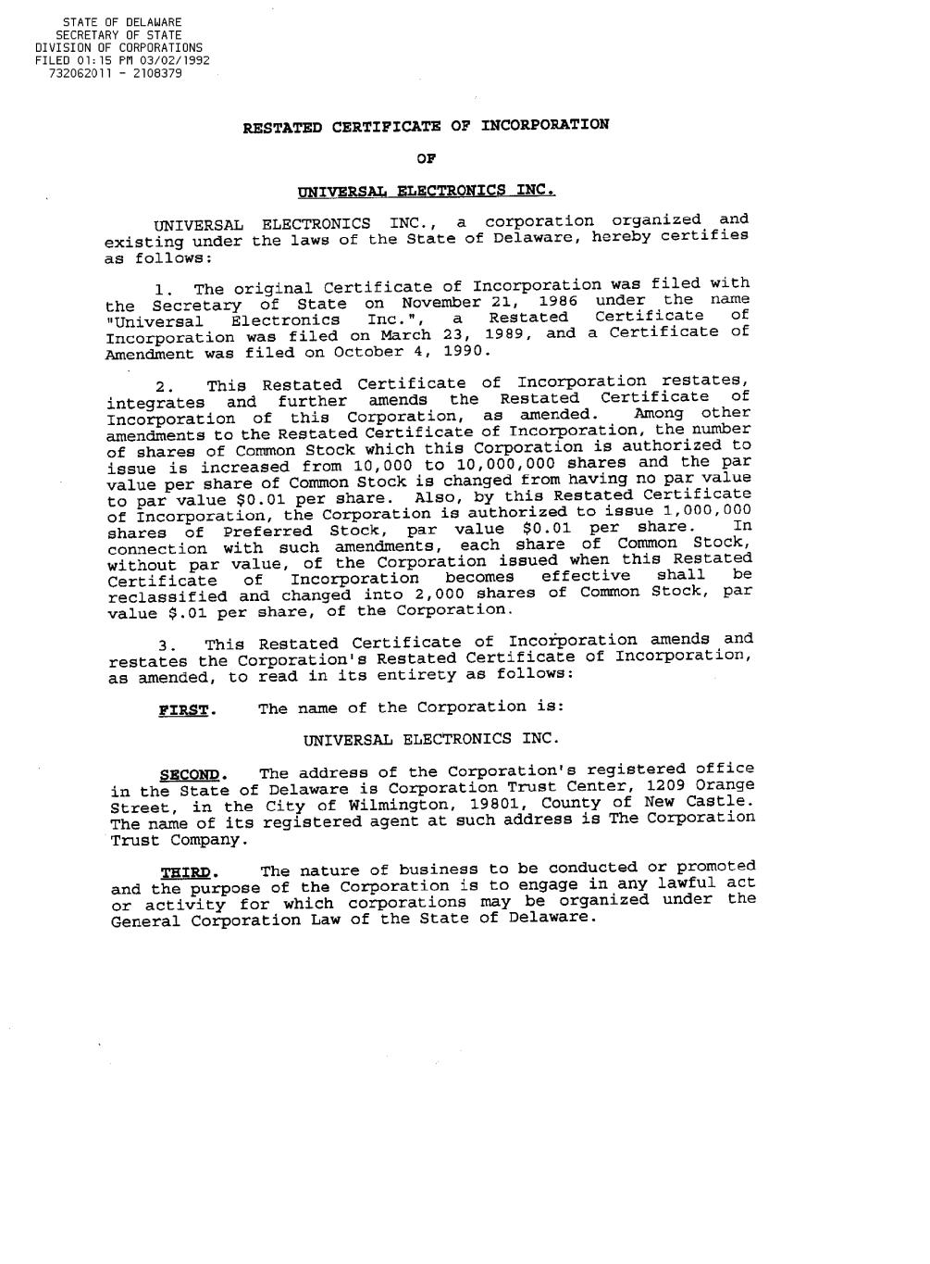
91

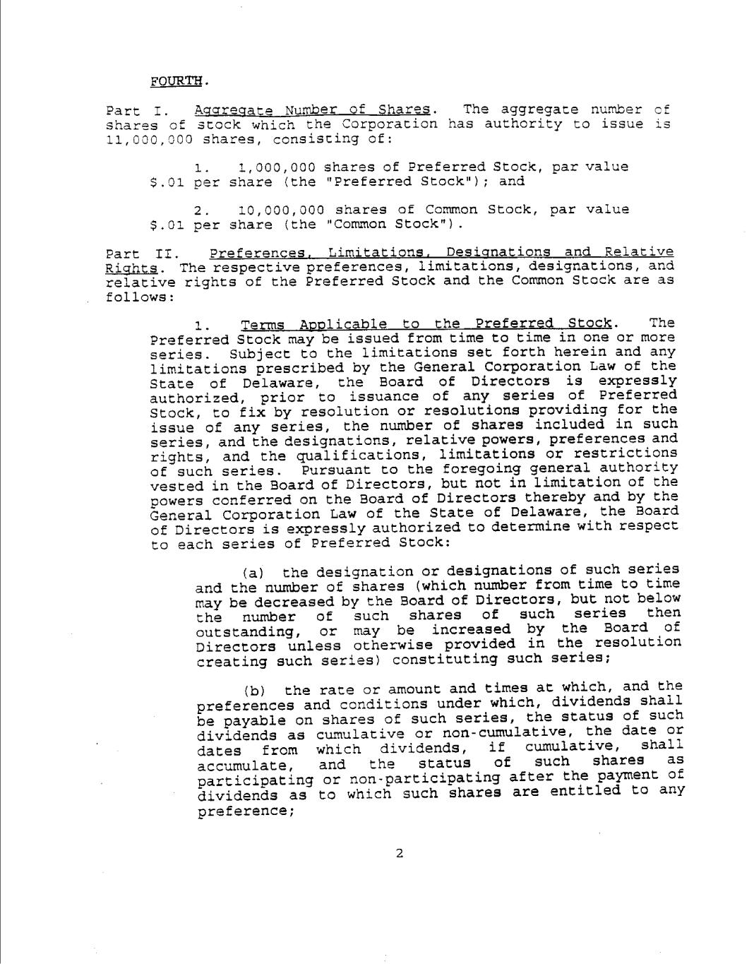

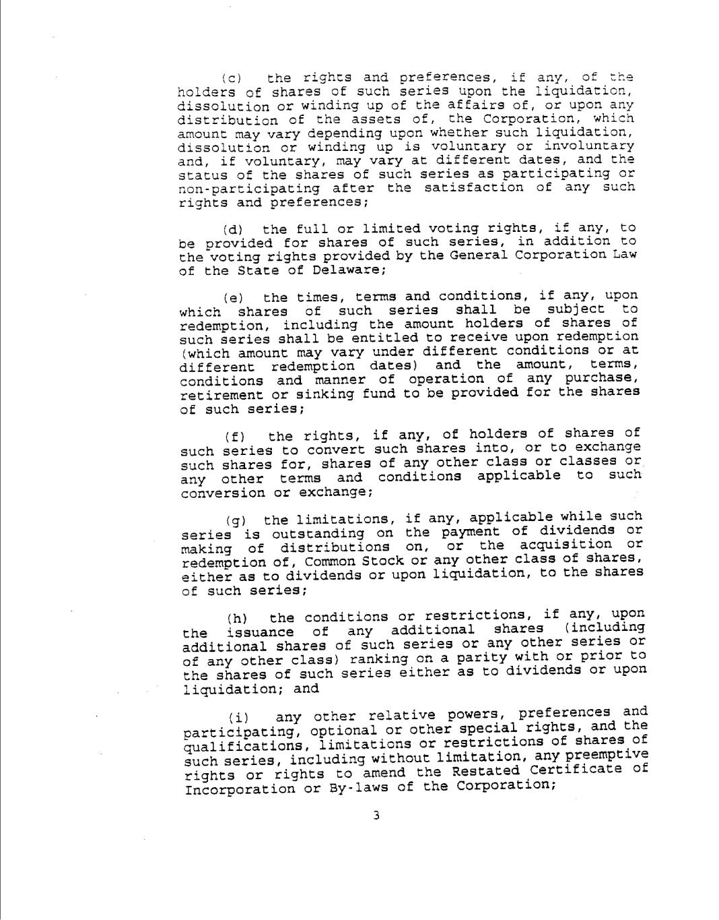

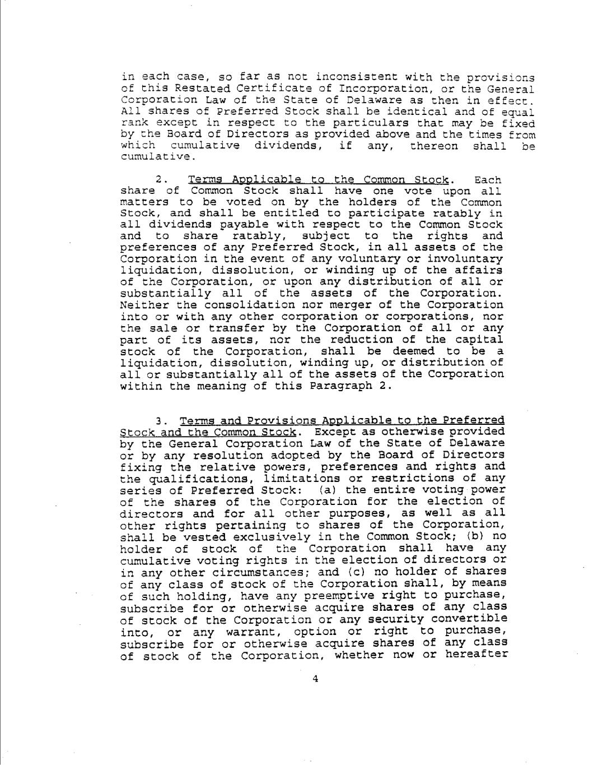

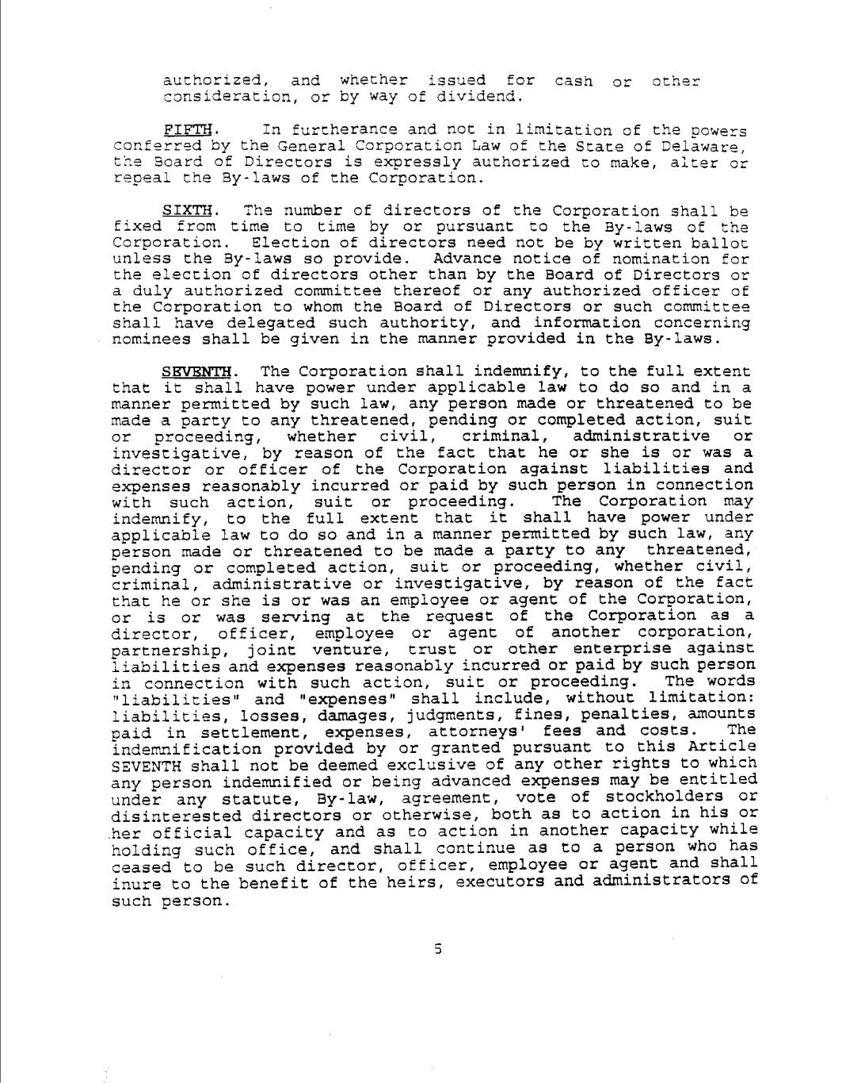

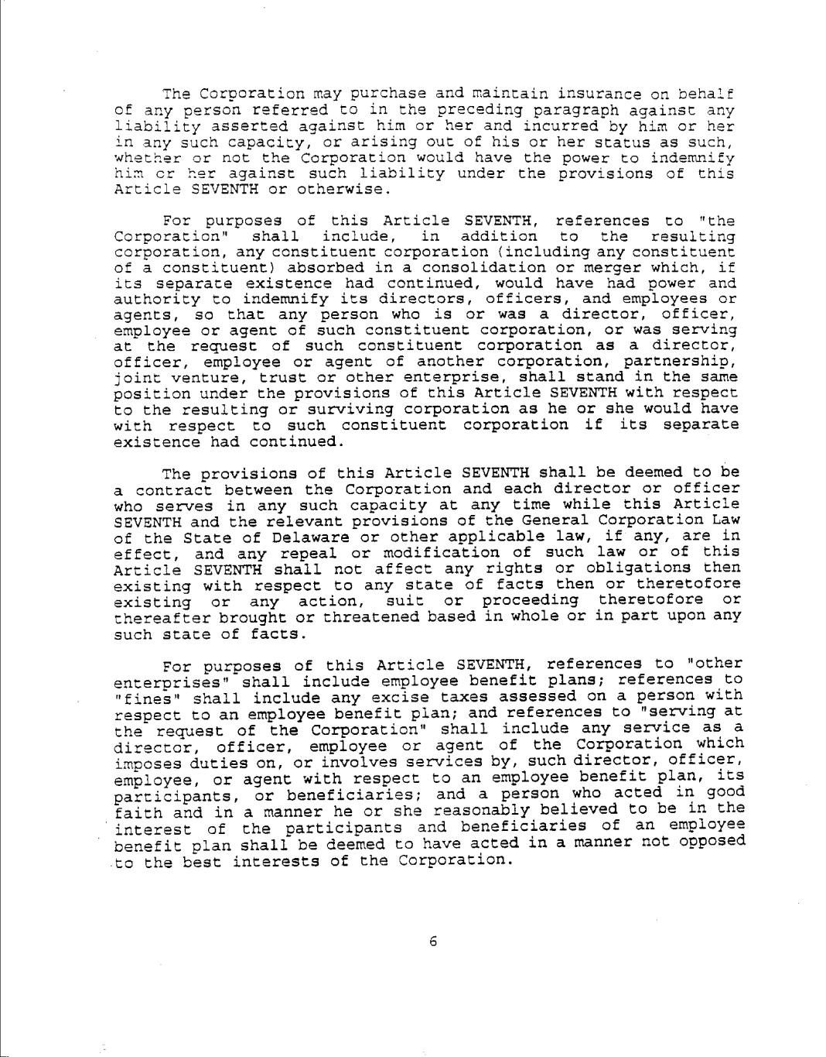

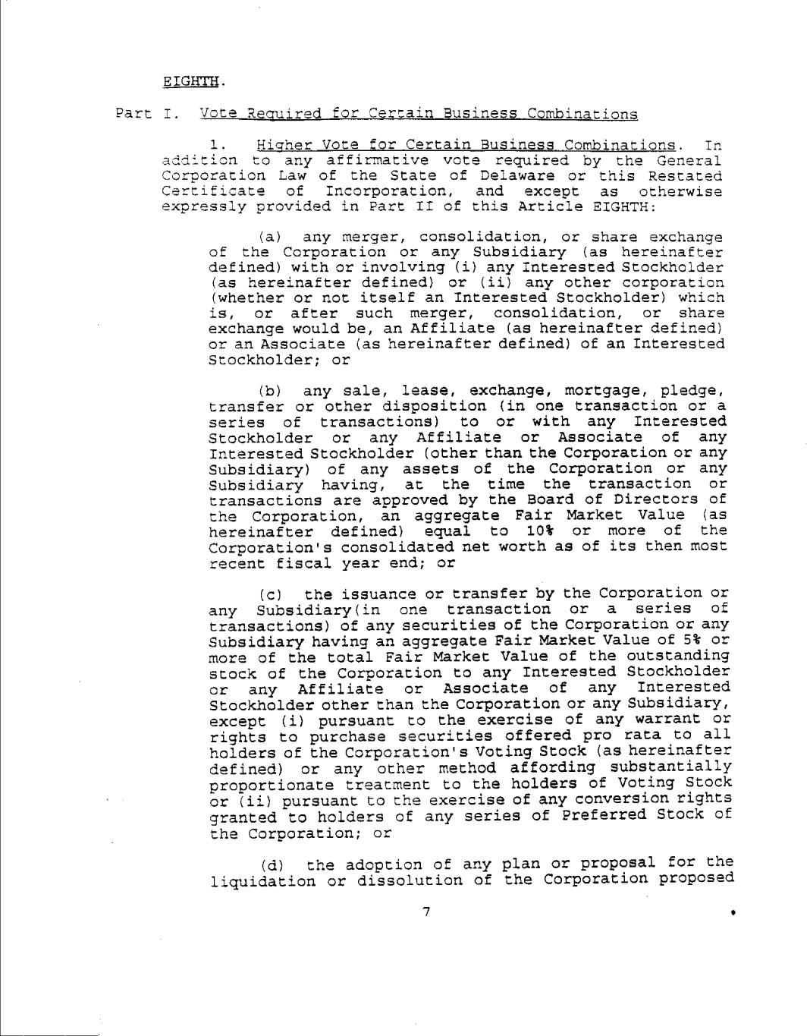

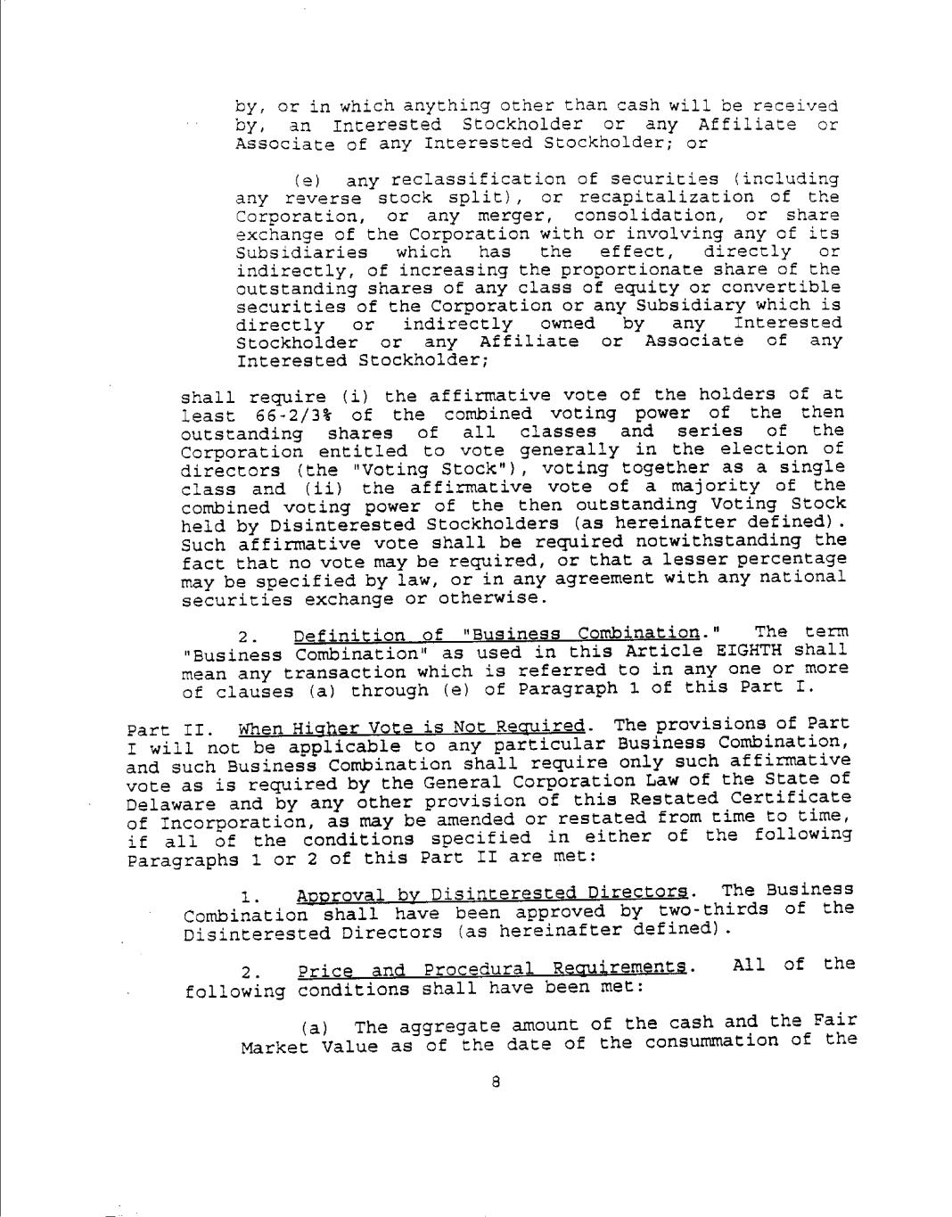

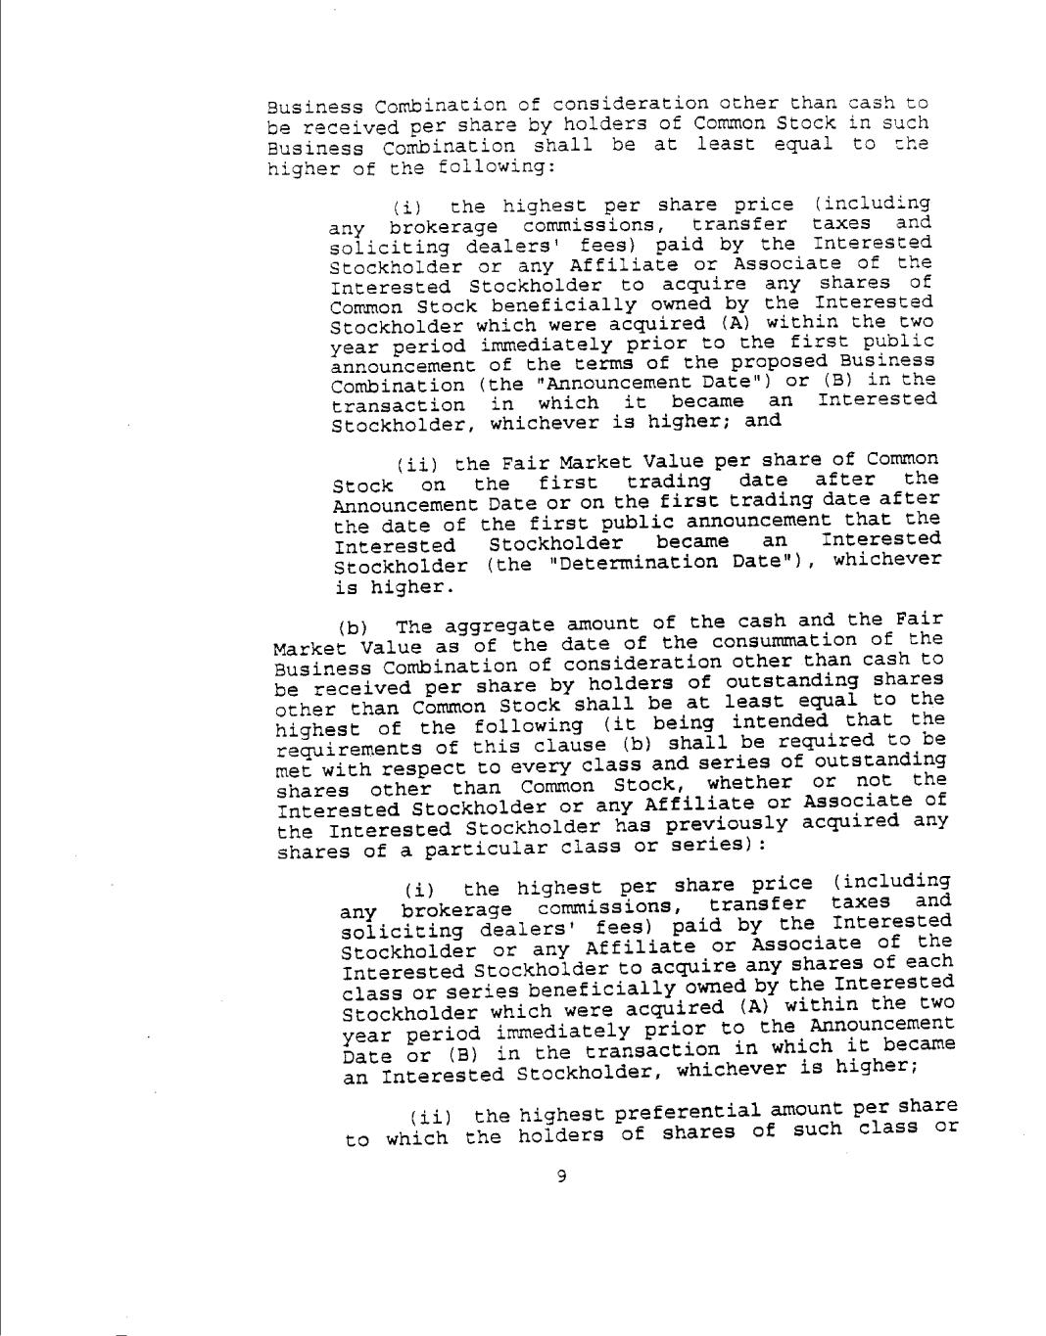

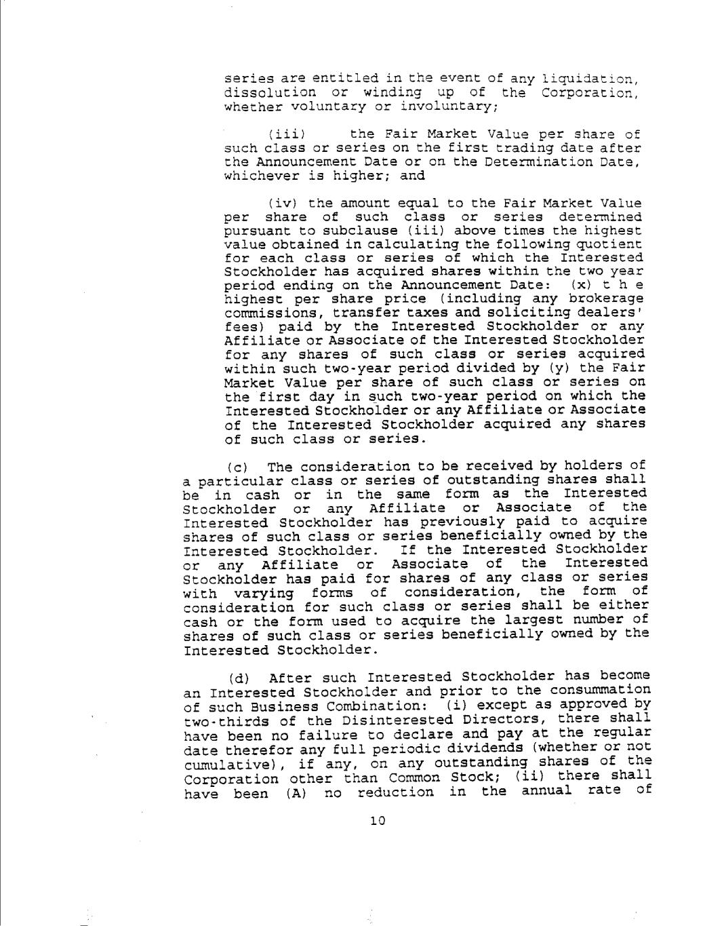

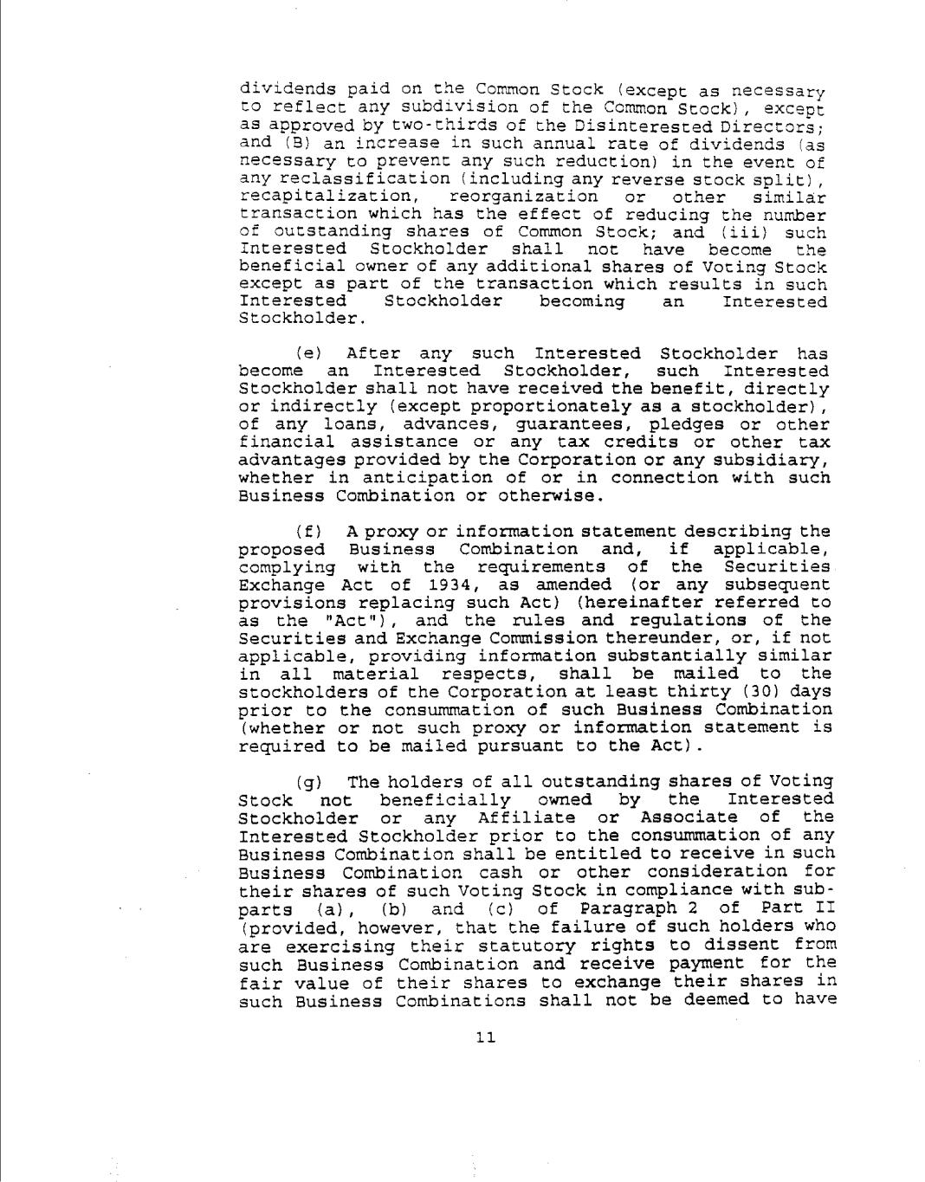

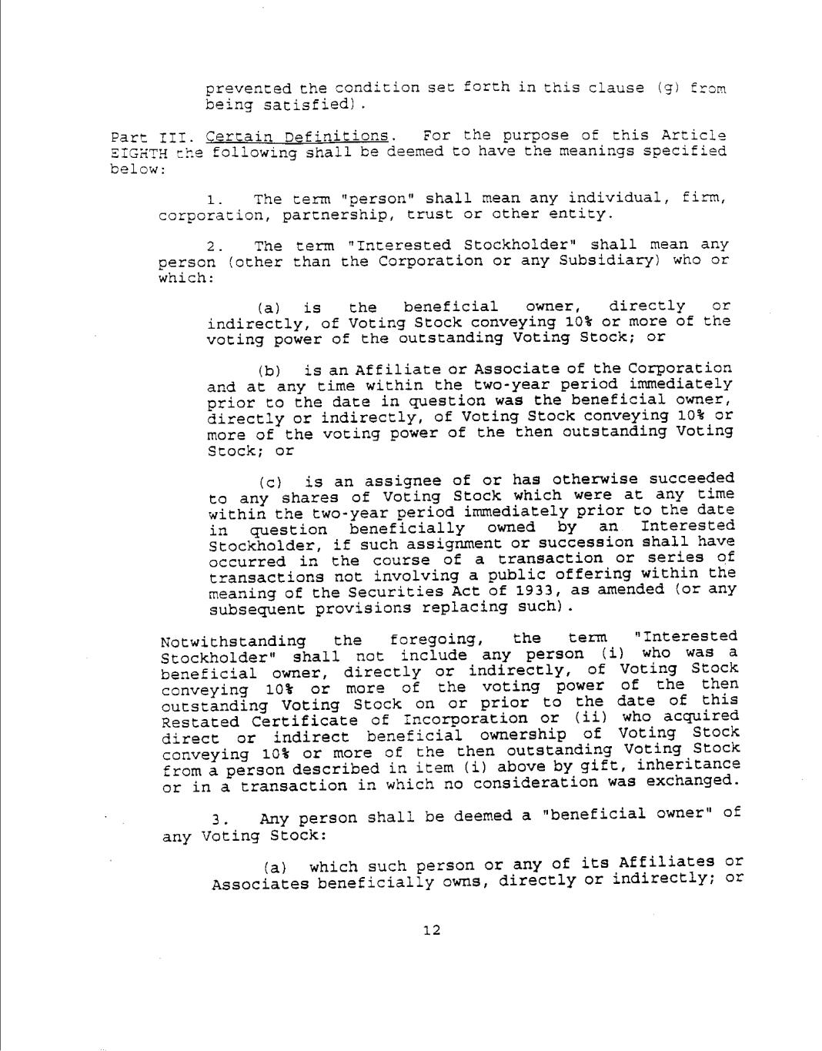

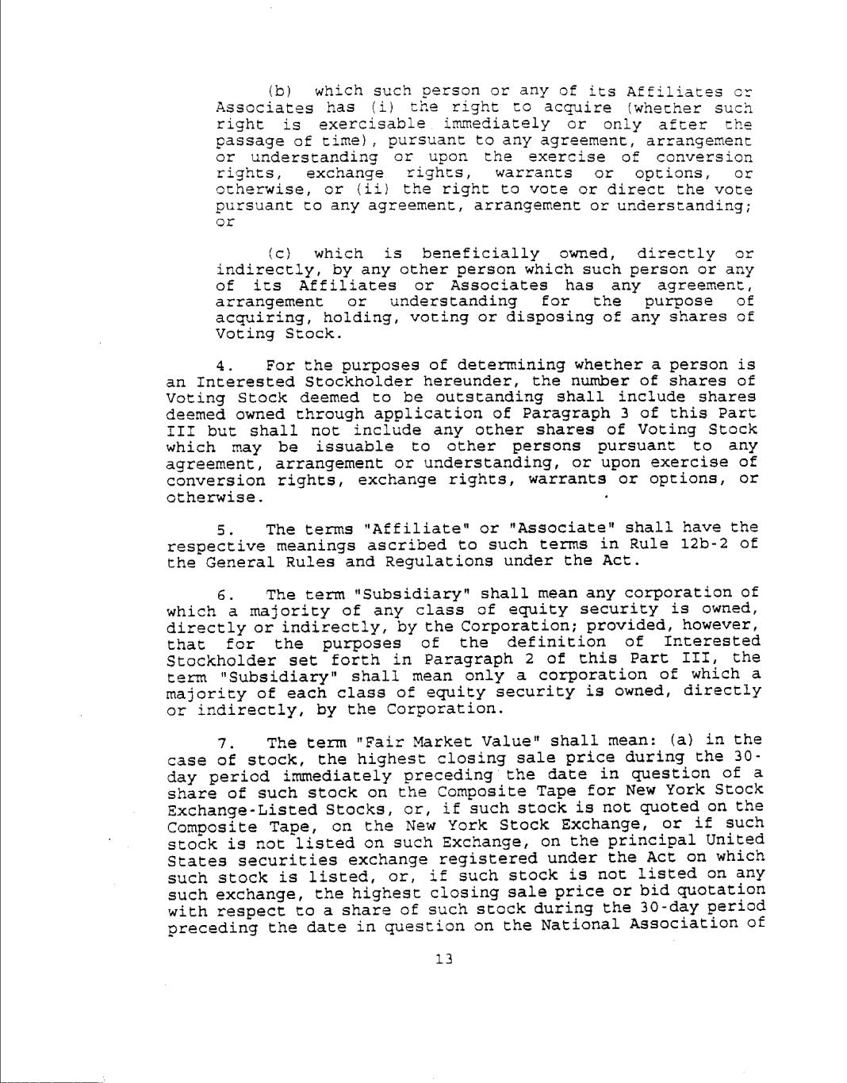



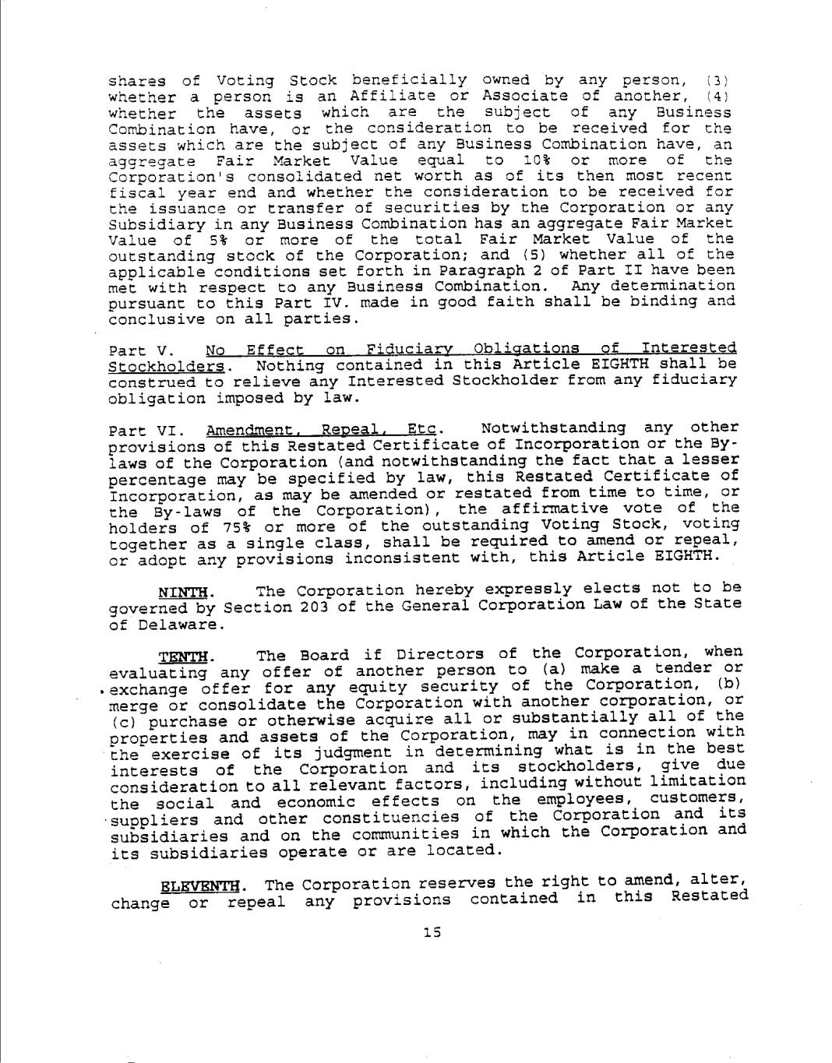

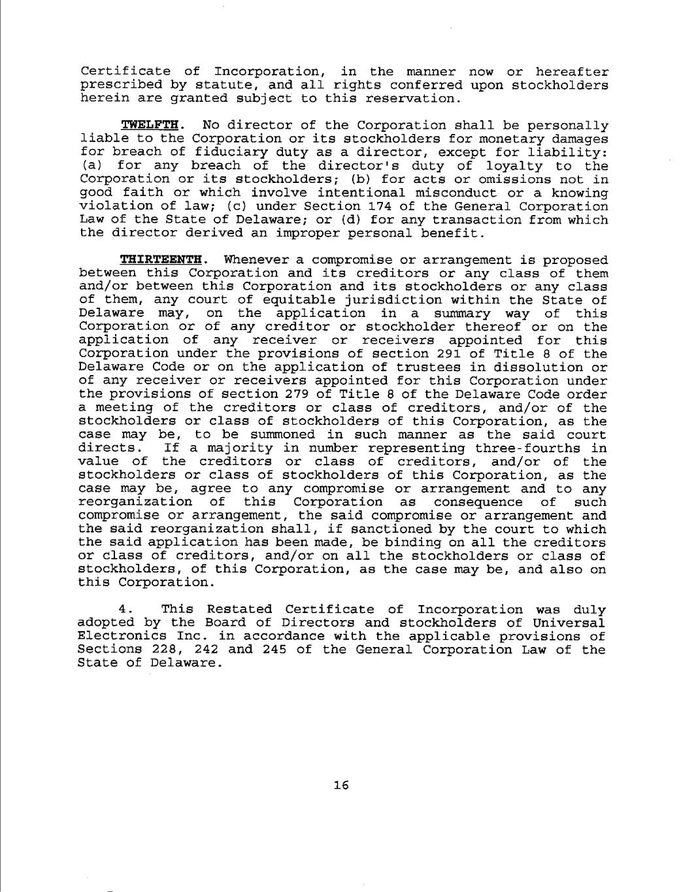



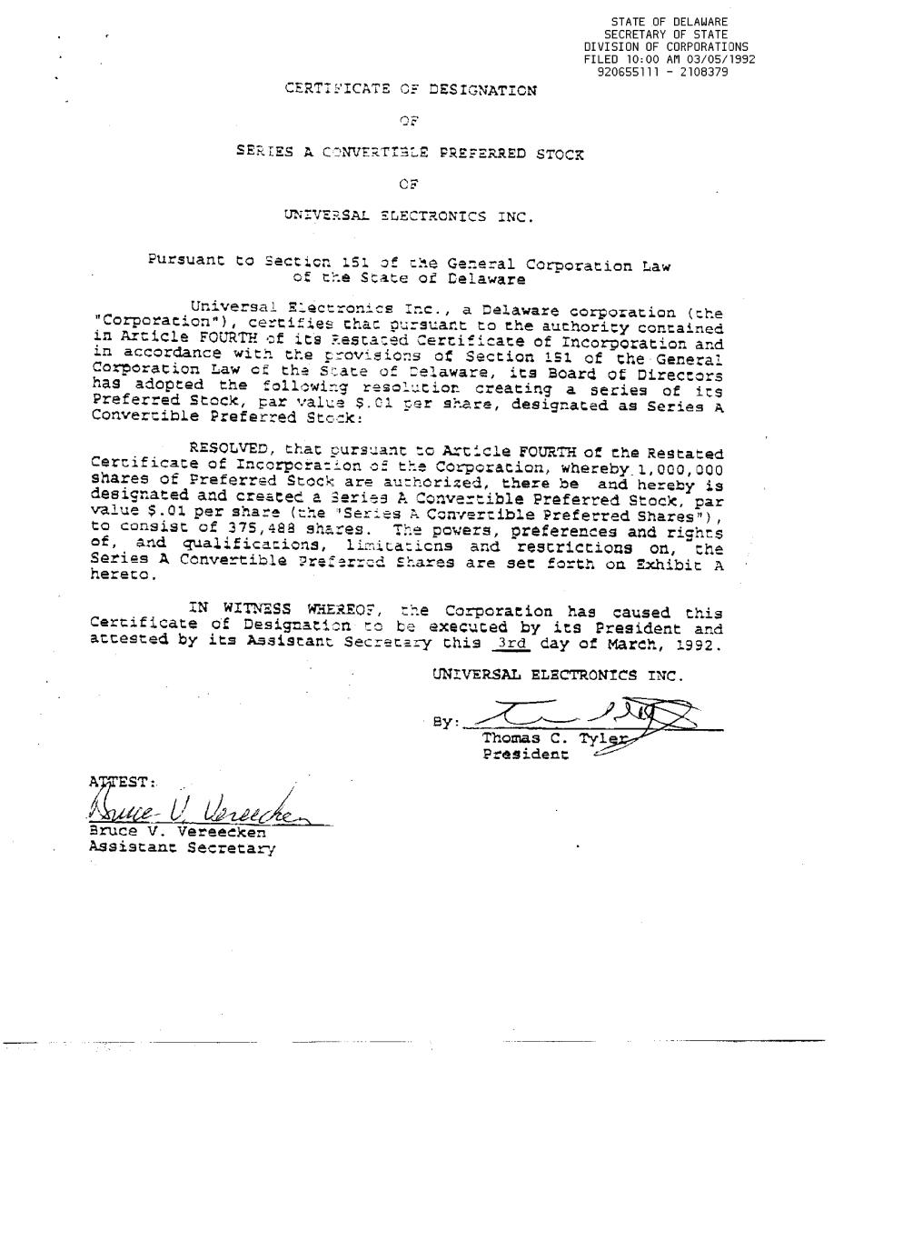

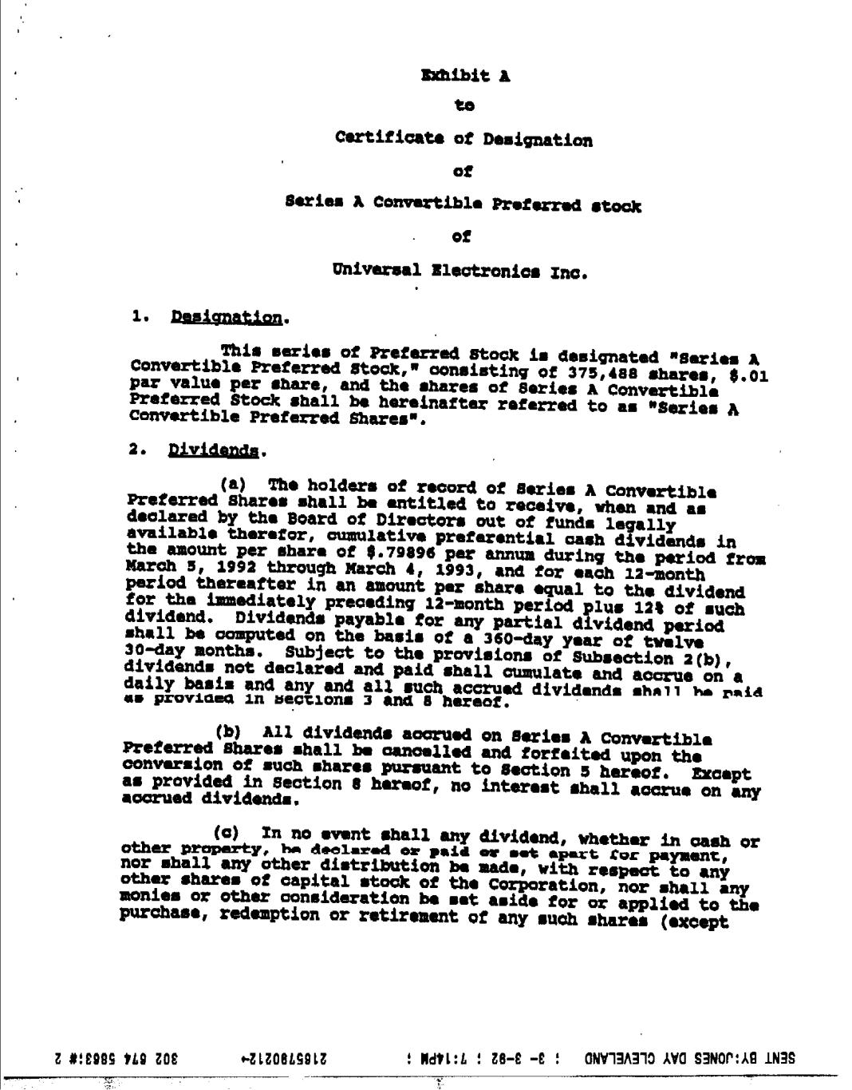

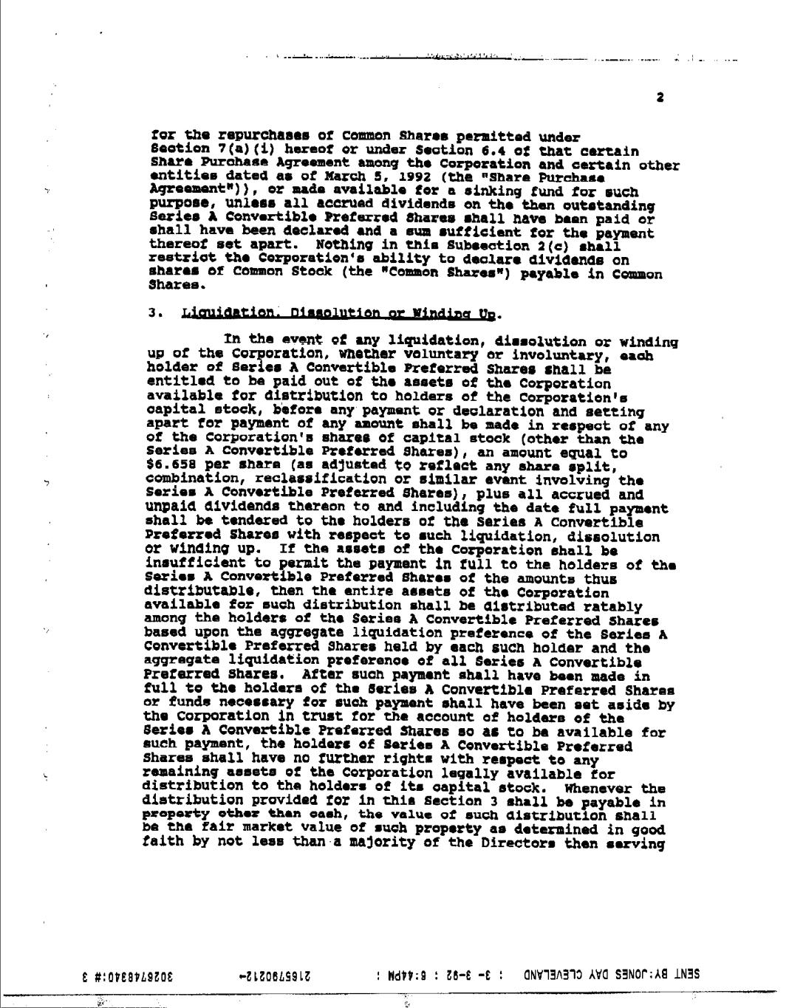

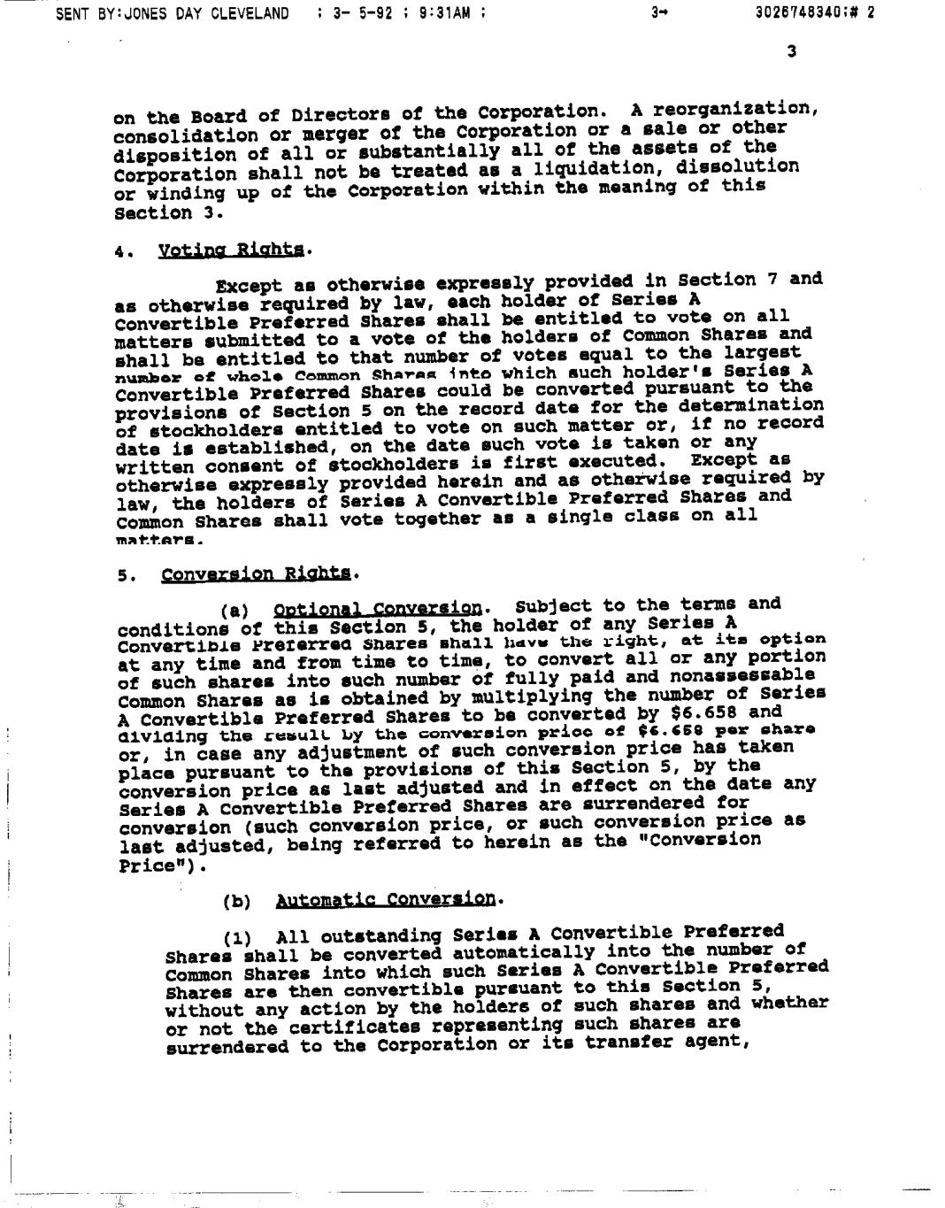

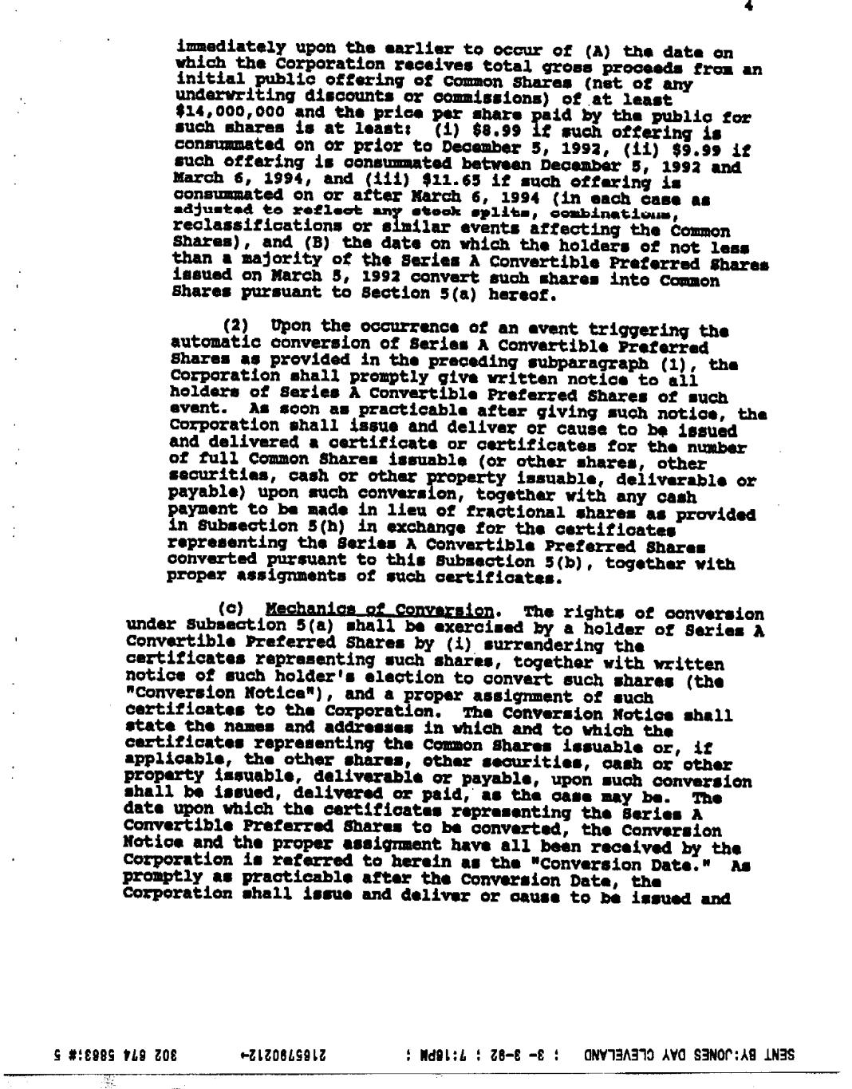

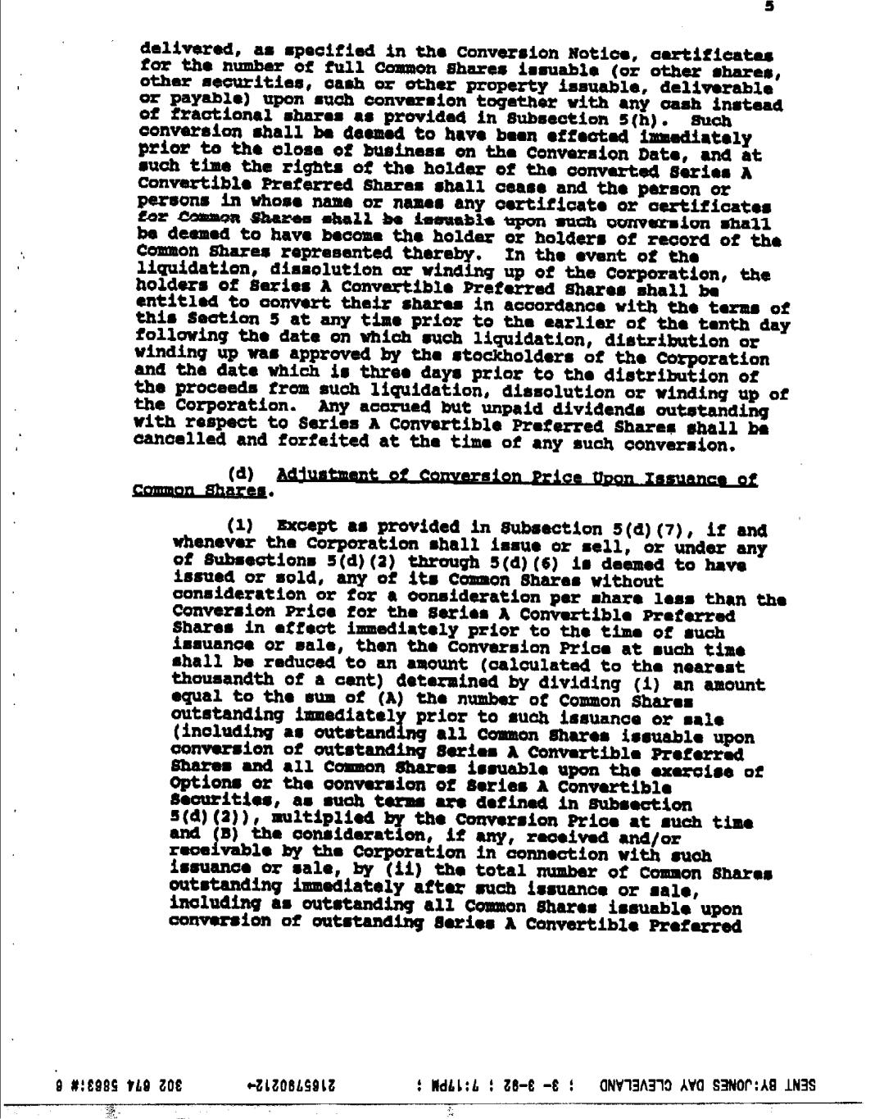

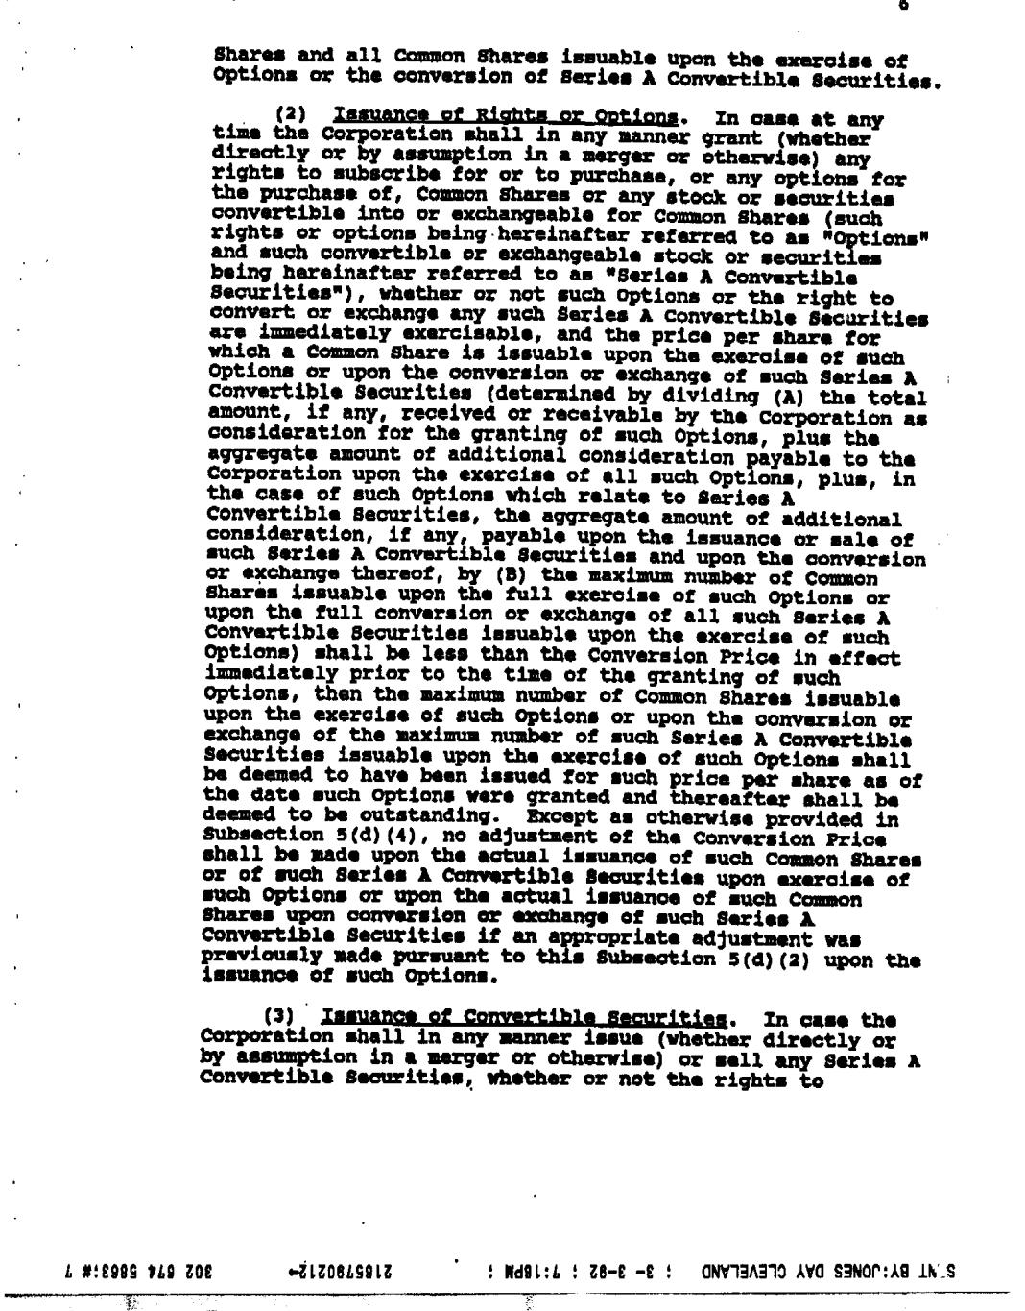

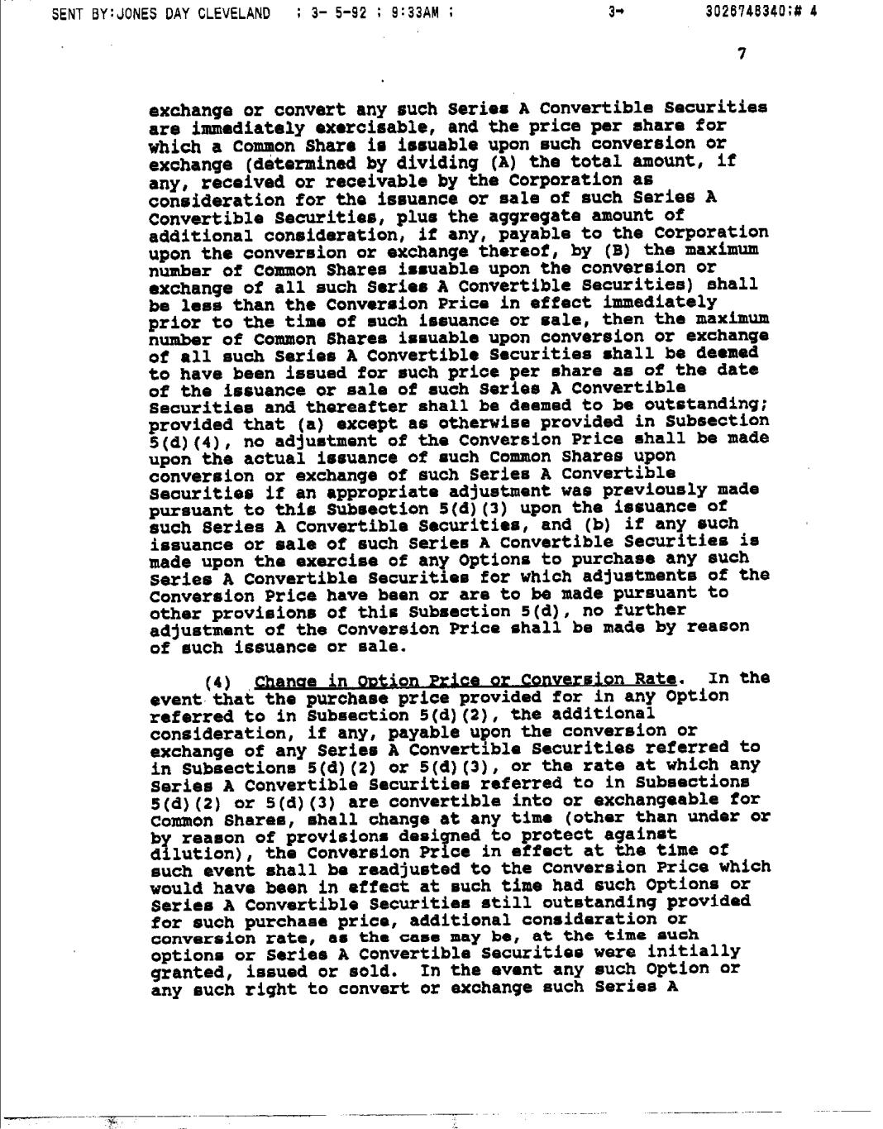

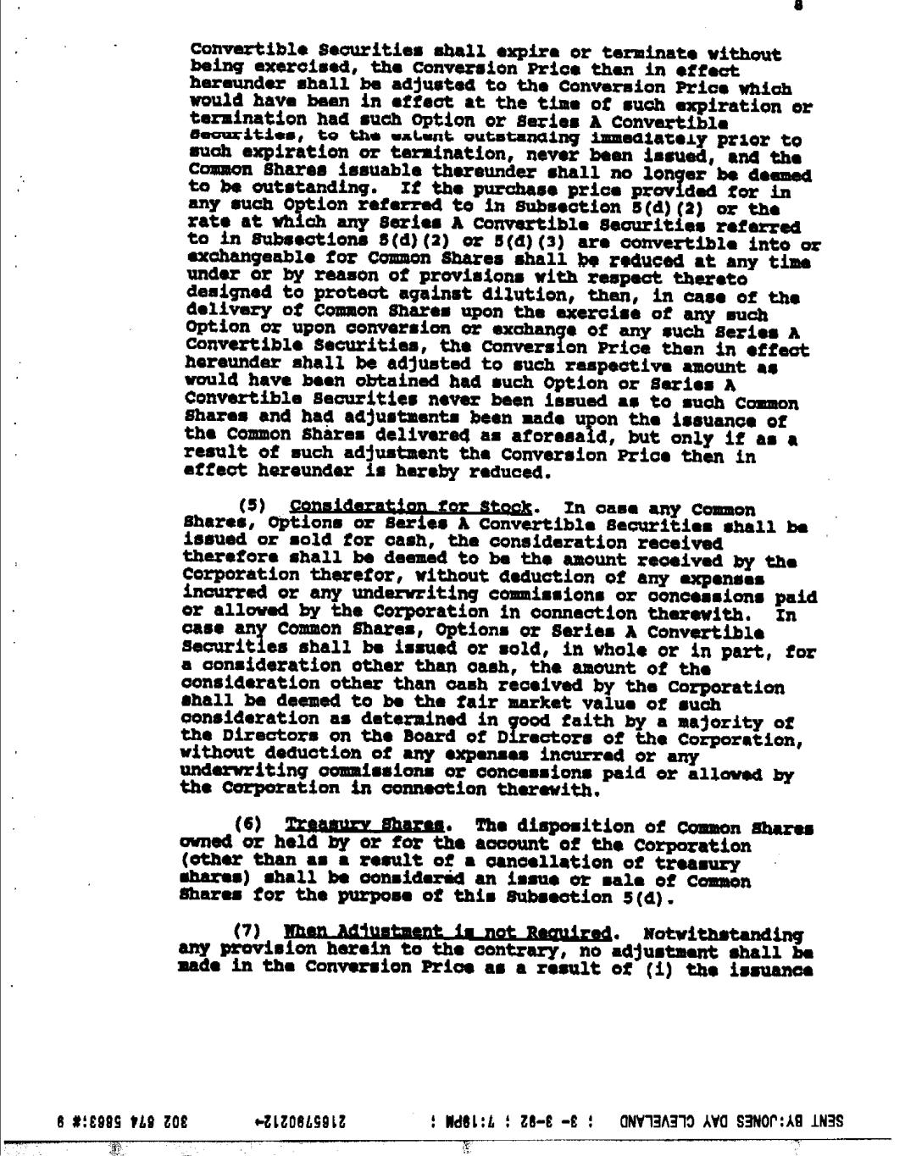

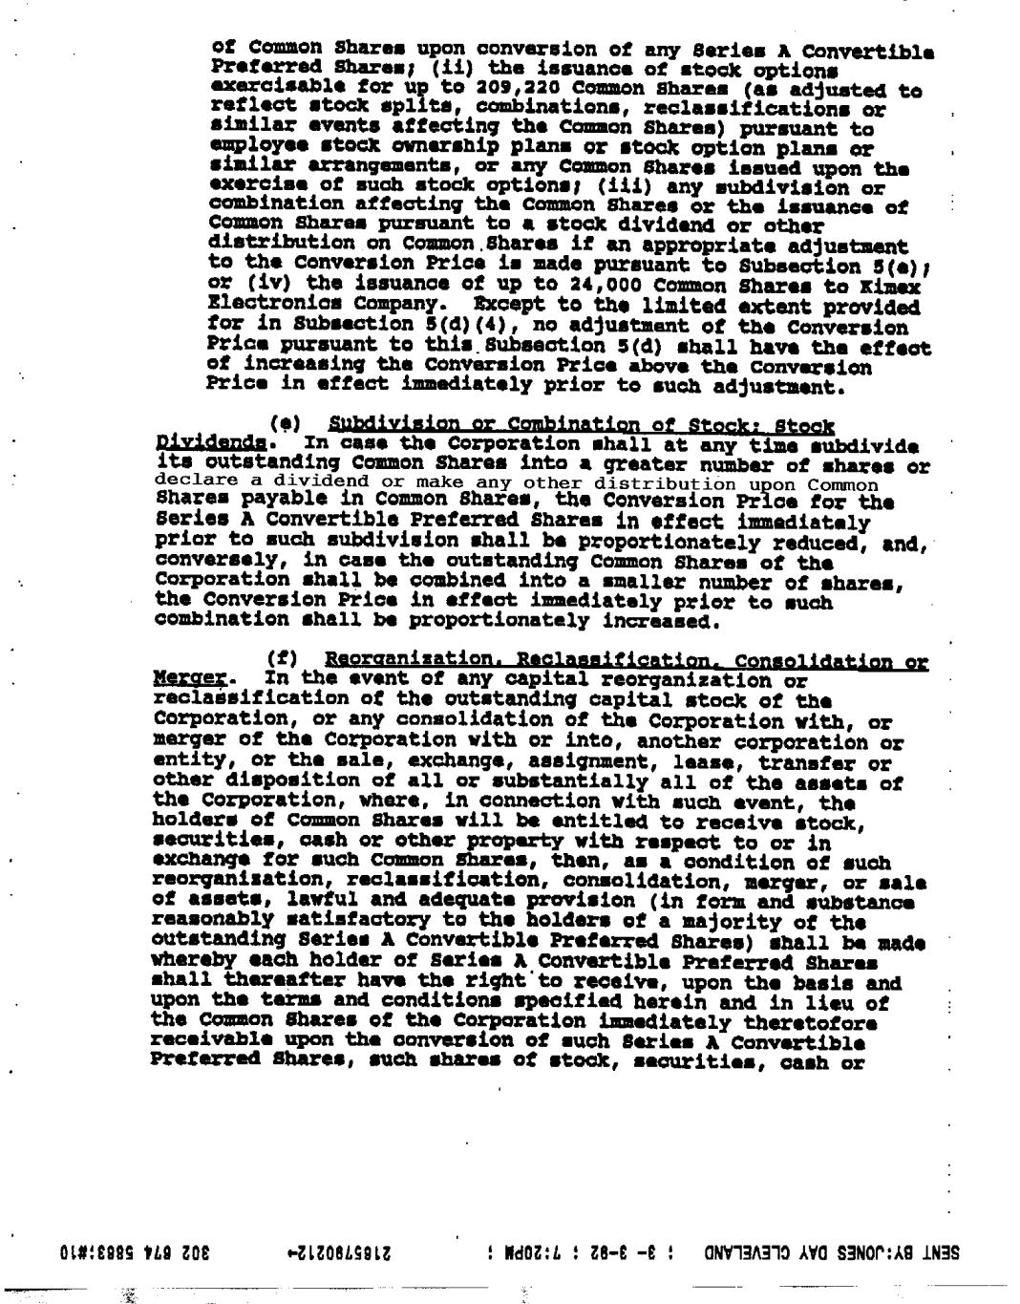

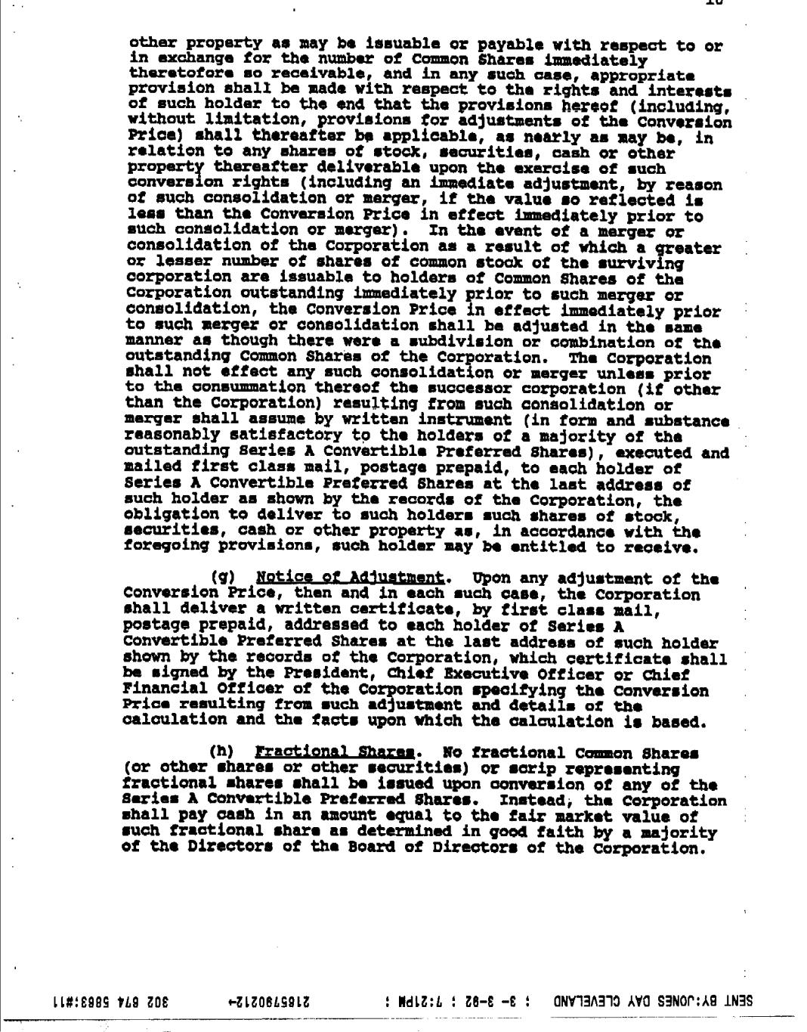

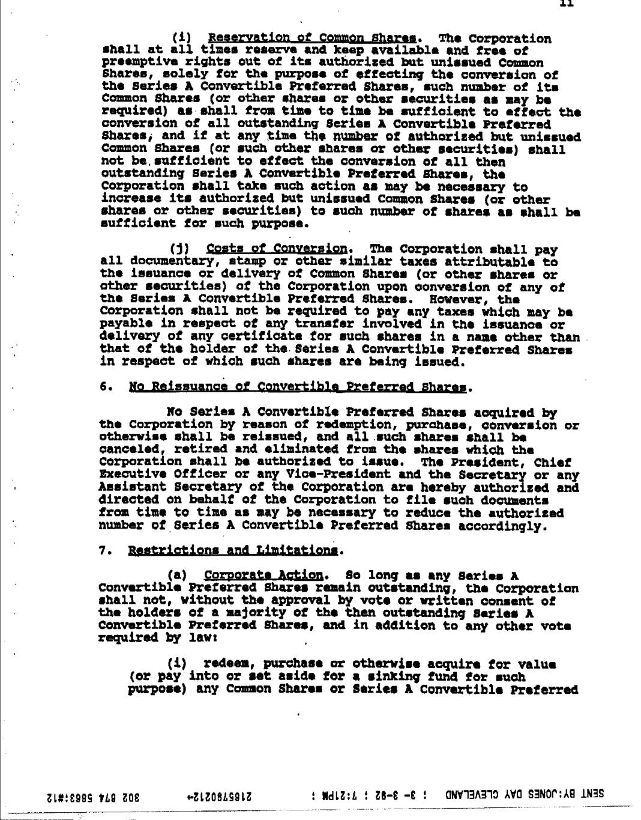

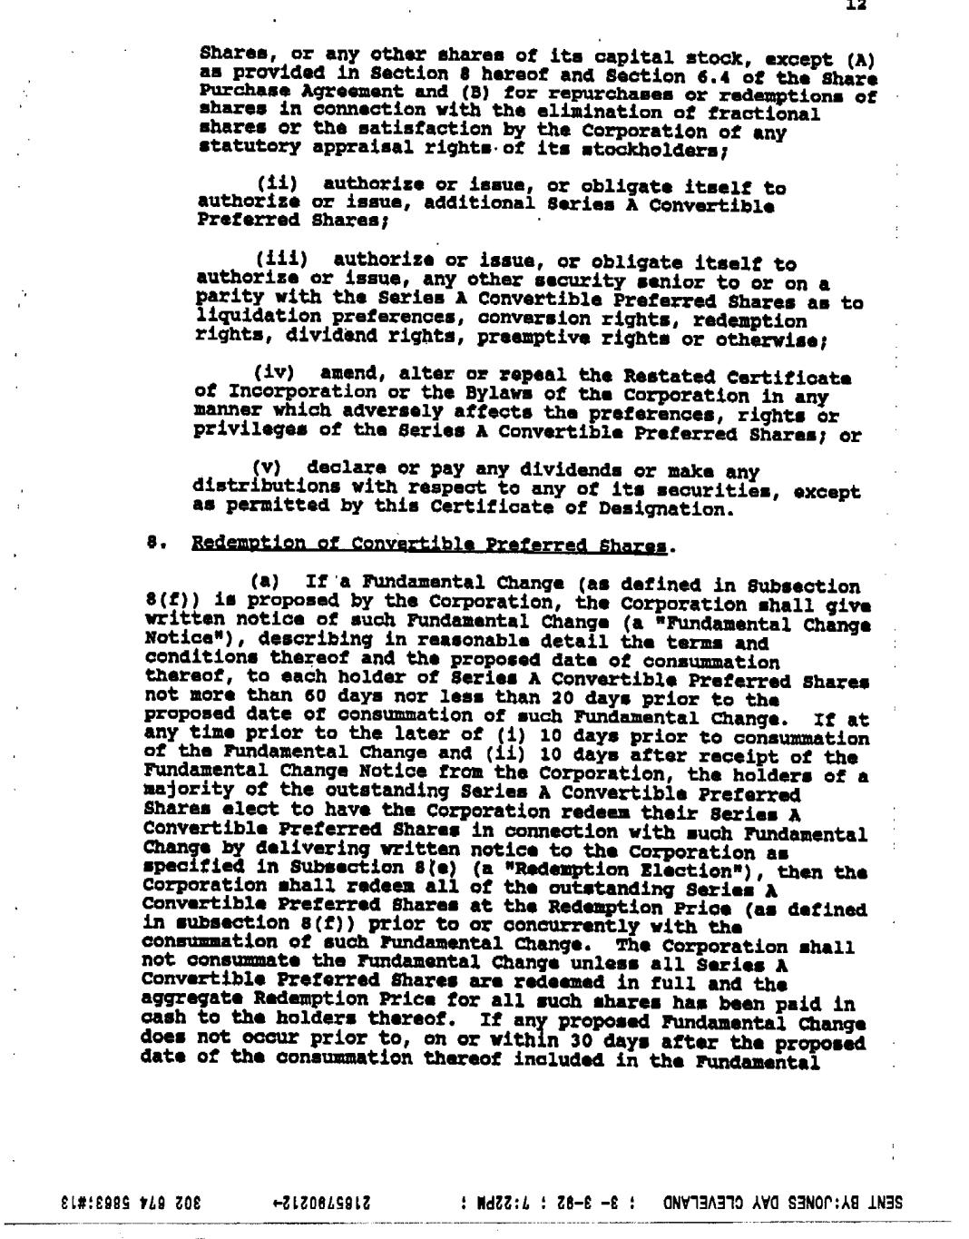

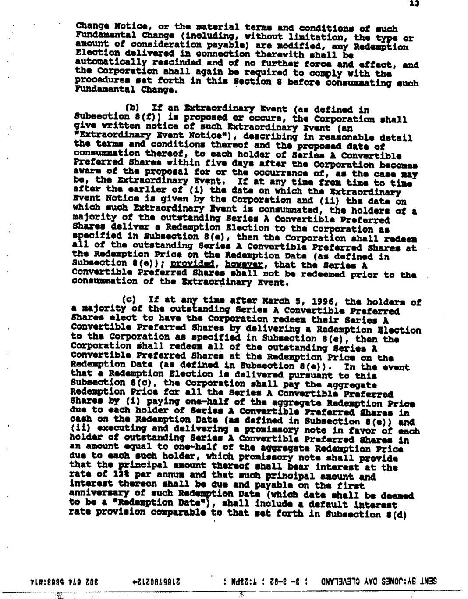

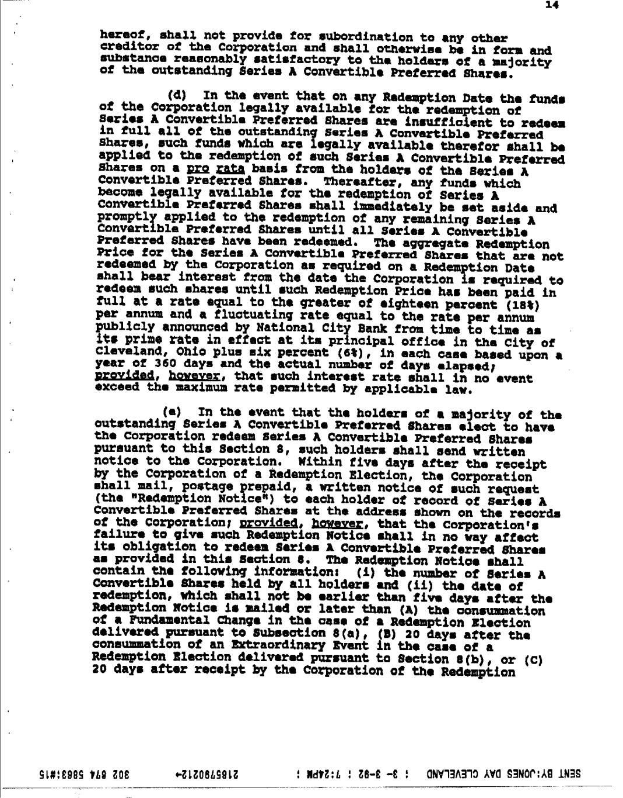

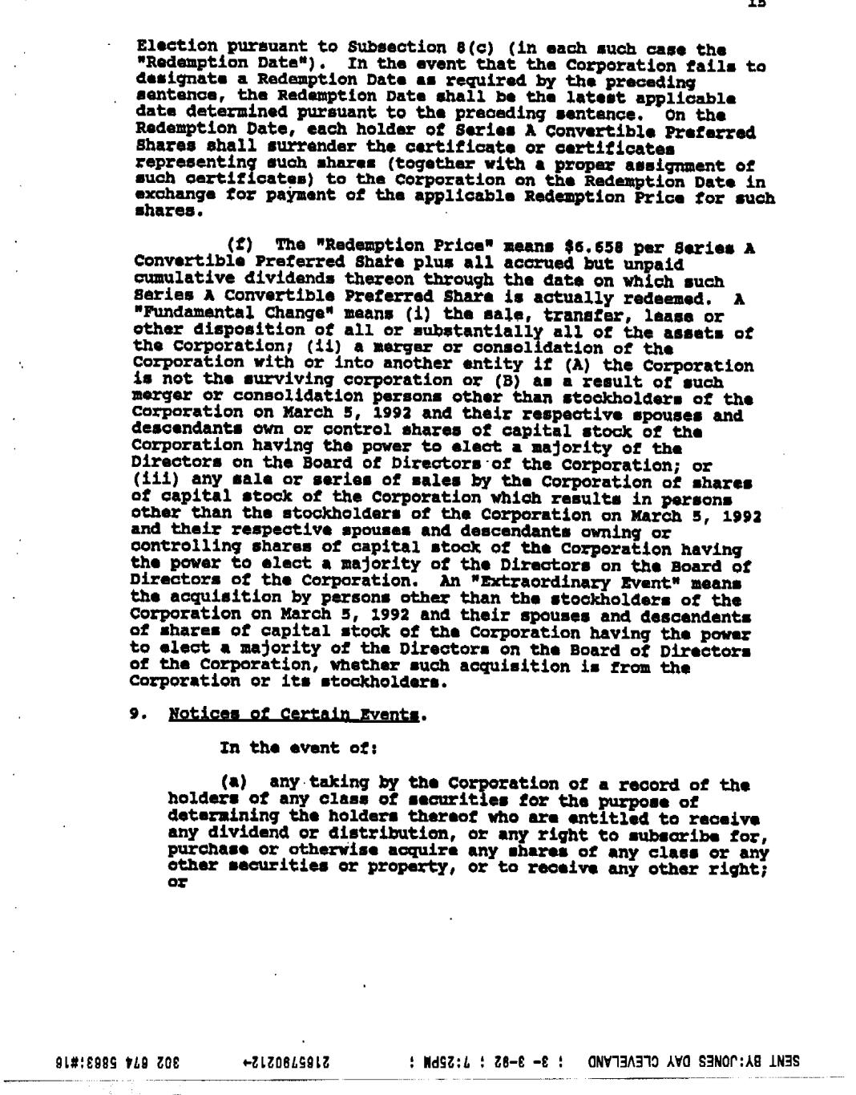

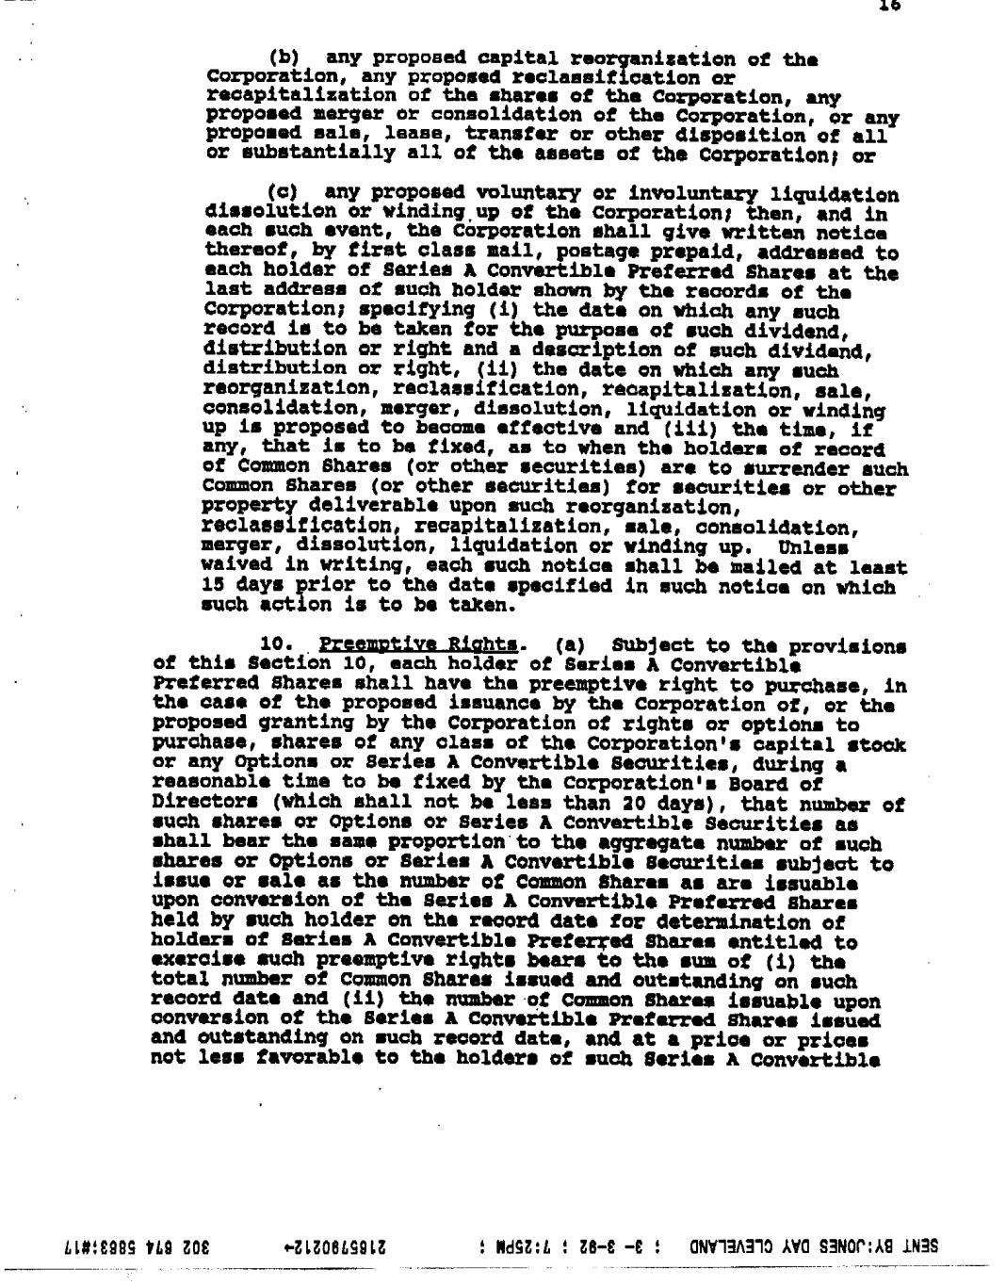

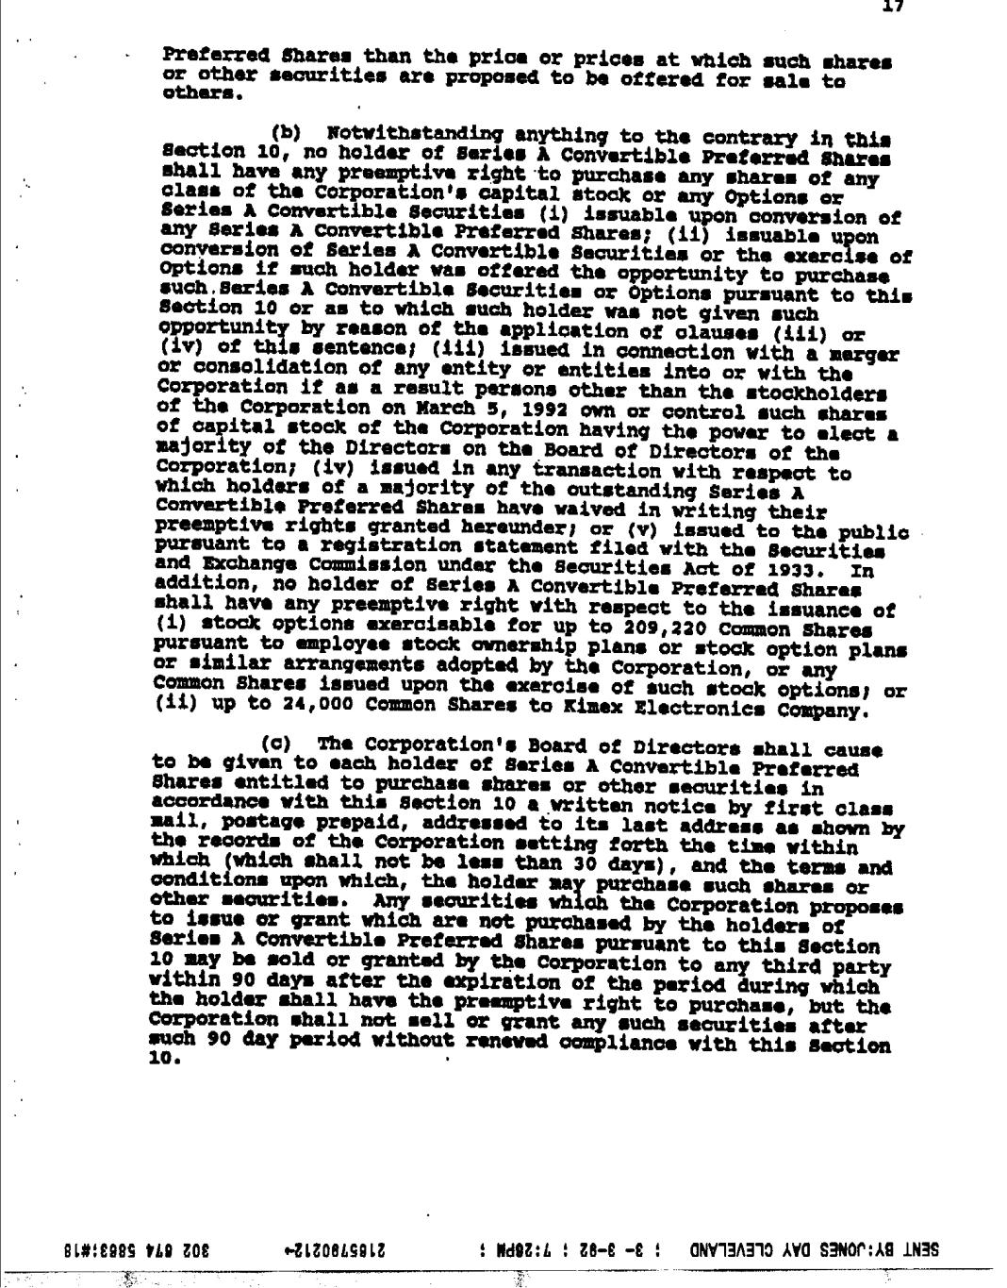

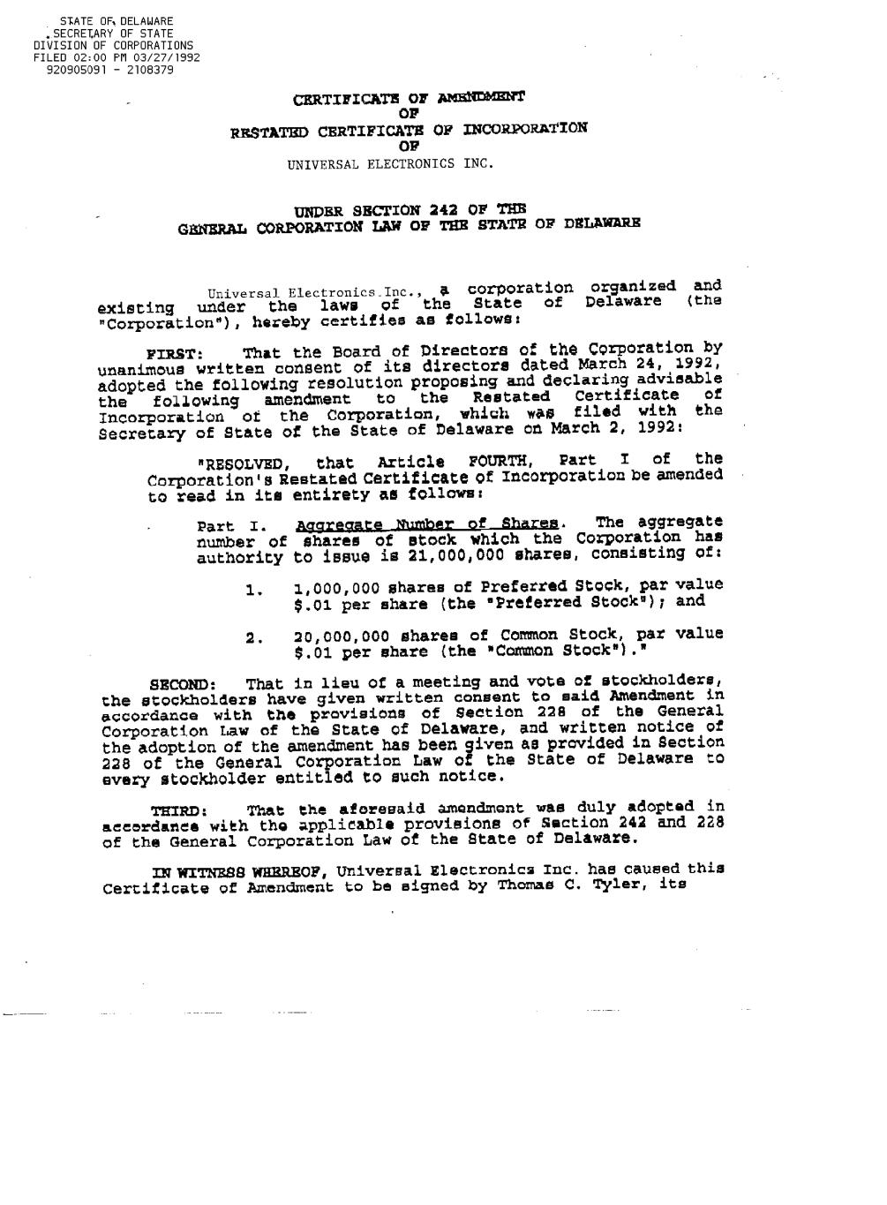

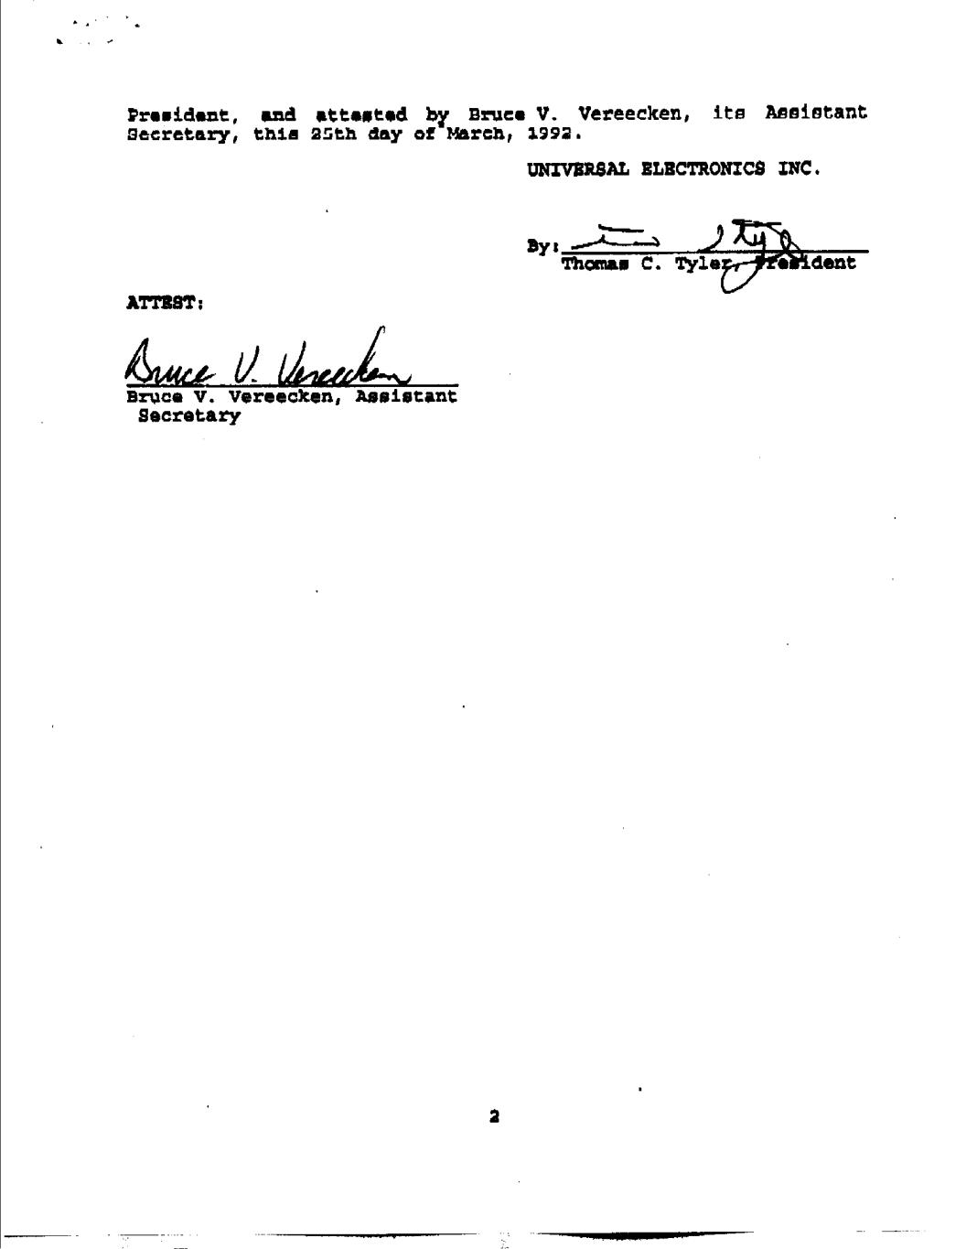

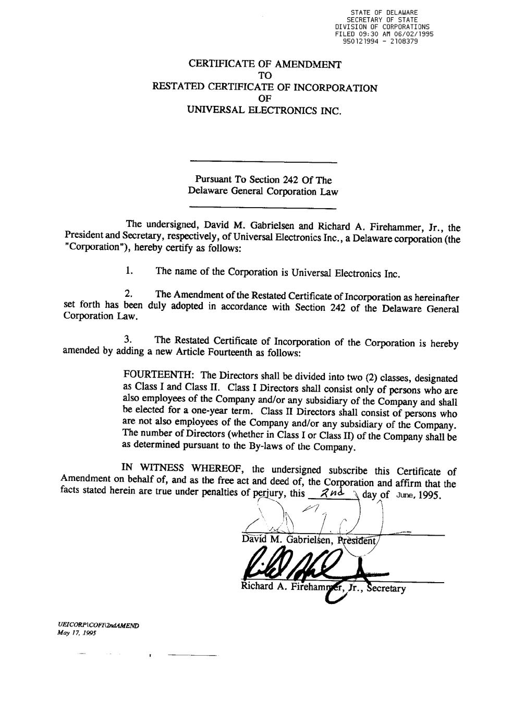

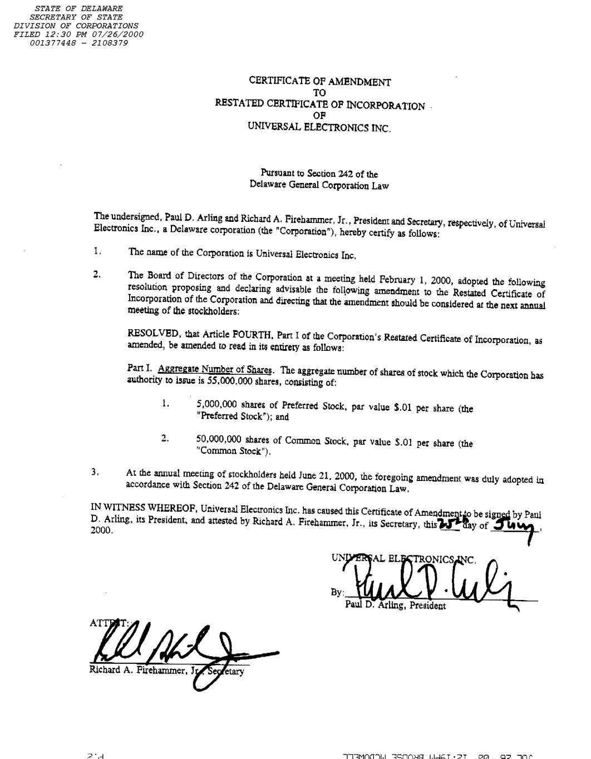

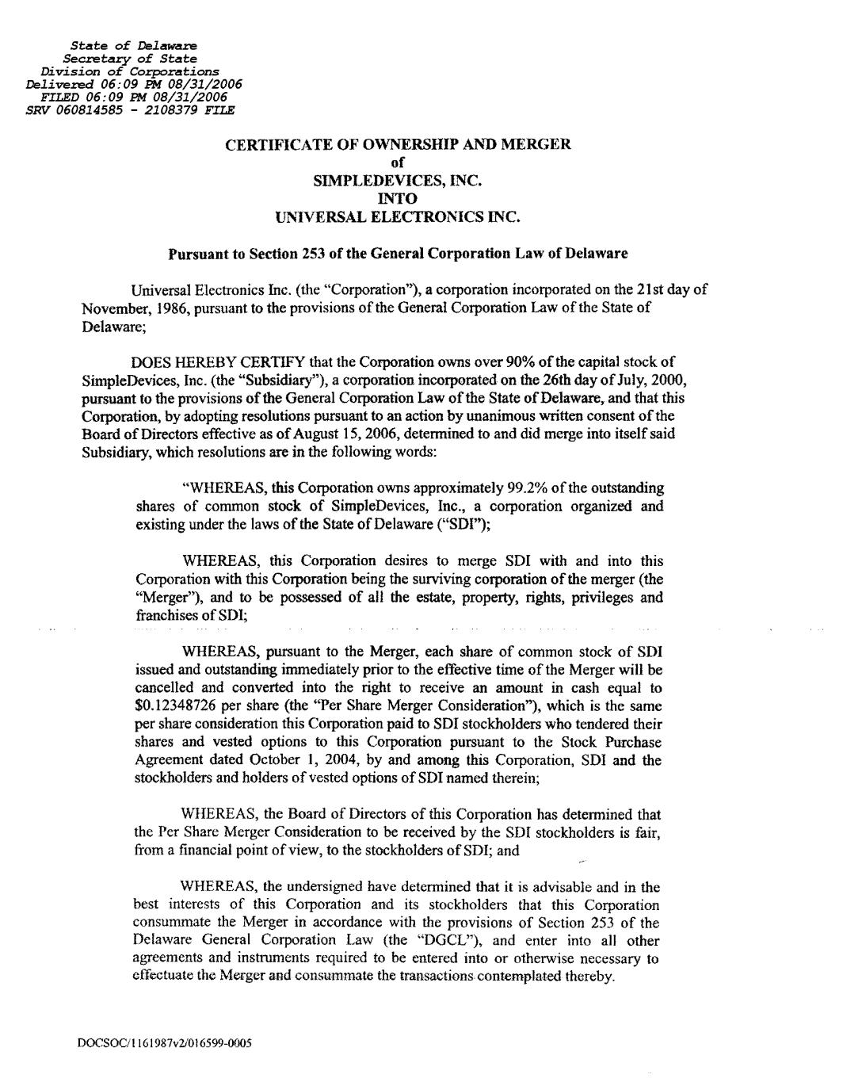

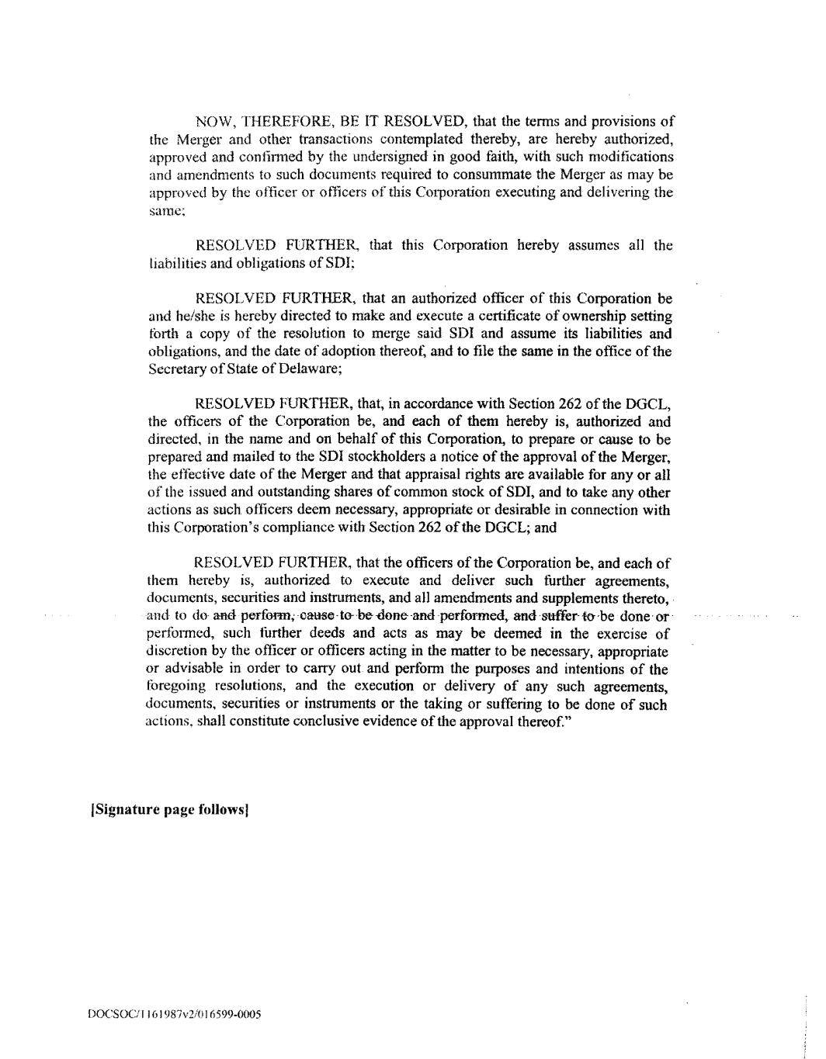

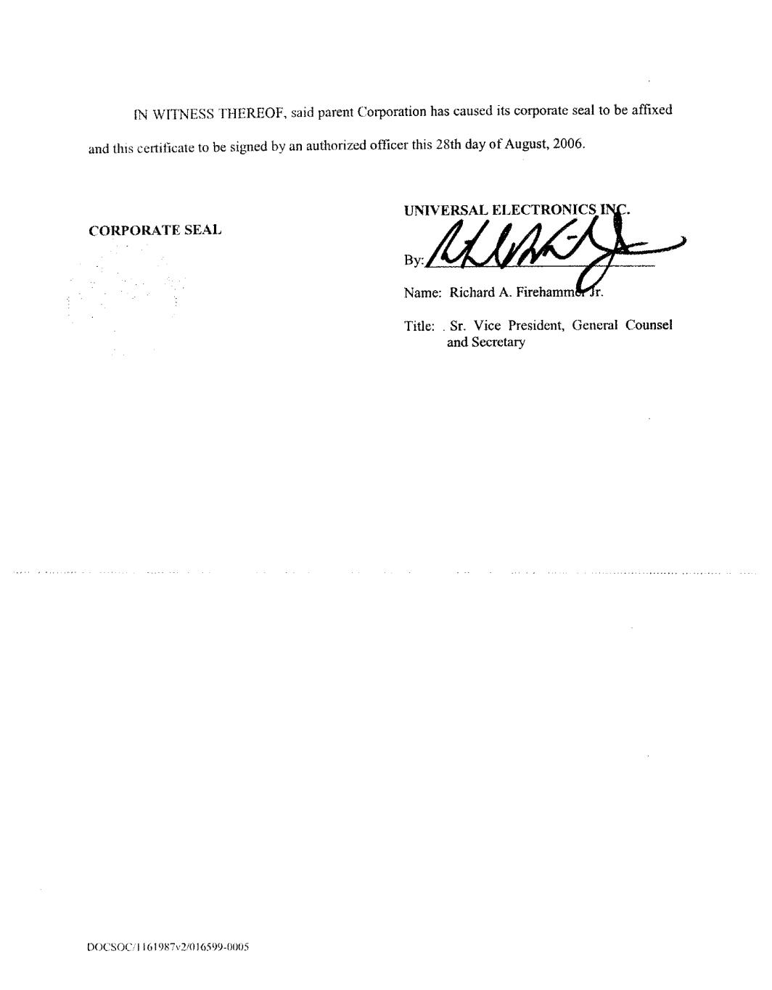

Exhibit 10.29
Certificate Number: [[GRANTNUMBER]]

Restricted Stock Unit Award Agreement

This Restricted Stock Unit Award Agreement (the “Agreement”) is made as of XXX, 20XX (the “Grant Date”) by and between Universal Electronics Inc., a Delaware corporation (the “Corporation”), and the undersigned employee (the “Employee”). As used in this Agreement, the term “Corporation” shall include, where applicable, any and all of its subsidiaries or related entities. Any capitalized term used in this Agreement that is not defined herein shall have the meaning thereof set forth in the Universal Electronics Inc. Amended and Restated 2018 Equity and Incentive Compensation Plan (the “Plan”), a copy of which can be obtained by written request to the Corporation’s Chief Financial Officer.

Whereas, the Board of Directors of the Corporation (the “Board”) has approved the Plan;

Whereas, the Board has designated and empowered the Compensation Committee of the Board (the “Committee”) to administer the Plan; and

Whereas, the Committee has authorized grants of Restricted Stock Units (the “RSUs”) to Eligible Persons, payable in shares of the Corporation’s Common Stock, par value $0.01 per share (each, a “Share”), pursuant to the terms and conditions set forth in the Plan and in this Agreement.

Now, Therefore, the parties, intending to be legally bound, hereto agree as follows:

1. Grant of the RSUs. Subject to the terms and conditions set forth herein, the Employee is hereby granted [[SHARESGRANTEDWORDS]] ([[SHARESGRANTED]]) RSUs on the Grant Date.

2. Vesting of the RSUs and Issuance and Delivery of Shares. Subject to earlier termination, acceleration or cancellation of the RSUs as provided herein, the RSUs shall vest in three (3) increments (rounded to the nearest whole unit) as indicated in the following vesting table (each a “Vesting Date”), commencing and continuing in accordance with the vesting table; provided that the Employee continues to be employed by the Corporation on each such Vesting Date. The following table indicates the number of RSUs that shall vest on each vesting date:

[[ALLVESTSEGS]]

Subject to Sections 6 and 7 of this Agreement, upon the vesting of the RSUs and as soon as administratively practicable after each Vesting Date (or, in the event the RSUs vest earlier in accordance with Section 4 below, as soon as administratively practicable following the date of termination or the effective date of the Change in Control, as applicable), the Corporation shall issue and deliver to the Employee (or the Employee’s estate or legal representative, in the event of Employee’s death or “Total Disability” (as such term is defined in Section 4(b)) one (1) Share free and clear of any restrictions for each vested RSU. Such issued and delivered Shares shall be in book-entry form maintained by the Corporation’s Transfer Agent and shall otherwise be transferable utilizing the Corporation’s Direct Registration System and Profile Modification System.

3. Effect of Termination of Employment. Except as set forth in Section 4, in the event that the Employee’s employment with the Corporation is terminated for any reason, any RSUs that are unvested as of such date shall be immediately forfeited and cancelled without further action by the parties hereto, and the Employee shall no longer have any rights with respect to the forfeited

and cancelled RSUs (or any Dividend Equivalents (as defined in Section 5 hereof) with respect thereto).

4. Effect of Certain Qualifying Terminations of Employment and Effect of Change In Control.

(a) In the event that (i) the Employee’s employment with the Corporation is terminated (A) by the Corporation without “Cause,” (B) by the Employee as the result of a “Constructive Termination” (as such term is defined in Section 4(b)), (C) as a result of the Employee’s death, or (D) as a result of the Employee’s “Total Disability” (as such term is defined in Section 4(b)), or (ii) a “Change in Control” occurs, the Employee shall be fully vested in the RSUs as of such date of termination or the effective date of the Change in Control, whichever may apply, without further action by the parties hereto.

(b) (i) For purposes of this Agreement, “Constructive Termination” shall mean the termination of the Employee’s employment with the Corporation by the Employee within eighteen (18) months after the occurrence of a material diminution in the Employee’s authority, duties, or responsibilities; provided that a termination by the Employee will only constitute a Constructive Termination if (A) the Employee gives the Corporation a “Notice of Constructive Termination” (as defined in Section 4(b)(ii) below) within ninety (90) calendar days following the occurrence of the event that constitutes a Constructive Termination and (B) the Corporation fails to remedy the event constituting a Constructive Termination within thirty (30) calendar days after receipt of the Notice of Constructive Termination from the Employee. If the Employee determines that a Constructive Termination exists and timely files a Notice of Constructive Termination, such determination shall be presumed to be true and the Corporation will have the burden of proving that a Constructive Termination does not exist. Failure of the Employee to provide a Notice of Constructive Termination within the 90-day period described above shall be conclusive proof that the Employee shall not have a Constructive Termination.

(ii) For purposes of this Section 4(b), “Notice of Constructive Termination” shall mean a written notice by the Employee to the Corporation which sets forth in reasonable detail the specific reason for a termination of employment for Constructive Termination and the facts and circumstances claimed to provide a basis for such termination and is provided to the Corporation in accordance with the terms set forth in Section 4(b)(i) above.

(iii) For purposes of this Agreement, “Total Disability” shall mean that (i) the Employee is unable to engage in any substantial gainful activity by reason of any medically determinable physical or mental impairment that can be expected to result in death or can be expected to last for a continuous period of not less than twelve (12) months or (ii) the Employee is, by reason of any medically determinable physical or mental impairment that can be expected to result in death or can be expected to last for a continuous period of not less than twelve (12) months, receiving income replacement benefits for a period of not less than three (3) months under an accident and health plan covering employees of the Corporation.

5. Employee’s Rights as Stockholder. Prior to the vesting of the RSUs and delivery of Shares pursuant thereto, the Employee shall have no rights as a stockholder with respect to the Shares to be issued upon the vesting of the RSUs. However, the Employee shall be credited with an amount equal to all cash dividends (“Dividend Equivalents”) that would have been paid to the Employee if one Share had been issued to the Employee on the Grant Date for each RSU granted to the Employee as set forth in this Agreement. Upon the vesting of the RSUs, in addition to the issuance and delivery of Shares in accordance with Section 2, the Employee shall be entitled to payment of the Dividend Equivalents in cash.

6. Taxes. The Employee shall be liable for any and all applicable federal, state and local tax withholding requirements arising out of this grant or the vesting of the RSUs hereunder. Employee shall satisfy his or her withholding tax obligation in accordance with Employee’s selection of one of the withholding options defined below which Employee shall make immediately prior to each Vesting Date via the participant portal and Employee agrees that each such selection is irrevocable.

(a)Share Withholding. The Employee hereby authorizes the Corporation to withhold the number of Shares required to satisfy the tax withholding obligations due on the Vesting Date from the Shares to be issued upon the vesting of RSUs.

(b)Cash Payment. The Employee hereby agrees to deliver payment to the Corporation on the Vesting Date in an amount equal to the amount required to satisfy the tax withholding obligations due on the Vesting Date as determined by the Corporation.

The Employee further agrees that the issuance and delivery of the Shares in accordance with Section 2 is conditioned on the payment by Employee to the Corporation of an amount equal to the taxes required to be withheld by the Corporation as a result of the vesting of the RSUs and that no such Shares shall be issued and delivered to Employee until Employee’s tax withholding obligations have been satisfied.

7. Transferability of RSUs. The RSUs or any of the rights granted hereunder may not be sold, pledged or otherwise transferred otherwise than by will or the laws of descent and distribution.

8. Notices. Any notice or demand provided for in this Agreement must be in writing and must be either personally delivered, delivered by overnight courier, or mailed by first class mail, to the Employee at the Employee’s most recent address on file in the records of the Corporation, and to the Corporation at 15147 N. Scottsdale Road, Suite H300, Scottsdale, Arizona 85254, Attention: Chief Financial Officer (with a copy to the Corporation’s legal department), or to such other address or to the attention of such other person as the recipient party shall have specified by prior written notice to the sending party. Any notice or demand under this Agreement will be deemed to have been given when received.

9. Severability. This Agreement and each provision hereof shall be valid and enforced to the fullest extent permitted by law. The invalidity or unenforceability of any provision of this Agreement shall not affect the validity or enforceability of any other provision. Without limiting the generality of the foregoing, if the scope of any provision contained in this Agreement is too broad to permit enforcement to its fullest extent, such provision shall be enforced to the maximum extent permitted by law, and the parties hereby agree that such scope may be judicially modified accordingly.

10. Complete Agreement. This Agreement and those documents expressly referred to herein embody the complete agreement and understanding among the parties and supersede and preempt any prior understandings, agreements or representations by or among the parties, written or oral, which may have related to the subject matter hereof in any way.

11. No Promise of Employment. Neither the Plan nor this Agreement nor any provisions under either shall be construed so as to grant the Employee any right to remain in the employ of the Corporation.

12. Counterparts. This Agreement may be executed by way of facsimile or electronic signature in separate counterparts, each of which shall be deemed an original and all of which taken together shall constitute one and the same agreement.

13. Successors and Assigns. This Agreement is intended to bind and inure to the benefit of and be enforceable by the Employee, the Corporation and their respective permitted successors and assigns (including personal representatives, heirs and legatees), and is intended to bind all successors and assigns of the respective parties, except that the Employee may not assign any of the Employee’s rights or obligations under this Agreement except to the extent and in the manner expressly permitted within this Agreement.

14. Remedies. Each of the parties to this Agreement will be entitled to enforce its rights under this Agreement specifically, to recover damages by reason of any breach of any provision of this Agreement and to exercise all other rights existing in its favor. The parties hereto agree and acknowledge that money damages may not be an adequate remedy for any breach of the provisions of this Agreement and that any party may, in its sole discretion, apply to any court of law or equity of competent jurisdiction for specific performance and/or injunctive relief in order to enforce or prevent any violations of the provisions of this Agreement, without the necessity of posting bond or any other security.

15. Waiver or Modification. Any waiver or modification of any of the provisions of this Agreement shall not be valid unless made in writing and signed by the parties hereto. A waiver by either party of any breach of this Agreement shall not operate as a waiver of any subsequent breach.

16. Governing Law. This Agreement shall be governed and construed and the legal relationships of the parties determined in accordance with the laws of the state of Delaware without reference to principles of conflict of laws.

17. Code Section 409A. This Agreement is intended to be interpreted and applied so that the Award set forth herein shall be exempt from the requirements of Section 409A of the Code and the final Treasury Regulations promulgated thereunder (collectively, “Section 409A”), and, accordingly, to the maximum extent permitted, this Agreement shall be interpreted to be exempt from Section 409A. To the extent that the Corporation determines that any provision of this Agreement would cause the Optionee to incur any additional tax or interest under Section 409A, the Corporation shall be entitled to reform such provision to attempt to comply with or be exempt from Section 409A through good faith modifications. To the extent that any provision hereof is modified in order to comply with Section 409A, such modification shall be made in good faith and shall, to the maximum extent reasonably possible, maintain the original intent and economic benefit to Optionee and the Corporation without violating the provisions of Section 409A. Neither the Corporation nor any employee, director or officer thereof guarantees that this Agreement

complies with Section 409A and no such party shall have any liability with respect to any failure of this Agreement to so comply.
In Witness Whereof, the parties have executed this Agreement electronically via the participant portal as of the date first above written.

Employee Universal Electronics Inc.

[[SIGNATURE]] |  |  |  |  |  | By:
Name: [[FIRSTNAME]] [[LASTNAME]] |  |  |  |  |  | Its: |  |  | Chief Executive Officer

Exhibit 10.30

Certificate Number: [[GRANTNUMBER]]

Universal Electronics Inc.
Performance-Based Stock Unit Award Agreement

This Performance-Based Stock Unit Award Agreement (the “Agreement”) is made as of XXX, 20XX (the “Grant Date”) by and between Universal Electronics Inc., a Delaware corporation (the “Corporation”), and the undersigned employee (the “Employee”). The Corporation has granted, pursuant to the Universal Electronics Inc. Amended and Restated 2018 Equity and Incentive Compensation Plan (the “Plan”), to the Employee an award of performance-based stock units, which are “Restricted Stock Units” under the Plan (the “PSUs”), subject to the terms and conditions set forth in this Agreement. As used in this Agreement, the term “Corporation” shall include, where applicable, any and all of its subsidiaries or related entities. Any capitalized term used in this Agreement that is not defined herein shall have the meaning thereof set forth in the Plan, a copy of which can be obtained by written request to the Corporation’s Chief Financial Officer.

Whereas, the Board of Directors of the Corporation (the “Board”) has approved the Plan;

Whereas, the Board has designated and empowered the Compensation Committee of the Board (the “Committee”) to administer the Plan; and

Whereas, the Committee has authorized grants of PSUs to Eligible Persons, payable in shares of the Corporation’s Common Stock, par value $0.01 per share (each, a “Share”), pursuant to the terms and conditions set forth in the Plan and in this Agreement.

Now, Therefore, the parties, intending to be legally bound, hereto agree as follows:

1.Grant of the PSUs. Subject to the terms and conditions set forth herein, the Employee is hereby granted a target number of [___] PSUs on the Grant Date. Each earned and vested PSU shall represent the right of the Employee to receive one Share subject to and upon the terms and conditions of this Agreement, the Plan and the achievement of the performance goals approved by the Committee, as set forth or contemplated in the Statement of Performance Goals attached hereto (the “Statement of Performance Goals”).

2.Performance Condition; Vesting of the PSUs; Issuance and Delivery of Shares.
(a)Subject to the terms and conditions set forth in this Agreement and in the Statement of Performance Goals, each Tranche (as defined in the Statement of Performance Goals) of PSUs shall vest upon the later of (i) the Committee’s certification of the achievement of the relevant performance goals for such Tranche (as defined in the Statement of Performance Goals) (the “Certification Date”) and (ii) the relevant Retention Date (as defined in the Statement of Performance Goals) for such Tranche as set forth in the Statement of Performance Goals (each such later date, a “Regular Vesting Date”), provided that the Employee remains continuously employed by the Corporation or a Subsidiary through the later of the applicable Performance Date (as defined in the Statement of Performance Goals) for such Tranche and the applicable Retention Date for such Tranche. Any PSUs that do not so vest will be forfeited, including, except as provided in Section 4 below, if the Employee ceases to be continuously employed by the Corporation or a Subsidiary for any reason prior to the end of the Performance Period (as defined in the Statement of Performance Goals). For purposes of this Agreement, “continuously employed” (or substantially similar terms) means the absence of any interruption or termination of the Employee’s employment with the Corporation or a Subsidiary. Continuous employment shall not be considered interrupted or terminated in he case of transfers between locations of the Corporation and its Subsidiaries.

(b)Subject to Sections 6 and 7 of this Agreement and except as set forth in Sections 4(a) and 4(b), as soon as administratively practicable after each Regular Vesting Date, the Corporation shall issue and deliver to the Employee (or the Employee’s estate or legal representative, in the event of Employee’s death or “Total Disability” (as such term is defined in Section 4(d))) one (1) Share free and clear of any restrictions for each vested PSU. Such issued and delivered Shares shall be in book-entry form maintained by the Corporation’s Transfer Agent and shall otherwise be transferable utilizing the Corporation’s Direct Registration System and Profile Modification System.

3.Effect of Termination of Employment. Except as set forth in Section 4, in the event that the Employee’s employment with the Corporation or a Subsidiary is terminated for any reason, any PSUs that are unvested as of such date shall be immediately forfeited and cancelled without further action by the parties hereto, and the Employee shall no longer have any rights with respect to the forfeited and cancelled PSUs (or any Dividend Equivalents (as defined in Section 5 hereof) with respect thereto). Notwithstanding the foregoing, in the event that the Employee’s employment with the Corporation or a Subsidiary terminates between a Performance Date and the corresponding Certification Date for a particular Tranche but after the applicable Retention Date for such Tranche, the Employee will remain entitled to vest in the PSUs for such Tranche upon the Certification Date.

4.Effect of Certain Qualifying Terminations of Employment and Effect of Change In Control.

(a)Notwithstanding anything to the contrary in this Agreement, in the event that the Employee’s employment with the Corporation is terminated (i) by the Corporation without “Cause,” (ii) by the Employee as the result of a “Constructive Termination” (as such term is defined in Section 4(c) below), (iii) as a result of the Employee’s death, or (iv) as a result of the Employee’s Total Disability, in each case prior to the end of the Performance Period, then the unvested PSUs shall remain outstanding and eligible to vest (subject to achievement of the relevant performance goals) as if the Employee’s employment had not so terminated as follows: Each Tranche of PSUs shall vest upon (x) the date of such termination if the Certification Date for such Tranche has already occurred as of the termination date or (y) the Certification Date for such Tranche (or upon an earlier Change in Control as described in Section 4(b) below). Subject to Sections 6 and 7 of this Agreement, as soon as administratively practicable after any PSUs vest in accordance with this Section 4(a), the Corporation shall issue and deliver to the Employee (or the Employee’s estate or legal representative, as applicable) one (1) Share free and clear of any restrictions for each vested PSU.

(b)Notwithstanding anything to the contrary in this Agreement, in the event that (i) a “Change in Control” occurs and (ii) except as provided in Section 4(a), the Employee remains continuously employed through the effective date of such Change in Control, any then-unvested Tranche of PSUs shall vest in accordance with Section 3(b) of the Statement of Performance Goals. Any PSUs that do not so vest in accordance with this Section 4(b) upon such Change in Control shall be immediately forfeited. Subject to Sections 6 and 7 of this Agreement, as soon as administratively practicable after any PSUs vest in accordance with this Section 4(b), the Corporation shall issue and deliver to the Employee (or the Employee’s estate or legal representative, as applicable) one (1) Share free and clear of any restrictions for each vested PSU.

(c)(i) For purposes of this Agreement, “Constructive Termination” shall mean the termination of the Employee’s employment with the Corporation by the Employee within eighteen (18) months after the occurrence of a material diminution in the Employee’s

authority, duties, or responsibilities; provided that a termination by the Employee will only constitute a Constructive Termination if (A) the Employee gives the Corporation a “Notice of Constructive Termination” (as defined in Section 4(c)(ii) below) within ninety (90) calendar days following the occurrence of the event that constitutes a Constructive Termination and (B) the Corporation fails to remedy the event constituting a Constructive Termination within thirty (30) calendar days after receipt of the Notice of Constructive Termination from the Employee. If the Employee determines that a Constructive Termination exists and timely files a Notice of Constructive Termination, such determination shall be presumed to be true and the Corporation will have the burden of proving that a Constructive Termination does not exist. Failure of the Employee to provide a Notice of Constructive Termination within the 90-day period described above shall be conclusive proof that the Employee shall not have a Constructive Termination.

(ii)For purposes of this Section 4(c), “Notice of Constructive Termination” shall mean a written notice by the Employee to the Corporation which sets forth in reasonable detail the specific reason for a termination of employment for Constructive Termination and the facts and circumstances claimed to provide a basis for such termination and is provided to the Corporation in accordance with the terms set forth in Section 4(c)(i) above.

(d)For purposes of this Agreement, “Total Disability” shall mean that (i) the Employee is unable to engage in any substantial gainful activity by reason of any medically determinable physical or mental impairment that can be expected to result in death or can be expected to last for a continuous period of not less than twelve (12) months or (ii) the Employee is, by reason of any medically determinable physical or mental impairment that can be expected to result in death or can be expected to last for a continuous period of not less than twelve (12) months, receiving income replacement benefits for a period of not less than three (3) months under an accident and health plan covering employees of the Corporation.
5.Employee’s Rights as Stockholder. Prior to the vesting of the PSUs and delivery of Shares pursuant thereto, the Employee shall have no rights as a stockholder with respect to the Shares to be issued upon the vesting of the PSUs. However, the Employee shall be credited with an amount equal to all cash dividends (“Dividend Equivalents”) that would have been paid to the Employee if one Share had been issued to the Employee on the Grant Date for each PSU granted to the Employee as set forth in this Agreement. In the event of, and contingent upon, the vesting of the PSUs, in addition to the issuance and delivery of Shares in accordance with Section 2 (or Section 4(a) or 4(b), as applicable), the Employee shall be entitled to payment of the Dividend Equivalents in cash.

6.Taxes. The Employee shall be liable for any and all applicable federal, state and local tax withholding requirements arising out of this grant or the vesting of the PSUs hereunder. Employee shall satisfy his or her withholding tax obligation in accordance with Employee’s selection of one of the withholding options defined below which Employee shall make immediately prior to each vesting date via the participant portal and Employee agrees that each such selection is irrevocable.

(a)Share Withholding. The Employee hereby authorizes the Corporation to withhold the number of Shares required to satisfy the tax withholding obligations due on the vesting date from the Shares to be issued upon the vesting of PSUs.

(b)Cash Payment. The Employee hereby agrees to deliver payment to the Corporation on the vesting date in an amount equal to the amount required to satisfy the tax withholding obligations due on the vesting date as determined by the Corporation.

The Employee further agrees that the issuance and delivery of the Shares in accordance with Section 2 is conditioned on the payment by Employee to the Corporation of an amount equal to the taxes required to be withheld by the Corporation as a result of the vesting of the PSUs and that no such Shares shall be issued and delivered to Employee until Employee’s tax withholding obligations have been satisfied.

7.Transferability of PSUs. The PSUs or any of the rights granted hereunder may not be sold, pledged or otherwise transferred otherwise than by will or the laws of descent and distribution.

8.Notices. Any notice or demand provided for in this Agreement must be in writing and must be either personally delivered, delivered by overnight courier, or mailed by first class mail, to the Employee at the Employee’s most recent address on file in the records of the Corporation, and to the Corporation at 15147 N. Scottsdale Road, Suite H300, Scottsdale, Arizona 85254, Attention: Chief Financial Officer (with a copy to the Corporation’s legal department), or to such other address or to the attention of such other person as the recipient party shall have specified by prior written notice to the sending party. Any notice or demand under this Agreement will be deemed to have been given when received.

9.Severability. This Agreement and each provision hereof shall be valid and enforced to the fullest extent permitted by law. The invalidity or unenforceability of any provision of this Agreement shall not affect the validity or enforceability of any other provision. Without limiting the generality of the foregoing, if the scope of any provision contained in this Agreement is too broad to permit enforcement to its fullest extent, such provision shall be enforced to the maximum extent permitted by law, and the parties hereby agree that such scope may be judicially modified accordingly.

10.Complete Agreement. This Agreement and those documents expressly referred to herein embody the complete agreement and understanding among the parties and supersede and preempt any prior understandings, agreements or representations by or among the parties, written or oral, which may have related to the subject matter hereof in any way.

11.No Promise of Employment. Neither the Plan nor this Agreement nor any provisions under either shall be construed so as to grant the Employee any right to remain in the employ of the Corporation.

12.Counterparts. This Agreement may be executed by way of facsimile or electronic signature in separate counterparts, each of which shall be deemed an original and all of which taken together shall constitute one and the same agreement.

13.Successors and Assigns. This Agreement is intended to bind and inure to the benefit of and be enforceable by the Employee, the Corporation and their respective permitted successors and assigns (including personal representatives, heirs and legatees), and is intended to bind all successors and assigns of the respective parties, except that the Employee may not assign any of the Employee’s rights or obligations under this Agreement except to the extent and in the manner expressly permitted within this Agreement.

14.Remedies. Each of the parties to this Agreement will be entitled to enforce its rights under this Agreement specifically, to recover damages by reason of any breach of any provision of this Agreement and to exercise all other rights existing in its favor. The parties hereto agree and

acknowledge that money damages may not be an adequate remedy for any breach of the provisions of this Agreement and that any party may, in its sole discretion, apply to any court of law or equity of competent jurisdiction for specific performance and/or injunctive relief in order to enforce or prevent any violations of the provisions of this Agreement, without the necessity of posting bond or any other security.

15.Waiver or Modification. Any waiver or modification of any of the provisions of this Agreement shall not be valid unless made in writing and signed by the parties hereto. A waiver by either party of any breach of this Agreement shall not operate as a waiver of any subsequent breach.

16.Governing Law. This Agreement shall be governed and construed and the legal relationships of the parties determined in accordance with the laws of the state of Delaware without reference to principles of conflict of laws.

17.Code Section 409A. This Agreement is intended to be interpreted and applied so that the Award set forth herein shall be exempt from the requirements of Section 409A of the Code and the final Treasury Regulations promulgated thereunder (collectively, “Section 409A”), and, accordingly, to the maximum extent permitted, this Agreement shall be interpreted to be exempt from Section 409A. To the extent that the Corporation determines that any provision of this Agreement would cause the Optionee to incur any additional tax or interest under Section 409A, the Corporation shall be entitled to reform such provision to attempt to comply with or be exempt from Section 409A through good faith modifications. To the extent that any provision hereof is modified in order to comply with Section 409A, such modification shall be made in good faith and shall, to the maximum extent reasonably possible, maintain the original intent and economic benefit to Optionee and the Corporation without violating the provisions of Section 409A. Neither the Corporation nor any employee, director or officer thereof guarantees that this Agreement complies with Section 409A and no such party shall have any liability with respect to any failure of this Agreement to so comply.
In Witness Whereof, the parties have executed this Agreement electronically via the participant portal as of the date first above written.

Employee Universal Electronics Inc.

 |  |  |  |  |  | By:
Name: |  |  |  |  |  | Its: |  |  | Chief Executive Officer

Statement of Performance Goals For
Performance-Based Stock Units

This Statement of Performance Goals applies to the PSUs granted to the Employee on the Grant Date and applies with respect to the Performance-Based Stock Unit Award Agreement between the Corporation and the Employee (the “Agreement”). The PSUs are subject to all of the terms and conditions in the Agreement and in the Plan.

1.Definitions. Capitalized terms used in the Agreement that are not specifically defined in this Statement of Performance Goals have the meanings assigned to them in the Agreement or if not defined therein, in the Plan. For purposes of this Statement of Performance Goals:
(a)“Performance Date” means, in the event a VWAP Goal (as defined below) is achieved for a particular Tranche, the first date as of which the VWAP Goal for such Tranche is achieved.
(b)“VWAP” means the trailing forty-five (45) day volume-weighted average price of the Shares. VWAP will be calculated using the daily high/low average price and total daily volume, each as presented by Yahoo Finance.

2.Performance Period.
(a)Performance Period: XXX, 20XX through XXX, 20XX
(b)Potential Payout %: 0% to 100%

3.Performance Goals.
(a)General Vesting. The target PSUs are divided into three vesting tranches (each, a “Tranche”). The PSUs in each Tranche shall vest upon the later of (i) the Committee’s certification of the achievement of the following VWAP applicable to each Tranche (the “VWAP Goal”), (which achievement must occur prior to the end of the Performance Period) and (ii) the relevant Retention Date for each Tranche as set forth below, subject to the Employee’s continued employment with the Corporation or its Subsidiary through the later of the applicable Performance Date and Retention Date for such Tranche, except as provided in Section 4 of the Agreement.

 |  |  | Number of PSUs |  |  | VWAP Goal |  |  | Retention Date
Tranche 1 |  |  | 1/3 of target |  |  | $XXX per Share |  |  | XXX, 20XX
Tranche 2 |  |  | 1/3 of target |  |  | $XXX per Share |  |  | XXX, 20XX
Tranche 3 |  |  | 1/3 of target |  |  | $XXX per Share |  |  | XXX, 20XX

(b)Change in Control Vesting. In the event that a Change in Control occurs, any then-unvested Tranche of PSUs shall vest upon the achievement of the following Change in Control price applicable to each Tranche (the “CIC Price Goal”), subject to the Employee’s continued employment with the Corporation or its Subsidiary through the effective date of the Change in Control, except as provided in Section 4 of the Agreement.

 |  |  | Number of PSUs |  |  | CIC Price Goal
Tranche 1 |  |  | 1/3 of target |  |  | $XXX per Share
Tranche 2 |  |  | 1/3 of target |  |  | $XXX per Share
Tranche 3 |  |  | 1/3 of target |  |  | $XXX per Share

4.Certification. The Committee shall periodically assess whether the VWAP for a particular Tranche has been achieved, and, if it concludes that such VWAP Goal has been achieved, shall

(a) promptly certify such achievement and (b) determine the Performance Date on which such VWAP Goal was first achieved. For the avoidance of doubt, the Committee may certify the achievement of the VWAP Goal for any Tranche following the last day of the Performance Period, provided that the applicable Performance Date occurred prior to the end of the Performance Period.

5.Expiration. Any outstanding, unvested PSUs for any Tranche with respect to which the Performance Date has not occurred on or prior to the end of the Performance Period will be immediately forfeited immediately following the end of the Performance Period.

Exhibit 10.31

Universal Electronics Inc.
Stock Option Agreement
This Stock Option Agreement (this “Agreement”) is entered into by and between [[FIRSTNAME]] [[LASTNAME]] (“Optionee”) and Universal Electronics Inc., a Delaware corporation (the “Company”), effective as of the Grant Date specified in the Stock Option Grant Statement attached hereto (the “Grant Statement”), which shall constitute an integral part of this Agreement. As used in this Agreement, the term “Company” shall include, where applicable, any and all of its subsidiaries or related entities. Any capitalized term used in this Agreement that is not defined herein shall have the meaning thereof set forth in the Universal Electronics Inc. Amended and Restated 2018 Equity and Incentive Compensation Plan (the “Plan”), a copy of which can be obtained by written request to the Company’s Chief Financial Officer.
1.Option Grant. The Company has granted Optionee a nonqualified stock option (“Option”) to purchase shares of the Company’s Common Stock (each, a “Share”) upon the terms and conditions set out in the Plan, this Agreement and the Grant Statement, subject to Optionee’s execution and delivery of this Agreement and the Grant Statement to the Company. This Option is granted under and subject to the terms and conditions of the Plan. In case on any conflict between the terms of the Plan and this Agreement or the Grant Statement, the terms of the Plan shall apply.
2.Defined Terms and Rules of Construction. Except as otherwise defined herein, capitalized terms in this Agreement and the Grant Statement shall have the meanings specified by the Plan. In addition, the following terms, when capitalized herein, shall have the meanings set out below:
(a)“Exercise Notice” means a written notice described in Section 4 of this Agreement.
(b)“Exercise Price” means the price set out in the Grant Statement.
(c)“Expiration Date” means the expiration date specified in the Grant Statement, subject to earlier termination or cancellation of the Option as provided in the Plan or herein.
(d)“Termination Date” the date that the Optionee’s status is considered terminated pursuant to Subsection 7(h) of this Agreement.
3.Term. Subject to earlier termination or cancellation of the Option as provided in the Plan or herein, the term of the Option shall be for the period specified in the Grant Statement.
4.Exercise of Option. The Option shall be exercisable during its term in accordance with the Vesting Schedule set out in Notice of Grant and with the applicable provisions of the Plan and this Option Agreement.
(a)Method of Exercise. The Option may be exercised by written notice to the Company to the attention of the Secretary of the Company, or as otherwise directed by the Company in writing to the Optionee (such notice, the “Exercise Notice”). The Exercise Notice shall (i) state (A) the election to exercise the Option and (B) the number of full Shares with respect to which the Option is being exercised, (ii) be signed by the person or persons exercising the Option and (iii) include payment of the Option exercise price for the Shares being purchased.

(b)Method of Payment. Unless another method is permitted by the Committee at the time of exercise, the Exercise Notice shall be accompanied by a certified or cashier’s check for the full amount of the purchase price of such Shares, plus any amount necessary to satisfy Optionee’s Tax Obligations. Subject to Committee approval, the Exercise Price may be paid by delivery of certificates for Mature Shares that have a Fair Market Value on the date of exercise equal to the Exercise Price, through a brokered cashless exercise approved by the Company (subject to the Federal Reserve Board’s Regulation T and applicable securities laws), or by a combination of the foregoing methods of payment. Upon receipt of the Exercise Notice and the Exercise Price for the Shares being purchased, the Company shall issue the Shares as to which the Option has been duly exercised and shall return the Exercise Notice, duly endorsed to reflect such exercise, to the Optionee. In a cashless exercise, the Optionee must notify the Company as to the manner of the transaction.
5.Effect of Termination of Employment.
(a)General. Except as provided in Subsection (b) or (c) below, if the Optionee’s employment terminates for any reason, the Optionee may, during the period following the Optionee’s Termination Date and ending on the earlier of (i) ninety (90) days after such Termination Date or (ii) the Expiration Date, exercise the Option to the extent such Option was vested and exercisable as of the Termination Date, and effective as of the Termination Date, that portion of the Option that was not vested and exercisable as of the Termination Date shall automatically terminate without further action by the parties hereto. In all events, to the extent not exercised, the Option shall terminate in its entirety at the end of business on the last day of the exercise period specified in this Subsection; provided, however, the Committee may, in its sole discretion, extend the exercise period to any date on or before the Expiration Date (as determined under this Subsection).
(b)Death or Disability. If the Optionee ceases to be an employee of the Company as a result of the Optionee’s death or Disability, the Optionee (or his/her estate or representative, in the event of the Optionee’s death) may, during the period following his/her Termination Date and ending on the earlier of (i) one year after such Termination Date or (b) the Expiration Date, exercise the Option to the extent such Option was vested and exercisable on the Termination Date and, on the Termination Date, that portion of the Option that was not vested and exercisable shall automatically terminate without further action by the parties hereto. In all events, to the extent not exercised, the Option shall terminate in its entirety at the end of business on the last day of the exercise period specified in this Subsection; provided, however, the Committee may, in its sole discretion, extend the exercise period to any date on or before the Expiration Date (as determined under this Subsection).
(c)Termination for Cause. If the Optionee’s employment is terminated for Cause, the Option, whether or not vested, shall immediately terminate and be of no further force or effect.
6.Restrictions on Exercise. The Option may not be exercised if the issuance of Shares upon exercise of the Option or the method of payment of consideration for such Shares would constitute a violation of any applicable federal or state securities or other law or regulation. As a condition to the exercise of this Option, the Company may require the Optionee to make any representation and warranty to the Company as may be required to comply with any applicable law or regulation. All exercises of the Option must be for full Shares only.
2
4902-7415-7441.v4
7.Optionee’s Covenants and Representations. In accepting the Option, the Optionee acknowledges, understands and agrees that:
(a)the grant of the Option is voluntary and occasional and does not create any contractual or other right to receive future grants of options, or benefits in lieu of options, even if options have been granted in the past;
(b)all decisions with respect to future option or other grants, if any, will be at the sole discretion of the Committee;
(c)the Optionee’s participation in the Plan is voluntary;
(d)the Option and Shares acquired under the Plan and the income and value of the same, are not part of normal or expected compensation for purposes of calculating any severance, resignation, termination, redundancy, dismissal, end-of-service payments, bonuses, long-service awards, pension or retirement or welfare benefits or similar payments;
(e)the future value of the Shares underlying the Option is unknown, indeterminable, and cannot be predicted with certainty;
(f)if the underlying Shares do not increase in value, the Option will have no value;
(g)if the Optionee exercises the Option and acquires Shares, the value of such Shares may increase or decrease in value, even below the Exercise Price;
(h)for purposes of the Option, the Optionee’s status as an employee will be considered terminated as of the date the Optionee is no longer actively providing services to the Company (regardless of the reason for such termination and whether or not later found to be invalid or in breach of employment laws in the jurisdiction where the Optionee is an employee or the terms of the Optionee’s employment or service agreement, if any) (such date, the “Termination Date”), and unless otherwise expressly provided in this Option Agreement (including by reference in the Grant Statement to other arrangements or contracts) or determined by the Committee: (i) the Optionee’s right to vest in the Option under the Plan, if any, will terminate as of the Termination Date and will not be extended by any notice period (e.g., the Optionee’s period of service would not include any contractual notice period or any period of “garden leave” or similar period mandated under employment laws in the jurisdiction where the Optionee is employed or otherwise provides services to the Employer or the terms of the Optionee’s employment or other service agreement, if any, unless the Optionee is providing bona fide services during such time); and (ii) the period (if any) during which the Optionee may exercise the Option after such termination of the Optionee’s employment will commence on the date the Optionee ceases to actively provide services and will not be extended by any notice period mandated under employment laws in the jurisdiction where the Optionee is employed or terms of the Optionee’s engagement agreement, if any; the Committee shall have the exclusive discretion to determine when the Optionee is no longer actively providing services for purposes of the Option (including whether the Optionee may still be considered to be providing services while on a leave of absence and consistent with local law); and
(i)unless otherwise provided in the Plan or by the Committee in its discretion, the Option and the benefits evidenced by this Option Agreement do not create any entitlement to have the Option or any such benefits transferred to, or assumed by, another company nor be
3
4902-7415-7441.v4
exchanged, cashed out or substituted for, in connection with any corporate transaction affecting the Shares.
8.Tax Obligations.
(a)Responsibility for Taxes. The Optionee shall be liable for any and all applicable federal, state and local income tax, social insurance, payroll tax, payment on account or other tax-related withholding requirements arising out of the Optionee’s participation in the Plan (“Tax-Related Items”). Notwithstanding any contrary provision of this Agreement or the Plan, no Shares will be issued to the Optionee unless and until satisfactory arrangements (as determined by the Committee) have been made by the Optionee with respect to the Tax-Related Items which the Company or the Subsidiary of the Company employing or retaining the Optionee (the “Employer”) determines must be withheld with respect to the Option or the Shares acquired upon exercise of the Option. In this regard, the Optionee acknowledges and agrees that:
(i)The Optionee is ultimately responsible for all Tax-Related Items and the Optionee’s liability for Tax-Related Items may exceed the amount withheld by the Company and/or the Employer, if any;
(ii)The Company and/or the Employer make no representations or undertakings regarding the treatment of any Tax-Related Items in connection with any aspect of the Option, including, but not limited to, the grant, vesting or exercise of the Option, and the subsequent sale of Shares acquired upon exercise of the Option;
(iii)The Company and/or the Employer do not commit to and are under no obligation to structure the terms of the Option to reduce or eliminate the Optionee’s liability for Tax-Related Items or achieve any particular tax result;
(iv)The Company and/or the Employer (or former employer, as applicable) may be required to withhold or account for Tax-Related Items in more than one jurisdiction if the Optionee is subject to tax in more than one jurisdiction between the Grant Date and the date of any relevant taxable or tax withholding event, as applicable; and
(v)If the Optionee fails to make satisfactory arrangements for the payment of any required Tax Obligations hereunder at the time of the applicable taxable event, the Optionee acknowledges and agrees that the Company may refuse to issue or deliver the Shares.
(b)Tax Withholding. Pursuant to such procedures as the Committee may specify from time to time, the applicable Employer will withhold the amount required to be withheld for the payment of Tax Obligations. The Committee, in its sole discretion and pursuant to such procedures as it may specify from time to time, may permit the Optionee to satisfy such Tax Obligations, in whole or in part (without limitation), if permissible by applicable local law, by (i) paying cash, (ii) electing to have the Company withhold otherwise deliverable Shares having a fair market value equal to the minimum amount that is necessary to meet the withholding requirement for such Tax Obligations (or such greater amount as the Optionee may elect if permitted by the Committee, if such greater amount would not result in adverse financial
4
4902-7415-7441.v4
accounting consequences), (iii) having the amount of such Tax Obligations withheld from the Optionee’s wages or other cash compensation paid to the Optionee by the applicable Employer, (iv) delivering to the Company Mature Shares with a fair market value equal to such Tax Obligations, or (v) selling a sufficient number of such Shares otherwise deliverable to the Optionee through such means as the Company may determine in its sole discretion (whether through a broker or otherwise) equal to the minimum amount that is necessary to meet the withholding requirement for such Tax Obligations (or such greater amount as the Optionee may elect if permitted by the Committee, if such greater amount would not result in adverse financial accounting consequences). To the extent determined appropriate by the Committee in its discretion, the Committee will have the right (but not the obligation) to satisfy any Tax Obligations by reducing the number of Shares otherwise deliverable to the Optionee.
9.Transferability of the Option. The Option is not transferable by the Optionee other than by will or the laws of descent and distribution. During the Optionee’s lifetime, the Option is exercisable only by the Optionee, or in the event of his/her legal incompetency, his/her guardian or legal representative.
10.Rights as Stockholder. Neither the Optionee nor any person claiming under or through the Optionee will have any of the rights or privileges of a stockholder of the Company in respect of any Shares deliverable hereunder unless and until certificates representing such Shares (which may be in book entry form) will have been issued, recorded on the records of the Company or its transfer agents or registrars, and delivered to the Optionee (including through electronic delivery to a brokerage account). After such issuance, recordation and delivery, the Optionee will have all the rights of a stockholder of the Company with respect to voting such Shares and receipt of dividends and distributions on such Shares.
11.Interpretation. The Committee will have the power to interpret the Plan and this Option Agreement and to adopt such rules for the administration, interpretation and application of the Plan as are consistent therewith and to interpret or revoke any such rules (including, but not limited to, the determination of whether or not any Shares subject to the Option have vested). All actions taken and all interpretations and determinations made by the Committee in good faith will be final and binding upon Participant, the Company and all other interested persons. Neither the Committee nor any person acting on behalf of the Committee will be personally liable for any action, determination or interpretation made in good faith with respect to the Plan or this Option Agreement.
8. Notices. Any notice or demand provided for in this Agreement must be in writing and must be either personally delivered, delivered by overnight courier, or mailed by first class mail, to the Optionee at the Optionee’s most recent address on file in the records of the Company, and to the Company at 15147 N. Scottsdale Road, Suite H300, Scottsdale, Arizona 85254, Attention: Chief Financial Officer (with a copy to the Company’s legal department), or to such other address or to the attention of such other person as the recipient party shall have specified by prior written notice to the sending party. Any notice or demand under this Agreement shall be deemed to have been given when received.

9. Severability. This Agreement and each provision hereof shall be valid and enforced to the fullest extent permitted by law. The invalidity or unenforceability of any provision of this Agreement shall not affect the validity or enforceability of any other provision. Without limiting the generality of the foregoing, if the scope of any provision contained in this Agreement is too broad
5
4902-7415-7441.v4
to permit enforcement to its fullest extent, such provision shall be enforced to the maximum extent permitted by law, and the parties hereby agree that such scope may be judicially modified accordingly.

10. Complete Agreement. This Agreement and those documents expressly referred to herein embody the complete agreement and understanding among the parties and supersede and preempt any prior understandings, agreements or representations by or among the parties, written or oral, which may have related to the subject matter hereof in any way.

11. Code Section 409A. This Agreement is intended to be interpreted and applied so that the Option shall be exempt from the requirements of Section 409A of the Code and the final Treasury Regulations promulgated thereunder (collectively, “Section 409A”), and, accordingly, to the maximum extent permitted, this Agreement shall be interpreted to be exempt from Section 409A. To the extent that the Company determines that any provision of this Agreement would cause the Optionee to incur any additional tax or interest under Section 409A, the Company shall be entitled to reform such provision without the Optionee’s consent to attempt to comply with or be exempt from Section 409A through good faith modifications. To the extent that any provision hereof is modified in order to comply with Section 409A, such modification shall be made in good faith and shall, to the maximum extent reasonably possible, maintain the original intent and economic benefit to the Optionee and the Company without violating the provisions of Section 409A. Neither the Company nor any employee, director or officer thereof guarantees that this Agreement complies with Section 409A and no such party shall have any liability with respect to any failure of this Agreement to so comply.

11. No Promise of Employment. Neither the Plan nor this Agreement nor any provisions under either shall be construed so as to grant the Optionee any right to remain in the employ of the Company or any of its Subsidiaries.
12. Counterparts. This Agreement may be executed by way of facsimile or electronic signature in separate counterparts, each of which shall be deemed an original and all of which taken together shall constitute one and the same agreement.

13. Successors and Assigns. This Agreement is intended to bind and inure to the benefit of and be enforceable by the Optionee, the Company and their respective permitted successors and assigns (including personal representatives, heirs and legatees), and is intended to bind all successors and assigns of the respective parties, except that the Optionee may not assign any of the Optionee’s rights or obligations under this Agreement except to the extent and in the manner expressly permitted within this Agreement.

14. Remedies. Each of the parties to this Agreement will be entitled to enforce its rights under this Agreement specifically, to recover damages by reason of any breach of any provision of this Agreement and to exercise all other rights existing in its favor. The parties hereto agree and acknowledge that money damages may not be an adequate remedy for any breach of the provisions of this Agreement and that any party may, in its sole discretion, apply to any court of law or equity of competent jurisdiction for specific performance and/or injunctive relief in order to enforce or prevent any violations of the provisions of this Agreement, without the necessity of posting bond or any other security.

6
4902-7415-7441.v4
15. Waiver or Modification. Any waiver or modification of any of the provisions of this Agreement shall not be valid unless made in writing and signed by the parties hereto. A waiver by either party of any breach of this Agreement shall not operate as a waiver of any subsequent breach.

16. Governing Law. This Agreement shall be governed and construed and the legal relationships of the parties determined in accordance with the laws of the state of Delaware without reference to principles of conflict of laws.

In Witness Whereof, the parties have executed this Agreement electronically via the participant portal as of the date first above written.

Optionee Universal Electronics Inc.

[[SIGNATURE]] |  |  |  |  |  | By:
Name: [[FIRSTNAME]] [[LASTNAME]] |  |  |  |  |  | Its: |  |  | Chief Financial Officer

7
4902-7415-7441.v4
Grant Statement Number: [[GRANTNUMBER]]

UNIVERSAL ELECTRONICS INC.
2018 EQUITY AND INCENTIVE COMPENSATION PLAN

STOCK OPTION GRANT STATEMENT

THIS GRANT STATEMENT CERTIFIES THAT, effective as of the Grant Date set out below, [[FIRSTNAME]] [[LASTNAME]], has been awarded a non-qualified stock option to purchase [[SHARESGRANTEDWORDS]] ([[SHARESGRANTED]])) shares of Common Stock, par value $0.01 per share (“Shares”), of UNIVERSAL ELECTRONICS INC. This Grant Statement is issued in accordance with and is subject to the terms and conditions of the related Stock Option Agreement of even date herewith (the “Agreement”). The Option terms include the following:
(a)Grant Date: XXX
(b)Number of Shares Subject to Option: [[SHARESGRANTED]]
(c)Exercise Price per Share: $XXX
(d)Expiration Date: [[GRANTEXPIRATIONDATE]], subject to earlier termination or cancellation of the Option as provided in the Plan or herein.
(e)Vesting: The Option will vest and become exercisable with respect to that percentage of the total number of Shares underlying the Option (as set forth above), subject to the Optionee’s continuous service as an employee of the Company through the applicable vesting date, as follows:
[[ALLVESTSEGS]]

IN WITNESS WHEREOF, UNIVERSAL ELECTRONICS INC. has caused this Stock Option Grant Statement to be signed by its duly authorized officer the XXX day of XXX, 20XX.

UNIVERSAL ELECTRONICS INC.

By: ______________________________
Its: Chief Executive Officer

Exhibit 10.40
8
4902-7415-7441.v4
TWELFTH AMENDMENT TO SECOND AMENDED AND RESTATED CREDIT AGREEMENT

THIS TWELFTH AMENDMENT TO SECOND AMENDED AND RESTATED CREDIT AGREEMENT (this “Amendment”) dated as of March 11, 2026 (the “Effective Date”), by and between: UNIVERSAL ELECTRONICS INC., a Delaware corporation (“Borrower”), the lenders from time to time parties hereto (each a “Lender” and collectively the “Lenders”), and U.S. BANK NATIONAL ASSOCIATION, a national banking association as administrative agent (the “Administrative Agent”), has reference to the following facts and circumstances (the “Recitals”):

A. Borrower, Lenders and the Administrative Agent have executed a Second Amended and Restated Credit Agreement dated as of October 27, 2017, as amended by a First Amendment to Second Amended and Restated Credit Agreement dated as of May 4, 2018, December 18, 2023, a Second Amendment to Second Amended and Restated Credit Agreement dated as of December 20, 2018, a Third Amendment to Second Amended and Restated Credit Agreement dated as of November 1, 2019, a Fourth Amendment to Second Amended and Restated Credit Agreement dated as of January 7, 2021, a Fifth Amendment to Second Amended and Restated Credit Agreement dated as of October 25, 2021, a Sixth Amendment to Second Amended and Restated Credit Agreement dated as of May 3, 2023, a Seventh Amendment to Second Amended and Restated Credit Agreement dated as of March 13, 2024, an Eighth Amendment to Second Amended and Restated Credit Agreement dated as of August 16, 2024, a Ninth Amendment to Second Amended and Restated Credit Agreement dated as of December 16, 2024, a Tenth Amendment to Second Amended and Restated Credit Agreement dated as of July 25, 2025, and an Eleventh Amendment to Second Amended and Restated Credit Agreement dated as of November 17, 2025 (as amended, the “Credit Agreement”; all capitalized terms not otherwise defined herein shall have the same meanings as ascribed to them in the Credit Agreement); and

B. Borrower’s obligations under the Credit Agreement and the Note executed by Borrower thereunder are described in and secured by certain security documents (collectively, the “Security Documents”), including, but not limited to (i) a Security Agreement dated as of October 2, 2012, executed by Borrower in favor of the Administrative Agent, as amended by an Amendment to Security Agreement dated as of October 27, 2017, (ii) a Confirmatory Grant of Security Interests in Trademarks dated as of September 14, 2012, executed by Borrower in favor of the Administrative Agent, as thereafter amended or supplemented from time to time, (iii) a Confirmatory Grant of Security Interests in Patents dated as of September 14, 2012, executed by Borrower in favor of the Administrative Agent, as thereafter amended or supplemented from time to time, and (iv) a Continuing Guaranty dated as of October 25, 2021, executed by Universal Electronics BV in favor of Administrative Agent.

C. Borrower has requested Lenders and the Administrative Agent to amend the terms of the Credit Agreement in the manner set forth herein; and Lenders and the Administrative Agent are willing to agree to amend the terms of the Credit Agreement on the terms and conditions set forth herein.

NOW, THEREFORE, in consideration of the premises, and other good and valuable consideration, the receipt and sufficiency of which are hereby acknowledged, Borrower, Lenders and the Administrative Agent hereby agree as follows:

1. Recitals. The Recitals are true and correct, and, with the defined terms set forth herein, are incorporated by this reference.

2. Amendment to Credit Agreement. As of the Effective Date, Section 6.19 of the Credit Agreement titled “Restricted Payments” is deleted in its entirety and the following substituted in lieu thereof:

“6.19 Restricted Payments.

The Borrower will not, nor will it permit any Restricted Subsidiary to, make any Restricted Payment, except that (i) any Subsidiary may declare and pay dividends or make distributions to the Borrower or to a Wholly-Owned Subsidiary of the Borrower subject to continuing compliance with Section 6.27, (ii) the Borrower may declare and pay dividends on its capital stock or repurchase shares of the Borrower’s capital stock provided that (x) such Restricted Payments do not exceed $8 million, and (y) no Default or Event of Default shall exist before or after giving effect to such dividends or repurchase as a result thereof.”

3. Binding Obligations. The Credit Agreement, the Note and the Security Documents are, and shall remain, the binding obligations of Borrower and/or other third parties, and all of the provisions, terms, stipulations, conditions, covenants and powers contained therein shall stand and remain in full force and effect, except only as the same are herein and hereby expressly and specifically varied or amended, and the same are hereby ratified and confirmed, and Lenders and the Administrative Agent reserve unto themselves all rights and privileges granted thereunder.

4. Reaffirmation; Authority. Borrower hereby reaffirms all representations, warranties, covenants and agreements recited in the Credit Agreement, the Note, and the Security Documents as of the date hereof, and the same are hereby adopted as representations, warranties, covenants and agreements of Borrower herein. Borrower further represents and warrants that it is not in default under any of its obligations under the Credit Agreement, the Note, and the Security Documents, and that it has full power and authority to execute and deliver this Amendment, and that the execution and delivery hereof has been duly authorized, and that all necessary and proper acts have been performed or taken.

5. Release. In consideration for and in order to induce Lenders and the Administrative Agent to enter into this Amendment, Borrower, for itself and its members, shareholders, directors, officers, employees, agents, guarantors, successors and assigns, hereby unconditionally release Lenders and the Administrative Agent and each of their shareholders, directors, officers, employees, agents, affiliates, successors and assigns (collectively, the “Lender Released Parties”) of and from any and all liabilities, claims, demands, suits and/or causes of action, if any, whether known or unknown, for any action taken by any of the Lender Released Parties or for any failure by any of the Lender Released Parties to take any action at any time prior to the execution of this Amendment. Borrower expressly acknowledges and agrees that this release applies to all claims for injuries, damages or losses that Borrower may have against the Lender Released Parties (whether those injuries, damages, or losses are known or unknown, foreseen or unforeseen, or patent or latent). This Release is not conditional and is effective notwithstanding the failure of Borrower to satisfy any of the conditions set forth in this Amendment.

6. Further Assurances. Following the Effective Date of this Amendment, Borrower agrees to execute and deliver to the Administrative Agent at any time and from time to time any and all further conveyances, assignments, confirmations, satisfactions, releases, instruments of further assurance, approvals, consents and any and all such further instruments and documents as may be reasonably necessary, appropriate, expedient or proper in the opinion of the Administrative Agent or its counsel in order to effectuate, complete, perfect or protect the transactions described herein or in the Credit Agreement, the Note, the Security Documents or any other documents executed in connection therewith or contemplated thereby.

7. Expenses. Borrower agrees to pay all reasonable expenses incurred by the Administrative Agent in connection with the Credit Agreement, as amended by this Amendment, including, but not limited to, the Administrative Agent’s legal fees, recording fees and collateral examination fees. Said sums are payable on demand and are secured by the Security Documents.

8. Applicable Law. This Amendment shall be governed by and construed in accordance with the substantive laws of the State of Arizona (without reference to conflict of law principles) but giving effect to federal laws applicable to national banks.
- 2 -

9. Counterparts; Electronic Images. This Amendment may be executed in any number of counterparts (including telecopy counterparts), each of which shall be deemed an original, but all of which together shall constitute one and the same instrument. Borrower hereby acknowledges the receipt of a copy of this Amendment and all other Loan Documents. The Administrative Agent may, on behalf of Borrower, create a microfilm or optical disk or other electronic image of this Amendment and any or all of the Loan Documents. The Administrative Agent may store the electronic images of this Amendment and any other Loan Document in its electronic form and then destroy the paper original as part of the Administrative Agent’s normal business practices, with the electronic image deemed to be an original.

10. Closing Conditions. Notwithstanding any provision contained in this Amendment to the contrary, this Amendment shall not be effective unless and until the Administrative shall have received the following, all in form acceptable to Lenders:

(a)this Amendment, duly executed by Borrower and each Lender;

(b)reimbursement of fees and expenses incurred by Lenders in connection with the negotiation and preparation of this Amendment;

(c)the Consent of Guarantors attached hereto, duly executed by each of the Guarantors; and

(d) such other documents and information as required by Lenders.

Borrower and Lenders have executed this Amendment as of the Effective Date.

[SIGNATURES ON FOLLOWING PAGE]

- 3 -

SIGNATURE PAGE-
TWELFTH AMENDMENT TO SECOND AMENDED AND RESTATED CREDIT AGREEMENT
dated March 11, 2026

UNIVERSAL ELECTRONICS INC.

By: /s/ Wade Jenke
Name: Wade Jenke
Title: Chief Financial Officer

Lenders:

U.S. BANK NATIONAL ASSOCIATION,
as a Lender, as LC Issuer and as Administrative Agent

By: /s/ Matt S. Scullin
Name: Matt S. Scullin
Title: Senior Vice President
- 4 -

CONSENT OF GUARANTOR

The undersigned hereby consents to the terms, provisions and conditions contained in that certain Twelfth Amendment to Second Amended and Restated Credit Agreement dated as of March 11, 2026 (the “Amendment”), executed by and between UNIVERSAL ELECTRONICS INC., a Delaware corporation (“Borrower”) and U.S. BANK NATIONAL ASSOCIATION, as a Lender, the L/C Issuer and the Administrative Agent (“Lender”). The undersigned hereby (i) acknowledges and agrees that the execution and delivery of the Amendment will not adversely affect or impair any of its obligations to Lender under that certain Continuing Guaranty dated as of October 25, 2021, executed by the undersigned in favor of Lender with respect to the indebtedness of Borrower to Lender (collectively, the “Guaranty”) (ii) agrees that the payment of all of the indebtedness, liabilities and obligations of Borrower to Lender, including without limitation, all obligations of the Borrower arising under or in connection with the Credit Agreement described in the Amendment (as defined in the Amendment), is guaranteed to Lender by the undersigned pursuant to the terms of the Guaranty, (iii) warrants and agrees that the Guaranty is in full force and effect on the date hereof and the same is hereby ratified and confirmed, and (iv) the release set forth in Section 5 of the Amendment applies mutatis mutandis to the undersigned with full force and effect as though the undersigned were a party to such provisions as set forth therein.

UNIVERSAL ELECTRONICS BV

By: __/s/ Wade Jenke_______________
Print Name: Wade Jenke
Title: CFO

- 5 -

Exhibit 19.1

UNIVERSAL ELECTRONICS INC. INSIDER TRADING POLICY
Introduction

The purpose of this Insider Trading Policy (this “Policy”) is to promote compliance with applicable securities laws by Universal Electronics Inc. and its subsidiaries (individually and collectively, the “Company”) and all directors, officers, employees, and representatives thereof (and members of the forgoing persons’ immediate families and households), in order to preserve the reputation and integrity of the Company, as well as that of all persons affiliated with it. Questions regarding this Policy should be directed to the Company’s General Counsel.

Policy

It is the Company’s policy to comply with all applicable federal and state securities laws, including those relating to buying or selling securities of the Company (“Company Securities”). In the course of conducting the Company’s business, directors, officers, employees, or representatives may become aware of material non-public information regarding the Company, its subsidiaries and divisions, or other companies with which we do business (this so-called “material non-public information” is defined below). Directors, officers, employees or agents of the Company and members of their immediate families and households may not buy or sell Company Securities, or securities of any other publicly-held company, while in possession of material non-public information obtained during the course of employment or other involvement with Company business, even if the decision to buy or sell is not based upon the material non- public information.
In addition, entities such as trusts or foundations over which a director, officer, employee, or representative has control, may not buy or sell Company Securities or securities of any other publicly-held company while in possession of such material non-public information. If you have material non-public information, you may not disclose that information to others, even to family members or other employees, except for employees whose job responsibilities require the information.
This Policy will continue to apply to any director, officer, employee, or representative whose relationship with the Company terminates as long as the individual possesses material non-public information that he or she obtained in the course of his or her employment or relationship with the Company.

Applicability

The general policy stated above applies to all directors, officers, employees, and representatives of the Company. In order to ensure compliance with this Policy, the Board of Directors of the Company has adopted the following additional procedures, which apply to directors, officers and certain employees and representatives of the Company, as specified in Annex A (“Covered Persons”) and their Related Persons (as defined below), which Annex may be amended from time to time by the Company’s General Counsel and Chief Financial Officer. The Company has determined that these Covered Persons are likely to have access to material non-public information by virtue of their position with the Company. These procedures apply regardless of the dollar amount of the trade or the source of the material non-public information. Any questions regarding the applicability of this Policy to a specific situation should be referred to the Company’s General Counsel.

1

Exhibit 19.1

Definition/Explanations
Who is an “Insider”?
The concept of “insider” is broad. Any person who possesses material non-public information is considered an insider as to that information. Insiders include Company directors, officers, employees, and representatives, such as independent contractors and those persons in a special relationship with the Company, e.g., its auditors, consultants or attorneys. The definition of an insider is transaction specific; that is, an individual is an insider with respect to each material non-public item of which he or she is aware.
What is “Material” Information?
The materiality of a fact depends upon the circumstances. A fact is considered “material” if there is a substantial likelihood that a reasonable investor would consider it important in making a decision to buy, sell or hold a security or where the fact is likely to have a significant effect on the market price of the security. Material information can be positive or negative and can relate to virtually any aspect of a company’s business or to any type of security, debt or equity. Some examples of material information include:
•unpublished financial results (including earnings estimates);
•unpublished statistics about sales;
•news of a pending or proposed company transaction;
•major litigation;
•recapitalizations;
•significant changes in strategic objectives;
•change in control or a significant change in management;
•news of a significant sale or impairment of assets;
•changes in dividend policies, the declaration of a stock split or the offering of new or additional securities;
•defaults under debt agreements, if any; and
•liquidity issues.
The above list is only illustrative; many other types of information may be considered “material,” depending on the circumstances. The materiality of particular information is subject to reassessment on a regular basis. When in doubt, please contact the Company’s General Counsel.
What is “Non-public” Information?
Information is “non-public” if it is not available to the general public. In order for information to be considered public, it must be widely disseminated in a manner making it generally available to investors through a report filed with the Securities and Exchange Commission or through such media as Dow Jones, Reuters Economic Services, The Wall Street Journal, The Associated Press or United Press International. The circulation of rumors, even if accurate and reported in the media, does not constitute effective public dissemination. In addition, even after a public announcement of material information, a reasonable period of time must elapse in order for the market to react to the information.
2

Exhibit 19.1

Generally, one should allow approximately two (2) full trading days following publication of material information as a reasonable waiting period before such information is deemed to be public. Therefore, if an announcement is made before the commencement of trading on a Monday, trading in Company Securities may start on Wednesday of that week, because two full trading days would have elapsed by then (all of Monday and Tuesday). If the announcement is made on Monday after trading begins, trading in Company Securities may not start until the following Thursday. If the announcement is made on Friday after trading begins, trading in Company Securities may start on Wednesday of the following week. Note that this restriction is in addition to any other restrictions that apply under this Policy, including the requirement that trades be pre-cleared (see below) and that they occur during specified open window trading period (see below).
Who is a “Related Person?”
For purposes of this Policy, a “Related Person” includes your spouse, minor children and anyone else living in your household; partnerships in which you are a general partner; corporations in which you, either singly or together with other “Related Persons”, own a controlling interest; trusts of which you are a trustee, settlor or beneficiary; estates of which you are an executor or beneficiary; or any other group or entity where the insider has or shares with others the power to decide whether to buy Company Securities. Although a person’s parent, child or sibling may not be considered a Related Person (unless living in the same household), a parent, child or sibling may be a “tippee” for securities laws purposes. See below for a discussion on the prohibition on “tipping.”

Guidelines

Non-disclosure of Material Non-Public Information
Material non-public information must not be disclosed to anyone, except the designated persons within the Company or certain third-party agents of the Company (such as accountants, investment banking advisors or attorneys) whose positions require them to know it, until such information has been publicly released by the Company.
Prohibited Trading in Company Securities
No Covered Persons or their Related Persons may place a purchase or sell order or recommend that another person place a purchase or sell order in Company Securities (including initial elections, changes in elections or reallocation of funds relating to 401(k) plan accounts, but excluding certain exercises of options (as described below), or in accordance with a Rule 10b5-1 Trading Plan (as described below)) outside of a open window trading period (see below) or when he or she has knowledge of material information concerning the Company that has not been disclosed to the public.
Twenty-Twenty Hindsight/Pre-Clearance Procedures
If securities transactions ever become the subject of scrutiny, they are likely to be viewed after-the- fact with the benefit of hindsight. Therefore, Covered Persons must pre-clear all proposed transactions in Company Securities with the Company’s General Counsel, or outside counsel retained by the Company for such purpose. A request for pre-clearance must be submitted in advance of the proposed transaction. Pre- clearance may only be obtained by speaking directly with the Company’s General Counsel, and if granted, you will be notified by email. As a part of the pre-clearance, you will be required to certify compliance with this Policy (certification to be in the form set forth in Annex B). Each proposed transaction will be evaluated to determine if it raises insider trading concerns or other concerns under the federal or state securities laws and regulations. Any advice will relate solely to the restraints imposed by this Policy and by federal and state securities law and will not constitute advice regarding the investment
3

Exhibit 19.1

aspects of any transaction. Clearance of a transaction is valid only for ten (10) business days following receipt by you of the Company’s General Counsel’s emailed clearance notice. If the transaction order is not completed within that ten-day period, clearance of the transaction must be re-requested. If a transaction is effected via a “limit order”, the end date of such order must coincide with the end date of your trading authorization. If clearance is denied, the fact of such denial must be kept confidential by the person requesting such clearance.
Exceptions to Pre-Clearance Requirements.
•Stock Option Exercises. An exercise of a stock option need not be pre-cleared if such exercise does not involve the sale of any Company Securities, such as a sale of Company Securities to finance a broker-assisted “cashless” exercise, such that after such exercise, you continue to hold the Company Securities that were issued to you via the option exercise.
•10b5-1 Plans. See discussion regarding Pre-arranged Trading Plans below.
“Tipping” Information to Others
Insiders may be liable for communicating or tipping material non-public information to any third party (“tippee”), not limited to just Related Persons. Further, insider trading violations are not limited to trading or tipping by insiders. Persons other than insiders also can be liable for insider trading, including tippees who trade on material non-public information tipped to them and individuals who trade on material non-public information that has been misappropriated. Tippees inherit an insider’s duties and are liable for trading on material non-public information illegally tipped to them by an insider. Similarly, just as insiders are liable for the insider trading of their tippees, tippees who pass the information along are liable for the insider trading of persons to whom they have tipped the information. In other words, a tippee’s liability for insider trading is no different from that of an insider. Tippees can obtain material non-public information by receiving overt tips from others or through, among other things, conversations at social, business or other gatherings. Therefore, it is the Company’s policy that Covered Persons are required to keep completely and strictly confidential all non-public information relating to the Company.
Avoid Speculation
Covered Persons and their Related Persons may not trade in options, warrants, puts and calls or similar instruments on Company Securities or sell Company Securities “short.” Investing in Company Securities provides an opportunity to share in the future growth of the Company. Investment in the Company and sharing in the growth of the Company, however, does not mean short-range speculation based on fluctuations in the market. Such activities may put the personal gain of the Covered Person or Related Person in conflict with the best interests of the Company and its security-holders. Covered Persons and their Related Persons are also prohibited from participating in on-line chat rooms involving the Company, its business or its stock.
Anyone may, of course, exercise options granted to them by the Company and, subject to the restrictions discussed in this Policy and other applicable Company policies, sell shares acquired through exercise of options.
Margin Accounts and Pledges
Covered Persons and their Related Persons are prohibited from holding Company Securities in a margin account, nor may such persons pledge Company Securities as collateral for a loan. This is because Company Securities held in a margin account or pledged as collateral for a loan may be sold without your consent by the broker if you fail to meet a margin call or by the lender in foreclosure
4

Exhibit 19.1

if you default on the loan. A margin or foreclosure sale that occurs when you are aware of material nonpublic information may, under some circumstances, result in a violation of this Policy and may be considered to be unlawful insider trading.
Trading in Securities of Other Public Companies
No Covered Person or Related Person may place purchase or sell orders or recommend that another person place a purchase or sell order in the securities of another company if the person learns of material non-public information about the other company in the course of his or her service to, or employment with, the Company.
Quarterly Blackout Periods
The Company’s announcement of its quarterly financial results almost always has the potential to have a material effect on the market for Company Securities. Therefore, to avoid even the appearance of trading on the basis of material nonpublic information, Covered Persons and their Related Persons may not trade in Company Securities during the period beginning after the close of the U.S. market on the fifteenth day of the third month of a fiscal quarter, and ending after the second full trading day following the release of the Company’s earnings for that quarter.
Event Specific Blackout. From time to time, an event may occur that is material to the Company and is known by only a few persons. So long as the event remains material and nonpublic, the persons who are aware of the event, as well as other persons covered by the quarterly earnings blackout procedures, may not trade in Company Securities, as follows. The existence of an event-specific blackout will not be announced, other than to those who are aware of the event giving rise to the blackout. If, however, a person whose trades are subject to the advance discussion or pre-clearance procedures of this Policy requests permission to trade in Company Securities during an event-specific blackout, the Company’s General Counsel will inform the requesting person of the existence of a blackout period, without disclosing the reason for the blackout. Any person made aware of the existence of an event-specific blackout should not disclose the existence of the blackout to any other person. The failure of the Company’s General Counsel to designate a person as being subject to an event-specific blackout will not relieve that person of the obligation not to trade while aware of material nonpublic information.

SEC’s Regulation Blackout Trading Restrictions. Covered Persons and their Related Persons may also be subject to event-specific blackouts pursuant to the SEC’s regulation prohibiting certain sales and other transfers by insiders during certain pension plan blackout periods.

Even if a blackout period is not in effect, you may NOT trade in Company Securities at anytime that you are aware of material nonpublic information about the Company.

Pre-arranged Trading Plans
Rule 10b5-1(c) under the Securities Exchange Act of 1934, as amended, provides a defense from insider trading liability if trades occur pursuant to a pre-arranged “trading plan” that meets specified conditions. Under this rule, you may claim a defense to insider trading if you enter into a binding contract, an instruction or a written plan that specifies the amount(s), price(s) and date(s) on which securities are to be purchased or sold, and if these arrangements are established during an open window trading period and at a time when you are not otherwise prohibited from transacting in Company Securities. Arrangements
5

Exhibit 19.1

under the rule may specify the amount(s), price(s) and date(s) through a formula or may specify trading parameters that another person has discretion to administer, but you must not exercise any subsequent discretion affecting the transactions, and if your broker or any other person exercises discretion in implementing the trades, you must not influence his or her actions and he or she must not possess any material non-public information at the time of the trades. Trading plans can be established for a single trade or a series of trades.
It is important that you document the details of a trading plan properly. Please note that, in addition to the requirements of a trading plan described above, there are a number of additional procedural conditions to Rule 10b5-1(c) that must be satisfied before you can rely on a trading plan as an affirmative defense against an insider trading charge. These requirements include that you act in good faith, that you not modify your trading instructions while you possess material non-public information and that you not enter into a corresponding or hedging transaction or position. Because this rule is complex, the Company recommends that you work with a broker and the Company’s General Counsel and be sure you fully understand the limitations and conditions of the rule before you establish a trading plan.
All trading plans must be reviewed and acknowledged by the Company’s General Counsel before they are implemented. All such plans must be entered into during an open window trading period and at a time which the Covered Person is not otherwise prohibited from transacting in Company Securities.
No Circumvention
No circumvention of this Policy is permitted. Do not try to accomplish indirectly what is prohibited directly by this Policy and federal and state securities laws. The short-term benefits to an individual cannot outweigh the potential liability that may result when an individual is involved in the illegal trading of securities.
No Exception for Hardship
The existence of a personal financial emergency does not excuse you from compliance with this Policy and federal and state securities laws.
Penalties for Insider Trading

Penalties for trading on or communicating material non-public information are severe, both for individuals involved in such unlawful conduct and their employers. A person can be subject to some or all of the penalties below even if he or she does not personally benefit from the violation. Penalties include:
•jail sentences of up to 20 years;
•criminal fines (no matter how small the profit) of up to $5,000,000 plus, in the case of entities only, a criminal penalty of up to $25,000,000;
•civil fines for the person who committed the violation of up to three times the profit gained or loss avoided, whether or not the person actually benefited;
•fines for the employer or other controlling/supervisory person of up to the greater of $1,000,000 or three times the amount of the profit gained or loss avoided;
•disgorgement of profits, including reasonable interest;
•civil injunctions; and
•treble damages;
6

Exhibit 19.1

In addition, any violation of this Policy can be expected to result in serious sanctions by the Company, including dismissal of the persons involved.

Acknowledgment

All employees and Covered Persons must certify in writing that they have read and intend to comply with the procedures set forth in this Policy. See Annex C.
Amendment; Waivers

The Board of Directors of the Company, by itself or through its Corporate Governance and Nominating Committee reserves the right to amend this Policy at any time and to grant a waiver of this Policy but only on a case-by-case basis, and then only under special circumstances.

7

Exhibit 19.1

ANNEX A

COVERED PERSONS

Section 16 Reporting Persons
-All Members of the Board of Directors of the Company

-All Executive Officers of the Company

Non-Section 16 Reporting Persons
-All Senior Vice Presidents of the Company who are NOT Section 16 Reporting Persons

-All Vice Presidents of the Company in the following departments or functions:
•Accounting
•Corporate Communications
•Finance/Treasury
•Financial Planning
•Financial Reporting
•Internal Audit
•Investor Relations
•Legal
•Strategy/Corporate Development
-All Managers and above of such above-referenced departments, plus such other members of the above-referenced departments as may be designated by the Company’s General Counsel or Chief Financial Officer from time to time because such other members’ work with or who otherwise have regular access to Company material non-public financial information.

A-1

Exhibit 19.1

ANNEX B
Pre-Trading Clearance and Certification Form

For All Covered Persons who are NOT Section 16 Reporting Persons

I desire to make a trade or trades in securities of Universal Electronics Inc. (“the Company”). I hereby certify that I have read and understand the Company’s Insider Trading Policy and I am not in possession of any material non-public information concerning the Company nor am I otherwise prohibited from transacting in the Company’s securities. I intend to execute this transaction within the time frame and in the manner set forth in your email to me or pursuant to a 10b5-1 Trading Plan. If I effect my trade via a limit order, I will place an end date on the order to coincide with the end date of my trading authorization, subject to the terms of any 10b5-1 Trading Plan. I further understand that I must obtain clearance if the transaction(s) does not take place within that time frame or if I do not enter into a 10b5-1 Trading Plan within that time frame.
For All Covered Persons who ARE Section 16 Reporting Persons
I desire to transact in securities of Universal Electronics Inc. (“the Company”). I hereby certify that I have read and understand the Company’s Insider Trading Policy and I am not in possession of any material non-public information concerning the Company nor am I otherwise prohibited from transacting in the Company’s securities. I intend to execute this transaction within the time frame and in the manner set forth in your email to me or pursuant to a 10b5-1 Trading Plan. If I effect my trade via a limit order, I will place an end date on the order to coincide with the end date of my trading authorization, subject to the terms of any 10b5-1 Trading Plan. I further understand that I must obtain clearance if the transaction(s) does not take place within that time or if I do not enter into a 10b5-1 Trading Plan within that time. I also certify that I am or my representative is responsible for preparing and filing any notice pursuant to Rule 144 and that I or my representative will provide you with all necessary information regarding my transaction(s) in UEI stock so you may timely prepare and file the required Form 4(s) on my behalf. Finally, I certify that I understand the “short-swing” rules under Section 16(b) of the Exchange Act of 1934, as amended and the liabilities imposed upon me thereunder and that any transaction by me in the Company’s securities will not result in “matchable” transactions under Section 16.

B-1

Exhibit 19.1

ANNEX C
Acknowledgement of Universal Electronics Inc. Insider Trading Policy

To the Board of Directors of Universal Electronics Inc.:
I acknowledge that I have read and understand the Universal Electronics Inc. Insider Trading Policy and agree to abide by its provisions.

Signature:
Name (Please Print):
Phone number:
Email:

C-1
Exhibit 21.1
Universal Electronics Inc.
List of Subsidiaries of the Registrant
C.G. Development Ltd. (organized under the laws of Hong Kong)
CG Mexico Distribution Co., S de R.L. de C.V. (organized under the laws of Mexico)
CG Mexico Remote Controls, S de R.L. de C.V. (organized under the laws of Mexico)
Ecolink Intelligent Technology, Inc. (organized under the laws of Delaware)
Enson Assets Ltd. (organized under the laws of the British Virgin Islands)
Gemstar Polyfirst Ltd. (organized under the laws of Hong Kong)
Gemstar Technology (Qinzhou) Co. Ltd. (organized under the laws of the People's Republic of China)
Gemstar Technology (Yangzhou) Co. Ltd. (organized under the laws of the People's Republic of China)
Guangzhou Universal Electronics Service Co., Ltd. (organized under the laws of the People's Republic of China)
One For All France S.A.S. (organized under the laws of France)
One For All GmbH (organized under the laws of Germany)
One For All Iberia S.L. (organized under the laws of Spain)
One For All UK, Ltd. (organized under the laws of the United Kingdom)
Qinzhou Universal Trading Co. Ltd. (organized under the laws of the People's Republic of China)
UE Japan Ltd. (organized under the laws of Japan)
UE Korea Ltd. (organized under the laws of South Korea)
UE Singapore Pte. Ltd. (organized under the laws of the Republic of Singapore)
UE Vietnam Company Limited (organized under the laws of Vietnam)
UEI Electronics Pte. Ltd. (organized under the laws of India)
UEI Hong Kong Pte. Ltd. (organized under the laws of Hong Kong)
Universal Electronics B.V. (organized under the laws of the Netherlands)
Universal Electronics Italia S.R.L. (organized under the laws of Italy)
Universal Electronics Yangzhou Co. Ltd. (organized under the laws of the People's Republic of China)
Universal Electronics do Brasil Ltda. (organized under the laws of Brazil)
Yangzhou Universal Trading Co. Ltd. (organized under the laws of the People's Republic of China)

Exhibit 23.1
CONSENT OF INDEPENDENT REGISTERED PUBLIC ACCOUNTING FIRM

We have issued our reports dated March 12, 2026, with respect to the consolidated financial statements and internal control over financial reporting incorporated by reference in the Annual Report of Universal Electronics Inc. on Form 10-K for the year ended December 31, 2025. We consent to the incorporation by reference of said reports in the Registration Statements of Universal Electronics Inc. on Forms S-8 (File No. 333-198083, File No. 333-227594, File No. 333-258488, and File 333-281411).
/s/ GRANT THORNTON LLP
Phoenix, Arizona
March 12, 2026

Exhibit 31.1
Rule 13a-14(a) Certifications
I, Richard K. Carnifax, certify that:
1.I have reviewed this Annual Report on Form 10-K of Universal Electronics Inc.;
2.Based on my knowledge, this report does not contain any untrue statement of a material fact or omit to state a material fact necessary to make the statements made, in light of the circumstances under which such statements were made, not misleading with respect to the period covered by this report;
3.Based on my knowledge, the financial statements, and other financial information included in this report, fairly present in all material respects the financial condition, results of operations and cash flows of the registrant as of, and for, the periods presented in this report;
4.The registrant’s other certifying officer and I are responsible for establishing and maintaining disclosure controls and procedures (as defined in Exchange Act Rules 13a-15(e) and 15d-15(e)) and internal control over financial reporting (as defined in Exchange Act Rules 13a-15(f) and 15d-15(f)) for the registrant and have:
a.designed such disclosure controls and procedures, or caused such disclosure controls and procedures to be designed under our supervision, to ensure that material information relating to the registrant, including its consolidated subsidiaries, is made known to us by others within those entities, particularly during the period in which this report is being prepared;
b.designed such internal control over financial reporting, or caused such internal control over financial reporting to be designed under our supervision, to provide reasonable assurance regarding the reliability of financial reporting and the preparation of financial statements for external purposes in accordance with generally accepted accounting principles;
c.evaluated the effectiveness of the registrant’s disclosure controls and procedures and presented in this report our conclusions about the effectiveness of the disclosure controls and procedures, as of the end of the period covered by this report based on such evaluation; and
d.disclosed in this report any change in the registrant’s internal control over financial reporting that occurred during the registrant’s most recent fiscal quarter (the registrant’s fourth fiscal quarter in the case of an annual report) that has materially affected, or is reasonably likely to materially affect, the registrant’s internal control over financial reporting; and
5.The registrant’s other certifying officer and I have disclosed, based on our most recent evaluation of internal control over financial reporting, to the registrant’s auditors and the audit committee of the registrant’s board of directors (or persons performing the equivalent functions):
a.all significant deficiencies and material weaknesses in the design or operation of internal control over financial reporting which are reasonably likely to adversely affect the registrant’s ability to record, process, summarize and report financial information; and
b.any fraud, whether or not material, that involves management or other employees who have a significant role in the registrant’s internal control over financial reporting.

Date: March 12, 2026

/s/ Richard K. Carnifax
Richard K. Carnifax
Interim Chief Executive Officer
(principal executive officer)

Exhibit 31.2
Rule 13a-14(a) Certifications
I, Wade M. Jenke, certify that:
1.I have reviewed this Annual Report on Form 10-K of Universal Electronics Inc.;
2.Based on my knowledge, this report does not contain any untrue statement of a material fact or omit to state a material fact necessary to make the statements made, in light of the circumstances under which such statements were made, not misleading with respect to the period covered by this report;
3.Based on my knowledge, the financial statements, and other financial information included in this report, fairly present in all material respects the financial condition, results of operations and cash flows of the registrant as of, and for, the periods presented in this report;
4.The registrant’s other certifying officer and I are responsible for establishing and maintaining disclosure controls and procedures (as defined in Exchange Act Rules 13a-15(e) and 15d-15(e)) and internal control over financial reporting (as defined in Exchange Act Rules 13a-15(f) and 15d-15(f)) for the registrant and have:
a.designed such disclosure controls and procedures, or caused such disclosure controls and procedures to be designed under our supervision, to ensure that material information relating to the registrant, including its consolidated subsidiaries, is made known to us by others within those entities, particularly during the period in which this report is being prepared;
b.designed such internal control over financial reporting, or caused such internal control over financial reporting to be designed under our supervision, to provide reasonable assurance regarding the reliability of financial reporting and the preparation of financial statements for external purposes in accordance with generally accepted accounting principles;
c.evaluated the effectiveness of the registrant’s disclosure controls and procedures and presented in this report our conclusions about the effectiveness of the disclosure controls and procedures, as of the end of the period covered by this report based on such evaluation; and
d.disclosed in this report any change in the registrant’s internal control over financial reporting that occurred during the registrant’s most recent fiscal quarter (the registrant’s fourth fiscal quarter in the case of an annual report) that has materially affected, or is reasonably likely to materially affect, the registrant’s internal control over financial reporting; and
5.The registrant’s other certifying officer and I have disclosed, based on our most recent evaluation of internal control over financial reporting, to the registrant’s auditors and the audit committee of the registrant’s board of directors (or persons performing the equivalent functions):
a.all significant deficiencies and material weaknesses in the design or operation of internal control over financial reporting which are reasonably likely to adversely affect the registrant’s ability to record, process, summarize and report financial information; and
b.any fraud, whether or not material, that involves management or other employees who have a significant role in the registrant’s internal control over financial reporting.

Date: March 12, 2026

/s/ Wade M. Jenke
Wade M. Jenke
Chief Financial Officer
(principal financial officer and principal accounting officer)

Exhibit 32.1

Section 1350 Certifications
Richard K. Carnifax, as Interim Chief Executive Officer of Universal Electronics Inc. (the “Company”), certifies, pursuant to 18 U.S.C. Section 1350, as adopted pursuant to Section 906 of the Sarbanes-Oxley Act of 2002, that:
(1) the Company’s Annual Report on Form 10-K for the fiscal year ended December 31, 2025 as filed with the Securities and Exchange Commission on the date hereof (the “Report”) fully complies with the requirements of Section 13(a) or 15(d) of the Securities Exchange Act of 1934; and
(2) the information contained in the Report fairly presents, in all material respects, the financial condition and results of operations of the Company.

/s/ Richard K. Carnifax
Richard K. Carnifax
Interim Chief Executive Officer
(principal executive officer)
March 12, 2026

Exhibit 32.2

Section 1350 Certifications
Wade M. Jenke, as Chief Financial Officer of Universal Electronics Inc. (the “Company”), certifies, pursuant to 18 U.S.C. Section 1350, as adopted pursuant to Section 906 of the Sarbanes-Oxley Act of 2002, that:
(1) the Company’s Annual Report on Form 10-K for the fiscal year ended December 31, 2025 as filed with the Securities and Exchange Commission on the date hereof (the “Report”) fully complies with the requirements of Section 13(a) or 15(d) of the Securities Exchange Act of 1934; and
(2) the information contained in the Report fairly presents, in all material respects, the financial condition and results of operations of the Company.

/s/ Wade M. Jenke
Wade M. Jenke
Chief Financial Officer
(principal financial officer and principal accounting officer)
March 12, 2026

